TRANSFORMING OUR WORLD: THE 2030 AGENDA FOR SUSTAINABLE DEVELOPMENT

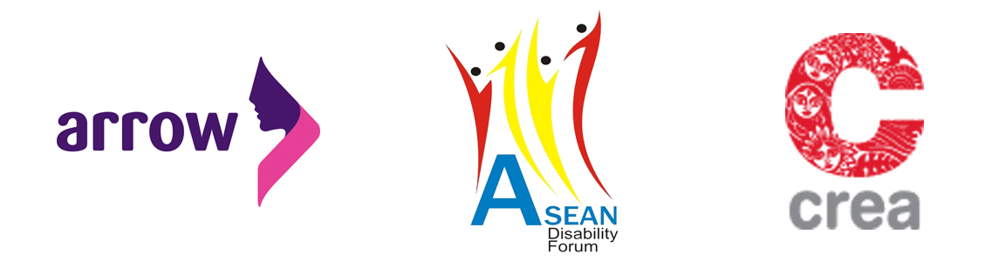
Response to the Outcome Document for the UN Summit to adopt the Post-2015 Development Agenda by the ASEAN Disability Forum (ADF), Partners and Allies

We welcome the outcome document of the United Nations Summit for the adoption of the post-2015 development agenda, which is a result of the hard work and perseverance of the co-facilitators, Member States, UN agencies, civil society, Major Groups and other stakeholders.

We, as representatives from the ASEAN Disability Forum, our partners and allies would like to stress for more effective inclusion of people with disabilities not only within the outcome document but also in terms of implementation programmes. People with disabilities remain a marginalized community. Needs of people with disabilities remain invisible and not included within policy documents at all levels - global, regional and local. Within this, women with disabilities are further marginalized because of the double discrimination on the basis of gender and on disability.

We welcome the inclusion of human rights, gender equality and empowerment of all women and girls in the preamble. The document reaffirms the Programme of Action of the International Conference on Population and Development (ICPD POA) and the Beijing Platform for Action (BPFA), and the follow up of these conferences. We would also like to stress for the inclusion of strong international commitments in declarations and documents including the UNCRPD, the Rio+20 document, CEDAW declaration, the MDGs and finally the Incheon strategy that are important documents our governments have ratified and signed on to.

Goal 3 talks about ensuring healthy lives and promoting wellbeing for all people at all ages. This is particularly of interest to People With Disabilities (PWDs) including women and girls with disabilities. Issues of maternal mortality and morbidity are further exacerbated for PWDs who are often denied access and information on maternal health services; women with disabilities are also more vulnerable to HIV and AIDS and other diseases. Further, forced sterilization, institutionalization and forced medical interventions are forms of violence that women with disabilities (WWDs) are subjected to. WWDs must be included in these discourses. Further, universal access to Sexual and Reproductive Health (SRH) services including family planning and other RH services, along with sexuality education will be incomplete if these do not include WWDs.

PWDs face a number of barriers including systemic barriers, attitudinal barriers (in families and in societies). Girls and women with disabilities also face additional barriers in schooling and education as they usually get left behind in comparison to men and boys. We therefore request for the need for better access to education for PWDs and especially for women and girls with disabilities in Goal 4 of the document. We call for better capacity development of teachers and instructors to be more sensitive to issues of disability. We call for our governments to look into specific challenges faced by PWDs in making education more inclusive for all.

There is greater need for inclusion of issues of PWDs within Goal 5 of the document, which addresses concerns on gender equality. 15% of the world’s populations are people with disabilities; within this more than half are women with disabilities (World Health Organisation). This population is therefore additionally vulnerable to risks of abuse, violence and also trafficking. These issues must therefore be more effectively included within the sustainable development agenda.

Goal 7 mentions important issues of energy. Accessibility can get severely affected by availability and access to energy. With inadequate access to energy, we won’t have good services at schools, offices, and markets etc. Lack of effective energy systems for cooking, can also affect PWD especially people with visual disability with smoke etc. Lack of accessible energy also leads to discrimination. For example, when lifts don’t work, PWD can’t come to work, can’t move around. Inadequate access to energy also affects transport systems and thus affects mobility especially for PWDs. Lack of mobility also affects sexual and reproductive health and rights (SRHR) issues of WWD with less access to SRH services. We therefore recommend for assurance of existing energy for all services and buildings for transportation, better access to transportation and energy to operate devices, machines and to work with Disabled People’s Organisations (DPOs) to review the issues we have. Civil Society Organisations (CSOs) should include DPOs and key persons in disability movement.

Most often for PWDs, systemic and structural barriers lead people to feel ‘disabled’ instead of the disability itself. In Goal 9, which addresses the need for building resilient infrastructure, we call for better inclusion of concerns of people with disabilities. It is important to look at better physical environments in the construction of buildings and roads for better mobility. This would help in enhancing lives of PWDs and enable better and independent living facilities. Dealing with physical environment is a crucial cause of our disability. PWD may not feel they are disabled. Infrastructure doesn’t only include building and environment accessible. It also includes attitudes of society – this affects access of WWD. We call for developing inclusive societies and infrastructures so that data systems do not leave PWDs and WWDs out.

Goal 13 mentions combating climate change and its impact on people. PWDs as a community are worst affected in conditions of climate change and disaster situations. When PWD are impacted from disaster, they have less access to reach safe spaces for shelter. In a family with two or more children, families often protect non-disabled children first thus jeopardizing lives of children with disabilities further. In an example in Cambodia, during a disaster situation, PWDs had to face additional challenges with inaccessible toilets and safe shelter spaces. Shelters were often higher to reach thus making PWDs including people with visual impairments and people using wheelchairs extremely vulnerable. People also need to be transported from islands (in situations of disaster) to safe spaces and often these situations exacerbate concerns of PWDs. We therefore call for improving education and better preparation for disaster relief and in places of climate change. More effective planning must be made to include PWD and especially WWDs better. Capacities of government authorities must be developed so they have the additional knowledge and empathetic understanding towards concerns of PWDs in their programmes.

Goal 16 promoting peaceful and inclusive societies for sustainable development will not be possible without including it in national levels laws and policies. We recommend better systems of sign language and other inclusive modes of communication including audio-visual materials. We also need better access to information and communication on access to justice including education officers working on laws and policies. We also need more focus on criminal justice systems including police, lawyers and judiciary.

We recommend better and disaggregated methods of data collections to include issues of PWDs more effectively. We need better qualitative and quantitative methods of generating evidence-based research on PWDs.

Lastly, we reiterate and emphasize the inclusion and full participation of PWDs in all planning, organizing, and implementation of the sustainable development agenda to make this truly transformative and reaching out to marginalized communities including people with disabilities.

Signed:

ARROW: The Asian-Pacific Resource and Research Centre for Women (ARROW) is a regional non-profit women’s organization based in Kuala Lumpur, Malaysia. We work towards achieving sexual and reproductive health and rights for all through monitoring and evidence-based research for better advocacy, building strong and effective partnerships and networks, knowledge sharing through information and communication and building, and improving organizational systems for better outcomes.

ASEAN Disability Forum: The ASEAN Disability Forum (ADF) is a network composed by DPOs of the ASEAN region. It is a platform, where DPOs coordinate actions to advocate for disability inclusive policy formulation and implementation.

CREA, India: CREA is a feminist human rights organisation based in New Delhi, India. Together with partners from a diverse range of human rights movements and networks, CREA works to advance the rights of women and girls, and the sexual and reproductive freedoms of all people.

