Minutes of the First Coordination Meeting of Women with Disabilities Forum

Disabled Peoples’ Organization (PDPO/DPI – Pakistan)

On Saturday 24th January, 2009, first coordination meeting attended by 09 leading women with disabilities from DPO s, NGO s and INGO s, chaired by Ms. Abia Akram, Women Coordinator PDPO/DPI- Pakistan in Islamabad

Pertinent to mention, 5-6 women with disabilities have contributed and shared their observations through telephonic conversation.

Agenda of the Meeting was:

Specify the need of this Forum of leading women with disabilities in Pakistan
Organizational Best Practices on women with disabilities
Role of WWD s in DPO s specifically in Independent Living Centres
SCOT Analysis / Future Action Plan

Points Discussed During 2 ½ Hours Meeting:

Meeting was started with the short introduction of participants and followed by the agenda

Need of the Forum:
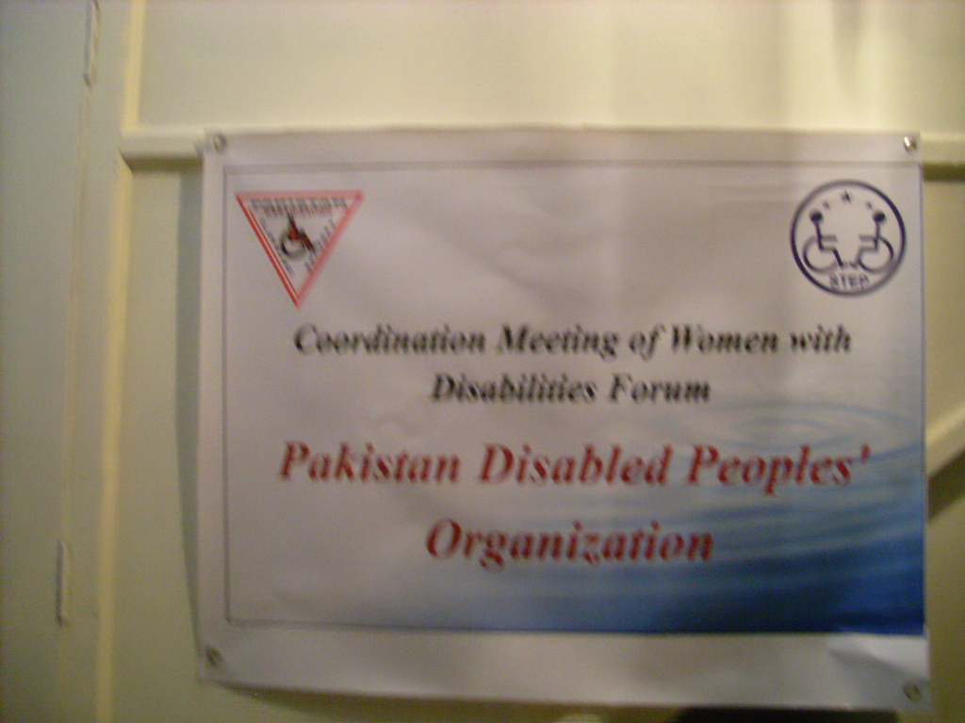
- After the one hour fruitful discussion we agreed that it is important to connect with other significant women in the disability movement. For many years women have often been neglected within the disability movement. Men have often dominated in leadership roles and the movement has reflected the gender discrimination of our society. Women with disabilities have often had less access to education, health, rehabilitation and employment and their opportunities to take up leadership roles have been severely restricted.

- We need to look at the key issue of women with disabilities in leadership and how other countries and organisations had supported this to occur. This forum needs to work not only disability specific it has an important role in maintaining a non-medical focus and looking at women's issues from a twin track approach

- Women with disabilities are disadvantaged in several key areas when compared with other women, men with disabilities, and the society as a whole, because we don’t have any representation, Ms. Uzma, Milestone, has raised the point that there are few issues particularly related to women with disabilities and need to be tackle separately

- There is a need to sensitize our own communities, families, or even working bodies of our own organizations that, if our environment is inclusive, then we would not require special arrangements

Sharing experiences/ best practices:

- Ms. Noreen Advocate raised the point that we as trained and educated women with disabilities have lead several projects on disability development but there is a dire need to involve that women as a role model or highlight their efforts to understand the social and economic realities and possibilities with regards to disability.

- Develop and maintain mechanisms which increase the participation and representation of disabled women in all decision-making

- In the context of Pakistani culture, women with disabilities played vital roles

- Disabled women are an important part of the movement for people with disabilities. But far too often, they are considered as “wife” roles in existing organizations (e.g. doing mailings, answering telephones).

Scot Analysis:

A Strengths, Challenges Opportunities and Threats (SCOT) analysis is a tool to develop a future plan after analysing the organization.

Strengths  key factors in the current period  - A good number of Women with Disabilities are working in all organizations  - All organizations implementing projects and women with disabilities are playing a key role in furthering the efficiency and effectiveness of development programs.  - Good working environment  - Governments have framed various policies for PWDs including reservation of jobs, concession facilities in travelling, special training institutions etc. The Government of Pakistan has made efforts to support the rights of Persons with Disabilities in the view of BMF and National Policy on disability and now Pakistan has signed the UN Convention on the rights of People with Disabilities | Challenges  key factors in the current period  - disabled women are actively pursuing their dreams within a system of extreme poverty and great physical inaccessibility,  - Including women with disabilities in programs from the drafting stage  - WWD s realized that disabled women's issues were being overlooked  - This need not be the case and as women with disabilities we can assist and encourage disabled men to understand our issues and thus become supportive of us."
Opportunities  key factors relating to the future that are external to the organisation–  - In the disability movement, especially in the Independent Living Movement, women are very active and lead the movement. In terms of organizations  - Have received a good response from national and international levels and everyone provided us a good support  - Women with disabilities realized that it is a need | Threats  key factors relating to the future that are external to the organisation  - It will not be an easy task, as, some disabled men perceive the forming of a disabled women's group as a threat to the organization in general.  - The role of women, extensive patterns of lack of services and gender-biased services that are not inclusive of women.  - The serious poverty faced by many Asian countries  - Lack of resources to facilitate future activities of the forum

Outcomes:
This Forum of women with disabilities will take initiatives to address these issues:
- Disability organizations, leadership training projects and independent living services must collect data on involvement of women and girls with disabilities and conduct specific outreach efforts to include women with disabilities.
- Mainstream organizations must support and work in partnership with organizations led by women with disabilities.
- Women with disabilities must be involved in all policy and decision making processes, and at every level of the projects: as staff, volunteers, participants, and evaluators.
- Education, vocational training and rehabilitation programs must include women with disabilities, to prepare women and girls for careers and gainful employment.
- Health service personnel must be trained to offer informed and sensitive service and education addressing the health needs of girls and women with disabilities.
Recommendations:

- Next meeting will held on 07th March
- Will make a online network in which all leading women with disabilities will share data/ case studies of women with disabilities
- Forum will review ten cases in each meeting for follow up from women perspective
- Will plan to raise funds to organize meetings, seminars trainings and future activities on national level.

Acknowledgment:

On behalf of PDPO/DPI – Pakistan, I would like to express my heartfelt gratitude to all those participants who have participated in this first leap. I am also thankful to STEP for facilitating this meeting in their office.

Abia Akram,
Women Coordinator – PDPO/DPI, Pakistan
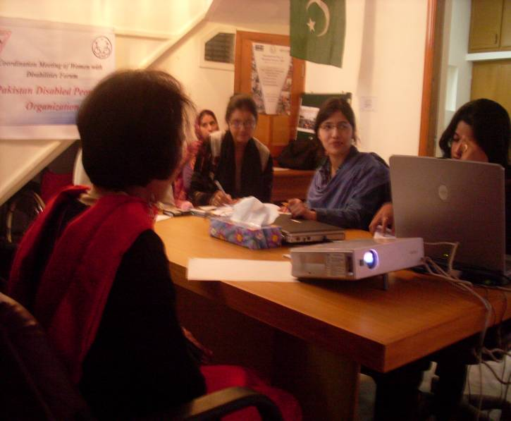
Abia.m.ilc@gmail.com
92-321-5278021

