DISABILITY EQUALITY TRAINING
UNITED NATIONS CONFERENCE CENTRE (UNCC)
2 DECEMBER 2008
BACKGROUND
After the Convention on the Rights of Persons with Disabilities (CRPD) came into force on 3 May 2008, the Economic and Social Commission for Asia and the Pacific (ESCAP) realized that it should be a leading organization to implement CRPD as one of the United Nations (UN) agencies. With this reason, in order to be a role model of CRPD implementation, ESCAP in collaboration with other UN agencies, Disabled Peoples’ International Asia-Pacific and Disabled People’s Organizations decided to establish a working committee called ‘ESCAP Inter-divisional Working Group on Accessibility’ as a consultation group to improve accessibility features in the UN premises in Bangkok, which still have many accessibility problems to persons with disabilities such as a registration desk that is too high, sticky carpets, heavy toilet doors, narrow spaces in meeting rooms, etc. More importantly, many of UN staffs, especially the security guards who always deal with visitors to the UN premises, do not know how to assist or accommodate needs of persons with different types of disabilities. Sometimes, this results in appropriate accommodation.
After a couple of meetings of the working group, we agreed that before renovation/improvement on accessibility in the UN premises, we should have a workshop on disability so that UN staffs can have a better understanding on disability and are able to assist/accommodate persons with disabilities properly. In this regard, the Disability Equality Training (DET) was suggested for this workshop. At first, DET was scheduled to 7 November 2008. However, due to the unstable situation in Bangkok, it was postponed to 2 December 2008.
WORKSHOP OBJECTIVES
- UN staffs to have a better understanding on disability and persons with disabilities
- UN staffs to know how to assist/accommodate persons with disabilities in the UN premises and services properly
DET OBJECTIVES
- To realize and recognize famous people who have a disability
- To identify language which is offensive to persons with disabilities and use more acceptable terms
- To begin to question and challenge attitudes and levels of awareness regarding disability
- To critically examine the Medical Model and introduce the Social Model of Disability

PARTICIPANTS

UN staffs from e.g. ESCAP, Security Department, Facility Management Unit, Conference Management Unit and Office of the High Commissioner on Human Rights (UNHCHR)

FACILITATORS

Ms. Saowalak Thongkuay, Regional Development Officer, DPI/AP

Mr. Sawang Srisom, Assistant Regional Development Officer, DPI/AP

Mr. Yongyut Borisut, President, National Association of the Deaf in Thailand (NADT)

Ms. Sawart Pramoolsil, Thailand Association of the Blind (TAB)
PROGRAM
09:00 – 09:15 Ice-breaking (15 min.)
09:15 – 09:40 Famous People (25 min.)
09:40 – 10:10 Word Power (30 min.)
10:10 – 10:20 Refreshment (10 min.)
10:20 – 10:50 Attitude & Awareness (30 min.)
10:50 – 11:10 TALK Video and Feedback (20 min.)
11:10 – 11:40 Medical and Social Model of Disability (30 min.)
11:40 – 12:00 Practice: How to Assist PWDs (20 min.)

SUMMARY OF THE WORKSHOP
FAMOUS PEOPLE
In this session, the participants could learn that there are many famous people e.g. Bill Clinton (one deaf ear), Tom Cruise (dyslexia), Vincent Van Goh (mental problem), Krisana Chairat (wheelchair user, Thai TV news reporter) who have a disability. More importantly, they learned that disability is not an obstacle to success. In contrast, there is no guarantee that disability is part of their success either. Success depends on several factors e.g. one’s ability, opportunity, barriers/obstacles, family support, etc.
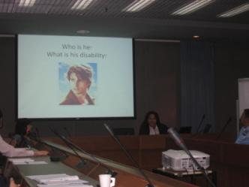
WORD POWER
In this session, the participants were broken into pairs. Each pairs were given a word related to disability e.g. ‘disabled people’, ‘cripple’, ‘handicapped’, ‘wheelchair-bound’, etc. to discuss whether or not the word they had is negative, positive or neutral. Participants could learn that the words like ‘handicapped’, ‘cripple’ and ‘wheelchair-bound’ have very negative meanings and portray negative images of persons with disabilities. These words should be avoided to use since words are from people’s attitude and translated into actions. The acceptable term now is ‘persons with disabilities’.
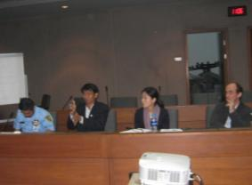
Mr. Yongyut Borisut, NADT
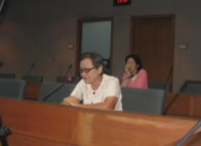
Ms. Sawart Pramoolsil, TAB
ATTITUDE AND AWARENESS
This session challenged the participants’ attitude on disability with questions related to perceptions or beliefs about disability e.g. ‘Blind people cannot play table tennis’ or ‘Accessibility is to make persons with disabilities more comfortable than others’, ‘All deaf people can lip read’, etc. The participants could learn that there are many misperceptions/misbelieves about persons with disabilities. Sometimes, persons with disabilities are judged by their disability (e.g. blind people cannot play table tennis). Some people misunderstand that deaf people can lip read, which is not always true since it depends on person to person. Therefore, this session helped the participants re-think and adjust their attitude towards persons with disabilities.
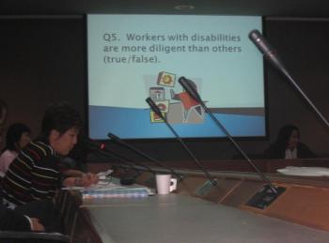
TALK VIDEO
TALK video was produced by the Disability Rights Commission, United Kingdom of Great Britain. TALK portrays a society in which non-disabled people are a pitied minority and persons with disabilities live full and active lives. In the video, one man, as the main actor, who has no disability is discriminated against in every place he goes. For example, when applying for a job, he has to read a Braille document, which he cannot; he is gossiped and starred at when he is in a pub with other friends with disabilities; he is asked if he brings a personal care assistant to take care of him; taxis do not accept him since all taxis are for persons with disabilities, etc. From this video, the participants could learn that discrimination and prejudice stem from less communication between persons with and without disabilities due to misperceptions/misbelieves. People should understand that people are diverse. Disability is just like other attributes that people have e.g. gender, complexion, race, religion, etc. People have to understand human diversity in order to live together without leaving someone behind.
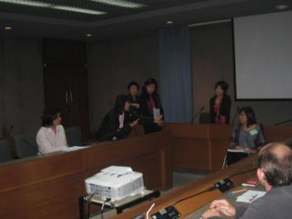
MEDICAL & SOCIAL MODEL
In this session, the participants learned different models on disability from the past to present. They learned that the ‘Chair-based Model’ looks at persons with disabilities as an object of charity but no development. The ‘Medical Model’ sees disability as a problem and needs to be cured, but no other actions taken apart from medical or vocational rehabilitation. The ‘Social Model’ says that the reason persons with disabilities cannot participate in society fully is because there are many barriers: physical, attitudinal, systematic/regulation and information, in our society. Also, they learned that ‘impairment’ plus ‘barriers’ equal to ‘disability’. In this sense, in order to enable persons who have an impairment to live in our society fully, barriers must be removed.
PRACTICE: HOW TO ASSIST PERSONS WITH DISABILITIES
The last session demonstrated how the UN staff can assist persons with different disabilities. There were 3 models for 3 different disabilities: visual, hearing and physical impairment. The participants learned that when assisting a blind person, we should let he/she catch our elbow and it is very impolite to lead he/she by catching his/her hand or white cane. When assisting a deaf person, the UN staff should have a pen and piece of paper to communicate if they do not know sign language. Lastly, when assisting a person on a wheelchair, they should know how to push the wheelchair properly and know how to deal with rocky surface, steps, ramps or even carrying. However, since persons with disabilities have different needs and details of assistance just like other people, it is better to ask before helping.
From the half-day workshop, the UN staffs were pleased and enthusiastic to learn since most of them do not have any experiences dealing with persons with disabilities. Apart from being able to assist persons with disabilities, they could also learn disability concepts and dimensions, which would help them give services to persons with disabilities more properly and effectively.
