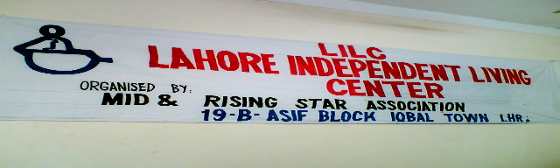

Report of the Inaugural Ceremony of the

Lahore Independent Living Center (LILC)

Many organizations in Pakistan are working for the People with Disabilities. They touch different aspects of their lives and help them in problems that they face. But very few organizations are working for the Independent Living Philosophy. Thus two reputed organizations of Lahore, Movement for Independence of Disabled (MID) & Rising Star Association, joined hands to initiate the Independent Living Movement and Hence Lahore Independent Living Center was established to provide the People with Sever Disabilities of Lahore slums with the services like Information sharing, PA Service, Peer-Counseling and advocacy.

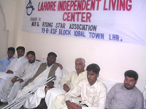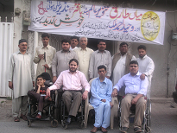

A ceremony was held at the main office of MID that is also used as IL Center. This inaugural ceremony was attended by many People with Cross Disabilities.
This was the one of successful ceremonies in Lahore by People with Disabilities themselves. The occasion was enlightened with the presence of Mr. Ch. Muhammad Bakir (coordinator to Ex-Chief Minister of Punjab) and Mr. Wahid Ahmed Malik (V- President PML-N Lahore region). They reached at 3:30 PM and the ceremony was formally started by the recitation of the HOLY QURAN and Naat was offered to Muhammad (PBUH).

The local Media was also invited to cover the occasion. Then the chief guest and the participants were told about the importance of independent living philosophy in the life of a people with Disabilities particularly and People with Sever Disabilities Especially and how effectively it helps them to cope with the daily barriers and discrimination that they face in life.

Independent Living Philosophy was explained in detail by Mr. Atif Raza (President MID, Project Director LILC). He explained that the People with Disabilities should come out of their houses and after learning the basic skills to solve their disability related problems through independent living and then they should move independently in the society and enjoy their life as well as their non-disabled counter parts. He intimated that People with Disabilities can solve their problems through sharing and Lahore Independent Living Center will provide them with the opportunity for that and will also provide them the Attendant Service for the severe People with Disabilities.

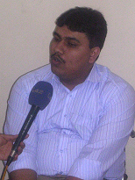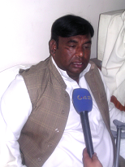

After that Mr. Syed Ali Mukhtar Jafferi (General Secretary DPI-P, President Rising Star Association and LILC) explained the participants about the problems that the People with Disabilities face in their daily lives in Pakistan and he also intimated that more the People with Disabilities will come in the mainstream the lives of the People with Disabilities will improve.
In the end Mr. Wahid the honorable guest shared his views and appreciated the effort made by the People with Disabilities and also the fact that the organizations working for the People with Disabilities are joining hands to improve the quality of living for the People with Disabilities which is a healthy sign towards a more barrier free and independent society for the People with Disabilities and he wished us good luck for our cause. The media covered the occasion and they also were impressed by the philosophy of Independent living for the People with Disabilities by the People with Disabilities. The ceremony was concluded on the positive note that the two organizations MID and Rising Star will help each other to full fill this dream of IL enter in Lahore to the best of their skills.

