Activity Report
Date: 06-02-2009
A training session (meeting and awareness walk) arranged in Muzaffrabad on 06-02-09 to 08-02-09.The training was arranged with the co-operation of Milestone, Handicap international, Helping Hand and a local NGO over voice. The program was started by Talawat-e-Qurani-e-Pak and hall was full of guest .A large number of disabled persons participated from different areas. The main role was played by Milestone. In this three days training different activities were played. Whole staff of different Milestone centers e.g. MZD. Bagh, Mansehra, Batagram, Islamabad and Lahore gathered in MZD.
At 1st day of training session a meeting was arranged in which the whole staff of Milestone and HI MZD discussed about different types of disabilities, awareness and accessibility. The technical officer of HI Mr. Kashif described different types of disabilities and their cures e.g. Impairment, Genetic disability, CP, Spinal card injury, Polio etc.Then Milestone staff of different centers shared their work problems on disability and made a proper plan to overcome these problems.

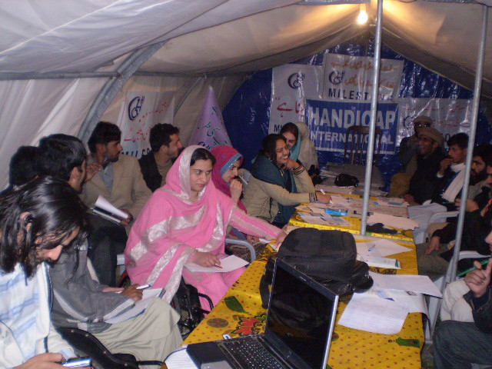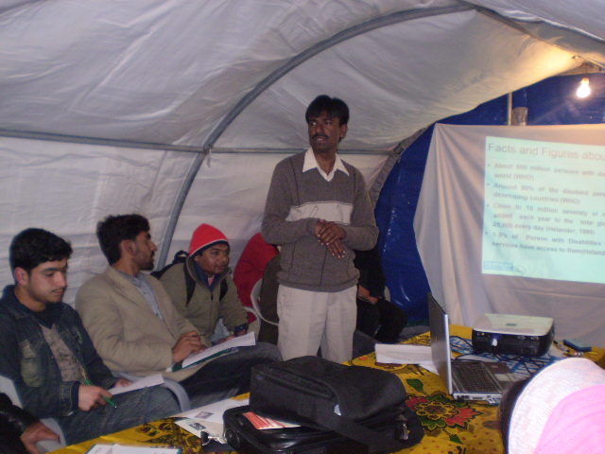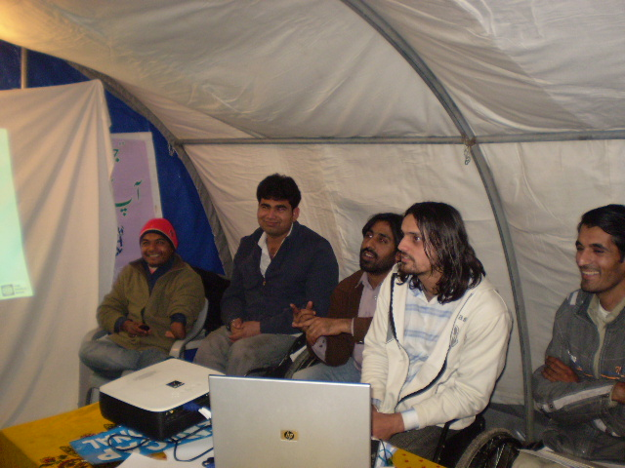

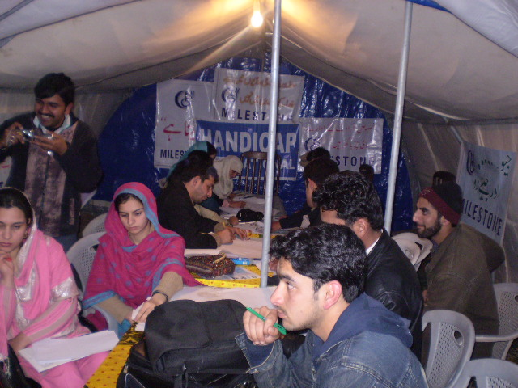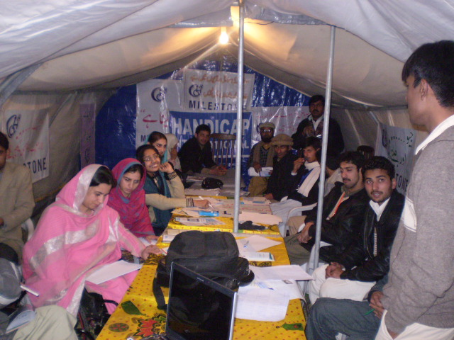

2nd day walk was arranged. The location selected for walk was from Press Club to Assembly Hall lower Chatter. Before walk whole staff of Milestone, HI MZD, Helping hand MZD and over voice gathered in Press club. Disable persons came for walk from different Regions of Pakistan and Kashmir were also present there. During conversation with Media Shafiq-ur-Rehman, President Milestone, The finance manager Mr. Malik Nasir from Milestone, Mr.Jawad from Helping hand MZD, Mr. Kashif from HI and Qazi Zahid Hameed from Milestone MZD addressed about Awareness, Disability and told that every disable person has place like a non-disable person in our society and we should also try to improve their personality and also try to overcome their problems.

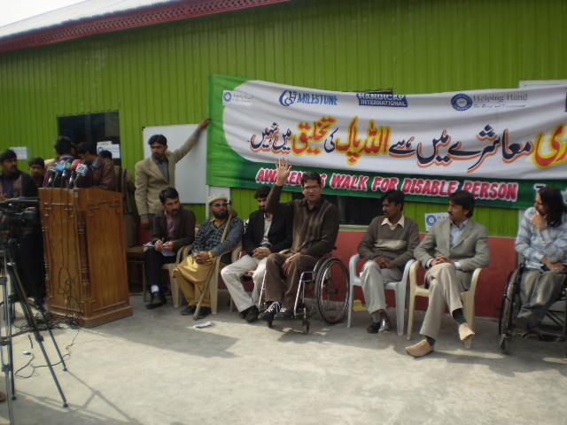
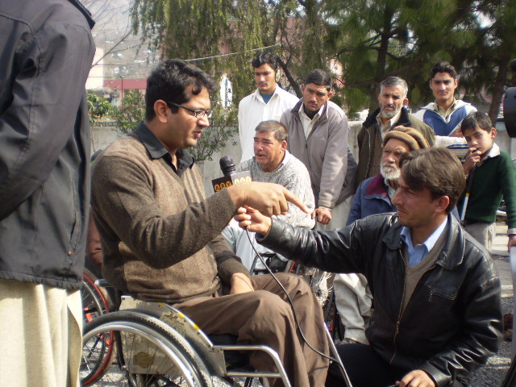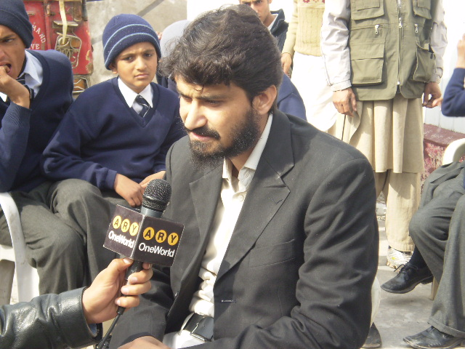
Then walk started at 12 pm. The participants commenced walk holding different banners and play cards. The basic purpose of this walk was to aware the people about disability and needs of disable persons in our society. The purpose of walk was also to aware the government about the problems of the disabled community. The walk end successfully after one an hour. At evening whole staff of Milestone again gathered and discussed about different problems to work on disability and made planning for future work.

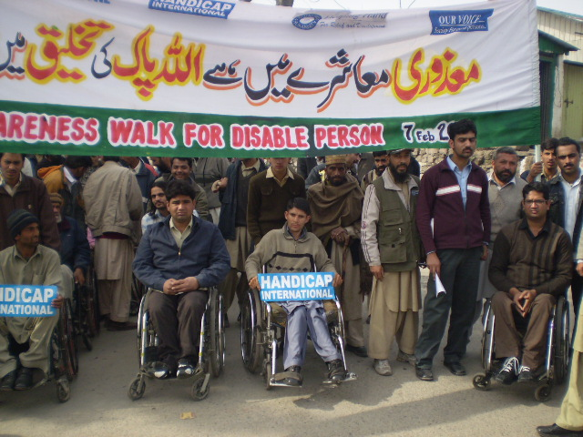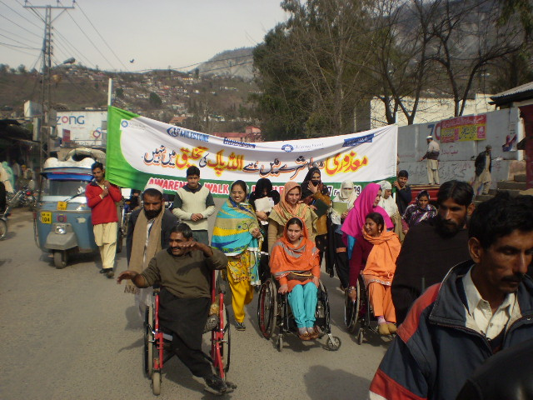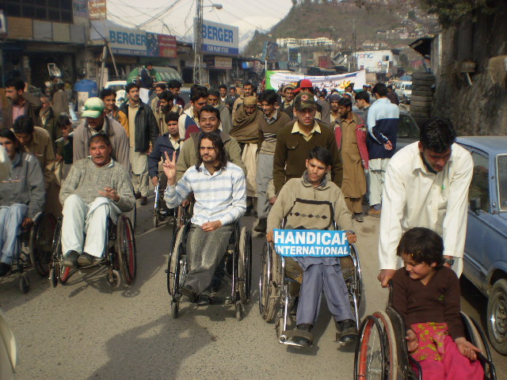
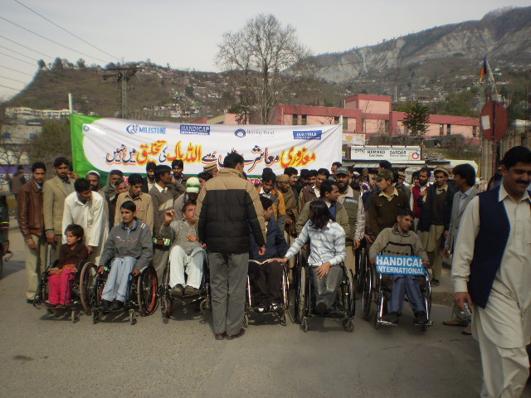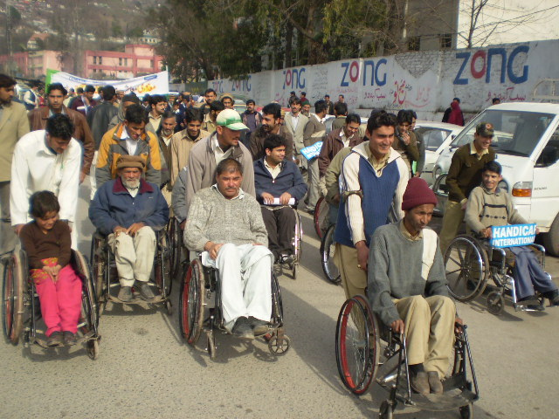

On 3rd day cricket match was held between special brothers club of disable persons and Press club of non disable persons at Narol Stadium MZD. This was a twenty twenty cricket Match .Whole staff of Milestone was present there. This match was sponsored by Milestone and over voice. Match won by special brothers club of disable persons. So disabled persons proved that nothing is impossible in this world. Every thing is possible if we make our mind that we can do it and try to do it.

