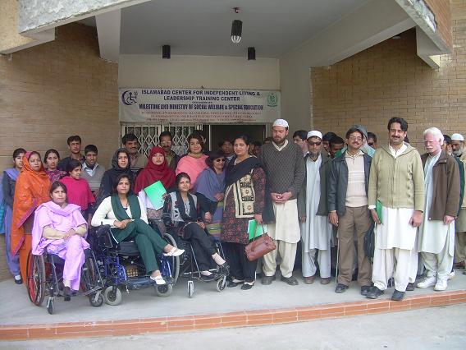

Second Independent Living Leadership Training

Second Leadership Training was organized in December 2008 at Islamabad Center for Independent Living for Visually Impaired Persons. The Training was organized by the cooperation of DO (District Education officer for Special Education ) Mrs. Nusrat Najeeb Visually Impaired persons from different aspects of life including students as well participated in it. Above fifty persons including Mr. Haq Nawaz the Principle of Govt. Qandeel School, Mrs. Waseem Sanaullah Principle Govt. School for Blind, Mr. Jamal Abdul Nasir from Govt. Special Education Center Murree etc also attended the leadership Training as guest.

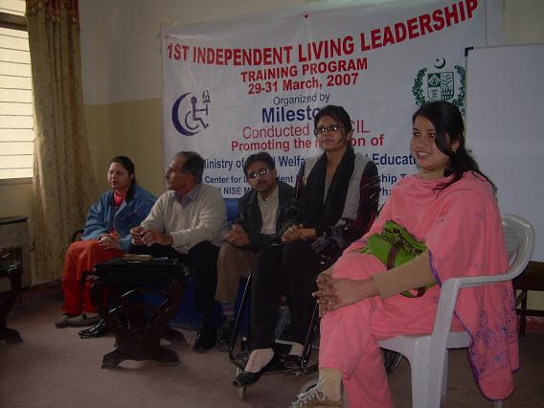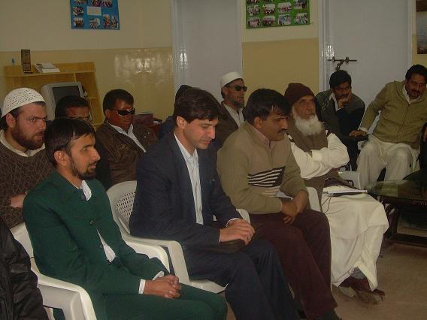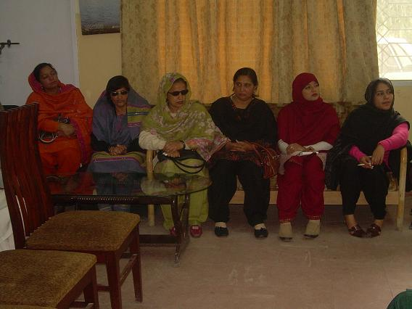


The object of the Leadership Training is to enhance the capacities and advocacy work of persons with VI to endorse their independent living. In this training the persons with VI will be imparted with the skills of independent living to live with their will in the community.

Miss Shamsa Kanwal Program Manager Milestone Computer Lab starts the training with the introduction of Milestone and the computer lab project running in collaboration with Sightsavers International. She delivered the lectures regarding independent living philosophy and described the Independent living skills to enable the disabled persons to lead better independent lives in their community rather than depend on their parents or stay in an institution. The topics she discussed are Empowerment, Disability Understanding, Personality Development Skills, Self Care, Social Participation etc. She elaborates the difference between worker and a leader as she discussed in the previous training because the students must know the difference. These students will be our leaders of future.

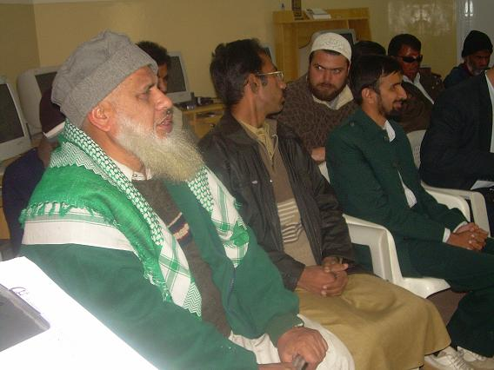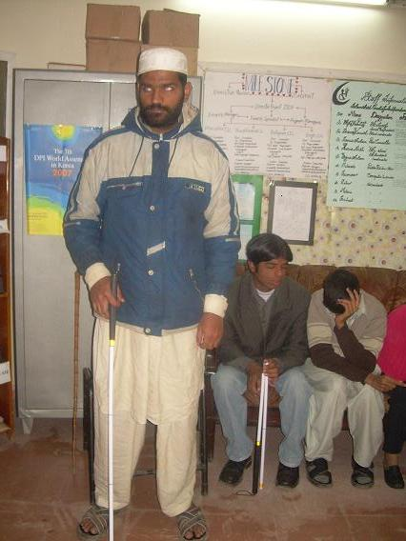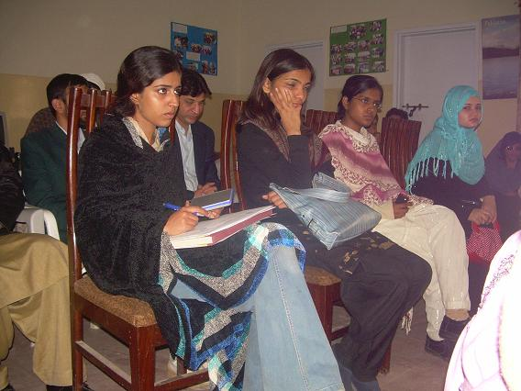

After that Miss Uzma Aslam elaborates about Attendentship and the importance of attendant in the life of disabled person. She said that the aim of providing the attendant service at independent living center is to support persons with disabilities in various ways for living life independently in a community and Personal Attendant Service manage the daily works of disabled persons like eating, toileting, and cloth changing, self cauterization and stool passing for spinal cord disabled persons to make them live independent life as useful member of society.
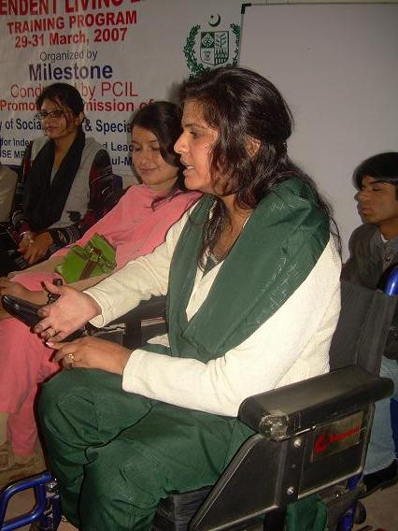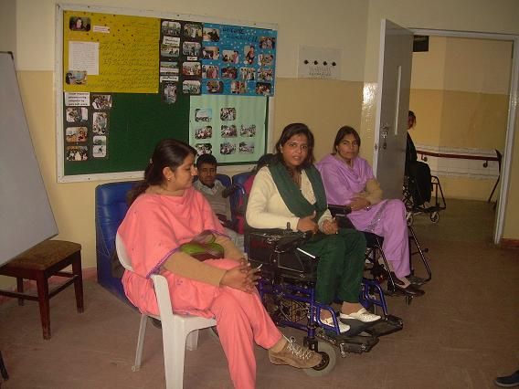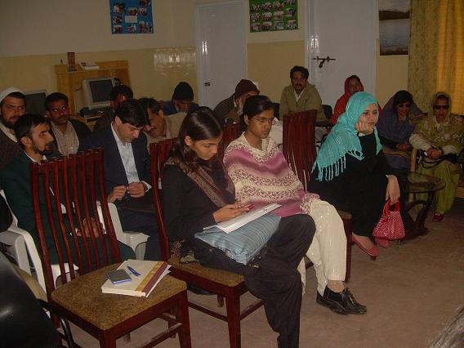
Miss Saima Aslam shared her personal experiences of life with Muscular Dystrophy disability, she compared her life before and after joining Milestone that she was on death bed at her home had nothing to do without any information about her disability, , burden on her family, especially her mother as she was growing, there were terrible times but she can’t forget the day that she joined Milestone and today delivering you lecture using Personal assistant, I am no more a burden on my family and perform my maximum chores by using attendant and this is independent Living. Mr. Taimoor Ahmed computer instructor Milestone computer lab and visually impaired parson then describer his personal experiences and achievements after getting independent. They shared their disability to the visually impaired persons so that they become know the information concerning other disabilities. This was their first experience of sharing with the cross disability persons. In the end the lecturers gave the answers of the cross questioning from the students and the persons participated.
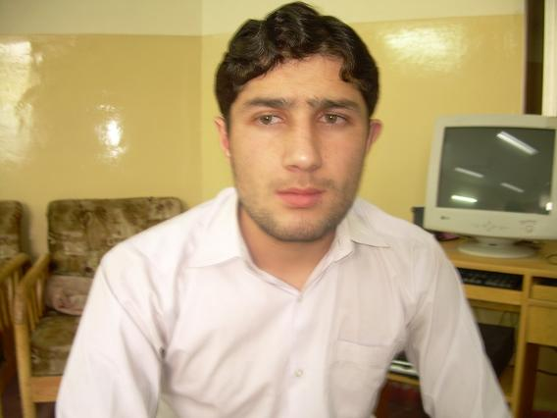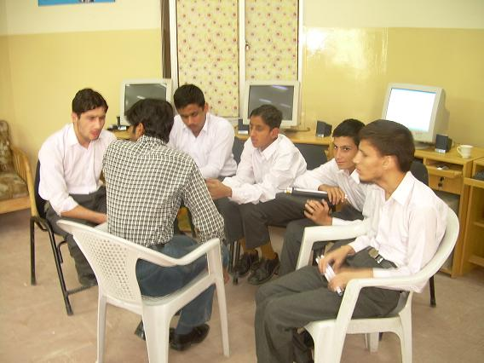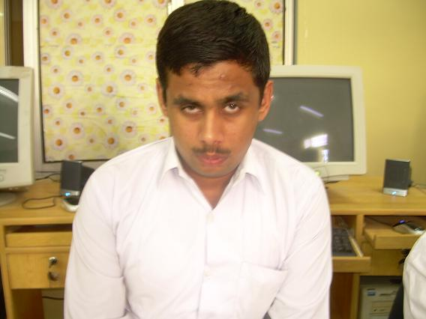
The students who have done the computer course are mostly the college students and after gaining the IT training the studies become easier for them. By getting the basic computer knowledge it become easier for some students to get more IT knowledge at their residential places and because of this, access to the computer is possible and easier. This will open the door for the visually impaired persons for their education and employment. Sightsavers International and Milestone together trying to improve the lives of VI persons by giving the training of independent living and after getting the mobility some persons have got the job relating telephone operator and some got others.
The Independent Living Training will brought a big change in the lives of the disabled persons which omitted the fear and trepidation from their lives.

