Activity Report
Wheelchairs Distribution in Sardaryab (District Charsadda KPK)
01/09/2010

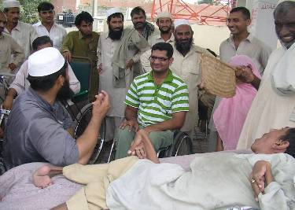
On Wednesday 1st September 2010 President Milestone and Director Pakistan Disabled Peoples Organization (DPI Pakistan) Mr. Shafiqur Rehman and his colleagues distributed the wheelchairs and food packages among the flood affected People with Disabilities in Sardaryab (District Charsadda). Most of the Physically Disabled Peoples which have received the Wheelchairs and Iftari Food Packages were belong from the flood affected areas of District Charsadda.
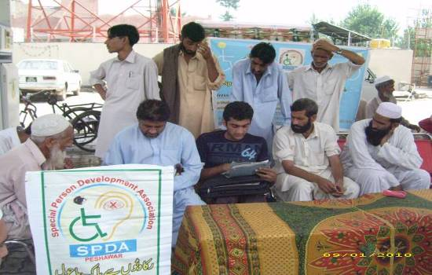

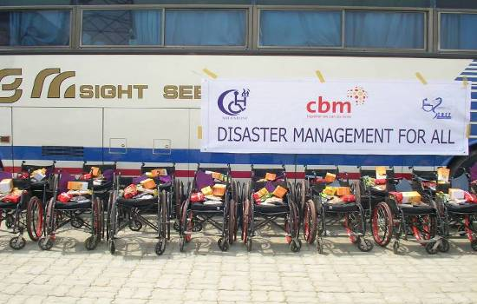
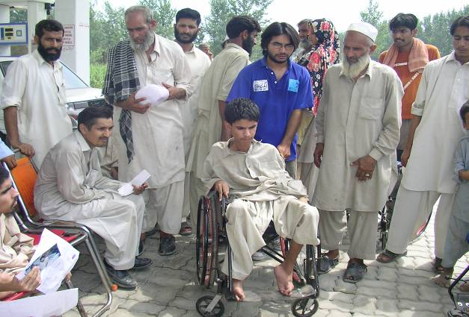
All the arrangements and assessments of the Peoples with disability have been made by the SPDA (Special Persons Development Association Peshawar KPK) member of PDPO (DPI Pakistan). Approximately 80 wheelchairs have been given to the persons affected by flood. Similarly 80 Disabled Persons have been received the Iftari Food Package from the Milestone under the banner of Milestone, CBM and CHEF.

SPDA has greatly appreciated the efforts of Milestone regarding the Disabled Persons. The peoples have also appreciated the Milestone efforts and said that this the first time in Charsadda that a DPO (Disabled Peoples Organization) has came to our area and distributed such a large number of Wheelchairs among the Disabled Perosns.

At the end Mr. Shafiqur Rehman has said that we are so grateful to SPDA for the arrangement of these persons. He also said that Milestone will again visit to the area and will organize such event.

