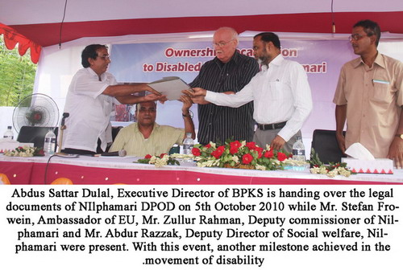

Abdus Sattar Dulal, Executive Director of BPKS is handing over the legal documents of NILphamari DPOD on 5 th October 2010 while Mr. Stefan Frowein, Ambassador of EU, Mr. Zullur Rahman, Deputy commissioner of Nilphamari and Mr. Abdur Razzak, Deputy Director of Social Welfare, Nilphamari were present. With this event, another milestone achieved in the movement of disability

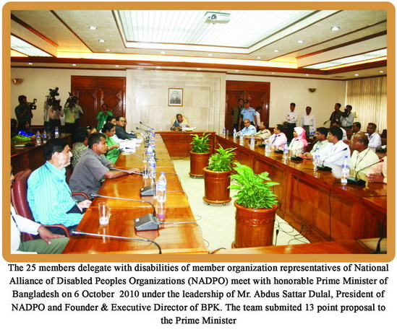.
The 25 members delegate with disabilities of member organization representatives of National Alliance of Disabled Peoples Organizations (NADPO) meet with honorable Prime Minister of Bangladesh on 6 October 2010 under the leadership of Mr. Abdus Sattar Dulal, President of NADPO and Founder and Executive Director of BPKS. The team submitted 13 point proposal to the Prime minister

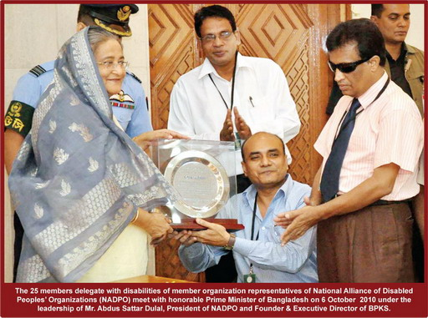

The 25 members delegate with disabilities of member organization representatives of National Alliance of Disabled Peoples Organizations (NADPO) meet with honorable Prime Minister of Bangladesh on 6 October 2010 under the leadership of Mr. Abdus Sattar Dulal, President of NADPO and Founder and Executive Director of BPKS.

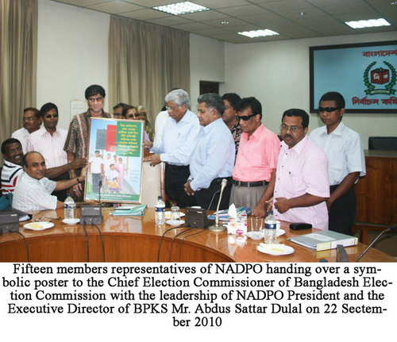
Fifteen members representatives of NADPO handing over a symbolic poster to the Chief Election Commissioner of Bangladesh Election Commission with the leadership of NADPO President and the Executive Director of BPKS Mr. Abdus Sattar Dulal on 22 September 2010

