NATIONAL DPO’s CONSULTATIVE WORKSHOP
5th to 7th OCTOBER 2010
KARACHI

Comprehensive Health & Education Forum (CHEF) International is a Peshawar based Non Government Development Organization (NGDO) and works in the fields of Health, Education and Disability. Chef International for the very first time in Pakistan organized a five days National DPO”s Consultative Workshop at Quaiden Special Education Complex Gulistan-e-Johar Karachi. With the collaboration of MILESTONE for this event all DPO’s (Disable Peoples’ Organizations) arrived from across Pakistan to Lahore and from Lahore by bus our journey started on 2nd October, 2010 towards Karachi. During journey we crossed different cities Multan, Haiderabad and received DPO’s from their respective cities .More than 100 participants from 40 DPOs participated in this workshop the basic aim of this event was to ensure the DPO’s participation in the society for the betterment of PWD’s(Persons’ with disabilities) and their future planning for the mainstreaming disability through PWD’s inclusion.

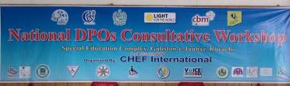
Banner of National DPO’s Consultative Workshop

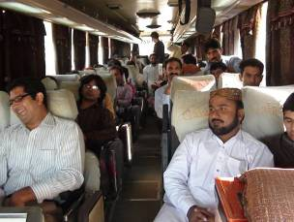 | 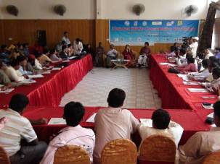
DPO’s Participants in bus on the way towards Karachi | Chief Guest Shazia Muree(Minister of Tourism sindh) charring the Workshop

Chief Guest Shazia Murre (Minister of Tourism, Government of Sind.) addressed the workshop and promised to raise the issues of PWD’s in national assembly.

At the conclusion of workshop leaders of the DPO’s realized the vital role of DPOs and other stakeholders in development.

40 delegates from across the country agreed upon a Joint Statement National Consultative Workshop.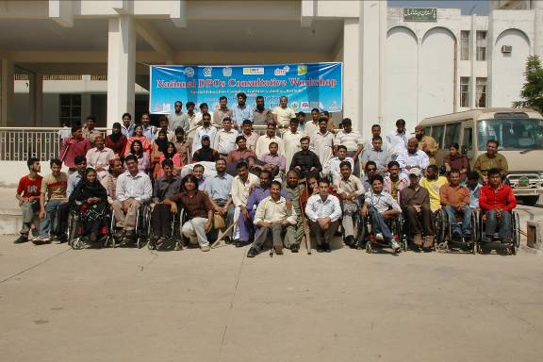

Joint Statement of Pakistan DPOs
at
National Consultative Workshop Karachi
on
5^{th-}7th October 2010

We the leaders of DPOs (Disabled Peoples’ Organizations) from all over Pakistan, at the National Consultative Workshop at Quaiden Special Education Complex, Gulistan-e-Johar, Karachi, with this joint statement realized the vital role of DPOs in inclusive development.

Ninety delegates from across the country agreed upon the following key areas.

- Thankful to CHEF International for taking initiative, organized event and provided opportunity.
- Also Thankful to CBM, LFW & DL for its collaboration with CHEF Int’l to promote activities of DPOs.
- Recognizing role of the Government to providing opportunities to DPOs such as facilities of venue for workshop.
- International day of person with disabilities 2010 will be marked jointly with activities at national level as well as at local level for 10 days starting from December 1^{st-}10^{th,} 2010 that means from world HIV/AIDS day to International human rights day.
- Joint efforts will be made to practice such event repeatedly every year with same spirit.
- That UNCRPD shall be ratified by the Government of Pakistan and DPOs must be included in implementation and monitoring process with the leadership role.
- Emphasis on the activities will be on promoting inclusive businesses and entrepreneurship of Persons’ with Disabilities.
- Efforts shall be carried out for the inclusion of DPOs in political process and at decision making level from the gross root level to national level.
- Promotion of the philosophy and practices of independent living shall be the key agenda in community based inclusive development initiatives.
- To promote peace and harmony among all DPOs of Pakistan, Organizations working in disability field and all other stakeholders include Government.

