Grams: Manovikas Phone : 91-40-27751741-45
Website: www.nimhindia org Fax: 91-40 -27750198


NATIONAL INSTITUTE FOR THE MENTALLY HANDICAPPED
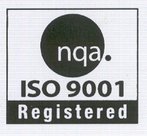
(Ministry of Social Justice & Empowerment, Govt. of India)
An ISO 9001:2000 Certified Institute

NIMH/DAIL/SAARCSEM/2009-10/ June 29, 2009

Sir / Madam,

It is my pleasure to announce that our Institute is conducting a SAARC SPECIAL EMPLOYEES MEET for Special Employees*, from 19–22 January, 2010 at NIMH, Secunderabad. You are requested to nominate two names of Special Employees from your organization, after going through the footnotes given in the application form.

I request you to send the filled in application forms to Shri K. Ravi Kumar, HoD & Lecturer in Vocational Counseling and Employment, Department of Adult Independent Living, who is the Coordinator of this SAARC Special Employees Meet. Last date for receipt of filled in applications is 31-08-2009.

Looking forward to hear from you,

Yours faithfully,

sd/-
T.C. SIVA KUMAR
DIRECTOR

* The persons with Mental Retardation engaged in remunerative employment are referred here as Special Employees.

Manovikas Nagar (P.O), Secunderabad – 500 009, A.P. India
Tel: 91-40-27751741-45 Fax: 91-40-27750198 Grams: MANOVIKAS
Email: saarcsem2010@gmail.com Website: www.nimhindia.org

SAARC SPECIAL EMPLOYEES MEET

19-22 January 2010

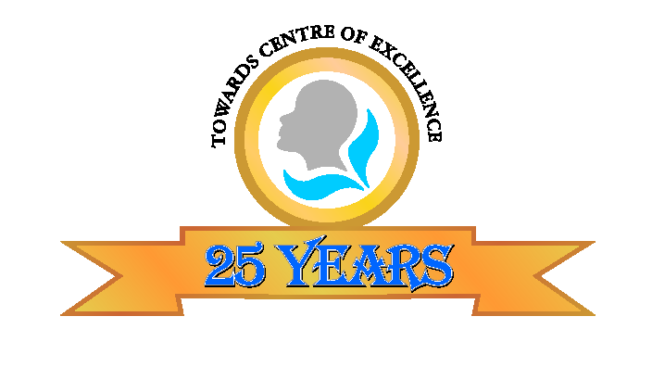
1984 - 2009

Organized by

National Institute for the Mentally Handicapped
(Ministry of Social Justice and Empowerment, Government of India)
Manovikasnagar, Secunderabad - 500 009 Andhra Pradesh, India
An ISO 9001:2000 Institution
Web site: www.nimhindia.org
E-mail: saarcsem2010@gmail
The National Institute for the Mentally Handicapped (NIMH) is a registered society established in the year 1984 as an autonomous body under the Ministry of Social Justice and Empowerment, Government of India. The institute is an apex body in the field of intellectual disability in the country. The major objectives of the institute are Human resource development, Research & developmental activities in the field of intellectual disability and development of service models for persons with intellectual disability. Celebrating its Silver Jubilee Year in 2009, the institute has been making striking advances in building capacities to empower persons with intellectual disability.

NIMH provides comprehensive services to the persons with mental retardation on the basis of life cycle approach from early detection and intervention till training in Adult Independent Living skills. Adult persons with Mental Retardation who are working and earning are called as “Special Employees”. We provide a platform for these special employees from all over the country to meet at one place and share their vocational potential, concerns and talents including self advocacy and artistic abilities. The Institute has been organizing the Special Employees National Meet for the last 14 years with an average participation of 100 Special Employees along with their parents / escorts. With the success of organizing these meets, it is felt that the meet may be extended from National level to SAARC level countries, in the context of our Silver Jubilee Celebration.

This will give an opportunity to gauge various existing similar models among South Asian countries and emulate the most viable model to suit our needs. This also helps in exchanging information on improving the quality of services and rehabilitation programmes for persons with mental retardation. This program has given an opportunity to the adult persons with mental retardation to meet at a common platform and share the views with each other and observe various modes of employment modalities and trades, which are being practiced in the country.

To create enthusiasm, confidence and sportive spirit amongst persons with mental retardation, NIMH is organizing this SAARC SPECIAL EMPLOYEES MEET (SAARCSEM) from 19 – 22 January 2010 at NIMH, Secunderabad, India.

Objectives

- To create awareness on the capabilities of persons with mental retardation with an emphasis on their learning & working capacity

- To promote employment opportunities for persons with mental retardation

- To develop the skills for self-advocacy amongst persons with mental retardation

- To improve skills of the special employees by conducting group activities, self-advocacy and cultural programmes at International level.

Number & Description of participants:

Maximum number – 250 (150 from India and 100 participants from other SAARC Countries)

Age: 18 years and above

Eligibility:

- Persons with mental retardation who are 18 years and above with an IQ of 70 or below and are on remunerative employment at least for one year, continuing in the job till date.

Selection criteria:

Selection will be based on:
- Competencies obtained
- Remuneration earned per month
- Duration of gainful employment
- Any significant achievements
- Preference will be given to first time applicants

NATIONAL INSTITUTE FOR THE MENTALLY HANDICAPPED
(Ministry of Social Justice & Empowerment, Government of India)
Manovikas Nagar (PO), Secunderabad - 500 009
An ISO 9001:2000 Institution

PHOTO

SAARC Special Employees Meet
19-22 January, 2010

Coordinator: Shri K. Ravi Kumar, Coordinator,
Department of Adult Independent Living

Note: Last date for submission of application is 31-08-2009. Late applications will not be accepted.

DETAILS OF THE SPECIAL EMPLOYEE

- Name of the Special Employee :

- Date of Birth/Age/Gender :

- Level of Mental Retardation :
(Please attach medical certificate clearly
mentioning IQ level of mental retardation)

- Address of the Special Employee :
(with phone no. and/or e-mail address)

- Name & Address of employer :
(with phone no. and/or e-mail address)

- Name & Address of sponsoring organization :

- Brief particulars about training undergone :

Skills/trades learnt | Age at the time of admission | Training offered by teacher/job coach/supervisor/parent/vocational instructor (please mention) | Duration
Special School
Pre-vocational
Vocational
On the job training
: 2 :

8. Whether self employed/employed in :
sheltered workshops/open/supported
employment/ others.

9. When payment started :

10. Employment site address :
(with phone / fax no.)

11. Please describe type of work the Special :
Employee does by highlighting work activities
involved in the job for example cutting, pasting etc.
(Please enclose a 10 Min video clip (CD/DVD)
depicting the work activities)

12. Monthly salary drawn by the Special :
Employee

13. Relations with fellow employees :

14. The special talents and interests :

15. After joining the employment, improvement gained by the Special Employee
[please tick mark (√)]:

- Regularity Yes/No
- Punctuality Yes/No
- Readiness to work Yes/No
- Acceptance of responsibility Yes/No
- Comprehension of work instructions Yes/No
- Memory at work Yes/No
- Learning from past experience Yes/No
- Accomplishment of work goals Yes/No
- Reporting of finished work Yes/No
- Spontaneous seeking for more work Yes/No

(To be filled in by the employer)

16. Functional Independence attained:

a) Does he/she travel from home to work place independently Yes/No
b) Does he/she maintain personal hygiene Yes/No
c) Does he/she keep the personal things in order Yes/No
d) Does he/she get ready to go to the work Yes/No
place without reminder.

17. Mention in details the above Employee’s :
participation in the previous National Meet for
Special Employees,

18. Write briefly on the vocational abilities of the Special Employee :
within 200 words (Attach separate sheets)

19. Vocational Trades: (Please tick the appropriate Traditional and Non-traditional Vocational Trades rendered by your organization)

Traditional Activities | Non-Traditional Activities
Paper Based | Paper Based | Agro Based
Book binding | Gift box making | Mushroom culture
Envelopes | Paper bag making | Agriculture
File making | Laminations | Horticulture
Greeting Cards |  | Tissue culture
Screen Printing |  | Seri culture
 |  | Vermi compost preparation
Cloth Based | Cloth Based | Animal husbandry
Embroidery | Tag making | Bio-gas maintenance
Hand block printing | Saree printing | Rose plantation
Muffler making |  | Poultry
Rug mat |  | Nursery
Stitching/Tailoring |  | Dairy
Weaving |  | Pig-rearing
Woolen works
Tie & Dye |  | Services / Open employment
Loom making |  | Service in Temple
Umbrella making |  | Stamping
Pillow making |  | Saree rolling
 |  | Car washing
Chemical Based | Chemical based | Care taker
Agarbathi | Photo developing | Helper in Shop
Chalk making | Vaseline making | Laundry
Candle making | Match box making | Provision stores
Phenyle making | Crayon making | Office assistant
Soap making |  | Packing
Washing powder |  | Telephone booth operator
Tooth Powder |  | Watchman
 |  | Teacher aid training
 |  | Jewelery Finishing
 |  | Sales man
 |  | Computer operations
Food based | Food based | Others
Cooking / catering | Snacks | Puppet making
Pickle making | Bakery & confectionery | Soft toy making
Papad making | Popcorn making | Xerox operation
Masala grinding and packing |  | Painting
Juice making |  | Garland
Home science/Management |  | Pottery
 |  | Flower bouquet making
Others | Engineering | Leaf Plate making
Handicrafts | Winding | Coir making
Mask making | Cradle clamps | Punching
Rakhi making | Assembling
Carpentry / wood work | Mechanical work
Chappal making | Welding
Leather bag making | Metal work
Mysore traditional art | Fan coil rewinding
Jute bag making
Diyas and wick making
Basket making
Cane & bamboo products
Any other (Please Specify)
20. Signature of the Special Employee:

DECLARATION

This is to certify that Mr/Ms. ____________________________ is working as _______________________ in ___________________________ and is being sponsored for SAARC Special Employees Meet to be held at NIMH, Secunderabad from 19-22 January, 2010. Accompanying escort Mr/Ms. ____________________________ will be fully responsible for his/her ward during the period of travel as well as stay at the venue.

(Signature of the parent/Guardian) (Signature of the Employer with seal)

Please tick mark (√) the facilities extended by your organization with regard to vocational training.

Particulars |  | Particulars
Admission Details |  | Production Details
Half yearly |  | On Demand
Yearly |  | On demand & order
Once in two years |  | No production
Throughout the year |  | Marketing Details
Admission Procedure |  | Exhibition Sales
Psychological Evaluation |  | Window Counter
Family resources |  | Direct marketing/ others
Community resources |  | Sale & Contract
Job Demands |  | Placement Details
Market Evaluation |  | Placement done
Duration of Vocational training |  | Self employment
1 year |  | Supported employment
2 years |  | Open employment
Depends on the case |  | Placement not done
Training Strategies |  | Please share any other details:
Sheltered workshops
Supported Employment Training
Home Based Training
Competitive Employment Training
Others
Venue:

National Institute for the Mentally Handicapped
Manovikas Nagar (PO) , Secunderabad – 500 009, Andhra Pradesh, India.

Traveling allowance

International Participants

No reimbursement of travel cost will be provided to the participants and escorts. However, local transport and hospitality (boarding and lodging) will be provided free of cost at the place of venue.

National Participants

To and fro concessional second-class railway fare/ ordinary bus fare by the shortest route will be provided to the National participants and escorts. Local hospitality will be provided free of cost at the place of venue.

Accommodation:

Hostel type of shared accommodation will be provided for both National and International participants and their escorts.

Last date for receiving applications:

For detailed information and applications, you may please browse our website: www.nimhindia.org. Completed application form along with attested copy of authorized medical certificate clearly mentioning Intelligence Quotient (IQ) level should be sent to
Shri K.Ravikumar, Program Coordinator, Department of Adult Independent Living, National Institute for the Mentally Handicapped, Manovikas Nagar (PO), Secunderabad – 500 009 (Andhra Pradesh), INDIA.

A copy of application may also be submitted through email to <saarcsem2010@gmail.com>. For any queries and clarifications, please email to <saarcsem2010@gmail.com> or call at 91-40-27754663.

The last date for receipt of application is 31-08-2009.

The selection will be done by the panel of experts and the decision of the panel will be final. Only the selected candidates will be informed.

*Mere submission of application will not qualify the applicants for their participation in the meet.

Important Dates:

Last date for submission of Applications: 31-08-2009
Intimating to participants: 15-10-2009
Receiving confirmation from the participants
along with their travel plan: 06-11-2009

Programme dates: 19-22 January 2010

Note: Please use separate entry form for each special employee

- Selected candidates will have to demonstrate their vocational abilities during the Meet.
- Selected candidates will have to bring their equipment/ materials for demonstration and display at their own cost.
- Preference will be given to the candidates who are gainfully employed in innovative work activities. In case, the job cannot be demonstrated, it can be displayed through CD/DVDs, photographs, models and finished products.
- You may demonstrate Innovative need/demand based services/occupations which have better scope for economic rehabilitation and independent living of persons with mental retardation.
- You may also display any adaptive devices/equipments/materials used in your organization for training and placement of Persons with mental retardation.
- There will be skill competition for the special employee who demonstrate their vocational abilities during the Meet.
- Prizes will be given for the selected equipments/ winners of the skill competition.

***

HYDERABAD – THE CITY OF PEARLS

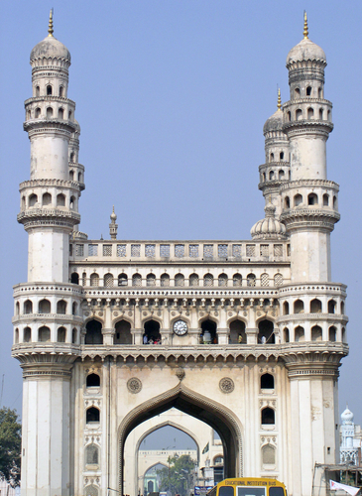
Hyderabad is a legendary city with a 400-year-old history, of the splendour of Qutb Shahi and Asaf Jahi dynasties, Mughal grandeur, exotic cuisine, and exquisite markets. It is world famous for its fascinating contrasts and unrivalled attractions. Hyderabad, the capital of Andhra Pradesh, is the fifth largest cosmopolitan city in India. The City thrives with variety of life styles intermingled into an astounding culture that gives it a distinct identity of its own. This is where tradition fuses with modernity, and heritage structures view with modern high-rise buildings to add to the beauty of the city.

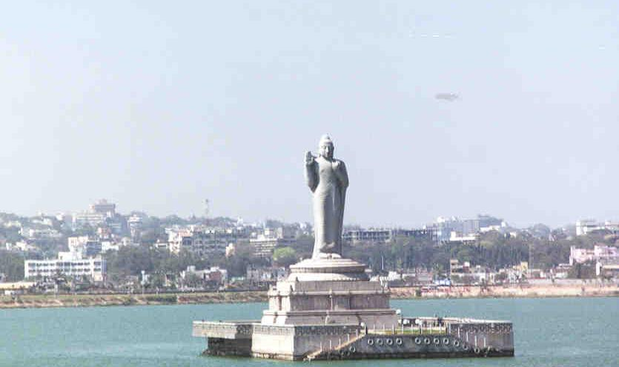
Hyderabad offers a variety of tourist attractions ranging from Heritage monuments, Lakes and Parks, Gardens and Resorts, Museums to delectable cuisine and a delightful shopping experience. The city of Hyderabad is a shopper's delight! From the world famous pearls to traditional arts & crafts, from textiles of all modern brand names to ethnic wear, the city offers an astounding variety of shopping. Hyderabad is famous world over for its fabulous diamond markets, glass embedded bangles and the delectable "Hyderabadi Cuisine". It is unique in being one of the few cities where tradition and technology co-exist, a revolution that has already attracted Microsoft and other major MNC's to set their overseas base here.
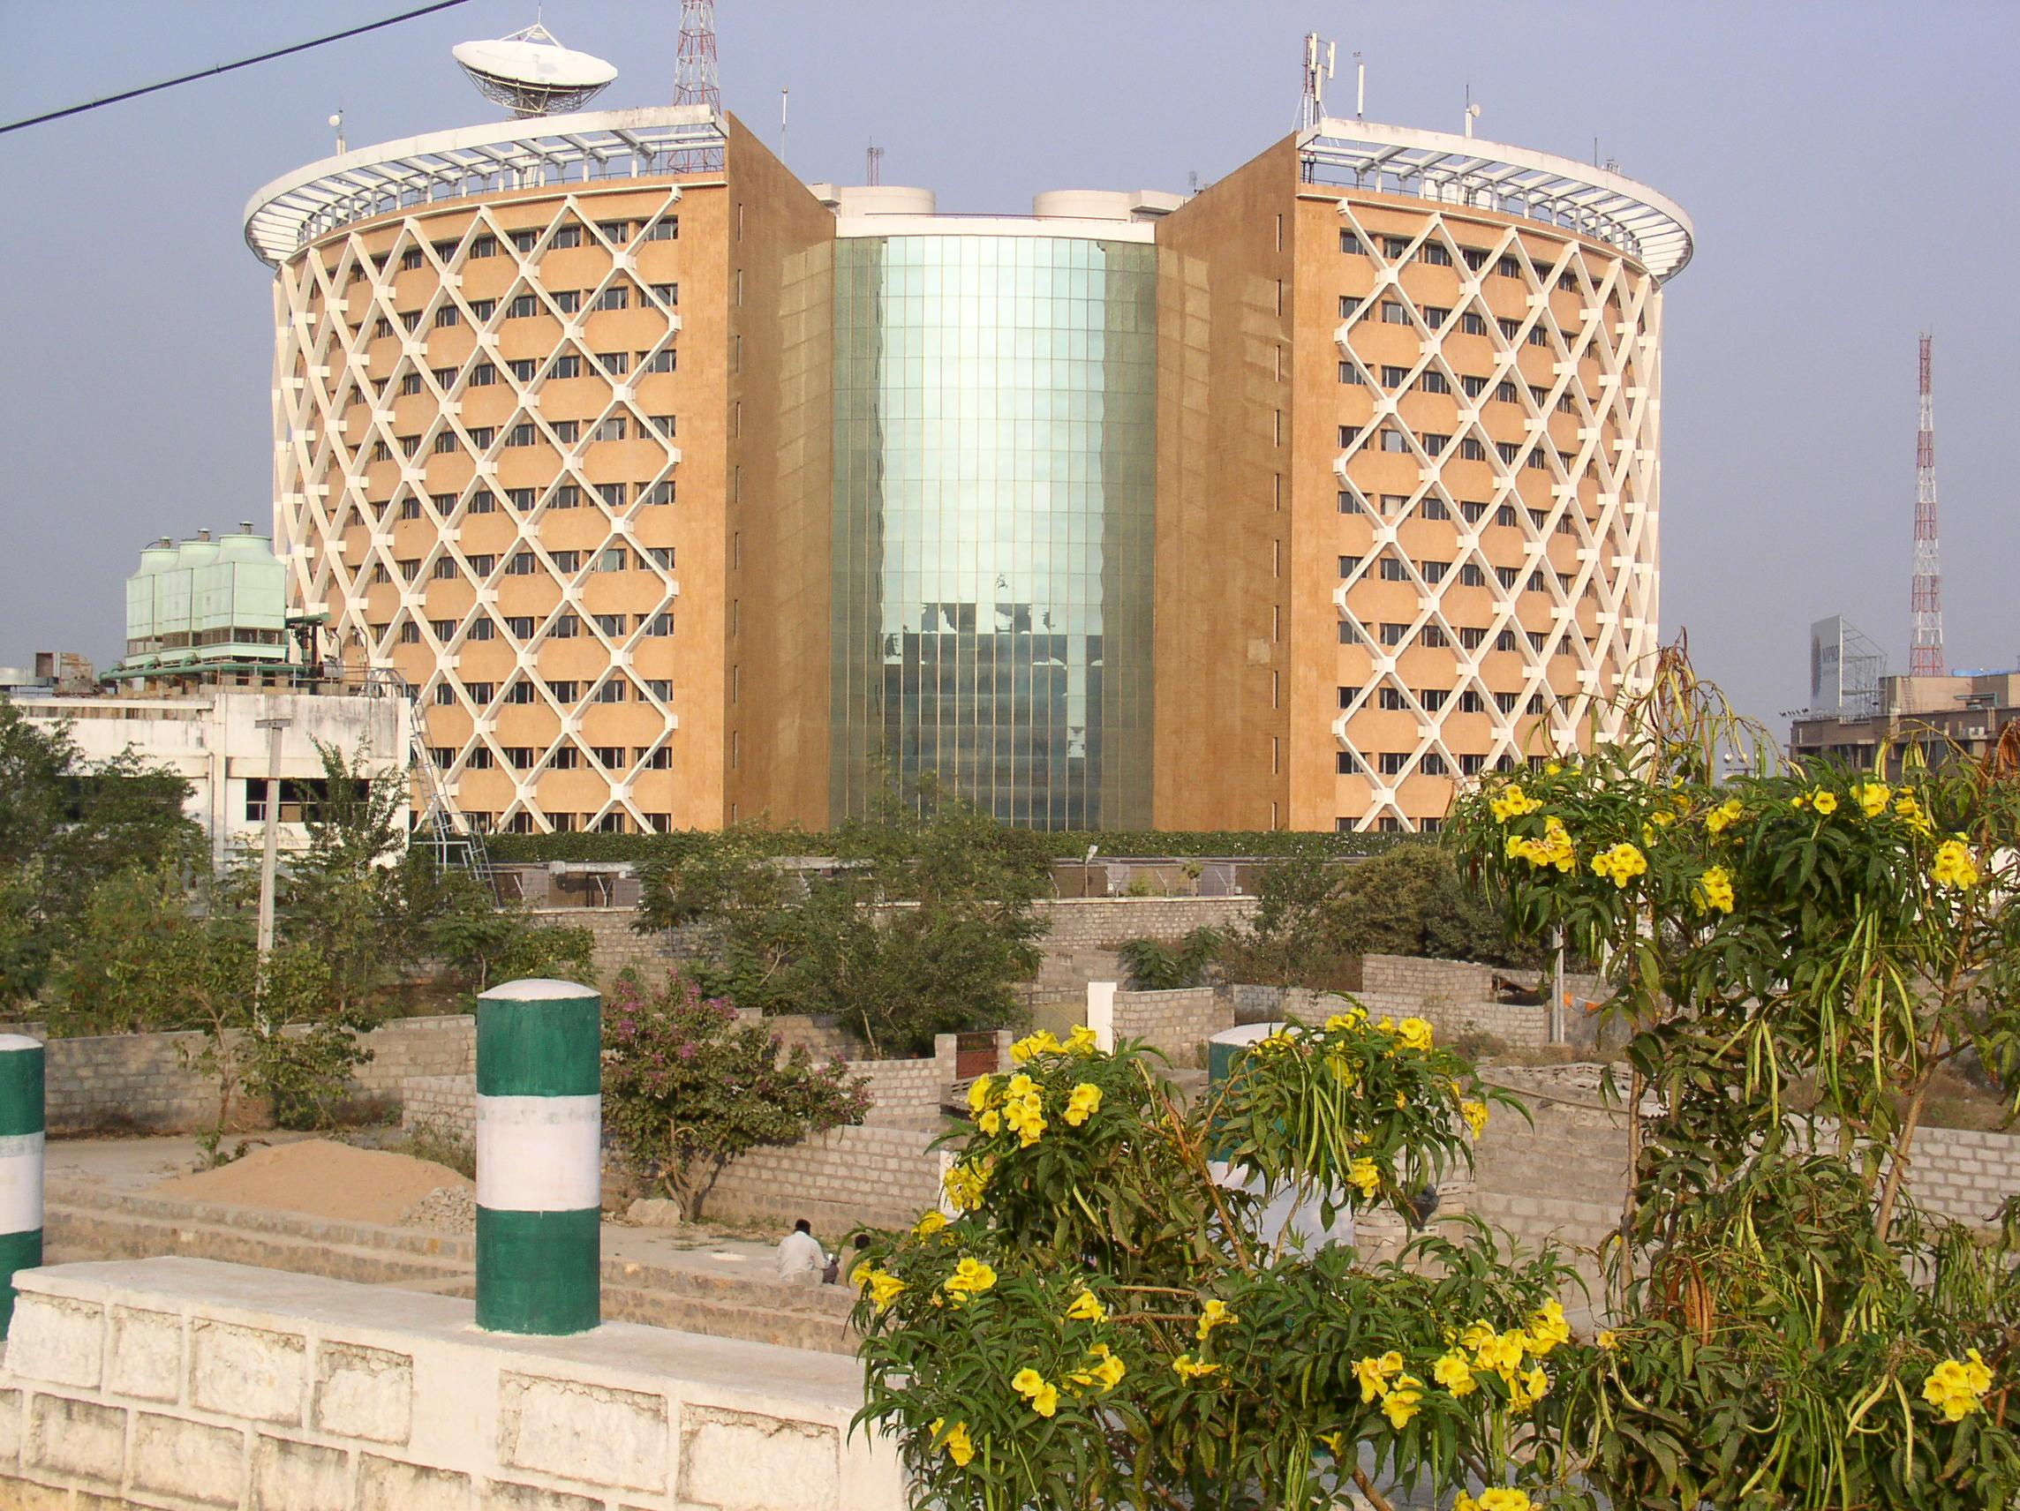
Hyderabad is also known as the city of pearls. The pearl market is situated near Charminar. Ornaments made with Rice Pearls can be brought from Char Kaman or the General Bazar Market. People from everywhere flock here to possess a few of these pearls. Strange that there is no sea anywhere near the city. Yet it has become almost synonymous with quality pearls.

Located in the heart of the Deccan plateau, 1760 ft above the sea level, Hyderabad has an invigorating climate with awe inspiring prehistoric rocks and natural lakes, along with a variety of flora and flauna. The climate of Hyderabad remains fairly warm through most parts of the year and with the onset of winters in North and central parts of India, temperatures come down. The temperature during winter is Max 22C and Min 13.8C.

P.S. Those who would like to have separate accommodation, the details on tariff of some of the moderate hotels are furnished below. They are requested to contact directly for their reservation under intimation to the Programme Coordinator.

Sl.No. | Name of the Hotel | Single (AC) | Double (AC)
1. | Marriott  Phone: 91-040-27522999 | Rs. 6699/- +  5 % Tax | NA
2. | Green Park  Phone: 91-040-66515151 | Rs. 5250/- +  5 % Tax | NA
3. | Fortune Katriya  Phone: 91-040-66135678 / 23325678 | Rs. 5800/- +  5 % Tax | Rs. 6400/- +  5 % Tax
4. | Ramada Manohar | Rs. 4500/- +  5 % Tax | Rs. 5500/- +  5 % Tax

