

2nd Regional Training of Trainers on
Disability Equality Training (DET)

3 – 11 November 2010
Institute of Training, National Council of Welfare and Social Development Malaysia
Kuala Lumpur, Malaysia

Disabled People’s International Asia-Pacific (DPI/AP)
Website: www.dpiap.org

Title: 2nd Regional Training of Trainers on Disability Equality Training (DET)
Date: 3 – 11 November 2010
Venue: Institute of Training, National Council of Welfare and Social Development Malaysia, Kuala Lumpur, Malaysia

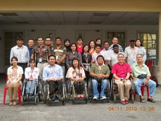
Aim of training
- To train participants to be effective DET trainers by gaining: comprehensive understanding of the soical model of disbility
- To facilitated participatory learing approach
- To implement DET as a disability education for the public, and as an empowerment for other PWDs in respective countries.
- Parrticipants are also expected to be members of APALA DET Forum, which is the network of DET trainers.

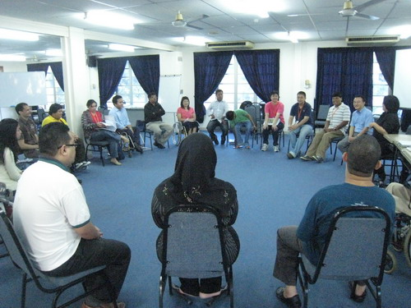
2nd Regional Training of Trainers on Disability Equality Training (DET) was held on 3rd - 11 November 2010 Institute of Training, National Council of Welfare and Social Development, Kuala Lumpur, Malaysia. The ^{2nd} DET regional training of Trainers organized by the Japan International Cooperation Agency (JICA), and the Department of Social Welfare, Ministry of Women Family and Community Development, Malaysia. There are 16 participants from Thailand, India, Nepal, The Philippines, Papua New Guinea and Malaysia. Main resources is Mr. Kenji Kuno, Senior Advisor on Social Welfare (Disability) for Japan International Cooperation Agency (JICA)

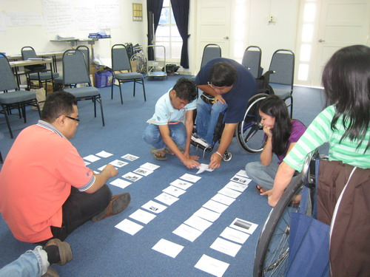
The contents of the course was included
- Introduction to DET
- DET Demonstration
- Methodologies of DET
- What is DET (Social Model Perspective, Definitions of Disability)
- Practice facilitation
- Action Plan Making
- Making Structure of DET and Presentation
- VDO analyze

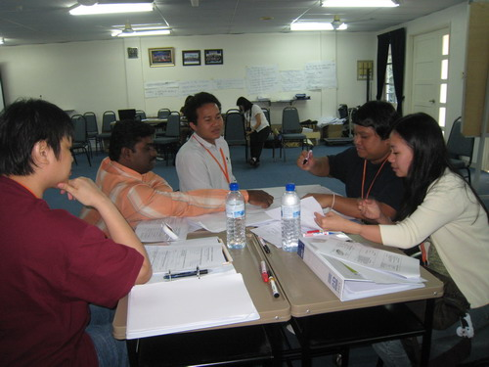
The seminar’s divided into two sessions.

The fist session 3^{rd –} 6th was introduction to DET, purpose of DET. On the beginning there was the DET demonstration by Mr. Kenji Kuno. The course was views the methodologies of DET. What is DET and different between individual model and social model. Finally participants can explain and understand the different between individual and social model and the perspective on disability from the social model. The course was practiced the skill of public speaking, presenter and facilitator to conduct DET parallel the educated the DET contents. Public speaking, presenter and facilitator were important skill to conduct DET.

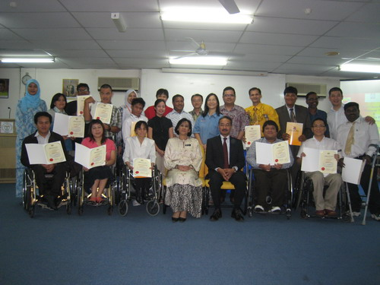
The second session 8^{th –} 11th resource was continue practice the Facilitator, structure and slides preparation making included tip and technical to conduct the DET. DRC Talk VDO was one of the DET tool for participants to utilize the VDO to conduct DET course by watching VDO and analyze in the perspective of social model. The last session participants had a chance to practice to conduct DET.

DET is not the lecture, propaganda, speech and simulation exercise courses but the course enables participants to identify, discover the definition and check the understanding of “Disability” in the perspective of social model. The course let participants challenge the negative myths and values of disabled people and why social exclude disabled people from full participation in society.

Comments

- This is a good opportunity for DPI/AP to gain the DET from this training
- DET is the “Disability education” which is one of the tools for DPO to promote the rights and equality of disabled people to full participate society.
- Social Model perspective, and facilitate proactive actions to break disabling
- To share the DET to colleague in organization

