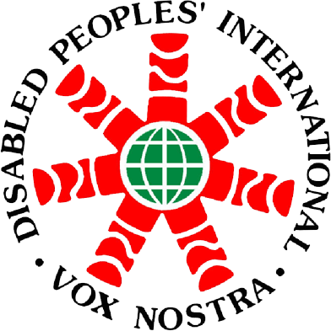

Report

ASEAN Workshop
On the Rights of Persons with Disabilities
And the UN Convention on the Rights
Of Persons with Disabilities (CRPD)

26 - 28 June 2012

At Siam City Hotel, Bangkok Thailand

Purpose: The workshop aims to provide a platform for ASEAN member state participants to exchange views and gain additional knowledge on the rights of persons with disabilities, while enhancing knowledge and understanding on CRPD, its implementation, mechanisms and challenges, and the benefits of ratification.

Organizer: The National office for Empowerment of Persons with disability (NEP)

Contact Persons: Disabled Peoples’ International, Asia Pacific (DPI/AP)
Kanokporn Nakchatree (Ms.)
Project Coordinator on ASEAN, (DPI/AP)
Telephone: 66 (0)2 271-2123
Fax: 66 (0)2 271-2123
Email: Kanokporn_ADF@dpiap.org

Address Disabled Peoples’ International – Asia Pacific
92 Phaholyothin 5 Road, Samsennai,
Phayathai Bangkok 10400 Thailand
Tel: 66 (0)2 271-2123
Fax: 66 (0)2 271-2124

Duration: 26 - 28 June 2012

Summary

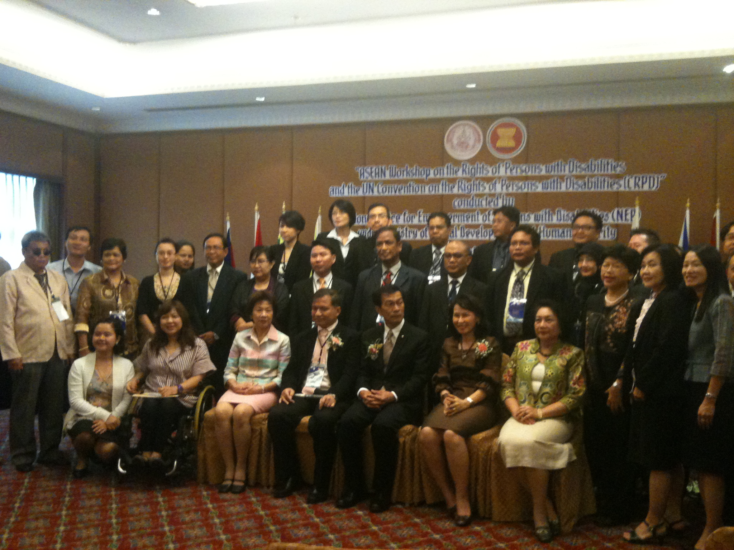

The National office for Empowerment of Persons with disability (NEP) have been involved for developing ASEAN's Strategic Framework on Social Welfare and Development 2011-2015,
The office of Policy and Research. They organized the ASEAN workshop on "Rights of Persons with Disabilities and the Convention on the Rights of Persons with Disabilities" CRPD as a strategic framework and development of the ASEAN Community 2011- 2015 (ASEAN's Strategic Framework on Social Welfare and Development 2011-2015) Workshop on the Rights of Persons with Disabilities and the Convention on the Rights of Persons with Disabilities (CRPD) was coordinated by Thailand and Laos.
The meeting also agreed to publish resources that mutual understanding and support for people with disabilities and for the Convention on the Rights of Disabled Persons of 9 issues summary is to ensure the implementation of the Decade of Disabled Persons. ASEAN recognizes the 2011-2020 international cooperation in promoting human rights and disability rights, urging Member States to ratify the Convention on the Rights of Persons with Disabilities and the Optional Protocol to the Convention and the implementation of the Convention. In cooperation with the Economic and Social Commission for Asia and the Pacific.
Recently, ASEAN has recognized the joined efforts of multi-stakeholders that include various organizations, such as the Disabled Persons Organizations (DPOs) and the Civil Society Organization (CSO) in order to promote the equal rights and equal opportunities for persons with disability. In addition, ASEAN has emphasis on the importance of the people-oriented society through various events and forums, such as the ASEAN Disability Forum (ADF) and the Disabled People Organization (DPOs) in order to ensure that persons with disability will have equal opportunity to be included in all development processes within the society.
Bangkok Declaration, as an outcome document of the workshop, will strive to move forward constructive proposals, for the international community, to further realize the right of persons with disabilities and the disability issues into post 2015 development strategy.
26 June 2012

Day 1

Opening Ceremony: Mrs. Napa Setthakorn, NEP Secretary-General

We are here to proudly celebrate this first international disability thematic human right law, which we have been patiently waiting for. The CRPD puts emphasis on social model and human rights model of disability. Disability is not just impairments of individuals as characterized by old medical model of the charity based society but dynamic interaction between characteristics of individuals and various barriers from external factors.

In addition, the CRPD has its unique characteristics of being an integral and comprehensive convention that embracing the concept of social development and protection of human rights, and promoting civil right, political right, and economical right, as well as social right and cultural right. Especially, the CRPD has also emphasis on elimination of discrimination based on disability that includes denial of reasonable accommodation of personal with disability.

Topic: “Situation of Persons with Disability in the ASEAN Community and future challenges.

Keynote Address: Mr. Monthian Bunthan, CRPD Expert and Thai Senator

For many of us, CRPD clearly represents dramatic changes within our human history, especially for person with disability, which accounted for more than 600 million people around the world. Being the first international human rights law of the twenty-first century, the CRPD will help us in order to move forward the PWDs that have been kept powerless, isolated from any development process, and suffered all forms of discriminations. The CRPD will serve us like a vehicle, which will take us toward rights-based society where we can see the full effective enjoyment of human rights and fundamental freedom is guaranteed for every person with disabilities.

Topic: ASEAN Socio Cultural Pillar

Speakers: Ms. Wimolrat Ratchukool, MSDHS Office of the Permanent Secretary

ASEAN was established on 8 August 1967. It is a community that consisted of three pillars, including ASEAN Political Security Community (APSC), ASEAN Economic Community (AEC), and ASEAN Socio-culture Community (ASCC).

While all policies must referred to ASEAN charter, ASEAN Charter has primary goal of ASCC to contribute to the realization of an ASEAN community that consisted of people-centred and social responsibility with a view to achieve solidarity and unity among the nations. The ASCC will strive to achieve its goals by forging a common identity and building a caring and sharing society, which will enhance the livelihood and well being for all people to live harmoniously.
Topic: ASEAN Decade of Persons with Disabilities
Speakers: Dr. Wilaiporn Kotbungkair, Professor Thammasat University

ASEAN has recognized the decade of persons with disabilities as the thematic years to officially promote the recognition toward person with disability. This will includes the existing international and regional mechanisms of the World Program of Action (WPA); as well as, the Convention of the Rights of Persons with Disability (CRPD) and the Biwako Millennium Framework (BMF). These events together with the philosophy of independent living have set measurable goals to support the promotion of various initiatives, which are complement to each other, including those prioritized in the ASEAN strategic framework for social welfare and development.

Although the ASEAN’s Decade for Persons with Disabilities and the ASEAN’s strategic framework on social welfare and development (2011 – 2015) are initiated under the ASCC, we all should realized that disability is a cross-cutting issue that embedded within all three ASEAN communities. Therefore, the ultimate goal of the decade is to mainstream disability perspectives in all ASEAN communities, member states, and secretariat, at national and regional level.

Topic: Disability Rights (Representative from 10 countries)

Brunei Darussalam: Mr.Awang Mohd Nasbullah El-Hakiem Bin Haji Awang Mohammed, Principle, Ministry of Culture Youth and Sports.

The primary goal of the welfare program in our country is to promote the well being of the vulnerable populations, which include elderly persons as well as persons with disability. The Old Age and Disability Pensions statistically considered people who have registered for the pension under the Department of Community Development (DCD) is about 23,769 people. One of the objectives of the Pensions and Allowances, which aims to improve the quality of the life of PWDs, are to ensure the personal well-being of every PWDs in Brunei. This acted as recognition and an appreciation for PWDs who have once contributed their lives to develop the socio-economy of the country.

Cambodia: Mr.Sem Sokha, Secretary of State of the Ministry of Social Affairs, Veterans and Youth Rehabilitation.

The royal government of Cambodia has continue to worked hard to promote the welfare of the PWD by following the constitution of the kingdom of Cambodia, which consisted of the policies and rectangular strategy of the royal government of Cambodia forth mandate of the national assembly, and the Cambodian Millennium Development Goals (MDG); as well as, the Ministry of Social Affairs.

At the same time, the Veterans and Youth Rehabilitation (MoSVY) has given priority to disability-related work, as stated in the work platform of MoSVY, through the development of policies and other regulations in order to promote and extended the basic rights of PWD. Any veterans with disabilities will receive physical rehabilitation and vocational training services without being charge. Braille and sing languages have been developed for person with visual and hearing impairment: Community Based Rehabilitation helps to improve livelihood of PWDs and improve the exercise of rights in participation in social activities: person with disabilities take more ownership through formation of self help groups of PWDs.: discrimination towards PWDs has been reduce and legal rights of PWDs are protected and promoted.

Indonesia: Mr.Babang Mulyadi, Director, Ministry of Social Affairs

CRPD in Indonesia, which caring under coordination of the Ministry of Coordinator of Prosperity as well as the Ministry of Social Affairs, is responsible in implementing the Art No.33 under the coordination of the National Coordinating on an issue of an increasing of social welfare effort for PWD, which comprising of representative from various ministries and institutions. Indonesia has ratified the CRPD through the implementation of law. The Ministry of Social Affairs has organized a national workshop on evaluation and implementation of National Action Plan (NAP) and APDDP-II and also the proposed draft for an Inchone strategy.

Lao PDR: Mr.Sisavath Khomphonh, Deputy Director General, Ministry of Labor and Social Welfare

Lao PDR are nearly 70,260 peoples with disabilities (according to the census of population 2005), and average to 1.3 % of the population. The rights of PWDs are protected and guaranteed by constitution and general concerned legislation such as Lao constitution and Law of Health Care. The Challenges for Lao PDR government are the existing legislations have not been improve yet and lack of specific law, including of National strategic plan on PWDs development. The existing mechanism to implement CRPD has not expanded to the some provinces and districts. The raising awareness on PWDs right to the societies is not wide and employments for PWDs are still limited. Technical staffs including of teachers and nurse who are working directly to PWDs are insufficiency. Even though Lao PDR implement the PWDs right in the recent years achieved goal and objective such as some legislation has been improved and created in order to protect and promote PWDs. But it is first strep that Lao PDR continues to expand the best practise and improving the weak point that Lao PDR facing.

Malaysia: Dr. Haji Al-Azmi Bin Baker, Deputy under Secretary, Ministry of Women Family and Community Development of Malaysia (MWFCD)

Malaysia's ratification of the Convention on the Rights of Persons with Disabilities can help bring real improvement in the lives of people with disabilities in Malaysia.
The Disability Rights Convention affirms broad protections for people with disabilities, including the rights to life, freedom from discrimination, equal recognition before the law, and access to justice, education, employment, and health. The treaty will go into effect in Malaysia on August 18, 2010.

"Malaysia has taken an important step to protect the rights of people with disabilities,” the convention should be seen as a springboard for changing Malaysian laws, policies, and practices that violate the rights of people with disabilities."

Myanmar: Mr.Tin Win, Deputy Director, Ministry of Social Welfare, Relief and Resettlement

2.32 % of population is PWDs (1.3 millions). Myanmar have current activity for PWDs rights such as June 2012 Myanmar will Celebrate make the Right Real Campaign, Drafting PWDs rights law inline with UN CRPD, Disability inclusive election training for PWDs before by election, Advocated to senators, PWDs rights lecture for teacher and special training at Central Institute of Civil Services, every 2 months, implement National Plan of action for PWDs (2010-2012). The challenges for Myanmar are rare well trained and qualified PWDs, lack of national Level DPOs. But Myanmar has way forward by the way plan to conduct nation wide advocacy and public awareness of PWDs right, capacity building for PWDs, encourages PWDs to form national level DPOs.
Philippines: Ms.Marlene Paralta, Director Assistant Regional Director, National Council on Disability Affairs.

Disability rights in The Philippines. Philippines statistics of PWDS shows that in the census of year 2000, it is 1.23% of the total population of the country of 76,506,928. The figure indicates 942,098 PWDS. The figure shows low vision as the leading disability followed by partial blindness, physical-social and intellectual disability. And multiple disabilities consist of 2.92% of the total persons with disability population.
The following are some of the developments in the disability rights. We have domestic laws that promote and protect the right of PWDs in addition to the 1987 constitution of the Philippines. In the Phillipines constitution, there are provisions that specifically mention PWDs particularly mandating the provisions of programs and service addressing their needs such as republic Act 7277(The Magna Carta for PWDs), BP 44 (The accessibility law).

Singapore: Ms.Tan Bee Lan, Senior Assistant Director, Ministry of Community Development Youth & Sports.

Singapore has 3 outlines.
1. Enabling Master plan (2007-2011)
2. Key Programs/Initiatives
3. UN Convention on the Rights of PWDs.
For Enabling Masterplan1 (2007-2011). Singapore had steering Committee set up in 2006. Call 3p (people, public and private sectors) and then review and chart disability services and programmes for 5 years (2007-2011).Life Course approach. For all recommendations accepted by the Government.
For Enabling Masterplan2 (2012-2016).Singapore had steering Committee set up in 2011. Call 3p (people, public and private sectors) also life course approach add on build on Enabling Master plan 1.
Standing Committee on Disability are form Public People sector body to address disability issues and to track implementation of Enabling Master plan recommendation, Chaired by Permanent Secretary, MCYS, Comprise representative from relevant ministries, statutory boards, and healthcare agencies includes representative from the National Council of Social Service, umbrella body for the voluntary welfare organizations.

Vietnam: Ms. Nguyen Ngoc Anh, Official, Ministry of Labour, Invalids and Social Affairs.

Statistics on PWDs in Vietnam. PWDs in Vietnam are approximately 5.3 millions people. For Rights and obligations of PWDs.
A) Rights of PWD, Equal participation in social activities, Independent living, community system, Exemption or reduction of certain contributions to the social activities, Health care, rehabilitation, education, vocational training, employment, legal aid, access to public facilities, transportation, information Technology, cultural service, sports tourist and other service in accordance with forms and degrees of disability.
B) Obligation PWDs perform civil obligation in accordance with the law.
27 June 2012

Day 2

Topic: CRPD Overview

Speaker: Mr. Monthian Bunthan, CRPD Expert and Thai Senator

After five years of negotiations, the first human rights treaty of the 21st century, the Convention on the Rights of Persons with Disabilities (CRPD), was adopted by the United Nations General Assembly on December 13, 2006. The negotiations toward the CPRD included an unprecedented participation from civil society, particularly disabled peoples’ organizations. To date, more than 115 countries have shown their commitment to the human rights of persons with disabilities by taking legal steps- signature and ratification - to adopt this new international legal instrument into their national laws. The CRPD will enter into force on May 3, 2008, which means that the treaty will officially become international law, but only for the countries that ratify it.

The purpose of the CRPD is to “promote, protect and ensure” the human rights and fundamental freedoms of all persons with disabilities and to promote the respect for their dignity. The CRPD does not define disability, but Article 1 states that “persons with disabilities include those who have long-term physical, mental, intellectual, or sensory impairments which in interaction with various barriers may hinder their full and effective participation in society on an equal basis with others.

28 June 2012

Day 3

Draft Bangkok Recommendation includes additions/ suggestion from participants.

Please see file attached for Bangkok Recommendation.
End.

