Report
ILO Global Business and Disability Network
16-20 February 2011
Bangalore , India
There are 3 days program in this mission. First day program is visiting yahoo! Site in Bangalore Second day program is Asian Meeting: Bangalore hosted by Wipro Limited Bangalore. And the third day program is Visit: Indian Institute of Management, Bangalore (IIM-B) Office of Disability Services
The ILO is developing a global network of employers’ organizations, private sector businesses, multinational companies, existing employer networks on disability and selected nongovernmental organizations for the purposes of both meeting the needs of the Network members and advising the ILO. Advice to the ILO would include that related to activities, projects and products aimed to increase workplace diversity, open new markets, create job and training opportunities for disabled persons as well as result in employers across the globe realizing ILO disability standards, national non-discrimination and quota laws and industry and company policies. Since most companies and the ILO are organized regionally, a regional structure might be more practical for operational activities and meetings.
The meeting brought together representatives of multinational companies, employer networks employers’ organizations and Disabled people organizations who are interested in the issue of disability. The agenda includes both knowledge sharing and discussion about the Network’s organizational procedures, possible activities and future steps.
The objective of this meeting are
- Sharing knowledge and identifying good practices among companies ,employers’ organizations and Disabled people organizations.
- Developing joint products and services for employers and companies to facilitate hiring.
- Strengthening the work of ILO employers' organizations, who have greater access to small and medium size companies at the national level, and building their technical expertise on disability issues.
- Establishing linkages and partnerships among companies, non-governmental organizations, employers’ organization and other business network to facilitate the network.
16th February 2011 Visiting of Yahoo! Site Bangalore
The purpose of the site visit is to allow the Network’s participants to gain an understanding of Yahoo’s disability-related practices and policies and to learn about the accessibility process and techniques incorporated by Yahoo! into the Web to make the company’s sites and services accessible to everyone. Mr. Srinivasu Chakravarthula will talk about Yahoo!’s Accessibility Lab, which plays an integral role in educating web designers, product managers, engineers and marketers across the company on the importance of Web accessibility.
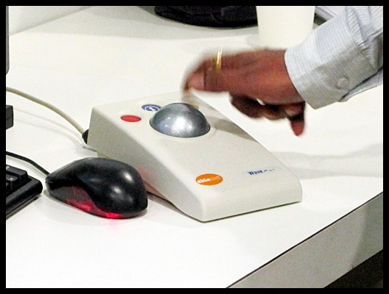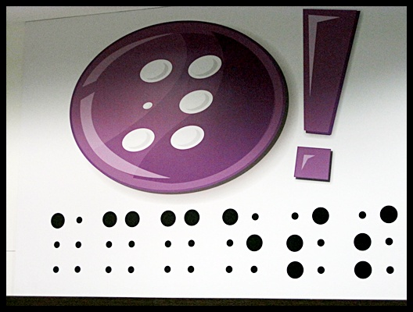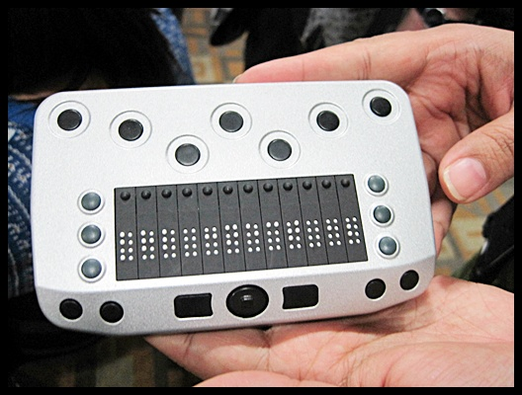
17th February 2011 : Asian Meeting at Wipro Limited Bangalore
The purpose of ASIAN meeting is to increase disability diversity among workforces through knowledge sharing, joint action, increasing technical skill of members and their network or staff including ILO and Disabled people organizations. And through corporate social activities or engaging in other activities, as well as to assist companies adapt product and services to the needs of disabled persons.
This day is separated into 2 sessions. The morning session is stared by sharing experience on employment of people with disabilities . The company presentation are Carrefour, MphasiS, Marks and Spencer, Telenor, Tata Consulting Services, Wipro Limited and Nokia. And follow by the employer network presentation (Australian Employers’ Network on Disability, Employers’ Federation of Ceylon and Vietnam Chamber of Commerce and Industry)
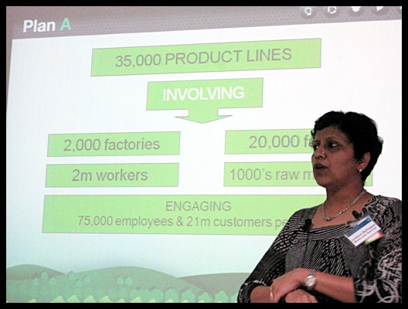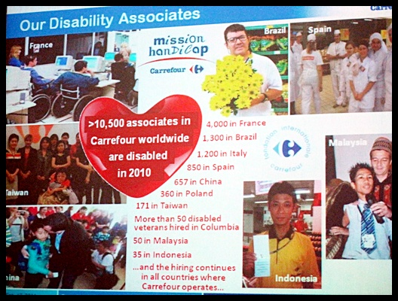
The Afternoon session is started by sharing the information of resource group presentation
(Global Partnership on Disability and Development, Disabled peoples’ International Asia pacific and National Centre for promotion of Employment for Disabled people) This session is to assist the company who decide to employ people with disabilities, How to employ people with disabilities and what are the important things when employ people with disabilities.
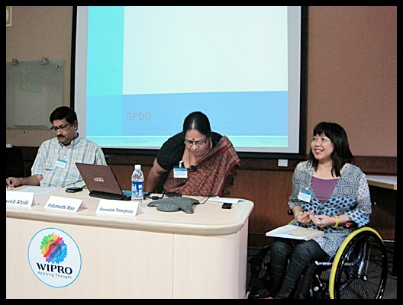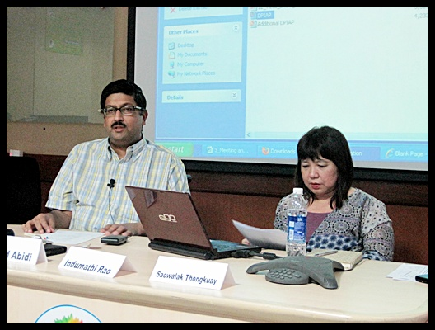
After that is the Round table Instruction: the participants has been separated in 5 groups to discuss in each topic. All topic is to establish the network among the participants to facilitate the ILO global business and disability network. The topics are
- Draft operational procedures
This topic was discussed about Should the network have a regional structure? , Should there be an annual assembly?
- Funding
This topic was discussed about how to funding for the network activities. And The member of this group suggest that we should collect the member fee for registration to the network and the subscription or development costs should be requested for activities or services that are desired by the network.
- Communication method
The network has already been offered a URL, includes the video of network member on ILO TV, held three inaugural planning meeting and published “Disability in the workplace”.
- Future Activities
The member in this group discussed about what should consider to be the most important immediate future activities for the network?
- Group for Employers’ network.

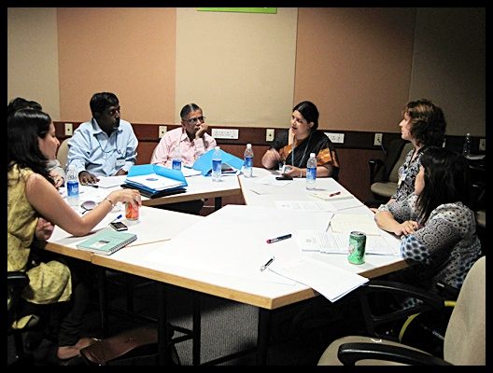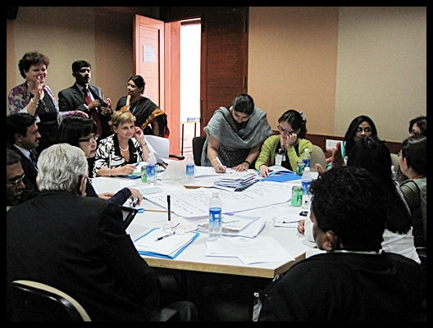

18th February 2011 Visiting Indian Institute of Management, Bangalore (IIM-B) Office of Disability Services
The purpose of the visit is to allow the Network’s participants to learn how the Office of Disability Services was established and see how it provide services to the university’s students with disabilities. The Office was set up with the support from MphasiS (a Network member) in early 2010 to cater the specific needs of disabled students in the university. Professor Rishikesha Krishnan, the Chairperson of the Office of Disability Services, and Ms. Meenu Bhambhani, Head of Corporate Social
Responsibility at MphasiS, lead the event.
The Indian Institute of Management Bangalore (IIMB) is a recognized hub of academic activity, both in India as well as globally . IIMB is known for excellence in research and scholarship, global character, values, diversity and for the impact we make on multiple stakeholders and the society.
Established in 1972, IIMB is the third in the series of the IIMs set up by the Government of India.

The Indian Institute of Management Bangalore (IIMB) endeavours to remove all barriers that prevent students with disabilities from realizing their potential. The objective of this policy is to provide “equal opportunity” for all students. IIMB commits to a time-bound program to remove all barriers to access faced by students with disabilities. Access includes, but is not limited to:
Physical access to all parts of the campus used by students; Access to teaching and reference material using appropriate technology wherever necessary; Access to e-resources through the adoption of WCAG and other relevant standards.

IIMB will assess the needs of each enrolled student with disability individually and determine what needs to be done to provide the best possible educational experience for that student. An Office of Disability Services will arrange such an assessment and be the nodal point to ensure that the needs of the student are communicated to every relevant office/department/person of IIMB and fulfilled appropriately.

While IIMB will follow the Persons with Disabilities Act and other legal provisions, the intent of this policy is to go beyond the legal requirements to provide a truly supportive environment to students with disabilities. As a first step towards this objective, IIMB has set up a “Committee on Disability” at the institute level that will provide leadership and focus. In the future, IIMB will form partnerships with industry bodies and reputed non-governmental organizations (NGOs) working in the field.
