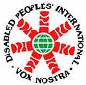
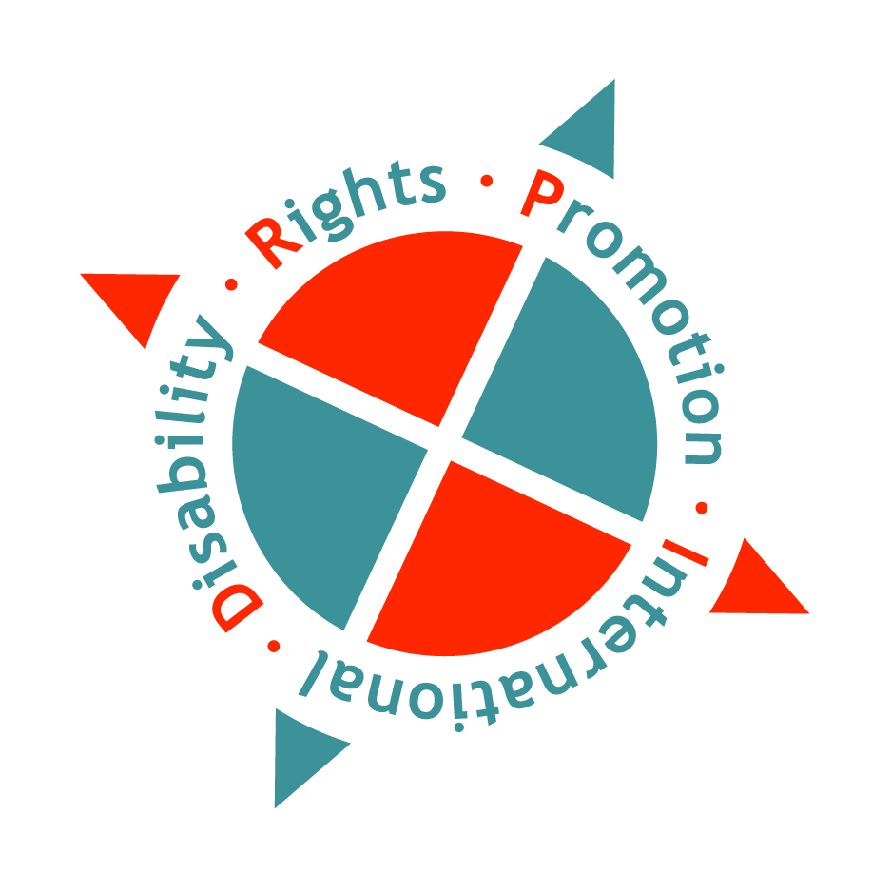

Disability Rights Promotion International (DRPI) is conducting an Asia-Pacific Regional Disability Rights Monitoring Training h in Bangkok, Thailand for 7 days (July 03-09, 2011) co-hosted by the partner Disabled Peoples’ International Asia Pacific (DPI/AP), financial support by The Swedish International Development Cooperation Agency (SIDA)

Country target are Bangladesh, Cambodia, Lao PDR, Nepal and Thailand.

1. What is DRPI?

Disability Rights Promotion International (DRPI) is a collaborative project working to build global capacity to monitor the human rights of persons with disabilities. Using a human rights approach to disability, DRPI seeks to establish a sustainable, holistic monitoring system to address disability-based discrimination throughout the world. The DRPI project is co-directed by Bengt Lindqvist of Sweden (UN Special Rapporteur on Disability 1994-2002) and Marcia Rioux of Canada (Professor, York University).

- Working with Persons with Disabilities: DRPI monitoring is led by persons with disabilities themselves. Persons with disabilities and their organizations play leading roles in project governance and implementation. Also, DRPI works on a cross-disability basis, ensuring the participation of persons with a broad range of types of impairments.

- Human Rights Approach: DRPI is grounded in a human rights approach to disability that recognizes that persons with disabilities have the same rights as all other people. It highlights the ways that disability discrimination increases vulnerability to abuse, poverty, and other unjust social conditions.

- Sustainable: Through capacity-building and making results widely available, DRPI creates sustainable networks of individuals and organizations that will continue to call attention to disability rights issues in their communities beyond the life of the DRPI project.

For more about DRPI, please refer to the project website at: http://www.yorku.ca/drpi

DRPI has established an Asia-Pacific Regional Disability Rights Monitoring Centre in Bangkok, Thailand. The Centre is hosted by DRPI’s partner, Disabled Peoples International Asia-Pacific Region (DPI-AP) and staffed by Ms. Chona Sabo, DRPI Asia-Pacific Regional Officer.

For more about our partner DPI-AP, please refer to its website at: http://www.dpiap.org.

2. Purpose of the Training Workshop:
Disability rights monitoring involves collecting information about the whether or not persons with disabilities are able to enjoy their human rights. Credible and accurate information about the human rights situation of people with disabilities can persuade governments that abuses are occurring and that action is needed to fulfill human rights obligations. Recording information about the experiences of individual persons with disabilities can uncover a pattern of discrimination affecting large numbers of people. Data outlining the extent of disability discrimination can:
- promote greater awareness of the need for social change,
- provide facts and figures useful for lobbying and other advocacy, and
- supply governments with credible documentation to support the creation of more inclusive social policies and laws.
The DRPI project has developed a holistic approach to monitoring disability rights, focusing on finding the facts in three key areas:
1. Individual experiences of persons with disabilities (through face to face interviews);
2. Systemic measures taken to protect and promote disability rights (laws, policies, programs)
3. Societal attitudes toward disability (by looking at depictions and coverage of disability in the media)

In this training workshop, participants will learn about DRPI’s tools and methods for monitoring in the first two focus areas (individual experiences of persons with disabilities and systems). The training will also address how the information collected can be analysed and reported as well as how to organize and coordinate a disability rights monitoring project.

3. Profile of Training Participants:

Participants should:
- Be primarily persons with disabilities who are actively working/volunteering in organisations of persons with disabilities (DPOs). (The desire to have cross-disability representation should be kept in mind when identifying the three (3) participants from each country);
- Be interested and motivated in learning about disability rights monitoring;
- Be eager to improve their own skills and pass on what they learn to their organization;
- Be able to communicate and work in English. (Note that training materials and sessions will be in English);
- Be motivated to develop and take an active role in a disability rights monitoring project in their own countries, following the training.

4. Technical and Other Information about the Training:

Official Language:
Training materials and sessions will be in English.

Sign language interpretation and/or captioning will be provided if requested by any participant. (Participants are asked to indicate this requirement on the Registration Form which is attached).

Training materials will be provided in large print, Braille or electronic format if requested by any participant. (Participants are asked to indicate these requirements on the Registration Form.

Methodology:
The training will involve lectures, general and small group discussions, debates, role play and brainstorming. Please be aware that the workshop is designed to be a dynamic and interactive learning experience and that everyone will be expected to attend and actively participate in all sessions.

