Title: Expert Group Meeting on the Harmonization of National Legislations with the Convention on the Rights of Persons with Disabilities in Asia and the Pacific.
Date: 8-10 June 2009
Venue: UNCC, UNESCAP, Bangkok, Thailand

- The Expert Group Meeting was organized by UNESCAP and OHCHR. The meeting invited 13 Expert from Australia, Bangladesh, Republic of Korea, The Philippines, Japan, Thailand, Lao PDR, Vanuatu, India, Turkmenistan and China. The observers were from DPOs and University from Japan, China, Fiji, Republic of Korea, and Thailand.

- The objectives of the meeting aims to facilitate the harmonization of the domestic legislative frameworks in countries of Asia Pacific with the Convention on the Rights of Persons with Disabilities (CRPD) and to review main obligations of the State parties under the Convention and the key legal measures for its implementation as well as consider as set of policy options and recommendations.

- The discussion topic are 1) key concepts and legislative measures on the harmonization of domestic legal measures with the convention on the Rights of Persons with Disabilities. 2) National Experience in harmonizing domestic legal measures with the Convention. 3) Policy recommendations on key issues in harmonizing domestic legal framework with the Convention.

- The outcome of the meeting
  - The Report about a study on domestic legislative measures on disabilities and their harmonization with CRPD in Republic of Korea, Japan, Philippines, Lao PDR, Vanuatu, Turkmenistan, Bangladesh and Thailand.
  - The clear concept in the prohibitions of discrimination and three types of discrimination indentified in the convention on the rights of persons with disabilities.
  - The recommendation to the harmonization of domestic legal measure and CRPD.
  - The recommendation on the key issues such as
- CRPD awareness rising is needed.
- Independent system should be established to monitor the implementation of CRPD
- Networking and Collaboration is crucial.
- Budget allocation is necessary.
- The participation of stakeholders especially DPOs are key requirements.
- Lobby and advocacy are an effective method.
- Data collection is important for the implementation.

- Comments. There was not sufficient discussion on data collection during the meeting. In fact, the availability of data in term of information and of understanding, to 1) the fact of disability 2) the relationship between disability, poverty 3) other dimension of disability and development, are limited in every country in Asia Pacific Region therefore the lack of quality of such data in international and national level comparable information further weakness th evidence base to inform decision makers.

- All the documents of the meeting can be found and retrieved at
http://www.unescap.org/esid/psis/meetings/EGM_CRP_2009/index.asp

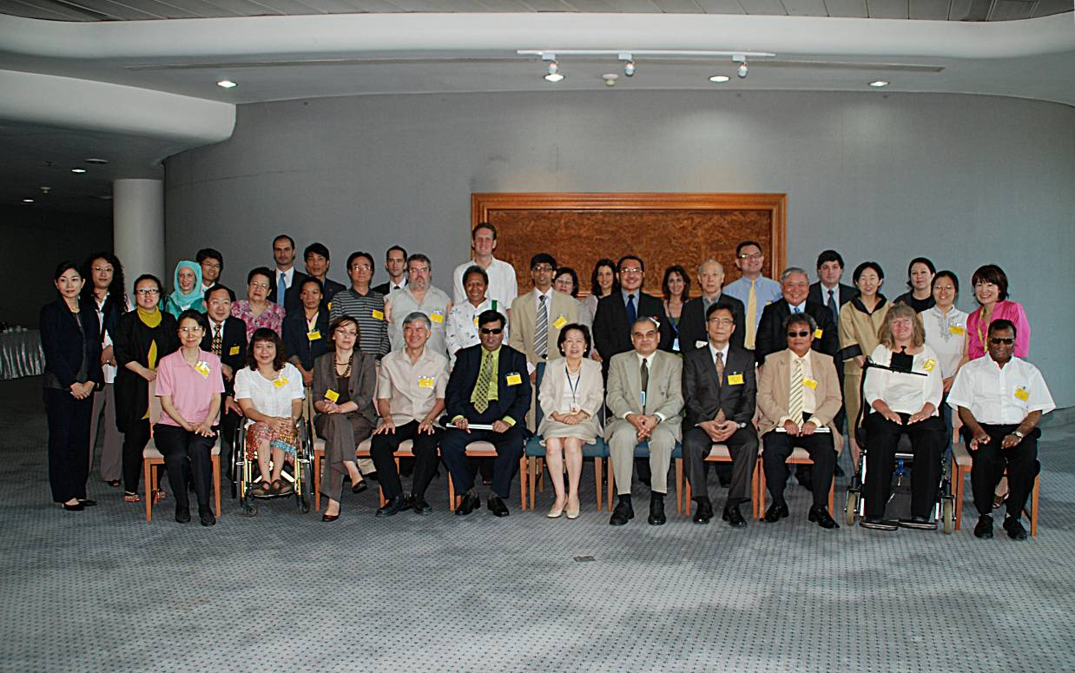
Group Photo
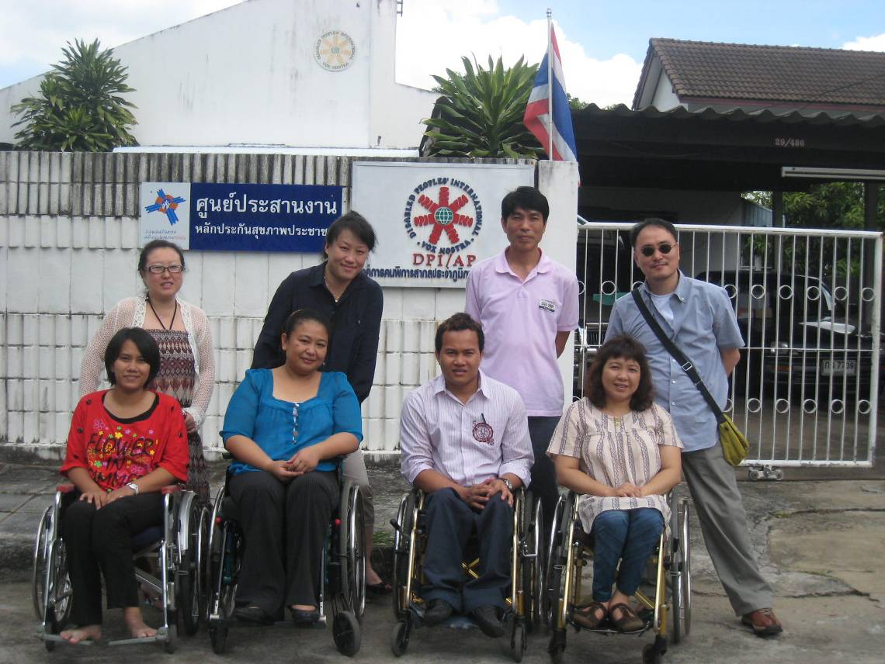

DPI Korea visited to DPI/AP office.

Title: Regional Inter-agency Meeting on the Promotion and Implementation of the Convention on the Rights of Persons with Disabilities in Asia and the Pacific.
Date: 11-12 June 2009
Venue: UNCC, UNESCAP, Bangkok, Thailand

- The Regional Inter-agency Meeting was organized by OHCHR, ESCAP and ILO. The participants were from UNAIDS, UNHCR, UNICEF, UNCCD, UNIFEM, UNFPA, ITU, UNESCO, UNISDR, WHO, DPIAP, II Japan, PDF, RI, APCD, and APDF.
- The meeting aims to incorporate CRPD into other Developmental instruments such as The ILO Convention 159 on Vocational Rehabilitation and Employment and Employment (Disabled Persons) and the other Human Rights mandate.
- The meeting discusses key concepts, stereotypes and perceptions about disability. The awareness of the reality of disability is limited because we live in a society geared towards people whose bodies and minds are fully functioning. This may seem strange when one considers that disability or illness can happen to anyone at any moment of their lives - it is an inevitable part of the human experience. Nevertheless, society is organized in such a way as to treat disability as an exceptional circumstance that requires special and, in the main, separate provision which is often inadequate and serves only to maintain the divisions and lack of understanding between persons without disabilities and persons with disabilities. However, in recent years, many public and private sector bodies have gradually realized that their work practices and policies fall far short of fulfilling the needs, rights and aspirations of persons with disabilities who are their clients, customers and coworkers and that, in order to change this situation, they need to turn to persons with disabilities for education and guidance, which aims to help people understand the meaning of disability, identify changes in work practice and plan strategies to implement change.
- The United Nations Initiatives and tools in the field of disabilities, United Nations Inter-Agency Support Group for the Convention on the Rights of Persons with Disabilities (IASG) established. Through the IASG, the United Nations will support the States parties, based within a framework of coordinated planning and action. The IASG will ensure that the programmes and policies of the United Nations are inclusive of persons with disabilities, and will work to strengthen recognition of and respect for the principles of the Convention on the Rights of Persons with Disabilities. Membership of the IASG: United Nations departments, regional commissions, agencies, funds and programmes whose work is relevant to the Convention.
- Possible initiatives at the Regional level and way forward, the Second Asia Pacific Decade of Persons with Disabilities will be terminated in 2012 therefore the DPOs and NOGs related to disability agreed to propose to ESCAP that the monitoring of identifying the achievement and challenges during the 2 decade and also the following up of the outcome of the Mid-point year Meeting are necessary.
- The review of the BMF’s strategies are as important as awareness raising since 1993 the AP Decade has been promoting and the Biwako Millennium Framework for Action towards an Inclusive, Barrier-free and Rights-based Society for Persons with Disabilities in Asian and the Pacific was adopted in October 2002 to be a regional mechanism aimed at the empowerment of persons with disabilities through networking and collaboration, information and support, and human resource development. In this connection, the midpoint review found that at least twenty-seven governments reported having national mechanisms on disability. Twenty governments reported that their national coordination mechanisms had representatives from more than one ministry and disabled people’s organizations. But some governments still lack the financial and human resources as well as the technical capacity to engage in policy development and implementation using these mechanisms.

- After the second Decade of Persons with Disabilities 2012, networking and collaboration focusing to each sub region among civil society organizations, government agencies, international development agencies, and multilateral and bilateral agencies are key requirements in the implementation of CRPD and other human rights instruments that incorporate the rights of persons with disabilities in their development agenda.

UNAIDS: JOINT UNITED NATIONS PROGRAMME ON HIV / AIDS
UNHCR: OFFICE OF THE UNITED NATIONS HIGH COMMISSIONER FOR
REFUGEES
UNICEF: UNITED NATIONS CHILDREN’S FUND
UNCCD: UNITED NATIONS CONVENTION TO COMBAT DESERTIFICATION
UNIFEM: UNITED NATIONS DEVELOPMENT FUND FOR WOMEN
UNFPA: UNITED NATIONS POPULATION FUND
ITU: INTERNATIONAL TELECOMMUNICATION UNION
UNESCO: UNITED NATIONS EDUCATIONAL, SCIENTIFIC AND CULTURAL
ORGANIZATION
UNISDR : UNITED NATIONS INTERNATIONAL STRATEGY FOR DISASTER
REDUCTION
WHO: WORLD HEALTH ORGANIZATION
DPI: DISABLED PEOPLES’ INTERNATIONAL
II JAPAN: INCLUSION INTERNATIONAL JAPAN
PDF: PACIFIC DISABILITY FORUM
RI: REHABILITATION INTERNATIONAL
APCD: ASIA-PACIFIC DEVELOPMENT CENTER ON DISABILITY
APDF: ASIA-PACIFIC DISABILITY FORUM

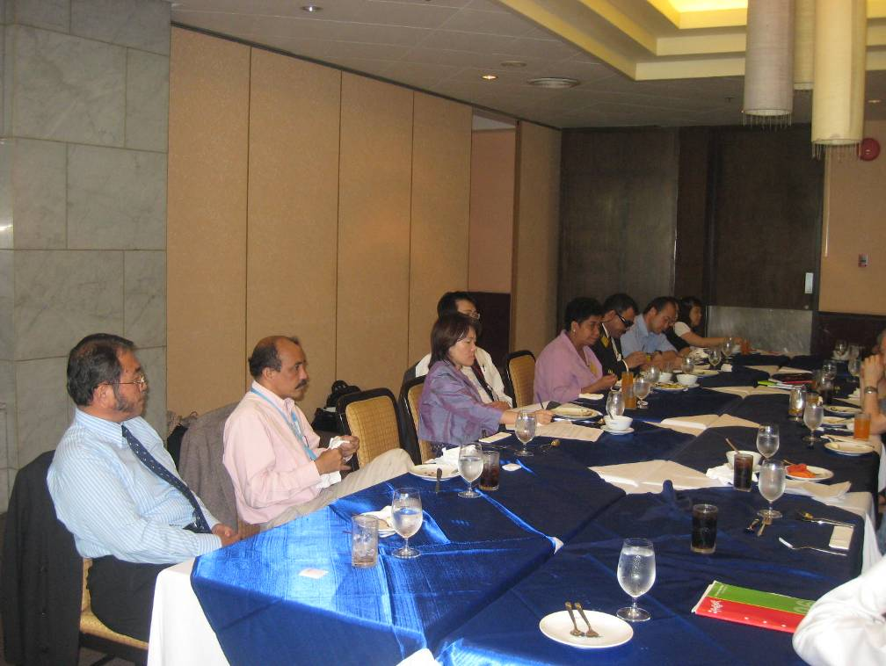
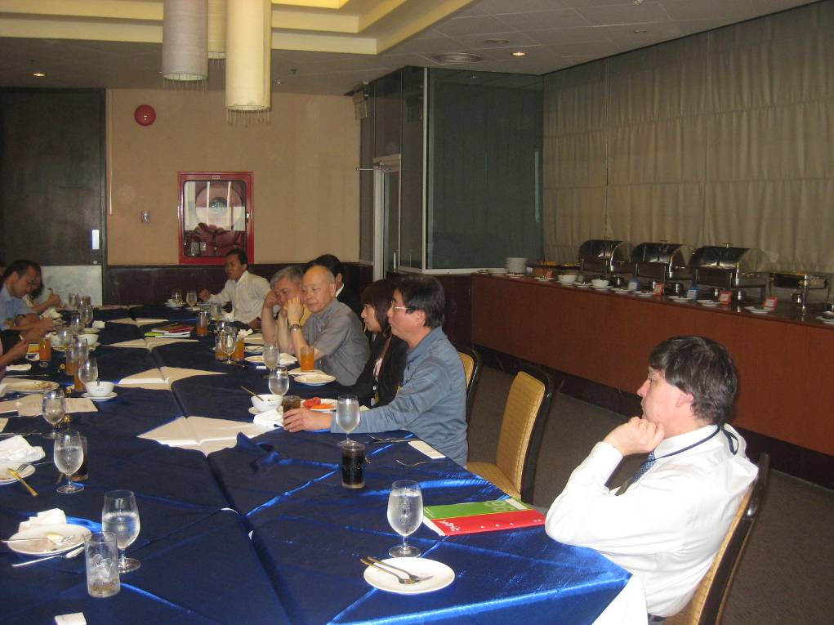
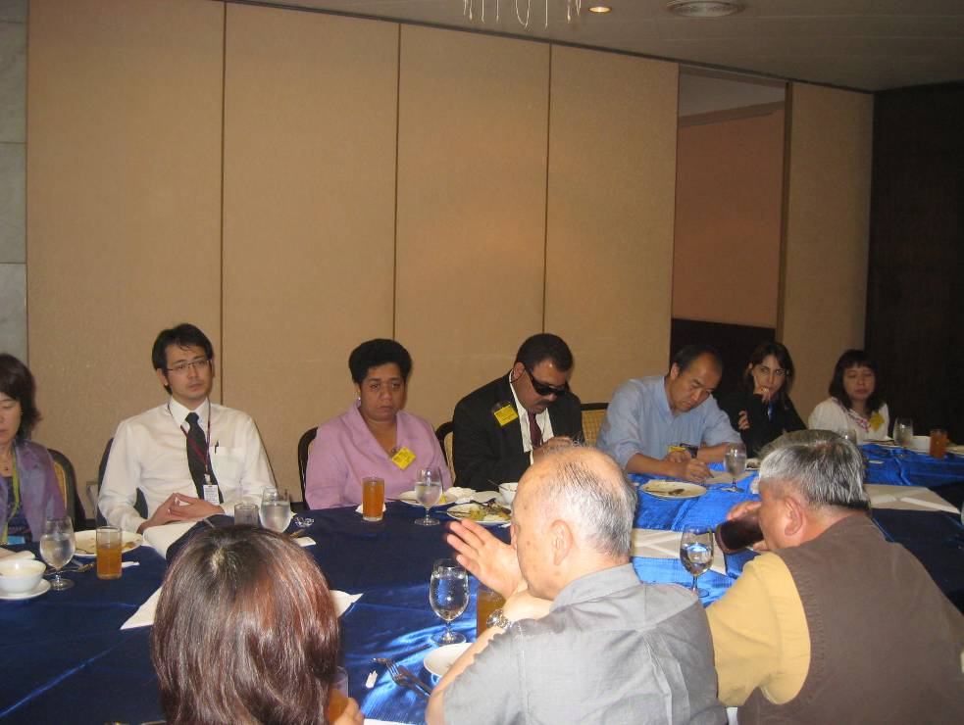

Title: ILO Technical Round Table” Promoting the Employability and Employment of Persons with disabilities Through Effective Legislation 2009-2012
Date: June 5, 2009
Venue: ILO Meeting room, UNESCAP, Bangkok, Thailand

- The International Labor Organization (ILO) organized a Technical Round Table on Disability to frame the context of the ILO sub regional project on promoting the Employability and Employment of people with disabilities through effective legislation or PEPDEL in short which is implemented in China, Thailand and Vietnam.
- Participants were from GOs, Business enterprises, DPOs.
- PEPDEL aims to increasing the capacity of national government to collaborate with employers, workers and DPOs in planning the implementation of effective legislation, policy and programs addressing the employability and employment of persons with disabilities.
- The proposed of the Technical Round Table aims at indentifying priority areas that could be supported by the project through a consultative approach.
- The Outcome were the series of key areas as
  - Support system to implement PEPDEL and ILO convention 159 in order to promote decent work.
  - Research strategies.
  - Reasonable accommodation
  - Job matching.
  - Self employment ( entrepreneur)

