By Saowalak Thongkuay
Regional Development Officer
Disabled Peoples’ International Asia Pacific (DPIAP)

Asia Pacific Forum on Women, Law and Development (APWLD) was conducting a Feminist Legal Theory and Practice (FLTP) Training, held in Chiang Mai, Thailand from 6th to 10th February 2011. This year, the Sub-Regional FLTP will focus on building the capacity of activists and lawyers from South East Asia and South Asia.

FLTP training has been a significant activity and has grown into a dynamic program that offers a unique model in the region. It enables participants to use feminist analysis and perspectives in legal practice and legal activism. The FLTP framework has feminism as its core and human rights as its foundation. The training seeks to challenge the traditional notion that law is a neutral, objective and rational set of rules, unaffected by the perspective of those who wield power in societies. Participants address the social, cultural and political contexts that shape the legal system. Given that law (as a culture, system and as an institution) is a reality that women face and engage with, it is essential for women’s rights activists to explore how law can be utilized to transform women’s lives. During the course participants apply the principles to a particular law, policy or practice limiting women’s human rights and are encouraged to develop strategies to change the practice.

The specific objectives of the training are: Participants will be selected based on the following;

- To enable participants to share their experiences of feminist legal advocacy;
- To develop greater understanding of gender, discrimination, equality, law and human rights ;
- To identify and address dilemmas encountered by women’s rights advocates in their use of legal strategies to address women’s rights ;
- To enhance the capability of participants to effectively challenge discriminatory laws and practices in their countries by feminist, rights-based legal practice and by applying
international conventions and precedents for advancement of women’s human rights ;
- To ignite campaigns to advance women’s human rights in the region
- To build a network of feminist legal practitioners and activists .

The training is focus on the following themes:

- Feminism as a tool and concept for understanding women’s realities; feminism and women’s movement;
- Feminism and law; women, human rights and developments in international law; and strategies for feminist legal theory and practice.

Target are activists and Lawyers, paralegal, activists, prosecutors, case workers, defence lawyers who engage with law or use law for issues of social justice.

Summary;

- Moot court exercise is very practical to allow participants both lawyer and activist working together and explore from the international law to national law;
- A small group discussion in each session could support a real participatory approach;
- Open space session was excellent to allow participants to release stressful after taking a long intensive lecture on human rights law;
- Intersectionality is new terminology for DPOs but it was introduce for quite a long time in CEDAW. Its meaning is similarly to cross cutting in disability development. Therefore it is easier to introduce mainstreaming disability perspective in women agenda;
- The intersectionality explain the multi discrimination of women’s identities, to explain identity-based policies, the dilemmas its poses to women and its practical implications for feminist analysis and action, to appreciate the heterogeneity amongst women; the multiple sources of privilege, power and disadvantage that combine to produce distinct levels and forms of disadvantage and privilege amongst women
- The Three major aspects of law from a feminist perspective are substance, structure and culture that are useful to analyze a law to defense a case or planning for policy formulation;
- Film screening was deepest trusting our sense to understand how women’s human rights issues, especially domestic violence have been dealt in film or multimedia;
- The role of law in women’s rights gave a knowledge on how law can be used to change women’s reality, particularly to promote substantive equality for women;
- The strategies for change introduce analytical framework to access strategies for change and to enable participants to identify contributing or enabling factors to the success of a strategy and the achievement of and objective.

Comments
- The training strategy and methods can be applied as part of DPOs strategy to bring about changes in laws, policies or practices and they could be prioritized in the logical frame work;
- The core learning points from the training can be applies in our work in the area of women with disability’s rights and disability rights.
 | 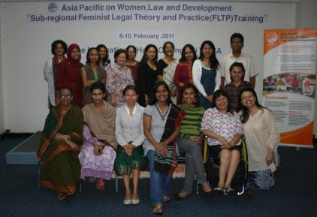
 |  | 
 |  | 
 |  | 
 |  | 
 |  | 

 | 
 | 

