Report

Gender in Asia: “Gender Equity and Development Effectiveness”
APWLD and Open Forum on CSO Development Effectiveness Consultation

1st -2nd March 2011
Chiang Mai, Thailand

By

Chona M. Sabo

Sureeporn Yupa

Mission: Consultation on Gender in Asia: "Gender Equity and Development Effectiveness"1st - 2nd March 2011Chiang Mai, Thailand
Organized by: Asia Pacific Forum on Women, Law and Development (APWLD)
Contact Address: Girl Guide Association Compound 189/3 Changklan Road, Amphur
Muang, Chiang Mai 50100, THAILAND
Tel: (66-53) 284 527, 284 856
Fax: (66-53) 280 847
Email: apwld@apwld.org
Website: www.apwld.org

Contact Person: DPI/AP
Ms. Chona M. Sabo
Mobile: 66-8-3826-5156
Email: chona@dpiap.org

APWLD
Claire, Tomoko (programme) and Navarat (Liaison)
Phone: +66 53 284 527, +66 53 284 856
Email: Claire@apwld.org;
riwwenpo@apwld.org;
navarat@apwld.org

Duration: February 28 – March 3, 2011

Mission members:
No. | Name | Position | Remark
1. | Ms. Chona M. Sabo | Regional Officer  Disability Rights Promotion International Project | DPI AP
2. | Ms. Sureeporn Yupa | Project Coordinator  Promotion of Access to Reproductive Right for Women with Disabilities Project | DPIAP

Aims:
To give Asia Pacific’s women’s organization and CSO’s an opportunity to:
- Develop a common understanding of the Development Effectiveness and the implications of CSO’s;
- Establish some indicative policies, practices and environments that enable women’s rights to work proliferate;
- Contributes to the CSO Guidelines by developing feminist indicators; and
- Identify the areas and process which need further discussion and elaboration in applying and monitoring the Principles.

The mission’s methods:

- Attending the consultation on Gender in Asia: “Gender Equity and Development Effectiveness.

- Developing Principles and practical applications (Indicators) for CSO’s to promote gender equity in their Internal Operations.

- Developing Indicators for CSOs to promote gender equality in the way they
implement their programs.

Outcomes:

- Establish a common understanding of the Development Effectiveness and the implications of CSO’s;

- Identify some indicative policies, practices and environments that enable women’s rights to work proliferate;

- Develop feminist indicators for the CSO guidelines; and

- Applying and monitoring the principles to further discuss the outstanding issues identified by the participants.

Schedule
Date | Time | Details | Ramarks
28 Feb. (mon.) | 18:15 | Arrival in Chiang Mai PG 219 | Ms. Chona M. Sabo  Ms. Sureeporn Yupa
01 March (tues.) | 11:30  12.00 – 1.00  1.00– 2.00  2.00 – 3.00  3.00 – 3.15  3.15 – 3.45  4.15 – 5.45 | Registration Open  Lunch  Consultation open Welcome and Introductions  Consultation Objectives, and Background  Tea Break  Istanbul Principles for Development Effectiveness (Presentation)  Experiences of good and poor practices relating to gender equity | Holiday Garden Hotel and Resort  16/16 Huay Kaew Road,  Changphuak, Muang District,  Chiang Mai 50300, Thailand  Tel. 6653-211333, 6653-210901-4  Fax. 6653-210905, 6653-218467  E-mail address: info@holidaygardenhotelandresort.  com  Website: www.holidaygardenhotelandresort.  com  : www.holidaygardenhotel.com
02 March (Wed.)  03 March (thur.) | 9.00 – 9.15  9.15 – 11.30  11.30 – 1.00 Group Work: Developing Indicators for CSOs to promote gender equality in the way they implement their Programmes  1.00– 2.00  2.00 – 3.30  3.30–3.45  3.45 – 4.45  4.45– 5.45  10:00 | Re-cap from Day 1 and Introduction to Day 2  Group Work: Developing Principles and practical applications (Indicators) (includes tea break) for CSOs to promote gender equity in their Internal Operations  Group Work: Developing Indicators for CSOs to promote gender equality in the way they implement their Programmes  Lunch  What is required for an Enabling Environment to promote CSO efforts towards gender equity? Presentation, followed by groups developing recommendations  Tea Break  ‘Open Space’ - for dialogue on outstanding issues identified by participant  Synthesis and Evaluation  Depart from Chiang Mai PG 216 | Ms. Chona M. Sabo Ms. Sureeporn Yupa
Report on Gender Equity and Development Effectiveness Open Forum
An open forum is a three-year internationally-recognized and CSO-led process that offers a space for CSOs worldwide to engage in a global and fully participatory process towards defining and introducing a framework of mutually shared development effectiveness principles and guidelines. Its objectives are
1. The creation of open process,
2. The development of a CSO vision on development effectiveness,
3. An agreement on common principles,
4. An agreement on guidelines on how to apply these principles and documentation of good
practices for context-relevant mechanisms appropriate to each country and region.
5. A global agreement on minimum standards for an enabling environment at the 4th High
Level Forum in South Korea in late 2011.

1st day of March 2011
Registrations and introductions of the participants from Asia Pacific countries were made. Lyn Pano from Asia Pacific Research Network (lpano@aprnet.org) and Ava Danlog from IBON/ Reality of Aid (adanlog@realityofaid.org) were the two presenters for the Open Forum and Better Aid processes.
About Betteraid
BetterAid is a diverse global platform that brings together Civil Society Organizations (CSOs) that engage in development cooperation. It enables their voluntary pro-active participation in dialogue and policy influencing opportunities on a wide range of issues to deepen aid and development effectiveness. (Visit www.betteraid.org for more information)
Social Development Programs: NGO Experiences
- Violence against women receives marginal attention of many NGOs
- Health is not addressed as a right based issue, but viewed as welfare.
- Health and education programs are used as an entry point for other programs and not in itself as important issues.
- Isolating women’s program – Despite the rhetoric on mainstreaming, the issue of gender equality often remains “separate”.
- NGO’s concentration on women and development is restricted to merely fulfilling the practical gender needs of women.
2nd day of March 2011
We were grouped into four groups and discussed further the eight guidelines for CSO practice.
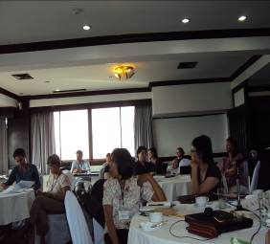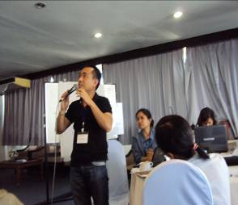
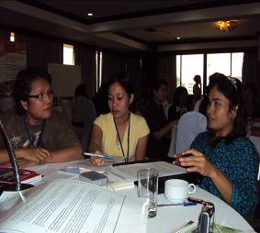
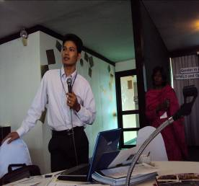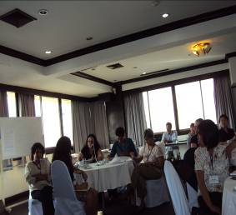

Implementing the Istanbul Principles for CSO Development Effectiveness:
Guidelines for CSO Practice

1. Respect and promote human rights and social justice
a) Promote human rights based approaches through training and capacity building with staff, in programmatic analysis, design and implementation, mechanisms for participation and dialogue, and holding governments to account for human rights obligations.
b) Establish measurable indicators for development effectiveness, in relation to international human rights standards.
c) Create mechanisms that allow free, prior and informed consent on the part of affected communities and stakeholders.
d) Safeguard and make operational the right of beneficiary populations to participate in the design, implementation and assessment of country-led CSO strategic plans and program.

2. Embody gender equality and equity while promoting women and girl’s rights
a) Integrate and implement gender equality and women’s rights in the constitutive practices of CSOs, in their mandate, their policies, in their active dialogue with counterparts, and in their allocation of human and financial resources.
b) Embed gender equality and equity indicators in program plans by ensuring CSO program planning, implementation, monitoring and evaluation are based on gender equality and women’s rights indicators, including consideration of issues affecting girls and young women.
c) Invest CSO time and resources to extend and deepen gender analysis, learning and training based on challenges in applying this principle (on a scale proportional to organizational capacity).
d) Invest in partnerships for organizational capacity in gender equality and women’s rights, including significant support for women’s organizations and movement, while respecting local dynamics and profiling successes in gender equality and women’s rights as part of CSO public engagement and advocacy.
e) Seek opportunities for collaboration policy dialogue to promote context-appropriate changes relating to strategic issues affecting women’s rights and gender equality.

3. Focus on people’s empowerment, democratic ownership and participation
a) Focus on engagement by people whose lives are directly affected by development policies and initiatives, with an emphasis on the poor and the marginalized, through identification, integration and participation of these populations, particularly women, taking account their proposals for development directions and activities.
b) Give priority to capacity building and sustainable self-development of counterparts to be independent CSO actors in the areas of governance, financing, program management and engagement with other development actors.
Draft Framework, Version 2, November, 2010 11

c) Promote a diversity of CSO stakeholder influence and participation in CSO programs, along with local civic participation in monitoring local and national government policies and in advocacy to resolve significant social and political issues.
d) Amplify the voices of the poor and marginalized in public policy in the countries where CSOs work, including voices for developing country counterparts in the global development arena and in opportunities for advocacy.
e) Build awareness among publics in donor countries about the complex reality of development and the importance of accompanying, not directing, change on the part of beneficiary populations.

4. Promote Environmental Sustainability
a) Explicitly incorporate issues of sustainability into CSO policies, program planning and design processes, advocacy and public engagement, ensuring long-term environmental and ecological integrity, listening to and supporting local stakeholders.
b) Build strategic alignments and collaboration between CSOs involved in environment and development initiatives that strengthen the ability of both sectors to promote and implement environmental sustainability.
c) Promote the rights for all people to live and work in health environments in the context of national development strategies and actions.
d) Influence policies and approaches to reduce the negative impacts of climate change and environmental degradation with linkages to the socio-economic, cultural and indigenous conditions for ecological integrity and justice.
e) Establish measurable indicators for environmental sustainability drawing on national and international research and guidelines.

5. Practice transparency and accountability
a) Provide public access to all constitutive CSO policies and documents and publish regular audited financial and programmatic reports, including reports required by regulatory bodies.
b) Provide an accessible list of major counterpart organizations involving a financial partnership, taking account where specific information may endanger the partner’s organization and/or lives of people associated with the organization.
c) Provide timely and accessible responses to information requests, including utilization of appropriate languages and provision of accurate information provided to the public.
d) Promote and practice a democratic culture within the organization with accountable and effective leadership, assigning clear responsibilities, transparent operational policies and demonstrating integrity, honesty and truthfulness.
Draft Framework, Version 2, November, 2010 12

6. Pursue Equitable Partnerships and Solidarity
a) Conditions and terms of partnership are explicitly and clearly defined in a “Partnership Agreement”, with roles, contributions, responsibilities, decision-making and accountability clearly set out through respectful dialogue and enhanced through adequate allocation of resources to ensure counterpart capacity and participation. Partnerships agreements should not be considered inter-changeable with financial contracts.
b) Build common actions on a programmatic rather than project basis, by investing in institutionalizing long-term relationships with program counterparts, with appropriate consideration of core institutional financing arrangements and ensuring on-going participation of relevant stakeholders at all levels of the partnership.
c) Strengthen strategic alignment and program collaboration among CSOs, domestically and internationally, utilizing existing opportunities and structures, such as platforms, coalitions and networks, and encourage new forms of collaboration.
d) Establish mutually agreed conditions and mechanisms for ongoing monitoring, evaluation, accountability and co-learning processes, with all parties and constituencies in the partnership.
e) Invest in public engagement activity that links domestic conditions and issues to the reality and experiences of counterparts, promoting a deeper, subjective understanding and commitment to the relationship over time.

7. Create and share knowledge and commit to mutual learning
a) Foster opportunities and conducive environment for systematic mutual learning and exchange based on participation, openness and trust within institutional and program activities and between organizations, while internalizing and mainstreaming lessons learned, thinking and practices.
b) Encourage collaboration for knowledge sharing among CSOs through networks and coalitions, with a diversity of development stakeholders (government, business etc.) where appropriate, to encourage innovation and improve development performance.
c) Facilitate the sharing and use of local / indigenous knowledge in development initiatives and policy dialogue.
d) Establish professional and ethical responsible methods and tools to engage critically in gathering and sharing reliable data and information on which to build CSO knowledge.

8. Commit to realizing positive sustainable change
a) Utilize results-oriented tools for planning and monitoring development activities, with an orientation to determining and assessing conditions for long-term sustainable development outcomes affecting change for poor and marginalized people.
b) Strengthen CSO collaboration with other development stakeholders to maximize sustainable impacts of activities on shared and mutually agreed development goals, particularly with government, to strengthen its role to deliver and be accountable for public goods for all people under its jurisdiction.

Days onward:
- Gender sensitivity is not added on; it cannot be relegated to a “component” but must be integral and central to the very plan itself.
- Organizations need to move away from the notion of women’s development as a component, to women’s development as a process to achieve and attain ‘empowerment’.

Reflection Point…
“Gender Equality is more than a goal itself. It is a pre-condition for meeting the challenge of reducing poverty, promoting sustainable development and building good governance”
-Kofi Annan
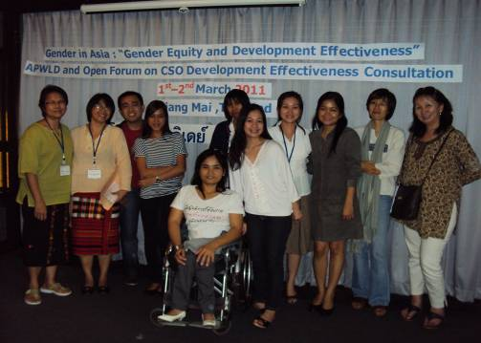

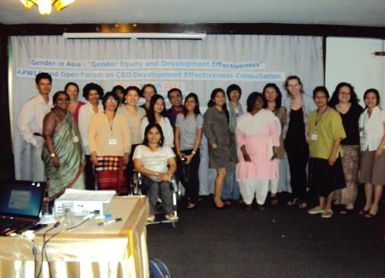

In this open forum we found that Women with Disabilities are one of the marginalized citizens across the globe. With all the negative treatment of women in the society nowadays, it is said to be that women with disabilities experiences demeaning issues as far as gender is concerned not just in terms of employment but all other aspects of life.
Disabled Peoples International- Asia and the Pacific continue to mainstream women with disabilities in gender equality issues in order to take active and full participation in the society.

ACRONYMS

AAA - Accra Agenda for Action
AWID - Association for Women’s Rights in Development
CEDAW - Convention on the Elimination of All Forms of Discrimination against Women
CSO - Civil Society Organization
DAC - Development Assistance Committee
DAWN - Development Alternatives with Women for a New Era
DCF (UN DCF) - United Nations – Development Cooperation Forum
EC - European Commission
EU - European Union
ESCR - International Covenant on Economic, Social and Cultural Rights
FfD - Financing for Development
GNP - Gross National Product
HLF- 2 / 3 / 4 - High Level Forum on Aid Effectiveness 2 / 3 / 4
IADG - International Agreed Development Goals
IATI - International Aid Transparency Initiative
IFIs - International Financial Institutions
ISG - International Steering Group
MDGs - Millennium Development Goals
NGO - Non - governmental organization
NETRIGHT - Network for Women’s Rights in Ghana
ODA - Official Development Assistance
OECD - Organization for Economic Co-operation and Development
PD - Paris Declaration
PRSPs - Poverty Reduction Strategy Papers
SWAP - Sectoral Wide Approach
UN - United Nations
UNIFEM - United Nations Development Fund for Women (UN Women)
UNDP - United Nations Development Programme
UNSCR - United Nations Security Council Resolution
WB - World Bank
WP-EFF - Working Party on Aid Effectiveness
WWG on FfD - Women’s Working Group on Financing for Development

