Grounding the Global: Strategizing Workshop for the 57th Session of the Commission on the Status of Women

The Asia Pacific Forum on Women, Law and Development (APWLD), Asia Indigenous People’s Pact (AIPP), Disabled People International – Asia Pacific (DPI-AP) and the Fiji Women’s Crisis Center (FWCC) organized the Strategic Planning Workshop for The 57th Session of the Commission on the Status of Women on 3-4 February 2013, venue for the workshop is set at the Windsor Hotel in Bangkok.

The Preparatory Training Workshop aims to:
- Build capacity of marginalized women’s groups to understand and effectively utilise CSW and other regional and international mechanisms to eliminate VAW;
- Contribute in building the body of knowledge around VAW in Asia Pacific, particularly as experienced by marginalized women;
- Plan for strategic advocacy opportunities to strengthen policy at national, regional and international levels (both through CSW outcomes and to have the commission build pressure to include VAW in the Post2015 development goals);

The meeting will bring together about 41 women activists from Disabled Peoples’ Organizations, Indigenous people group, HIV advocacy agencies the Asia Pacific region to discover the experience of advocacy in UN level and to practice analysis skills on violence against women with disabilities;
Day 1, Sunday, 3 February 2013
Morning session started with the UN tour using the interactive participation on International Human Rights Mechanisms, this session is a significant to understand the CSW within the context of other international human rights mechanisms. Participants also understand the history role and the contribution of those mechanisms to promote women rights. The participants also learn the CSW should complement each other to advance women’s rights an VAW
Afternoon session discussed about milestones and achievements on addressing violence against women. This session is very useful to participants to illustrate on what has been achieved and done in term of policy, activities, declaration, key recommendation, and platform ext in national, regional and international level. To picture those achievements, participants are able to identify challenges and gap to implement those illustrations.
Understanding the violence against women-grounding from realities of women in Asia pacific, this session provides spaces for participants to share the current status, situation analysis on issues of VAW by answering questions below;
- What are key issues faced by women at the country level in addressing violence against women (VAW)
- What are existing mechanisms and its effectiveness that are available to women wand women’s groups to address VAW ?
- What are current initiatives that address VAW as a development concern? What do you think should be in place in order to address this?
- What are challenges and gaps in effectively addressing VAW that needs to be highlighted at the CSW-57 in order for states’ intervention to be successful and effective?
Comments: We (women with disabilities) have found difficulty to illustrate the policy, programs, convention, and recommendation on violence against women with disabilities (VAWWDs).
Violence against women with disability (VAWWDs) Gap and challenges
Women with Disabilities (WWD) experience multiple discriminations: as women within the disability movement. They are marginalized based on gender, and the issues of women with disabilities have been missing from the agenda of the broader women’s movement. Society often labels WWDs as persons (instead of women) with disabilities so WWDs are invisible in the society landscape. As a result, Women living with disabilities are amongst the most at risk of both intimate violence from family and carers and abuse by public authorities including teachers, co-workers, state officials and police. Yet the experience of women living with disabilities is rarely addressed in national policies in the region These abuses, violence and discrimination are part of the daily realities of women with disabilities even with the existence of international instruments that supposedly uphold their rights.
The most apparent critical challenge is still there are just a few voices of women with disability being heard in every stage from the bottom to the top therefore the measures for women and disability often lack of responsiveness to women with disabilities despite 2 decades of progress since UN Decade of Persons with Disabilities and Convention on the Elimination of All Forms of Discrimination against Women (CEDAW) in 1981
Day 2, Monday, 4 February 2013
Morning session ,orientation on the 57th Session of the UN-CSW, This session introduced the CSW 57 Thematic Focus, Process and intended outcomes by UN Women and the government commitments in the mead up to CSW by the Executive Director, Philippine Commission on Women and experience sharing by ex-participants.
Afternoon session, the session is about the strategizing for the CSW 57 advocacy planning, the session is meant to synthesis key issues surfaced in the meeting an develop an advocacy plan for the CSW57 that draws from lesion learnt and strong advocacy strategies at the CSW.
Outcome:
Women with disability need to be united and bring their voice heard in any the Asia Pacific. Therefore, Women with Disabilities United (AP WWDs United) was formulated with a support of APWLD as an inclusive platform of action to eliminate violence against women and girls with disabilities in Asia and the Pacific level and its statement was produced to present at Asia-Pacific Regional Preparatory Meeting for the 57th session of the Commission on the Status of Women
Statement
By Asia Pacific Women with Disability United (AP WWDs United)
We, the Asia Pacific Women with Disability United (AP WWDs United), attendees of the workshop on Grounding the Global: Strategising Workshop for the 57th Session of the Commission on the Status of Women in Bangkok, Thailand, hereby make this preliminary statement to call on member States to reaffirm their obligations under articles 6 and 16 of the Convention on the Rights of Persons with Disabilities (CRPD), Goal 6 of the Incheon Strategy to “Make the Right Real” for persons with disabilities in Asia and the Pacific, and the intersections of the CEDAW and CRPD
- Urge member States to recognize women and girls with disabilities as equal members of society with diverse and unique identities and consider the intersectional discrimination and gender-based violence they experience;
- Urge ESCAP member States to develop effective measures to prevent violence against women with disabilities, such as the establishment of separate hotlines and shelters for women with disabilities;
- Request ESCAP member States to establish national action plans to eliminate violence against women with disabilities with specific time frames and incorporate women and girls with disabilities in gender and disability policies and incorporate women and girls with disability into existing national action plan;
- Recommend ESCAP member States to provide adequate assistance during criminal procedures to survivors of violence against women and girls with disabilities, such as sign language interpreters during investigations and legal assistance;
- Encourage ESCAP member States to provide the outcomes of the Commission on the Status of Women (CSW) and other UN procedures in various accessible formats to ensure women and girls with disabilities enjoy the freedom of communication and right to access information on an equal basis with others;
- Encourage ESCAP member States to establish a quota system to increase the number of women with disabilities in political positions to ensure adequate representation and proper mechanisms to eliminate VAWWWDs in Asia and the Pacific.
- Encourage ESCAP member States to strengthen the regional, sub regional and interregional networks formed by DPOs and encourage and support the mechanisms and networks to advocate, promote and lobby for the rights of women and girls with disabilities.
- Recognize the Asia Pacific Women with Disabilities United (AP WWDs United) as an inclusive platform of action to eliminate violence against women and girls with disabilities in Asia and the Pacific and allocate adequate funding through relevant entities, such as the UN PRPP Trust fund and UN Women Fund, to ensure the voice of women and girls with disability in the region are heard.

We request that recommendations listed above are taken into consideration by government representatives in attendance to the Asia-Pacific Regional Preparatory Meeting for the 57th session of the Commission on the status of Women, 5-6 February 2013 and in the final draft of agreed conclusions for the 57th Session on the Commission on the Status of Women.

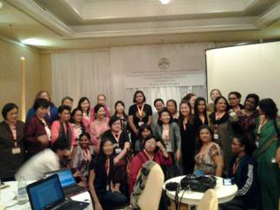 | 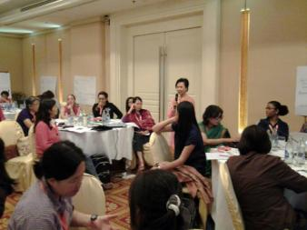
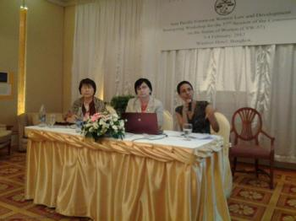 | 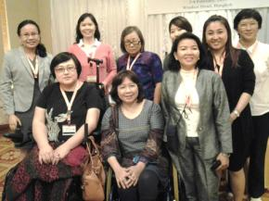
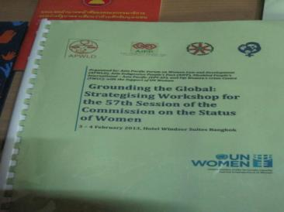 | 