

Report

Research and Meeting on "Mainstreaming Disability Perspective in ASEAN Strategic Framework" and
"The establishment of Jakarta Independent Living center (JILC) "
Jakarta, Indonesia
12 - 15 July 2010

By

Ms. Saowalak Thongkuay
Mr. Taisuke Miyamoto
Ms. Worapan Buranasilpin

Mission: Jakarta, Indonesia
Organized: Disabled Peoples’ International Asia Pacific (DPI/AP)
Contact Address: 92 Phaholyothin 5 Road, Samsennai,
Phayathai Bangkok 10400 THAILAND
Tel: 66 (0)2 271-2123
Fax: 66 (0)2 271-2124
Contact persons: Thailand
Mr. Taisuke Miyamoto or Ms. Saowalak Thongkuay
Mobile: 66-8-1558-1903
Email: saowalak@dpiap.org or miyamoto@dpiap.org
Indonesia
Ms. Maulani A Rotinsulu
Persatuan Penyandang Cacat Indonesia (PPCI, or DPI Indonesia)
Jl. Tambak No. 11 A, Jakarta - Pusat, INDONESIA.
Tel / Fax: 062-21-3904026 Mobile: +628128253598
Email: yanagia2001@yahoo.com
Duration: 12-15 July 2010
Mission members:
No. | Name | Position | Remark
1. | Mr. Shoji Nakanishi | Regional Chairperson | Mission leader
2. | Ms. Saowalak Thongkuay | Regional Development Officer | Mission member
3. | Ms. Worapan Buranasilpin | Independent living Project Coordinator | Mission member
4. | Mr. Taisuke Miyamoto | Project Coordinator, Mainstreaming Disability Perspectives in ASEAN Community | Mission member
5 | Mr. Siswadi | Chairperson of PPCI | Mission member
6. | Ms. Maulani A. Rotinsulu | Vice-chairperson of PPCI. | Mission member
7. | Mr. Masahiko Sakuma | Personal Assistant (PA) | Mission member
8. | Ms. Yoko Yokouchi | The Nippon Foundation | Mission member
Aims:
- to have a courtesy visit to the government focal points and key stakeholders ;
- to study the feasibility of establishing and Independent Living center in Jakarta as well as to seek potential persons with disabilities who can be leaders of IL;
- to discuss the further networking and collaboration to implement the DPIAP projects related to the new ASEAN Strategies Framework;
- to share information related to disability and development
The mission’s methods:
- Field and home visit to Disabled Peoples’ Organizations to search facts;
- Group discussion among DPOs for need assessment;
- Visit to Government focal point on disability and key stakeholders for exchange ideas and information ;
- Consultation to stakeholders related.
Outcomes;
- The future collaboration among DPIAP and key stakeholders especially government focal points;
- Necessarily information to establish independent living in Jakarta, Indonesia;
- The future plan to implement DPIAP projects related to ASEAN strategic framework.

Schedule
Date |  | Details | Remark
July 12 (Mon) | 11:25 | Arrival to Jakarta by TG 433  (Will be picked up by PPCI car to Nikko hotel) | Ms. Saowalak Thongkuay  Mr. Taisuke Miyamoto  Ms. Worapan Buranasilpin
July 12 (Mon) | 16:35 | Arrival to Jakarta by JL725 | Ms. Yoko Yokouchi  Tel: +81-90-6656-6133
July 12 (Mon) | 18.00 | Meeting with the Facilitators for ASEAN conference event preparation at Nikko hotel Lobby | Ms. Saowalak Thongkuay  Mr. Taisuke Miyamoto  Ms. Worapan Buranasilpin  Ms. Aria Indrawati  Ms. Eva Rahmi kasim  Ms. Mimi Maryani  Ms. Maulani A Rotinsulu
July 12 (Mon) | 20:35 | Arrival to Jakarta by KE627 20:35  (Will be picked up by PPCI car to Nikko hotel) | Mr. Shoji Nakanishi and PA
July 12 (Mon) |  | Check in at Nikko Hotel | Nikko Hotel Jakarta  Jl. MH. Thamrin 59, Jakarta 10350 INDONESIA  Tel: +62 21 2301122  Fax: +62 21 3909250
July 13 (Tue) | 10:00 | Meeting with Dr. Donald Tambunan, Director, Socio-Cultural Cooperation Directorate, ASEAN Socio-Cultural Community (ASCC) Department | Address: Persatuan Penyandang Cacat Indonesia /Indonesia Disabled Peoples´ Association (PPCI)  Jl. Tambak No. 11 A, Jakarta - Pusat, Indonesia  Tel: 062-21-42879844  Fax: 062-21-42879844  Contact person: Ms. Maulani A. Rotinsulu  Email: yanagia2001@yahoo.com
July 13 (Tue) | 13:30-15:00 | Meeting with Coordinating Ministry of People’s Welfare, Ministry of Foreign affairs (Asean collaboration),  Ministry of health, Ministry of labour and Jakarta city Government | At Coordinating ministry of People’s welfare office, address. Jl. Merdeka Barat No.3 Jakarta Pusat.
July 13 (Tue) | 15:00-16:00 | Meeting with Ministry of Social affairs (at Ministry of Social office) will be welcome by The Director General of Social Service and Rehabilitation of MSA | Ministry of Social Affairs,  address Jl. Salemba Raya No. 28. Jakarta Pusat
July 13 (Tue) | 18.00 | Meeting with Cucu at Hotel Nikko  Tel: (62)-8122489301 | Mr. Shoji Nakanishi  Ms. Saowalak Thongkuay  Mr. Taisuke Miyamoto  Ms. Worapan Buranasilpin  Mr. Masahiko Sakuma  Nikko Hotel Jakarta  Jl. MH. Thamrin 59, Jakarta 10350 INDONESIA  Tel: +62 21 2301122  Fax: +62 21 3909250
July 14 (Wed) | 09.00 -12.00 | IL lecturer for persons with disability at DNIKS | DNIKS Building, Jl. Tanah Abang timur II, No.15, Jakarta - Pusat  Responded by  Mr. Shoji Nakanishi  Ms. Saowalak Thongkuay  Mr. Taisuke Miyamoto  Ms. Worapan Buranasilpin  Ms. Ms. Maulani A. Rotinsulu  Mr. Masahiko Sakuma
July 14 (Wed) | 12.00-13.00 | Lunch
July 14 (Wed) | 13:30-16:30 | Selection on Executive candidate of Jakarta ILC
July 14 (Wed) | 16:30-17:30 | Meeting with Mr. Siswadi, PPCI
July 14 (Wed) | 20.00 | Meeting at Persatuah Paraplegia Indonesia
July 15 (Thu) | 12.00-  14.00 | Meeting with DPOs* | DNIKS Building, Jl. Tanah Abang timur II, No.15, Jakarta - Pusat  *(1) DPO that is working for realization and implementation of CRPD in Indonesia.  (2) DPO that is working at community level for advocacy, accessibility and support of local PWDs.
July 15 (Thu) | 14.00 | Radio program interview
July 15 (Thu) | 12:35 | Depart to Bangkok by TG 434 | Ms. Yoko Yokouchi
July 15 (Thu) | 22:05 | Departure to Tokyo by KE628 | Mr. Shoji Nakanishi and PA
July 16 (Fri) | 12:35 | Depart to Bangkok by TG 434 | Ms. Saowalak Thongkuay  Mr. Taisuke Miyamoto  Ms. Worapan Buranasilpin

Report of the Mission
July 12, 2010

18:00 PM Meeting with the Facilitators for ASEAN conference event in December (Nikko Hotel lobby)
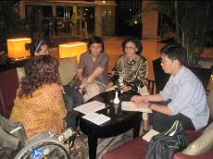
Ms. Maulani reported PPCI will organize the event to celebrate the International Day of Persons with Disabilities, the 3rd of December on 1-4 December 2010. The event will comprise of the Expo and the Forum. The 4-day Expo will be outsourced and to share good practices, products, photos and programs with CSOs, GOs, and private sectors including SMEs and entrepreneurs. The targeted participants are multi-stakeholders from ASEAN countries. PPCI also plans to mobilize good practices from each province including micro-finance for persons with disabilities. In this regard, PPCI already contacted local DPOs and the provincial governments.
The 2-day forum will be a part of the event. Its details will be further discussed. DPIAP considers co-organizing the event with PPCI.
A steering committee was already set up and meets almost every month in Jakarta. Ms. Maulani will write the article and send it to DPIAP soon to be published in the newspapers.

July 13, 2010

10:00 AM Meeting with Dr. Donald Tambunan, Director, Socio-Cultural Cooperation Directorate, ASEAN Socio-Cultural Community (ASCC) Department at PPCI or DPI Indonesia office
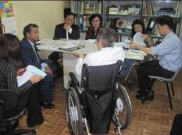
The meeting discussed the draft of ASEAN Strategic Framework on Disability, with a focus on the areas that DPIAP would be involved in under “The ASEAN Decade of Persons with Disabilities”: 1) Workshop on the Convention on the Rights of Persons with Disabilities 2) Independent Living 3) ASEAN Disability Forum. Dr. Donald suggested DPIAP should make concept papers in each area and submit to SOMSWD through the Thai Government (SOMSWD Thai) and ASEC office by October so that these papers will be circulated among SOMSWD focal points for consideration. The final draft will be presented on SOMSWD in November, in Brunei Darussalam.
Mr. Siswadi of PPCI also gave introduction of PPCI as DPI Indonesia as well as the upcoming event in December.
13:30-15:00 PM Meeting with Coordinating Ministry of People’s Welfare, Ministry of Foreign affairs (focal point of ASEAN), Ministry of Health, Ministry of Labour and Jakarta City Government

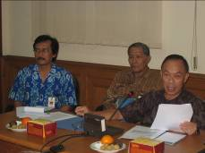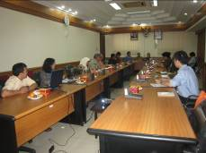

Mr. Adang Setiana, the Deputy Minister of the Coordinating Ministry, mentioned SOMSWD. He, as well as Ministry of health, Ministry of Labour and Jakarta city Government, expressed their support to the proposal of ASEAN Decade of persons with disabilities. However, they had less knowledge on the proposal therefore they appreciated if DPIAP can submit concept papers soon.
Regarding the establishment of Jakarta Independent Living Center, Mr. Shoji Nakanishi, DPIAP Regional Chair, proposed to the meeting that one day public seminar with maximum 300 participants from relevant stakeholders will be organized, followed by 4-day intensive workshop for potential leaders with disabilities to run the IL center. In this regards, Mr. Shoji requested a support of the Coordinating Ministry of People’s Welfare for a meeting venue, office of Independent living center, and media relations.

15:00-16:00PM Meeting with Ministry of Social Affairs (at the office of Ministry of Social Affairs)
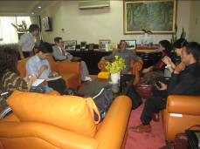

Mr. Makmur Sunusi, Director General for Social Rehabilitation and Services, introduced the background of the Ministry of Social Affairs and Mr. Shoji Nakanishi presented the new Decade of Persons with Disabilities in Asia and the Pacific and the establishment of Jakarta Independent Living Center that 20 persons with severe disabilities will be selected to formulate a working group from next year.

Mr. Sunusi also mentioned he is interested in the ESCAP meeting in October. A disability center is being planned to provide services to persons with disabilities along with the training for trainer from the government officers on how to work with persons with disabilities.

18:00 PM Meeting with Ms. Cucu Saidah, a former Duskin trainee, at Hotel Nikko.

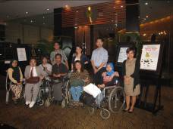

After training, she worked at the Inter-American Development Bank and currently she works at Handicap International (HI) in Solo, Indonesia. She also introduced the concept of independent living to her friend, Ms. Yati Suryati and established an IL center name BILIC (Bandung Independent Living Center).

July 14, 2010

9:00-12:00 AM IL workshop for persons with disabilities at DNIKS

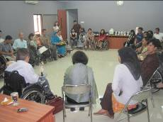

Mr. Shoji Nakanishi welcomed the participants, informed them the objective of IL workshop and the progress of IL movement in Vietnam. Before the IL concept was introduced, Vietnamese with disabilities were kept under their families and could not join social activities because of the lack of accessibility and the negative social attitude.
Mr. Shoji expressed his expectation that this IL workshop would change the lives of persons with disabilities of the next generation in Jakarta. After that, he asked other speakers and participants to introduce themselves. The participants expected to learn about IL, to be employed and to further their education. Some would like to participate in activities of organizations of persons with disabilities.
Mr. Shoji explained that the lives of persons with disabilities could gradually change through many services of ILC such as IL skill program, using experiencing room, peer counseling (PC), housing services for PWDs, wheelchair provision service, etc. Also he mentioned the effective use of role play in peer counseling program. All participants could see necessary assistive devices to transfer persons with disabilities from wheelchair to bed by one PA. Experiencing room was important for persons with disabilities who would like to live independently.
A video presentation also focused the life of a person with severe disabilities using respirator. He wished to rent an apartment room. He visited ILC for ILP training. As he learned IL concept and was provided with ILC’s services; he now lives independently in community with PA and assistive devices.

13:30-16:30 PM Selection on Executive candidate of Jakarta ILC

The executive candidates Jakarta Independent Living Center are;

No. |  | Name | Tel.
1 |  | Mr. Ridwan Sunabtra | Tel: + 62 21 99117335
2 | 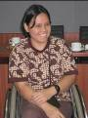 | Ms. Naila Savitti ( Bella) | Tel: +62 81 574 65953
3 |  | Ms. Retnowaty | Tel: +62 88 210 024687
4 | 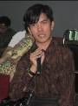 | Mr. Agung | Tel: +62 85 677 28303,  +62 21 985 46441
5 |  | Ms. Fenny | Tel: +62 81 808 246081
6 |  | Ms. Bernadeta | Tel: +62 85 646 66 9425

16:30-17:30 Meeting with Mr. Siswadi, PPCI

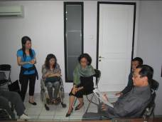

The agenda was on the January IL seminar. Mr. Siswadi said if this seminar invites Vice-President, the announcement should be released at latest in November. He also mentioned that to attract the attention of the society we should invite media, Minister of Social Affairs as keynote speaker and Hanoi IL as a role model. About the venue, PPCI will look for the hotel that is accessible and suitable to hold a public meeting with 300 participants.

20.00 Meeting at Persatuah Paraplegia Indonesia

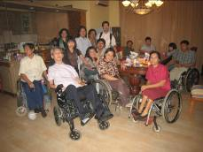

Mr. Amin Tjandrawinata is a person with severe disability (C4). He has been person with disability for 31 years by car accident. He uses nurse service to be his carer 3 persons a day (1 person/8 hours). He found Persatuah Paraplegia Indonesia in 1981 and uses his house as an office. He accepted that the organization is not active enogh since he also run his family business. Now the chairperson of Persatuah Paraplegia Indonesia is Mr. Suheri. There are approximately 90 members who are person with severe disability.
Ms. Saowalak informed about the establishment of Jakarta ILC and Mr. Amin is willing to support the center.
July 15, 2010

11:00 AM Meeting with DPOs at DNIKS Building

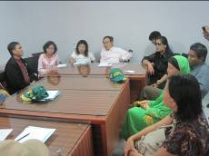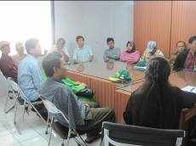

There are representatives from the Deaf organization, advocacy activists, sports associations for persons with disabilities, organizations for vocational training and women with disabilities. Due to time constraint, we could not discuss in detail but the mission had a feeling that PPCI is well organizing the DPOs in the country. During the meeting Ms. Saowalak mentioned about Asia Pacific Disabled Peoples’ Organizations (DPOs) United: Regional Congress toward the Establishment of the Regional Decade on Effective Implementation of the Convention on the Rights of Persons with disabilities (CRPD) which is organized by DPIAP in cooperation with the United Nations Economic and Social Commission for Asia and the Pacific (ESCAP) on 21-22 June 2010 in Bangkok. The out put of the meeting is Bangkok Declaration which has been sent to ESCAP in Expert Group Meeting-cum-Stakeholder Consultation to Review the Implementation of the Asian and Pacific Decade of Disabled Persons, 2003-2012: The Biwako Millennium Framework for Action.
Mr. Shoji informed about the establishment of ILC in Jakarta and would like DPOs to support this center to change society in Jakarta.

List of DPOs who attend this meeting

No. | Name | Organization | Email
1 | Mr. Aprizar Zakaria | Gerakan KesejahteraanTuna Rungu Indonesia (Gerkatin)  (Indonesia Association welfare for the Deaf IAWD) | zakariaaprizar@ymail.com
2 | Mr. Harpalis Alwi | Persatuan Olah Raga Tuna Rungu Indonesia (PORTURIN)  (Indonesian Sports Association of the Deaf) | isad_sport@yahoo.co.id
3 | Mr. Welly Ferdiouandus | Badan Pembinaan Olah Raga Cacat (BPOC) | bpocjakarta@ymail.com
4 | Ms. Kusih Ari | Lembaga Pemberdayaan Tenaga Kerja Peny. Cacat (LPTKP)
5 | Mr. Muhali | Lembaga Pemberdayaan Tenaga Kerja Peny. Cacat (LPTKP) | muhalimurad@gmail.com
6 | Mr. Suheri | Persatuah Paraplegia Indonesia | Tel: 7502303, 7513247
7 | Mr. Heppy Sebayang | Lembaga Advokasi dan Perlindungan Penyandang Cacat Indonesia (LAPPCI) | heppy_sebayang@yahoo.co.id
8 | Mr. Yahya Christian Suhandish | Himpunan Wanita Penyandang Cacat Indonesia (HWPCI)  (Indonesian Association for Disabled Women) | yahya_suhandish@yahoo.com
9 | Mr. PWS Yuyo Kusumo | Relausau/PEMERTATI
10 | Ms. Mahretta | Persatuan Tunanetra Indonesia (PERTUNI)  (Indonesian Association of Visually Impaired) | mahretta_maha@yahoo.com
11 | Ms. Ariani | Himpunan Wanita Penyandang Cacat Indonesia (HWPCI)  (Indonesian Association for Disabled Women) | ariani_0704@yahoo.com
12 | Mr. Mahmud Fasa | Federasi Kesejahteraan Penyandang Cacat Tubuh Indonesia (FKPCTI) | mahmudfasa@yahoo.com

14:00 Radio program interview at DNIKS Building

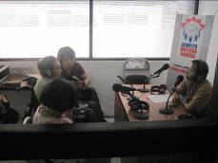

Mr. Shoji Nakanishi was interviewed by radio program on Independent Living and the establishment of Jakarta ILC in Indonesia.

