Report: Mission to New York, 30 Feb-5 March 2010
Objectives:
- to observe in the fifty-fourth session of the Commission on the Status of Women (CSW 54)
- to seek network with Global NGOs related to women.
The fifty-fourth session of the Commission on the Status of Women that will soon take place at United Nations Headquarters to assess progress in implementation of the Beijing Platform for Action and the outcomes of the twenty-third special session of the General Assembly, there were about 1,500 participants over the word both from governments and Civil Society Organization. Varieties of side events related to women were organized around the UN Headquarter areas. The CSW 54 program was ordinary started with welcome and official statement to celebrate women day by UN secretary General Ban Ki Moon and follow by the report of state party.
Comments;
- There were a few women with disability joined the event, I met only 3 of them, one from Kyrgyzstan, and 2 from Spain.
- The atmosphere of the meeting was so cool especially NGO forum and many side events so that participant had a chance to share each other experiences on Women issues.
- Women with disabilities were neglected since they are a few of them join the events even though we raised the issues however; it seems our voices are not strong enough.
- Most of women activists were financial supported participation by governments and their own organizations. I learnt that DPOs and organization of women with disabilities have to improve on fund raising and Networking especially to civil society organizations (CSOs).
- UN Headquarter did not prepare registration desk for women with disabilities therefore I have to ask them for a help since there were hundred persons came to register at the same time.
- Even thought I am only one woman with disability to move around the event and try to present/raise the issues of mainstreaming disability issues in regular women agenda. The feedback was quite good and positive. CSOs are friendly to incorporate disability in their agenda however; they mostly do not understand our issues. They really welcome us to cooperate with them.
- Disability movement should be seriously seeking the way to engage with CSOs in the new global development trend; engagement with civil society organizations.
Suggestion:
Women with disability should have their own global event to be visible to global development movement that they are existing and raising awareness that disability is cross cutting issues therefore incorporate disability issues will support to the sustainable development plan of women/ gender equity . Capacity building to WWD is important to empower them to be able to work with regular women development organization. Twin track approach is a key of success to mainstream disability in development agenda.
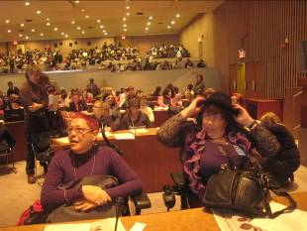 | 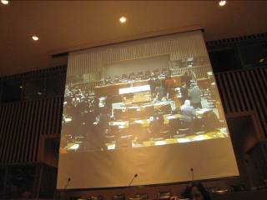
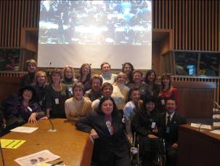 | 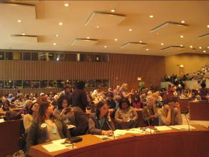
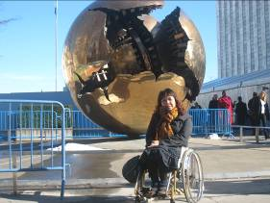 | 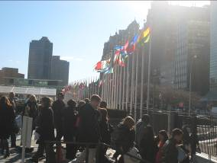
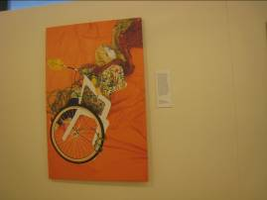 | 