

Report

Research and Meeting on "Mainstreaming Disability Perspective in ASEAN Strategic Framework" Manila, Philippines
15 - 19 August 2010

By

Ms. Saowalak Thongkuay
Mr. Taisuke Miyamoto
Ms. Worapan Buranasilpin

Mission: Manila, Philippines
Organized: Disabled Peoples’ International Asia Pacific (DPI/AP)
Contact Address: 92 Phaholyothin 5 Road, Samsennai,
Phayathai Bangkok 10400 THAILAND
Tel: 66 (0)2 271-2123
Fax: 66 (0)2 271-2124
Contact persons: Thailand
Mr. Taisuke Miyamoto or Ms. Saowalak Thongkuay
Mobile: 66-8-1558-1903
Email: miyamoto@dpiap.org or saowalak@dpiap.org
Philippines
Ms. Josephine S. De Vera (President, KAMPI)
Katipuman ng Maykapansanan sa Philippines, Inc. (KAMPI)
Unit 205 JBD Plaza, # 65 Mindanao Avenue Quezon City, Philippines
Tel: # (63) 2 9721827 & (63) 2 455-2729
Mobile Phone: # 09182181043 Fax:# (63) 2 454-2083
Email: josephine.devera@yahoo.com.ph, kampi_pwd@yahoo.com

Duration: 15-20 August 2010
Mission members:
No. | Name | Position | Remark
1. | Ms. Saowalak Thongkuay | Regional Development Officer | Mission member
2. | Ms. Worapan Buranasilpin | Independent Living Project Coordinator | Mission member
3. | Mr. Taisuke Miyamoto | Project Coordinator, Mainstreaming Disability Perspective in ASEAN Mechanism | Mission member
4. | Ms. Josephine S. De Vera | President, KAMPI | Mission member

Aims:
- to have courtesy visits to the government focal points and key stakeholders ;
- to discuss the further networking and collaboration to implement the DPIAP projects related to the new ASEAN Strategies Framework;
- to harmonize a proposal from the Filipino Government with DPI AP's ASEAN project;
- to intensively discuss the possibility of national seminar in the Philippines
- to share information related to disability and development

The mission’s methods:
- Meeting with Disabled People's Organizations for fact findings and needs assessment;
- Visit to Government focal point on disability and key stakeholders for exchange ideas and information ;
- Consultation with stakeholders related.

Outcomes;
- Support from Philippino Government to ASEAN Disability Forum
- The future collaboration among DPIAP and key stakeholders especially KAMPI and government focal points;
- The future plan to implement DPIAP projects related to ASEAN strategic framework especially national seminar in 2011.
Schedule
Date |  |  | Details | Remark
Aug 15 (Sun) | 13:20 |  | Arrival to Manila by TG 620  (pick up by van to hotel) | Ms. Saowalak Thongkuay  Mr. Taisuke Miyamoto  Ms. Worapan Buranasilpin  Meeting point  arrival area of the airport, signboard with name.
Aug 15 (Sun) |  |  | Check in at Great Eastern Hotel | Great Eastern Hotel  1403 Quezon Avenue  Quezon City Philippines  Phone: +63(02)371-8282  Fax: +63(02)371-3312
Aug 15 (Sun) | 15.00 |  | Summary of the mission schedule | Ms. Saowalak Thongkuay  Mr. Taisuke Miyamoto  Ms. Worapan Buranasilpin Ms. Josephine S. De Vera  Mr. Jose Pepito DG Manio  Mr. Lauro L. Purcil
Aug 16 (Mon) | 09.00 |  | Meeting with KAMPI | KAMPI  Unit 205 JBD Plaza, # 65 Mindanao Avenue Quezon City, Philippines  Contact  Ms. Josephine S. De Vera  Tel: # (63) 2 9721827 & (63) 2 455-2729  Mobile Phone: # 09182181043  Fax:# (63) 2 454-2083  Email: josephine.devera@yahoo.com.ph, kampi_pwd@yahoo.com
Aug 16 (Mon) | 14.00 |  | Meeting with DPOs/IL leaders | Yin Yan Suite  Great Eastern Hotel  1403 Quezon Avenue  Quezon City Philippines  Phone: +63(02)371-8282  Fax: +63(02)371-3312
Aug 17 (Tue) | 09.30 |  | Visit Department of Social Welfare and Development (DSWD) office welcomed by Ms. Victoria N. Navida, Chief, External Affairs Division Policy Development & Planing Bureau  Meeting with Department of Transportation and Communications by Mr. Rizal C. Morales, Senior Transport Development Officer/DOTC Focal Person to NCDA and Vice-Head, DOTC Task Force on Accessibility | Department of Social Welfare and Development (DSWD) office  Constitution Hills, Batasan Pambansa Complex, Quezon City, Philippines  Tel. (632)931-81-01 to 07
Aug 17 (Tue) | 13.00 |  | Visit Life Haven Inc. welcomed by Mr. Abner Nguyen Manlapaz,  President | Life Haven Inc.  4013-A. Gen. T. De Leon St.,  Valenzuela City  1442 Philipppines  Phone: +63 2 3553572  Fax: +63 2 3553572
Aug 17 (Tue) | 18.00 |  | Meeting with Engr. Bien C. Mateo, Assistant Vice President Operations SM Supermalls | SM Supermalls  Shopping Center Management Coporation  SM City North Edsa  North Avenue corner EDSA, Quezon City  Tel: (632) 929-6686-89  Fax: (632) 926-2219
Aug 18 (Wed) | 10.00  14.30  20.00 |  | Visit National Council on Disability Affairs (NCDA) welcomed by Mr. Mateo Lee, Executive director  Meeting with Commission on Human Rights of the Philippines by Ms. Atty Lovely Dominguez  Leave to Dagupan City  Check in at Lenox Hotel | National Council on Disability Affairs (NCDA) office  NCDA Building, Isidora Street, Barangay Holy Spirit, Diliman, Quezon City, Philippines 1127  Email: council@ncda.gov.ph · Tel.: (632) 9516401 · Fax: (632) 9516033  Lenox Hotel  Rizal Steet, Dagupan City  Pangasinan, Philippines 2400  Phone: +6375 515 8889, 515 7094-95  Fax: +6375 515 8522
Aug 19 (Thu) | 10.00 |  | Visit Breaking Barriers for Young Adults with Disabilities (BBCY)
Aug 19 (Thu) | 20:30 | Depart to Bangkok by TG 625 |  | Ms. Saowalak Thongkuay  Mr. Taisuke Miyamoto  Ms. Worapan Buranasilpin

Report of the Mission
August 15, 2010
15:00 PM Meeting with KAMPI’s staff to summarize the mission schedule. KAMPI will present their project. DPIAP summarized ASEAN project to KAMPI’s staff.

August 16, 2010
09:00-12.00 AM Meeting with KAMPI’s members at KAMPI office
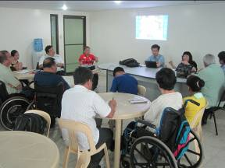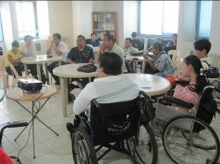
DPIAP presented about the aims of the mission. DPIAP works closely with ASEC on ASEAN project funded by The Nippon Foundation (TNF). ASEAN strategic framework will focus on disability issues in 2011-2015.

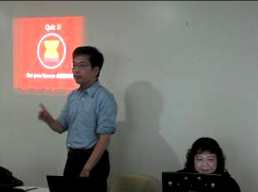
Mr. Taisuke Miyamoto presented ASEAN Project
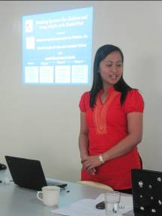
Ms. Visitacion E. Apostol, National Project Director, KAMPI presented the project “Breaking Barriers for Children and Young Adults with Disabilities”. This project is a joint project of KAMPI, the Danish Society of Polio and Accident Victims (PTU) and Local Government Units. The project has 2 components 1. Breaking Barriers for Children 2. Breaking Barriers for Young Adults with disabilities. The goal of the project is to promote the rights and improve life of children and young adults with disabilities. Their project has many activities such as rehabilitation, education, training to increase awareness and caring of parents, rehabilitation service, pre-school training, parents training programme – how to rehab their children, social rehabilitation training on understanding of disabilities issue and social skill.

14:00-16:30 PM Meeting with Meeting with DPOs/IL leaders

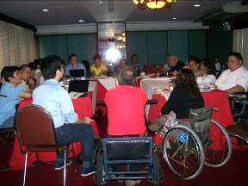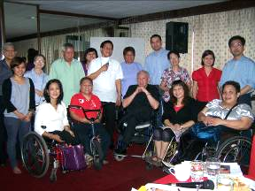

DPIAP introduced ASEAN project and ADF which DPIAP will facilitate. ADF uses the name of “forum” to follow ASEAN Women Forum and ASEAN Children Forum and ASEC agreed to use this word. The forum will be a loose coalition of DPOs from each country and the government will acknowledge the progress of the forum through ASEAN. ADF has many activities to support e.g. accessibility, employment, education etc. Thai government would like to promote IL, CRPD workshop and inclusive art, music and sport activities. Concerning the December event in Jakarta, the organizers will invite 3 participants including PAs from each country to the event. Selection of the delegates should consider gender and representativeness of cross disabilities. Filipino DPOs would like to present their works through posters in the exhibition. The procedure of selection of the delegates the application form will sent by KAMPI to others DPOs to apply and select for committee.

August 17, 2010

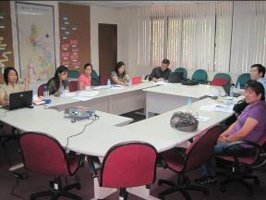

09.00 AM Meeting at Department of Social Welfare and Development (DSWD) office, welcomed by Ms. Victoria N. Navida, Chief, External Affairs Division Policy Development & Planning Bureau
Ms. Saowalak introduced DPI/AP and ASEAN project. The mission to Philippines is to consult what Filippino government will do in socio-cultural pillar of ASEAN related to PWDs and ASEAN. DPIAP would like to harmonize ASEAN project with the ideas of the Filippino government.
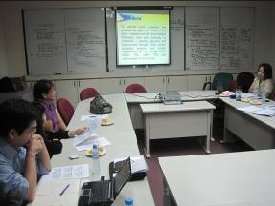

Ms. Victoria N. Navida, Chief, External Affairs Division Policy Development & Planning Bureau explained DSWD and their proposed project to ASEAN. One of the presentations from Filipino SOMSWD was “Program Evaluation for PWDs” which could be harmonized with DPIAP project. This program is in the process of discussion, so the Filipino government could consider the resource to be allocated to DPIAP project, after their program finishes before DPIAP project. They will inform when the project is approved. On 30 August -2 September 2010 Japan will organize Caring Society High-level Meeting. DPIAP would like Thai and Filipino SOMSWD to raise disability issues in the meeting since the theme of the meeting is about poverty reduction for the vulnerable population. PWDs should be the poorest of the poor and should be recognized in this topic.

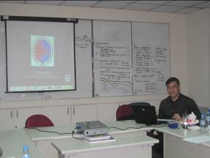

10.00 AM Meeting with Department of Transportation and Communications Mr. Rizal C. Morales, Senior Transport Development Officer/DOTC Focal Person to NCDA and Vice-Head, DOTC Task Force on Accessibility

Mr. Rizal explained the current situation of accessibility of the Philippines and what the department has done so far e.g. design of the signage poster stickers for posting on the public transportation, special lane for ticket vendor, accessible toilets in international and domestic airport, different level of public telephone, warning tactile blocks installed in railway station. They also conduct transportation and disability summit in selected cities. Some business sectors such as bus, Jeepney and taxi companies join the meeting. They organize activities for persons with cross disabilities such as CP, blind and autism. Wheelchair and tricycle hand out is also one of their activities.

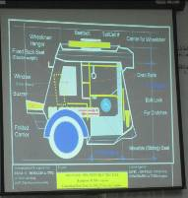

One of their project is design for disability-friendly tricycle waiting for budget to produce in rural areas since such places do not have bus nor jeepney as local transportation.

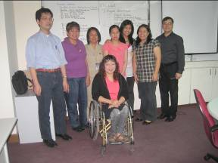

13.00 PM Visit Life Haven Inc. welcomed by Mr. Abner Nguyen Manlapaz,
President
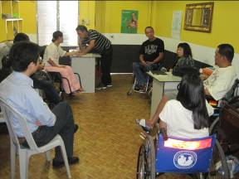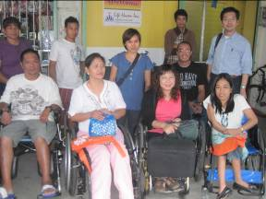
There are 5 staffs working at the center. They also have some members who usually join the activities. Ms. Gina is a wheelchair user who became a person with disability by car accident. She met Mr. Abner and join the center’s activities. Ms. Mayan is the only one WWD staff in Life Haven. She used to stay at home until she received her wheelchair. Mr. Abner met her and asked her to work in the center. Mr. Ali has spinal cord injury C5-6. His friend told him about IL. After learning IL he wanted to go out, not to stay at home as before. He helps the center to find PWDs in the community with his PA to wheel around. Life Haven is conducting a workshop on IL in September in Manila. The speakers are from Japan, Korea and Thailand.
They find PAs from universities and colleges.

18.00 PM Meeting with Engr. Bien C. Mateo, Assistant Vice President Operations SM Supermalls
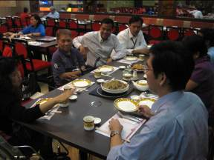

SM Supermall is a chain of shopping malls in the Philippines where they promote accessibility in their malls. They believe that the government cannot do it alone so private sector should help to provide accessibility. Providing accessibility in their mall is the benefit for them to get more family customers (baby and elderly), as it is common in the Philippines that customers want to bring all family members together to shopping malls. They also get more wheelchair users and persons with other disabilities as new customers to their mall.
Their staffs and securities are trained how to assist PWDs quarterly. They also provide training to the merchandises from the shops by showing video how to assist PWDs. SM shares their program on accessibility to other malls, some of them are starting to follow it. They have received awards from the government, this motivate them to improve accessibility in their malls step by step. To that end, DPOs are invited to audit accessibility and to be speakers in the malls. SM also promotes the employment of PWDs in their malls, at least 2 PWDs in one mall.

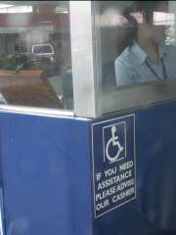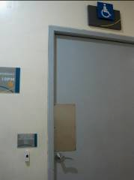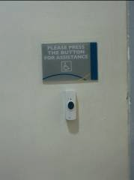
The challenge they face is Non PWDs usually use toilet or parking for PWDs so they have to lock them. When PWDs need to use these facilities, they have to press the button to request assistance from the mall staff.

August 18, 2010

10.00 AM Visit National Council on Disability Affairs (NCDA), welcomed by Mr. Mateo Lee, Executive Director

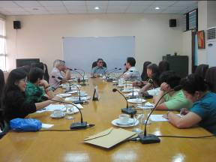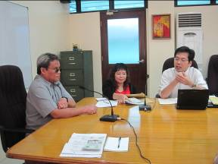

The National Council on Disability Affairs (NCDA) is the national government agency mandated to formulate policies and coordinate the activities of all agencies, whether public or private, concerning disability issues and concerns. As such, the NCDA is the lead agency tasked to steer the course of program development for persons with disabilities and the delivery of services to the sector. They have many projects concerning PWDs e.g. accessibility, UD, promotion of the rights of children with disabilities in collaboration with UNICEF, non-handicapping environment project with JICA since 2007, training for PWDs, DET training, advocacy, CBR, issuance of ID card for PWDs for 20% discount on several social services and sports activities such as basketball for persons with hearing impairment. They have main divisions of the secretariat, each division has its own activity concerning PWDs. The Information, Education and Communication Division deals with newsletter, Celebration on CP awareness week, deaf awareness week and Disability Week, and awareness raising through photo exhibition. The Technical Cooperation Division provides management information, website, web accessibility forum and scholarship.

11.00 AM Meeting with Commission on Human Rights of the Philippines by Ms. Atty Lovely Dominguez

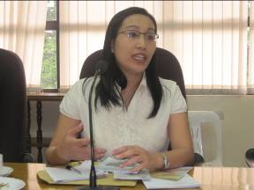
The Commission on Human Rights of the Philippines is empowered to investigate all forms of human rights violations involving civil and political rights, adopt rules of procedure, provide appropriate legal measures for the protection of human rights of all persons within the Philippines, and several other powers in relation to the protection of human rights. They are promoting many programs: Human Rights Information and Public Advocacy, Rights-Based Approach Application, Child Rights Center, Women's Rights Program Center, Asia-Pacific Institute of Human Rights and so forth.

August 19, 2010
10.00 AM Visit Breaking Barriers for Young Adults with Disabilities (BBCY)

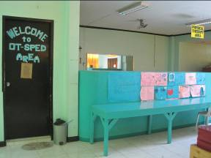
BBCY is a joint project of KAMPI and Danish Society of Polio and Accident Victims (PTU) in partnership with Dagupan City, which is aimed at building the capacities of Young Adults with Disabilities (YAWDs), 15-24 years old, for self determined living through the provision of free comprehensive development training. The center and their equipment are supported from the city government. Staff salary are from BBCY. There are social workers visit the community and search for YAWDs. YAWDs come to the center by public transportation. There are many training program for YAWDs such as cooking, personality development, vocational training and advocacy. The result of their advocacy makes people in the community aware of PWDs and services for PWDs.
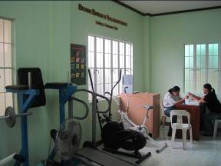
They also teach YAWDs in the center to do handicraft and their products are sold when BBCY conducts the events. YAWDs who finished the program will identified by the center if they will be sent to school or to work. Most of them study in school or university. Some of them work in garment company as merchandises, office staff. They also hire PWDs to work in the center.
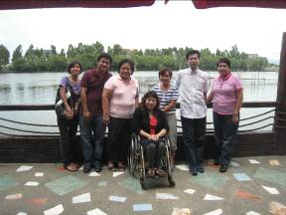

Source: http://www.ncda.gov.ph/about
Source: http://en.wikipedia.org/wiki/Commission_on_Human_Rights_%28Philippines%29

