1st prize
Name: Ng Wei Chean
Place: Singapore River
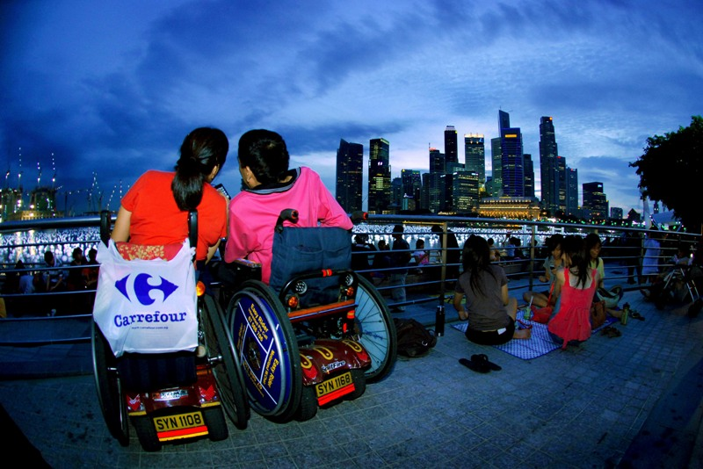
We count down for the coming New Year, and share the memory of the journey that we have passed through at the Love River.

2nd prize
Name: Lim Lean Eng
Place: Fort Cornwalli’s Field
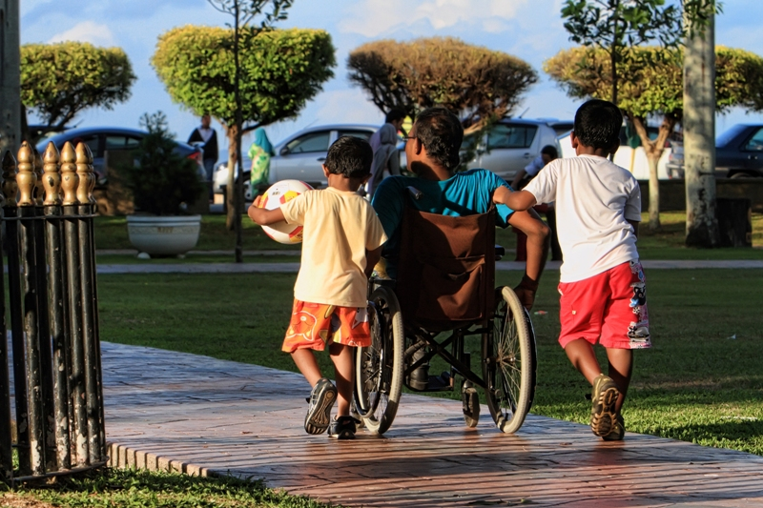
This evening, he is enjoying happily with his children at the park. This barrier-free park is wonderful and makes their life colourful.
3rd prize
Name: Cindy Chow Phik Kuan
Place: Dataran Pahlawan, Malacca
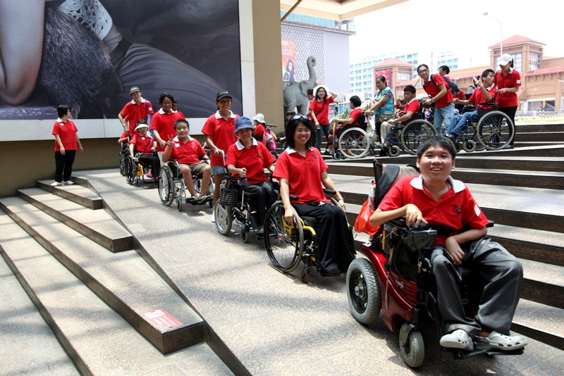
A group of wheelchair warriors arrive at Dataran Pahlawan, Malacca. They fight a barrier-free environment on this holiday. They queue up in a row, ready to conquer this beautiful ancient city.

4th prize
Name: How Bee Yok
Place: Dataran Merdeka, KL
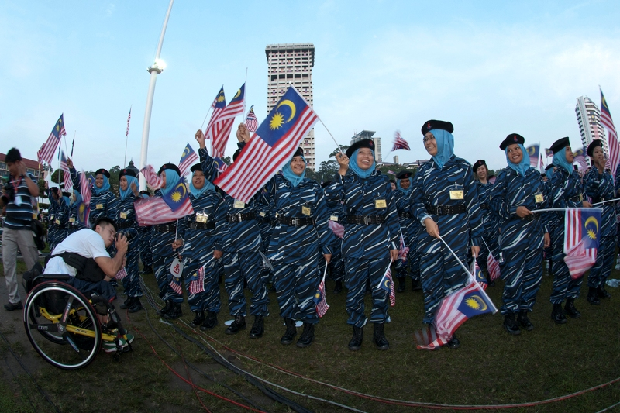
Everyone is celebrating the National Day at Dataran Merdeka. He is captivating the joyous scene. A true 1 Malaysia is to provide a barrier-free environment to accommodate people.

5th prize
Name: Tan Ai Bee
Place: Singapore
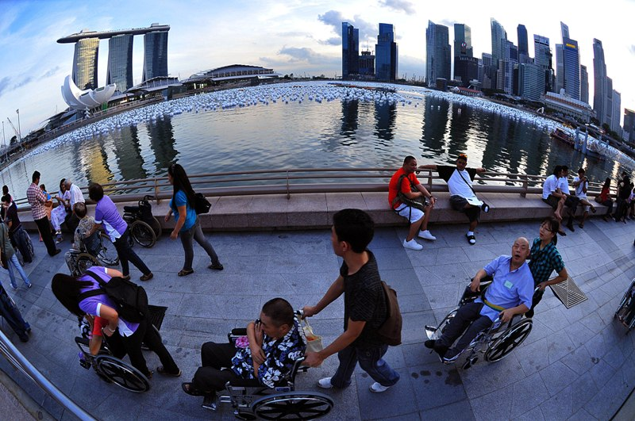
A disabled girl told me that the most precious and blissful Christmas gift to her is to bring her to the place. A barrier-free travel let them to have an unforgettable and beautiful memory.

6th prize
Name: Somennath Mukhopadhyay
Place: Jharkhand, India
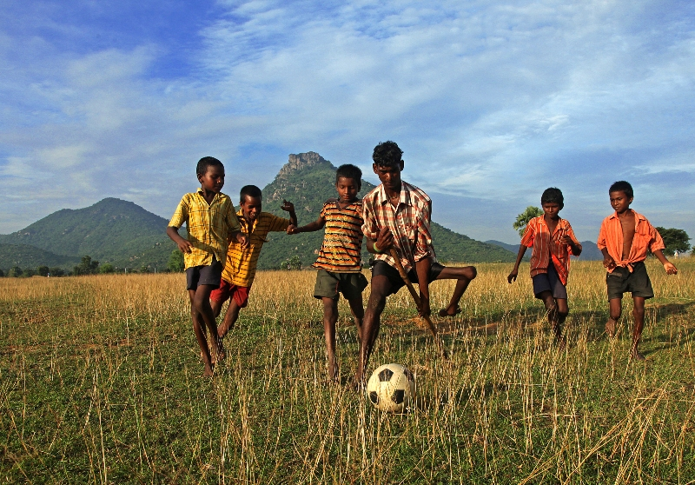
Although one of my feet is disabled, my enthusiasm for football remains strong. My group members never excluded me from playing with them.

7th prize
Name: Tonny George
Place: Kota Kinabalu, Sabah
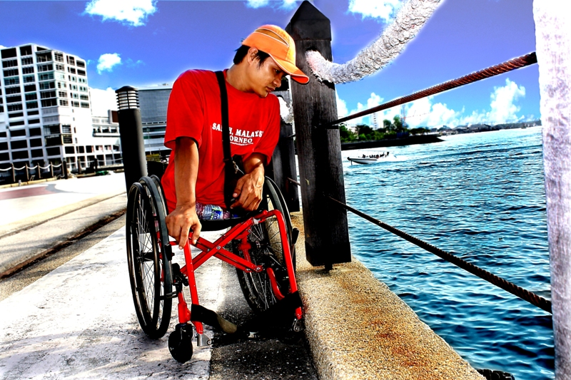
Because of this bridge, strolling alone at the ocean front coast makes me close to you. Ocean, how I wish in your hug!

8th prize
Name: Chong Lomg Chau
Place: Library Community, PJ
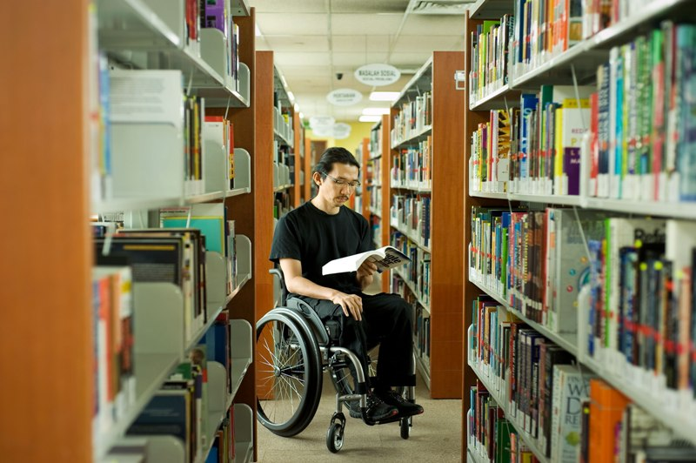
This library has never over looked the needs of wheelchair users, with this walkway space and the wide corridor enables have smooth maneuver and therefore the joy of reading.

9th prize
Name: Chung Hong Tsin
Place: Shopping Mall, Sibu
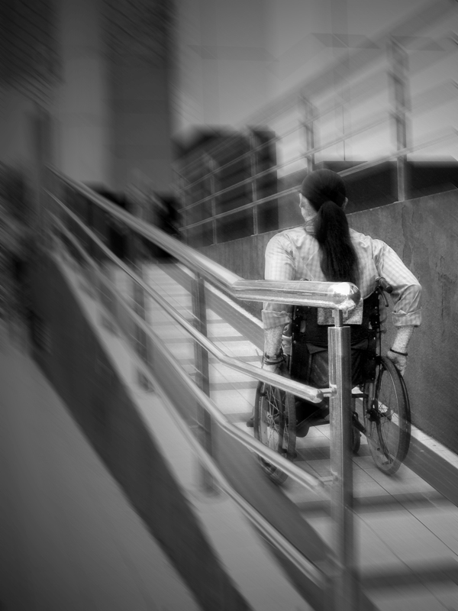
I can ride on this route with the construction of this slope
I’m not afraid of height and distance, I’m just afraid of staircases.
10th prize
Name: Fong Kim Leng
Place: Segari, Perak
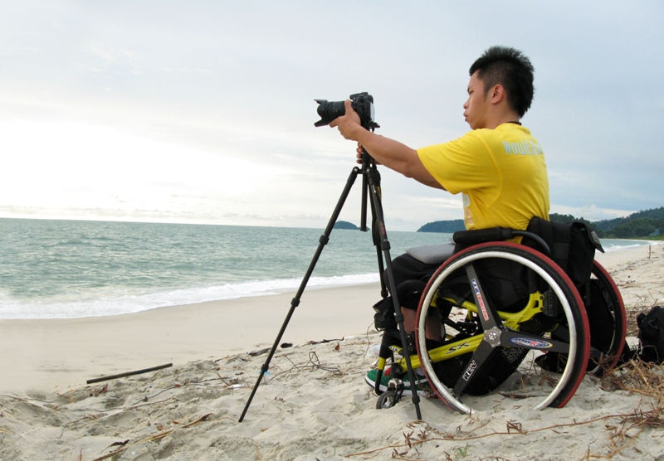
Beach is always “forbidden” for the disabled because the sand will make the tire sink in. If you insist on moving, it will only become worse. Although I can only take photo from far, I’m still able to capture the most breathtaking scene.

