

report

5th Asia Pacific Occupational Therapy
Congress 2011,

19 - 24 November 2011
Chiang Mai,
Thailand

by

Tina Schaarschmidt

Mission: The 5th Asia Pacific Occupational Therapy Congress 2011, Chiang Mai, Thailand
Organized: The Occupational Therapist Association of Thailand
Contact: APOTC 2011 Congress Secretariat
Address: GAT MICE 19/117 Soi Kubon 28, Kubon Rd., Kannayaow, Kannayaow, Bangkok 10230, Thailand
Tel: +66 2 509 2276, +66 81 618 8966, Fax: +66 2 509 8587
E-mail: secretariat@apotc2011.org
Website: http://www.apotc2011.org/

Contact persons: DPI/AP
Ms.Saowalak Thongkuay
Mobile: 668-1-558-1903

Email: saowalak@dpiap.org
Mr. Wansao Chaiyakul
Mobile: 66-8-1-978-4383

Email: wansao@dpiap.org
Address 92 Phaholyothin 5 Road, Samsennai,
Phayathai Bangkok 10400 THAILAND
Tel: 66 (0)2 271-2123
Fax: 66 (0)2 271-2124

Duration: 22- 24 November 2011

Mission members: 4 persons

No. | Name | Position | Remark
1. | Ms. Saowalak Thongkuay | Regional Development Officer | Mission Leader
2. | Mr. Wansao Chaiyakul | Coordinator, accessible Tourism | Member
3. | Ms. Tina Schaarschmidt | Information support | Member
4. | Mr. Somchay Phumcharoen | Transportation staff | Member

Aims:
- To introduce DPI-AP as the regional organization to promote accessible tourism for all in Asia Pacific region.
- To introduce DPI-AP as tourism industry's partner to promote accessible tourism in term of business.
- To sharing the experience and exchange the perspective of persons with disabilities on tourism industry.
- To build a partnership with Occupational Therapy network.

The mission’s methods:
- To attend the 5th Asia Pacific Occupational Therapy Congress at The Empress Convention Centre, Chiang Mai, Thailand;
- To be key speaker of the congress and present on Accessible Tourism: Creating friendly leisure environment for all citizen ;
- To make networking with the delegate whom attend the congress

Outcomes:
- Partnership with Occupational Therapy network
- DPIAP as the main regional Disabled People Organization to promote accessible tourism
- DPIAP is the tourism industry, providing the accessible tourism as business sector in Thailand
- Promote accessible tourism as part as the activities of occupational therapy.

Tentative Mission Program
Day 1 – Tuesday, 22 November, 2011: Preparation
Time | Activity | Speaker/Facilitator
21.20 | Mission team arrive to Chiang Mai | By Thai Airways (TG 710)  Check in The Empress Hotel and Convention Center 199/42 Chang Klan Road  Chiang Mai 50100, Thailand
Day 2 – Wednesday, 23 November, 2011: Congress day
Time | Activity | Speaker/Facilitator
08.30-09,00 | Register
09.00-09.45 | Education- Securing the Present, Shaping the Future | Dr. Kit Sinclair (Hong Kong)
09.45-10.30 | Accessible Tourism: Creating Friendly Leisure Environment for All Citizen | MS. Saowalak Thongkuay(Thailand)
10.30-11.00 | Coffee break
11.00-12.30 | Development of OT Measurement | Dr. Christine Chapparo (Australia) (Grand Hall, ECC)
 | Hand Rehabilitation | Assoc Prof. Shelley M Chow & Dr. Piya Trevittaya (Chiang Mai 2-3, ECC)
 | Practices in Pediatric OT (1) | Prof. Noriko Tomioka & Asst Prof. Dr.Supaporn Chincha (Chiang Mai 4-5, ECC)
12.30-14.00 | Lunch
14.00-15.00 | Cross-cultural Researches in OT | Dr. Clare Hocking (New Zealand)
15.00-15.30 | Coffee break
15.03-17.30 | Global OT: The Relationships between Occupation and Well-Being/Health | Dr. Clare Hocking (New Zealand) (Grand Hall, ECC)
 | Practices in Psychiatric OT | Assoc Prof. Shelley M Chow & Dr. Piya Trevittaya (Chiang Mai 2-3, ECC)
 | Practices in Geriatric OT | Prof. Noriko Tomioka & Asst Prof. Dr.Supaporn Chinchai (Chiang Mai 4-5, ECC)
Day 3 – Thursday, 24 November, 2011: field visit
AM | Accessible field visit
PM | Depart for Bangkok | TG113

Report about the 5th Asia Pacific Occupational Therapy 2011 Congress (APOTC)

The OT network, focuses on making occupational therapy practice on best effective and applicable to diverse cultural contexts with educational symposiums, workshops & congresses.
As a Regional Congress of World Federation of Occupational Therapists, the Asia Pacific Occupational Therapy Congress (APOTC) draws together eminent health care professionals, from the Asia Pacific and worldwide, to share the rich diversity of their research, skills and techniques. Every 4 years, since 1995, the congresses have been held in rotation among the Asia Pacific countries. The first one was 1995 in Malaysia, the second 1999 in Taiwan, the third 2003 in Singapore, the fourth 2007 in Hong Kong and now 2011 in Thailand.
The 5th Asia Pacific Occupational Therapy Congress (APOTC 2011) was jointly organized by the Occupational Therapy Association of Thailand and Department of Occupational Therapy, Faculty of Associated Medical Sciences, Chiang Mai University. The theme of the congress was “Opening World: Optimizing Occupational Therapy Practice”. It focused on how occupational therapy techniques and practices can be adapted to a wide variety of diverse cultural bases.
The event included a comprehensive scientific program of educational symposium, pre-workshops and congress sessions covering an extensive number of topics. A large number of internationally-renowned researchers and practitioners were invited to speak at the Congress. Approximately 600 -700 delegates attended this event.
The Highlights of the Congress were Cultural competence and diversity in OT practice, Occupation, participation and well-being, Evidence-based OT practice, Development of OT measurement, Cognitive rehabilitation, Sensory modulation disorders, Assistive technology, Hand rehabilitation, Work rehabilitation, Occupational justice, Disaster response, recovery and preparedness, Community-based practice and OT practice in mental health, pediatrics, physical dysfunctions and geriatrics.
On the 23th of November DPI/AP joined the event because Ms. Saowalak Thongkuay was invited as a speaker. The day started with a welcoming speech and the third Plenary Speech was a Tsuyoshi Sato Lecture represented through Dr. Kit Sinclair (Hong Kong) and the content of her speech was Education- Securing the Present, Shaping the Future. After a small break Ms Saowalak Thongkuay presented the relation between OT and Accessible Tourism. The content was about to create a friendly leisure and environment for all citizen. Accessible tourism becomes alternative choices for elderly persons and travelers with disabilities of which the number of them gradually increases. The tourism industry has to improve its services related to remove barriers in travelling. The strategies to reach this must include a rights-based and a profit-based approach. The leading stakeholders who will make accessible tourism possible are the government, the business and as well as persons with disabilities. All in all in the near future, it would be a surprise to those in the tourism industry who have not yet prepared their profit-based approach to disability. Some may need assistance from persons with disabilities who are expert on this field to improve their services. Persons with disabilities have an opportunity to contribute and to shape the travel industry with the rights-based emphasis through government, education or policy and on the other hand with the profit-based side through invention, construction, marketing or business creation.
However the cooperation between the OT network and DPI/AP is one important factor to promote accessible tourism. A partnership with the Occupational Therapy network is fundamental to introduce DPI/AP as the main regional Disabled People Organization to promote accessible tourism. Furthermore it is necessary that the OT network works together with DPI/AP as the tourism industry who will provide accessible tourism as business sector in Thailand. In conclusion accessible tourism should be a part of the activities of the occupational therapy.
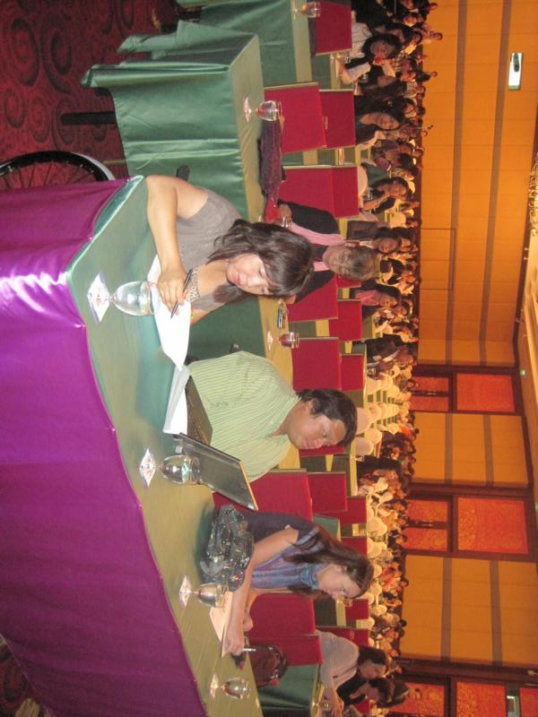
The congress room at the Empress Convention Center, Chiang Mai.

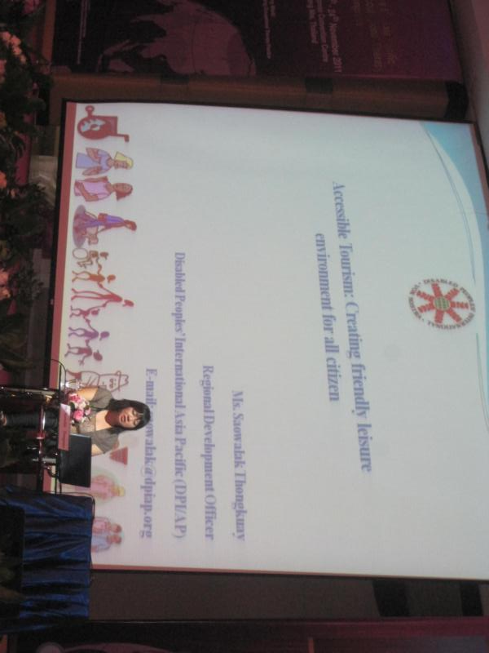
Ms. Saowalak Thongkuay as speaker at the congress.

