ASEAN Disability Forum (ADF)
Joint the 2nd Regional Consultation with CSOs
Of the ASEAN Intergovernmental Commission
On Human Rights on the ASEAN Human Rights Declaration

Manila,
10-12 September 2012

ASEAN Disability Forum (ADF) sent 3 representatives to join the draft
ASEAN Human Right Declaration (AHRD).

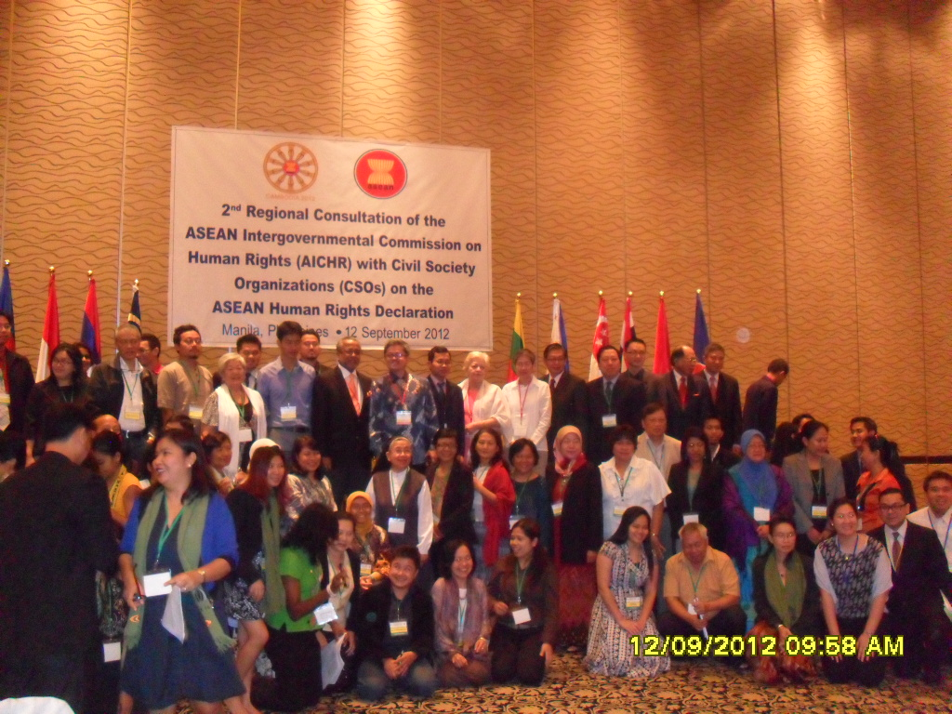

They were:
- Ms. Kanokporn Nakchatree of ADF Secretariat,
- Ms. Josephine De Vera, ADF member from Philippines
- Mr. Lauro L. Purcil Jr., ADF member from Philippines.

The ADF delegation prepared and submitted the ADF statement to the Civil Society Conference to be incorporated to the group’s document for the AICHR consultation and constructive dialogue done the 12 September 2012. Pleas see the file attached of the Joint Submission signed by 62 CSOs including ADF and its affiliated members in the Philippines.
Prior to the September 12, 2012 Constructive Dialogue with AICHR, a Forum to examine and formulate proposed amendments to the draft of the ASEAN Human Rights Declaration (AHRD) was conducted from September 10-11, 2012 at the Bay View Manila Hotel. It was jointly organized by the Philippines Alliance of Human Rights Advocates (PAHRA), Task Force Detainees of the Philippines (TFDP), Asian Forum for Human Rights and Development (FORUM-ASIA), Solidarity for Asian Peoples’ Advocacy Task Force on ASEAN and Human Rights (SAPA TFAHR) and the American Bar Association Rules of Law Initiatives (ABA-ROLI).
While the Joint Forum welcome the effort of the AICHR in organizing the second official regional consultation on the ASEAN Human Rights Declaration as a follow-up to the first official regional consultation, which was held on 22 June 2012 in Kuala Lumpur, Malaysia, however the same group saw the imperative to submit amendments to the document. There is really that need to further continue the strengthening the consultation processes with civil society organizations and expand such practices in other aspects of the work of AICHR.

Serious concerns were however expressed due to the fact that the second:
- AICHR consultation meeting was still insufficiently broad-based.
- Several organizations continued to be barred from participating in the meeting.
- Moreover, several countries have yet to organize any national consultation with their civil society organizations on the ASEAN Human Rights Declaration.
- The CSO Forum urges all AICHR representatives to ensure broad participation, more transparent and equal access by civil society organizations to AICHR in the future.

Among the concerns identified are:
- That the level of human rights protection in the ASEAN Human Rights Declaration should not be lower than that provided in International human rights laws and standards.
- Full acceptance of the aspiration to provide “added value” to the body of international human rights laws.
Lesson Learnt

- ASEAN is a platform to influence policy at the regional level (regional policies are increasingly affecting domestic politics, economics, and socio-cultural aspects of member countries).
- Despite contested, civil society contributes to the development of the meaning of a Community building and visible in number of ASEAN documents.
- Civil Society engagement improves the accountability of ASEAN. A critical and watchful civil society is a factor of paramount importance for good governance.
- Civil society participation in ASEAN can bring positive outcomes and at the same time detrimental consequences.
- Valuable inputs from civil society enhance the quality, number of ASEAN documents.
- Engaging civil society is now used to indicate whether ASEAN member state is incompliance with the Charter or not.

Prepared and Submitted by:

Ms. Kanokporn Nakchatree, ADF Secretariat
Ms. Josephine De Vera, ADF Member
Mr. Lauro L. Purcil Jr., ADF Member.

