Mission: Cambodian Mission: Preparation meeting on ASEAN Disability Forum (ADF)
Organizer: Cambodian Disabled People's Organization (CDPO)
Contact Persons: CDPO
Mr. Ngin Saorath
Executive Director
Email: director@cdpo.org

Address: #Wat Than, Norodom Blvd., Sangkart Tonle Basac Khan Chamcar Morn
Phnom Penh, CAMBODIA
Tel: +855 16 851 841, 855 12 851 841, Off: 855 23 221 823
Email: director@cdpo.org Website: www.cdpo.org

Contact person: DPI/AP
Saowalak Thongkuay (Ms.)

Regional Development Officer-DPI/AP

Email: saowalak@dpiap.org

Address 92 Phaholyothin 5 Road, Samsennai,
Phayathai Bangkok 10400 THAILAND
Tel: 66 (0)2 271-2123
Fax: 66 (0)2 271-2124

Duration: 20 - 24 December 2011

Mission members: 3 persons

No. | Name | Position | Remark
1. | Ms. Saowalak Thongkuay | Regional Development Officer – DPI/AP | Mission Leader
2. | Mr. Wansao Chaiyakul | Project Coordinator & Web Master – DPI/AP | Member
3. | Ms. Mariam Ali | Project Coordinator on Employment and ASEAN | Member

Aims:
- To introduce DPIAP and Cambodian Disabled People's Organization (CDPO) ASEAN task force team to Cambodia’s SOMSWD;
- To strengthen and encourage the collaboration between DPIAP and CDPO on ASEAN;
- To encourage the empowerment of Persons with disabilities in Cambodia and Disabled People Organization (DPOs) in Cambodia to become part of the ADF community and a stakeholder within ASEAN ;
- To set up programming and preparation on budget for the ADF meeting 2012 that will be organized by CDPO;
- To search for suitable venues for the ADF conference;

The mission’s methods:
- Courtesy visit to Royal Thai Embassy
- To have a preparation meeting between DPIAP and CDPO;
- To have a meeting with Cambodia’s SOMSWD and introduce DPIAP and CDPO as the main organization on ADF preparation meeting at Cambodia;
- To search for possible suitable venues for the ADF conference in March 2012.

Outcomes:
- Cooperation and support from Cambodia Multi stakeholders on promoting the ADF;
- DPIAP and CDPO complete the first draft on programming and preparation of budget fundraising for the ADF meeting 2012
- Networking and cooperation with PWDs leader with DPO in Cambodia on supporting the ADF and ASEAN
- Perform accessibility audits on possible venues.

Tentative Mission Program
Cambodia Mission: preparation meeting on ASEAN Disabilities Forum
20-24 December 2011, Cambodia
Day 1 (20 December 2011)
Time | Item/Activity | Remarks
07:45 - 09:00 | Arrive in Cambodia | DPI/AP Team  (TG 582)
10:00 – 11:30 | Accessibility audit at Hotel Cambodiana | DPIAP
14:00 – 16:00 | Visit the Thai Embassy in Phnom Penh | DPIAP and CDPO
Day 2 (21 December 2011)
10.00 - 12.00 | Meeting with Cambodia SOMSWD | DPIAP and CDPO
14.00 - 17.00 | Meeting with CDPO | DPIAP and CDPO
Day 3 (22 December 2011)
10.00 - 12.00 | Working on background documents for the ADF conference | DPIAP
14.00 – 15:30 | Meeting with the Disability Action Council under the Ministry of Social Affairs, Veterans and Youth Rehabilitation (MOSVY) | DPIAP and CDPO
16:00 – 19:00 | Working on background documents for the ADF conference | DPIAP
Day 4 (23 December 2011)
10.00 – 13:00 | Working on background documents for the ADF conference | DPIAP
14.00 – 15:00 | Meeting with CDPO’s Finance Manage to discuss estimates of the conference expenses. | DPIAP and CDPO
15:00 – 17:00 | Working on background documents for the ADF conference | DPIAP
Day 5 (24 December 2011)
20:45- 21:45 | Depart from Cambodia to Bangkok | DPI/AP Team  (TG 585)

20th December 2011
After arriving in Phnom Penh, the DPIAP team proceeded to the Hotel Cambodiana to do an accessibility audit, considering hotel rooms and the conference facilities. The hotel had appropriate rooms for wheelchair users however the bathroom doorways were quite narrow in the twin superior rooms. A large wheelchair would be unable to navigate through the doorway. The deluxe rooms had bigger doorways but also had a step and were therefore not practical.
There are two large conference halls at the Hotel Cambodiana. One is inaccessible as there are many steps to go down to access the hall. There was another conference room which was on the first floor which we were advised was accessible however it was in use and we were unable to view the facility.
After the accessibility audit, the team proceeded to the CDPO offices to meet the staff and our counterparts, and then went to lunch.
A courtesy visit had been arranged at 2:00pm at the Thai Embassy in Phnom Penh, which DPIAP along with CDPO’s Executive Director, Mr Ngin Saorath attended. At the Embassy, we met with H.E Ambassador Mr Sompong Sanguanbun, Minister Mr Surapol Maneepong, Counsellor Mr Soradjak Puranasamriddhi and Second Secretary Ms Sasilada Kusump.

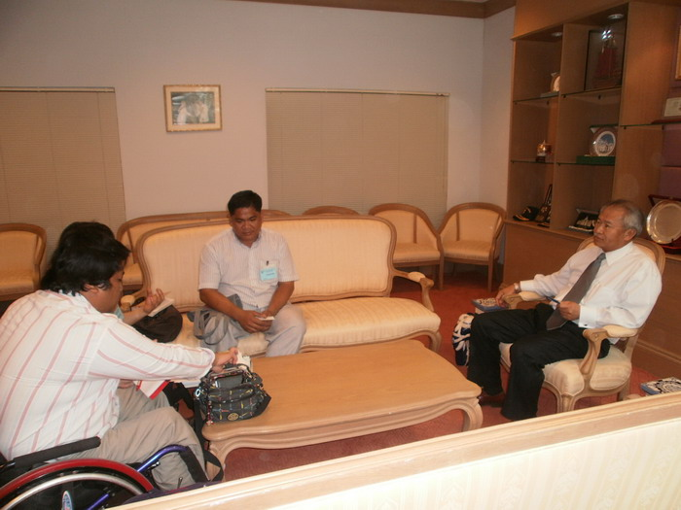
During the visit, DPIAP spoke on disability issues and of the ASEAN Disability Forum (ADF), and the upcoming conference to be held in Phnom Penh in March 2012. The Ambassador produced some useful ideas on the kind of support CDPO and DPIAP would be able to receive for the conference and recommended that the organizers should create a list of logistical support needed. He also recommended the organizers should pay courtesy calls to all ASEAN embassies in Phnom Penh and share information about the upcoming conference and Bali Declaration, and later request support from each embassy. Ms Sasilada Kusump kindly provided an updated list of all the ASEAN embassies, addresses and contacts to us for this purpose.
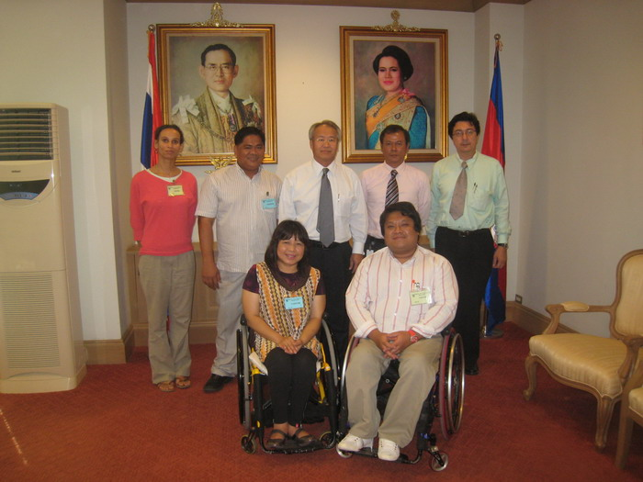
21st December 2011
In the morning, CPDO had arranged a meeting with the Ministry of Social Affairs, Veterans and Youth Rehabilitation (MOSVY) where we met with Mr. Prak Chanthoeurn, the Director General of Technical Affairs and Mr. Khem Sam Ath, Chief of ASEAN Bureau, International Cooperation Department.
DPIAP and CDPO introduced the ASEAN Disability Forum (ADF) and spoke of Cambodia’s year of chairing ASEAN in 2012, in which Cambodian Disabled People’s Organisation (CDPO) would host the ADF conference. The MOSVY representatives gave an overview of the function of the ministry vis a vis disability in Cambodia and explained that in Cambodia there was a disability law that came into effect in July 2009 and that a council Disability Action Council (DAC) had been established to coordinate disability matters. We were advised to meet with DAC to request cooperation from them. Mr Chanthoeurn also spoke at length about the quota system for employment of persons with disabilities in Cambodia. The government officials were interested in what sort of support the ministry would be able to give towards the initiative, and also provided useful information to CDPO about the required protocol and the procedure for sending official invitations and TOR to the ministry.
DPIAP further explained the achievements that had been made from the establishment of the ADF in Jakarta in December 2010 which included the Jakarta Declaration, a recognized document mentioned in the Bali Declaration 2011, as well as Indonesia ratifying the Convention on the Rights of Persons with Disabilities earlier this year.
Finally, Mr Prak Chanthoeurn presented DPIAP with the Ministry’s booklet on disability - The Law on the Protection and the promotion of the Rights if Persons with Disabilities OF July 2009.
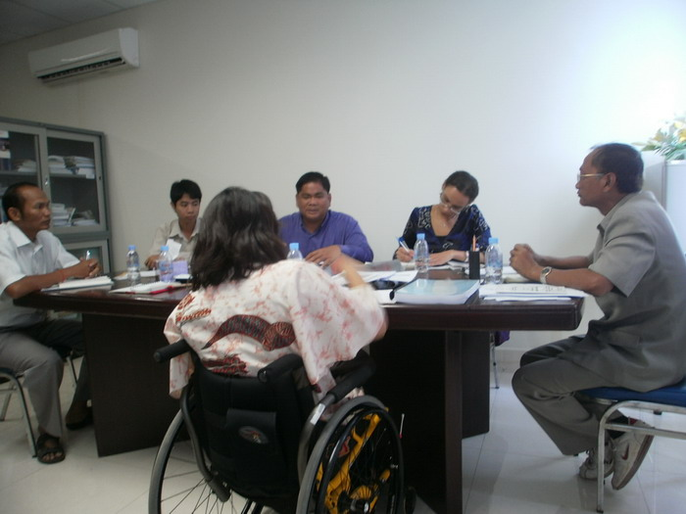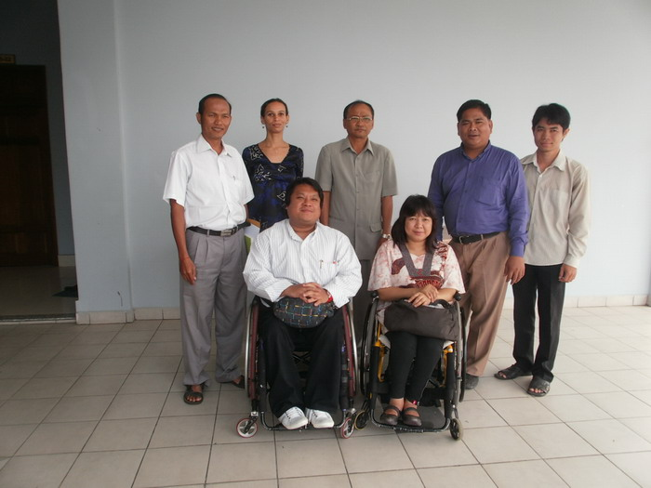

Later in the afternoon, we had a meeting with Mr Saorath of CDPO to discuss the organization of the upcoming ASEAN Disability Forum (ADF) in Phnom Penh, Cambodia in March 2012.
DPIAP and CDPO decided on a name, theme, terms of reference and DPIAP confirmed that the first draft of this background documentation would be developed while on mission in Cambodia.
It was also agreed that DPIAP would also create a template for the ADF estimate expense sheet for the upcoming conference in Cambodia and discuss this further with Mr Ky Sophan, CDPO’s Finance Manager.
The meeting also involved discussions on the funding, financial and other support to be considered for the conference with CDPO advising they were already negotiating with donors on these matters.

22nd December 2011
Work began on developing the first draft for the background documents which included the General Information, Terms of Reference, Title and Theme of the ADF conference for the ADF in Cambodia in March 2012.
A meeting had been scheduled at 2:00pm with Mr Lao Veng, the Director of the Disability Action Council (DAC) Secretariat and Mr Nhem Sareth, Disability Advisor of DAC to explain the ADF conference in March 2012 in Phnom Penh and request DAC to attend both opening and closing ceremonies. DPIAP and CDPO then requested the director of the DAC Secretariat to be a speaker and to make a presentation on the existing disability laws, and explain the role of the Disability Action Council.
Mr Veng also gave more details on the protocol which requires that CDPO should draft the Terms of Reference (TOR) and submit this to DAC by the middle of January 2012 for consideration. CDPO is also expected to draft a letter to DAC specifying support requirements requested, and also the specific subject matter that the presentation should be on. Additionally, Mr Veng and Mr Sareth advised that DAC would speak to some stakeholders involved and try to help coordinate a site visit to a centre for physical rehabilitation for the participants attending the conference in Cambodia.
Finally after some deliberation, Mr Veng advised that during his presentation, he would touch on Cambodia’s National Plan of Action, the quota system in Cambodia and the CRPD but would focus on the role of the government in promoting disability.
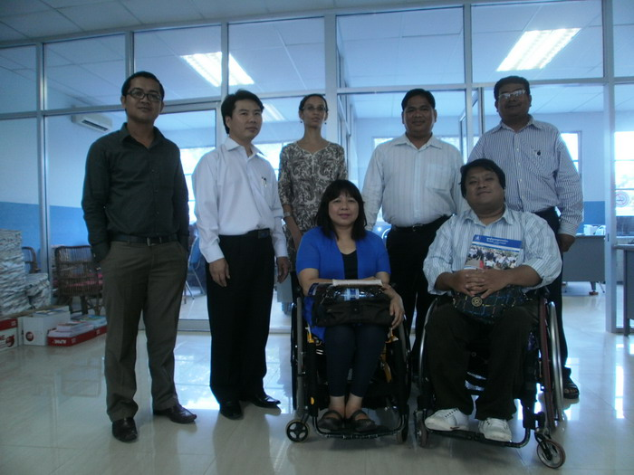

23rd December
Completed the first draft of the background documents required for the conference. Mr Ngin Saorath will make appropriate changes and email to DPIAP. We also finalised the first draft of the estimate expenses for the conference with Mr Ky Sophan who would further analyse the costs before presenting to doors and supporters of the conference.
24th December 2011
Return flight to Bangkok on TG 585 at 20:45

