

Report

Mainstreaming of Persons with Disabilities for African Francophone Countries-Independent Living Program
04 - 11 February 2012
Space 1 meeting Room– Amari Water Gate Hotel, Bangkok, Thailand

Purpose:
- To acquire strategic skills of planning to enhance their institutional capacity.
- To exchange ideas on the implementation of Millennium Development Goals (MDGs) and dialogue on the rights of person with Disabilities (CRPD) between Asian Pacific and Africa Region.

Organizer: Disabled Peoples’ International, Asia Pacific (DPI/AP)

Contact Persons: Disabled Peoples’ International, Asia Pacific (DPI/AP)
Kanokporn Nakchatree (Ms.)
Project Coordinator on ASEAN, (DPI/AP)
Telephone: 66 (0)2 271-2123
Fax: 66 (0)2 271-2123
Email: Kanokporn@dpiap.org

Address Disabled Peoples’ International – Asia Pacific
92 Phaholyothin 5 Road, Samsennai,
Phayathai Bangkok 10400 Thailand
Tel: 66 (0)2 271-2123
Fax: 66 (0)2 271-2124

Duration: 04 - 11 February 2012

Summary

The Training on Mainstreaming of Persons with Disabilities for African Francophone Countries-Independent Living Program for 2012 was first organized by Japan National Assembly of Disabled People’s International (DPI/Japan) followed by Disabled People’s International Asia-Pacific (DPI/AP) and supported by Japan International Cooperation Agency (JICA). The theme of this year’s training was ‘Addressing emerging social issues and real case studies in the Asia Pacific Region for Persons with Disabilities in Africa region.
In 2012, there were 10 participants from Togo, Tunisia, Senegal and Cape Verde as follows:
- Mr. Katatchom Palacbawy, Togo (Program Director / Togolese Federation of Associations for Persons with Disabilities )
- Mr. Karimu Wasiyou, Togo (Director of Person with Disabilities / Department of Person with Disabilities, Ministry of Social Affairs & National Security)
- Ms.Hentati Fatma Ali, Tunisia (Head of Unit of Social Welfare/ Division of Social Promotion in Sfax, Ministry of Social Affairs)
- Mr.Neffati Nizar, Tunisia (Administrator/ Ministry of Social Affairs)
- Mr.Diop Oumar, Senegal (Coordinator/Handicap Form Education C/CRPH (Resource Centre for the promotion of the rights of persons with disabilities))
- Ms.Ka Fama, Senegal (Fund and Accounting coordinator / Association des Handicap de Pikine Est)
- Ms.Wade Coumba, Senegal (Division Chef / Social and medical Action Division, Ministry of Social Action and National solidarity)
- Ms.Gueye Ndeye Dague, Senegal (Head of Division / Social Promotion service for disabled persons, Ministry of Social Action and National solidarity)
- Ms.Sarr Aida, Senegal (Communication and Programme Manager / Secretariat of the African Decade of Persons with disabilities)
- Mr.Tavares Osvaldo Benvindo Pinto, Cape Verde (Member of ACD Sao Miguel)

Program
Mainstreaming of Persons with Disabilities for African Francophone Countries-Independent Living Program
04-11 February 2012
Space 1 meeting Room, Amari Water Gate Hotel, Bangkok, Thailand

DAY 1 04 February 2012

Time | Activity | Remarks
16:00 – 18:00 | Leave Suvarnabhumi Airport & arrive Amari Watergate, Bangkok

DAY 2 05 February 2012

08:30 - 17:00 | Experience barrier free tourism for people with disabilities at The Grand Palace and Wat Phra Kaew (The Temple of the Emerald Buddha)

DAY 3 06 February 2012

09:00 - 09:30 | - Opening Ceremony by Mr.Seree Vachirathavornchai (Deputy Secretary General National Office for Empowerment of Persons with Disabilities)  - Welcome Speech by Ms. Saowalak Thongkuay  (Regional Development Officer, DPI/AP)
09:30 – 10:00 | Introduction of DPI/AP By Mr.Wansao Chaiyakul
10:00 – 10:20 | Break
10:20 – 11:10 | Question and Answer By Ms. Saowalak Thongkuay and Mr.Wansao Chaiyakul
11:10 – 12:40 | Disabilities Equality Training (DET) By Mr.Wansao Chaiyakul
12:40 – 13:30 | Lunch | .
13:30 | Depart from Hotel
14:00 | Arrive at APCD Building
14:00 – 14:40 | APCD regional program By Jasper Rom, Networking manager APCD
14:40 – 15:10 | Disability Policy in Thailand, Dr. Samrerng Virachanang, The Council of Disabled People of Thailand (CPDT)
15:10 -15:40 | Observer Accessibility at APCD building
15:40 | Depart from APCD building
17:00 | Arrive to IL Phutthamonthon
17:00-18:30 | Observe and learn Phutthamonthon Independent Living Centre activities present By Mr.Santi Rungnasuan, President of IL Phutthamonthon
20:00 | Arrive at hotel

DAY 4 07 February 2012
09:00 | Depart from hotel
10:00-12:00 | Observe and learn Nonthaburi Independent Living Center activities, present By Mr.Teerayudth Sukonthavit, President of IL Nonthaburi
12:00-13:00 | Lunch
13:00-16:00 | 2 home visits By Mr.Teerayudth Sukonthavit, President of IL Nonthaburi
17:00 | Arrival at hotel

DAY 5 08 February 2012
09:00-10:00 | Recap of the previous day
10:00-10:30 | Group discussion : situation analysis between developed and developing countries ( Japan and Thailand)
10:30-11:00 | Coffee break
11:00-12:00 | Group Discussion: All country
12:00-13:00 | Lunch
13:00 | Depart from hotel
14:00 | Arrive to UNESCAP
14:00-16:00 | Observe UNESCAP present By Ms. Aiko Akiyama, Social Affairs Officer (UNESCAP) and Mr. Sung-Jun Ha, Consultant UNESCAP
16:00 | Depart from UNESCAP
17:00 | Arrive to the hotel

DAY 6 09 February 2012
09:00-09:30 | Recap of the previous day
09:30-10:30 | Asia Pacific Decade of Persons with Disabilities and sub regional approach By Ms. Saowalak Thongkuay
10:30-11:00 | Coffee Break
11:00-12:30 | Group discussion : Keeping the dynamic of the movement, African decade and its beyond
12:30-13:30 | Lunch
13:30-14:30 | Independent Living from individual empowerment to community development By Mr.Teerayudth Sukonthavit, President of IL Nonthaburi
14:30-15:30 | Coffee Break
15:30-17:00 | Lets do it: implementation of IL in our countries
18:00-20:00 | Dinner with DPI/AP staff at ‘In Love’ restaurant

DAY 7 10 February 2012
09:00-10:00 | Review and share Thailand course
10:00-10:30 | Coffee Break
10:30-12:00 | Draft Bangkok Recommendation
12:00-13:00 | Lunch
13:00-15:00 | (Continue) Draft Bangkok Recommendation
15:00-15:30 | Coffee Break
15:30-16:00 | (Continue) Draft Bangkok Recommendation
16:00-17:00 | - Closing ceremony By Mr. Akihisa Tanaka, Senior JICA Representative and Ms. Saowalak Thongkuay, Regional Development Officer (DPI/AP)  - Adopt of Bangkok recommendation By Participants from Senegal Ms. Wade Coumba, (Division Chef / Social and medical Action Division, Ministry of Social Action and National solidarity)  - Certificate Ceremony for participants from Africa By Mr. Akihisa Tanaka, Senior JICA Representative and Ms. Saowalak Thongkuay, Regional Development Officer (DPI/AP)

DAY 8 11 February 2012
08:30-14:00 | Accessibility check , BTS and MRT
14:00 | Depart from hotel to airport

05 February 2012
The training in Thailand started with the field visit in Bangkok to experience barrier free tourism for people with disabilities at The Grand Palace and Wat Phra Kaew (The Temple of the Emerald Buddha)

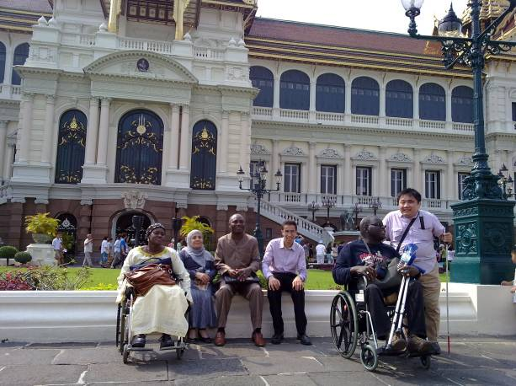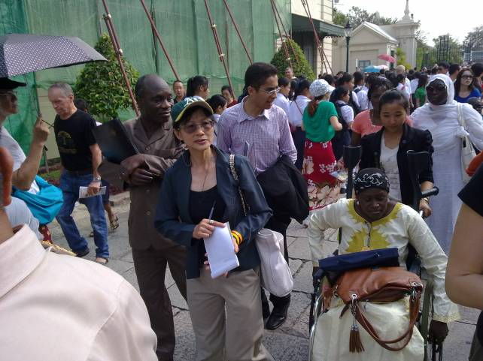

06 February 2012
Mr.Seree Vachirathavornchai, Deputy Secretary General of NEP, presided over the opening ceremony of Mainstreaming of Persons with Disabilities for African Countries – Independent Living Program on 6 February 2012 at Amari Watergate hotel, Bangkok. The purpose of the program was to exchange strategies on implementation of Millennium Development Goals (MDGs) and the Convention on the Rights of Persons with Disabilities (CRPD) between Asia Pacific and Africa region.
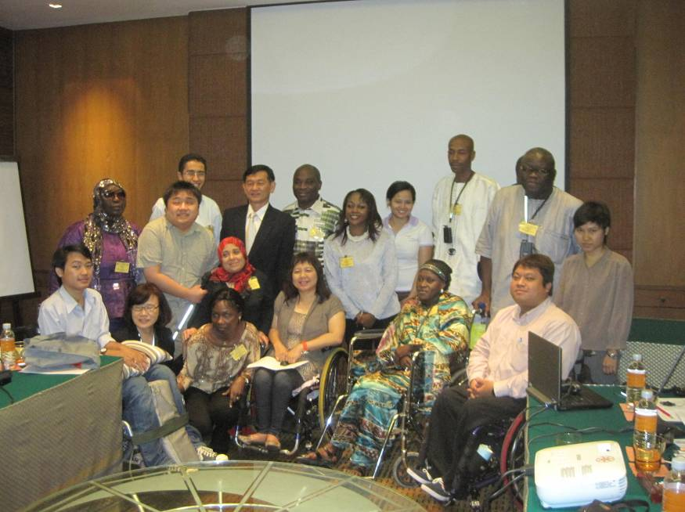

Introduction of DPI/AP by Mr.Wansao Chaiyakul

History
Disabled Peoples’ International (DPI) is a world cross-disability, self-help, human rights organizations of persons with disabilities established in 1981. We have been promoting full-participation and equalization of opportunity of persons with disabilities by delivering "A voice of our own." We hold special consultative status for the United Nations and have collaborated with many other international agencies as well. Disabled Peoples’ International Asia-Pacific Region has been playing an important role in the disability movement of Asia-Pacific Region.
The regional Development Office was moved to Metropolitan Bangkok in 1999 to further promote disability movement in the Asia-Pacific Region.

Our Logo

In 1981, when the United Nations General Assembly Declared International Year of Disabled Persons - IYDP - was launched, the member states moved rapidly and relentlessly towards developing programmes and projects for the full and equal participation of persons with disabilities. Until then and indeed during this period too, persons with disabilities all over the world had things done to them and for them. While lip-service was given to the full and equal participation of persons with disabilities, the reality was that persons with disabilities did not have a "Voice Of Our Own" - "Vox Nostra".
This imbalance had to be addressed. Fourteen motivated, committed and experienced grassroots persons with disabilities joined forces and forged a plan of action for that year. This plan was to culminate in the founding of the unique and historic movement of persons with disabilities as equals - Disabled Peoples´ International.
From the outset it was felt that there was a need to evolve slogans and symbols that would identify, signify and clarify the objectives and principles of the global movement. It needed a clarion call, it needed a totem pole. The clarion call was Vox Nostra (Voice Of Our Own) and the rallying totem was our logo, the wheel.
Our first step was to evolve a symbol which could demonstrate to the world and to persons with disabilities around the world the oneness and strength of persons with disabilities in their attributed separateness and weakness.
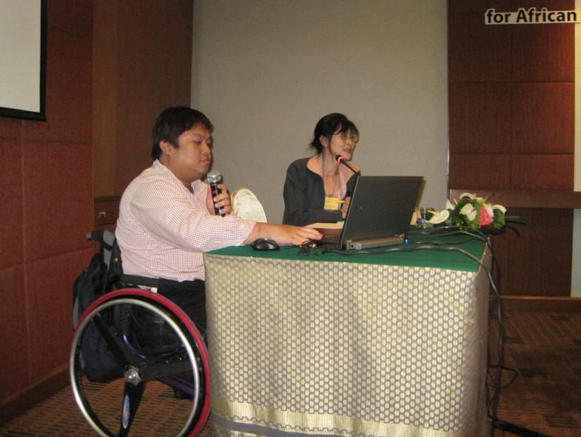

Disability Equality Training (DET) by DPI/AP

Background

What do we do?
DPI/AP provides Disability Equality related Training (DET) to the Public, Private and Voluntary sectors as well as individuals who wish to have a greater understanding of the topic.

What is DET?
Disability Equality Training has been developed by disabled people themselves over the last twenty years, in order to enable service providers to develop appropriate and accessible services for disabled people. Consequently there is a moral ownership of ‘equality training’ with the Disability Movement.
It is the only type of training to be endorsed by the United Kingdom’s Disabled People’s Council (UKDPC) - The international voice of the Disability Movement in the UK.

Why DET?
The Disability Discrimination Act 1995, for the first time, gave disabled people legal protection against discrimination both as users of services and as employees. This means that all organizations need to be confident that their staff will behave appropriately towards disabled people at all times. Unless you can justify that you have taken reasonable steps to prevent any inappropriate behavior, you will be held responsible under the law.
DPI/AP believe that the need for training is not just about complying with the law; it is about providing better customer care to all users of your services, and creating a better working environment for all staff. This way you benefit from increasing your market and you will be able to retain existing staff who acquire impairment. Ultimately you will be able to recruit and keep the best person to do the job.

Aims of DET
- To promote the Social Model of Disability
- To promote an understanding and the use of a disability equality perspective including a ‘rights not charity’ approach
- To promote a policy of inclusion
- To promote the ‘Independent Living’ agenda giving disabled people choice and control
- To develop and improve policies and procedures which may create a barrier to disabled people’s inclusion.
- To develop and share guidelines for best practice.
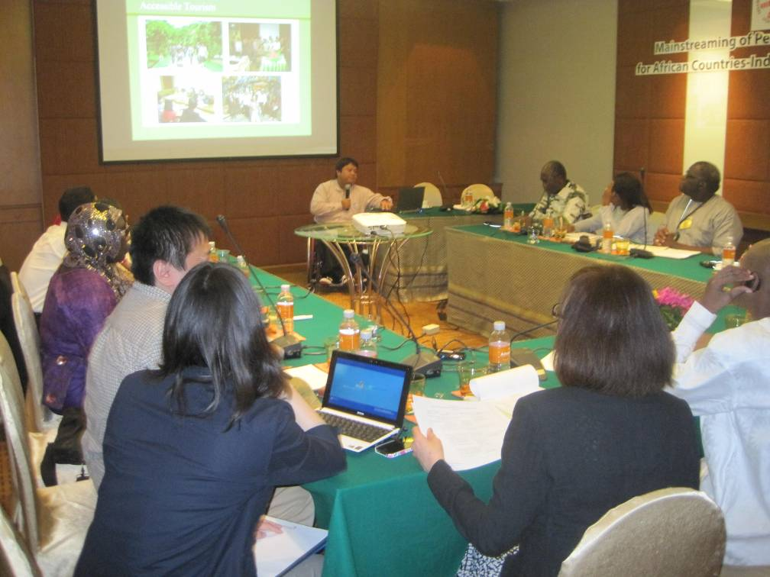

Roles of APCD to promote CRPD and MDGs by Asia-Pacific Development center on Disability (APCD)
The participants observed the accessibility features at the APCD Training building, which is designed based on the concept of Universal Design for people with difference types of disability. The accessibility features include ramps. Toilets, Braille, vibrating device for deaf person, etc. Then, the participants learned the history of APCD and its roles in promoting CRPD and MDGs through its program such as community base rehabilitation and self help organization of persons with disabilities.
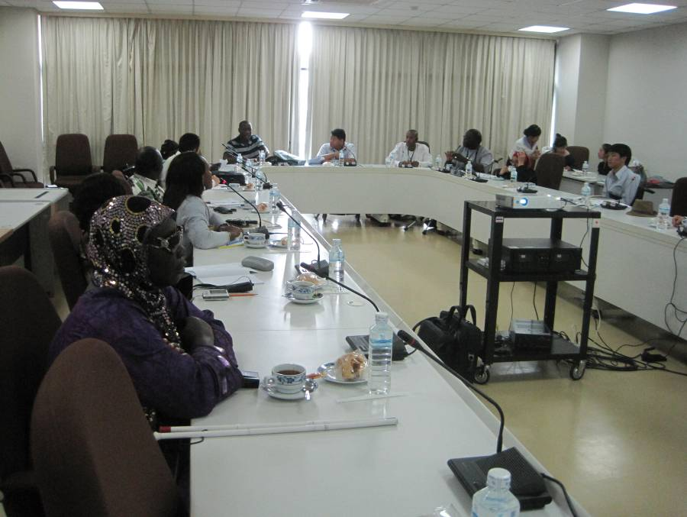
Dr. Samrerng Virachanang from the Council of Disabled People of Thailand (CPDT) gave a presentation about Disability Policy in Thailand.
First section started with background of CDPT and followed with the task of fully implementing this shift and ensuring that the values of the UN-CRPD trickle down to the grass root level and ensuring that there is knowledge among the community and among powerful members of society regarding the rights of persons with disabilities. In addition to this, social movement and proactive advocacy must be coupled with this. That is, wisdom, political and social power in all elements must be harnessed if the policies are to be developed in line with the UN-CRPD and are to have an effort on the grass roots level.

Introduction to Independent Living Phutthamonthon by Mr.Santi Rungnasuan, President of IL Phutthamonthon.
Background of Putthamonthon IL Center
- In 2002, an initiation of IL centers as pilot projects within 3 years in 3 provinces including Nonthaburi, Chonburi and Nakornpathom was set by collaboration between JICA and National Office for Empowerment of PWDs and Department of Public Welfare
- In 2003, Peer Counseling Training
- In 2004, Training of center management and personal assistant services
- In 2005, Opening IL Center Nakornpathom
- Peer Counseling Training
- Training of the trainer (TOT) for Peer Counseling
- In 2007, Opening Putthamonthon IL Center in order to expand the network as well as to increase accessibility and services of the Center for PWDs
Goal of Putthamonthon IL Center
- Empowerment of PWDs
- Driving societal movements for positive attitudes toward PWDs
Missions of Putthamonthon IL Center
- Providing services based on conceptual practices of IL for PWDs
- Initiating a network of IL for PWDs in communities
- Campaigning and raising public awareness and advocacy of PWDs
- Campaigning & social participation for appropriate environmental management for PWDs

Performances of PILC
Services
- Information and referral
- Peer counselling.
- Iindependent lliving skills training
- Advocacyy
- Peer Support Group
- Personal Assistant
Supports, Networking & Collaboration with other Organizations
- Local Administration e.g. Sub-district Administration Offices,
Municipalities
- Coordinate and contact PWDs for activity implementations in
Communities
- Coordinate for use of venue in the communities
- Coordinate for transportation to participate the Center’s activities
Every coordination is through a community development officer or involved staff before being submitted to Management.

- Networking, Groups and DPOs in communities
- Cooperation for assistance of PWDs in communities
- Coordination with PWDs in order to fully participate in the Center’s activities
- The Center is a mentor for work methods based on conceptual IL
Practices and implementations are supported by communities
Coordination is through the core PWD volunteers in the communities.

Local Governments;
Putthamonthon District Administration Office, Putthamonthon Hospital,
Bang Phra Hospital, Karnjanaphisek Medical Center and educational
Institutes
- Putthamonthon District Administration Office
Coordinate the use of venue, participation to district meetings and submission of project proposals. The coordination is through Deputy District Chief Head or courtesy visit to District Chief Head (Nai Amphur) with a letter of the request.
- Putthamonthon Hospital
Collaborate for medical check-ups for PWDs and “Disability Assessment” certification at on-site communities. The coordination is through the responsible nurse or courtesy visit to the hospital director with letter of the request.
- Bang Phra Hospital
Coordination for education of PWDs’ health care in communities. The coordination is through the responsible nurse or courtesy visit to the hospital director with a letter of request.
- Karnjanaphisek Medical Center (KMC)
Coordinate the use of venue, participation to activities of the KMC
The coordination is through the department of rehabilitation medicine or submission of a letter of the request.
- Community Health Center (CHC)
Coordinate the use of activity venue and education of PWDs’ health care in communities. The coordination is through the Head of the CHC.
- Educational Institutes (EI)
Coordinate for use of activity & training venue. Names included
- Karnjanaphisek School in Nakornpathom town – for training and
Campaign for public awareness of IL conceptual practices.
- School for Deaf (Sot Seuksa), Nakornpathom Province – request for sign
Language interpreter. Coordination is through responsible officer and a letter to
The School Director
Granted Supports and Existing Implementations
- Fund raising for initiation of the Putthamonthon IL Center
- Office equipment e.g. computer, table, air conditioner, refrigerator, fan
- Office setting e.g. restroom and door
- Granted supports from communities in form of money, materials and
Labor jobs
- Technical supports and trainings of IL concept for PWDs from
APCD
- Received subsidy for project implementation to extend
Networking of PILC by Institute of Health Promotion for PWDs.
Project duration–8 months
- Received subsidy for the Center’s management from
Nakornpathom Administration Organization. Subsidy is granted
Started from 2008 up to present.
Problems and Obstacles
- Transportation for PWDs to the PILC and its services is challenging and inconvenient.
- There is no any concrete system for remuneration for the Center’s staff.
- The Center’s office spaces are not well suited or designed for PWDs.
- There is no consistency of the subsidy from responsible governmental office.
- The Center is not able to provide and cover services for all types of PWDs.

Future Plan
- To provide services based on IL conceptual practices covering all types of PWDs
- To campaign accessible environmental setting in communities for PWDs in
Accordance with the Empowerment of Persons with Disabilities Act B.E. 2550
3) Together with networking partners, to drive and upgrade services of the Center
Integrated into government’s policy based on IL concept.
4) To campaign with networking partners for PWDs to strive toward the betterment of facilities for PWDs
5) To empower PWD Groups in communities in order to access and utilize
Community existing resources for helping each other in the communities based on
IL concept and in accordance to the Empowerment of Persons with Disabilities Act
B.E. 2550
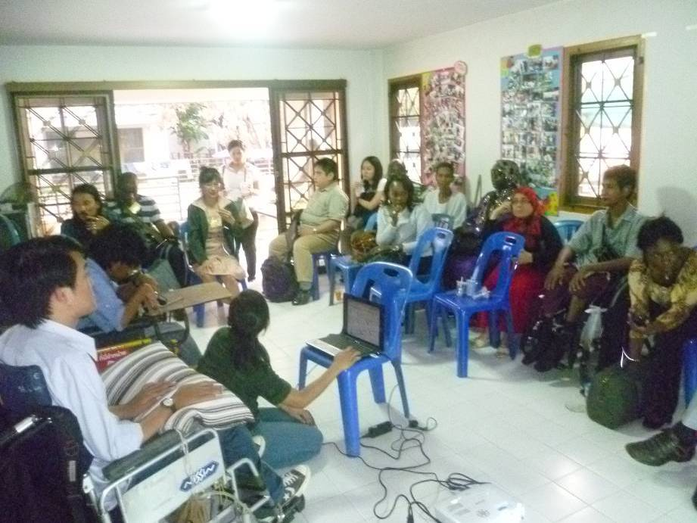

07 February 2012
Independent Living Concept and Strategy in Thailand
What is Independent Living?
If we are going to launch some campaign it is because we would like to make a change. For example, the Drink not Drive campaign occurred because a few years ago there were so many people drinking and driving at the same time which caused many accidents and fatalities
Independent living is about showing persons with disabilities how to live independently in the communities with self reliance.

Why aren’t people with disabilities living independently?
- Their own attitude
- The disability itself
- The lack of skills training
- Social judgment
- The environment
- Attitude of people without disabilities in the community
- The disabilities itself
- They need to learn how to live confidently with their own disabilities.

The attitude of people without disabilities in the community
- People without disabilities treat a person with disabilities like a patient or someone who always needs medical treatment.
- People without disabilities treat people with disabilities like children.
- People with disabilities have little or no participation in making decisions even in issues relating to their daily life.
- People without disabilities always think only how to make PWDs alive but they didn’t concerning on human basic needs.

The attitude of people with disabilities themselves
- People with disabilities themselves think that they are patients and need treatment like patients.
- Self-centered and always demanding like children.
- They accept the exclusion of the society.
- No ambition in their own life.
- No direction for the future.

Social judgment
- People in society give sympathy to PWDs but no opportunities for PWDs to participate in society
- Exclude PWDs from society
- People in society often use word about disability in the wrong way.

The Environment
- Lack of accessibility for PWDs is a major barrier.
- The accessibility that we have in our society is designed by people without disabilities and is sometimes not useful for PWDs.
- PWDs without disabilities use the accessibility in the wrong way.

How to push PWDs to live independently
- Love freedom
- Dare to do everything they want.
- Their imagination
- Not giving up and surrendering

The process of the Independent Living concept.
- PWDs sharing their own experiences to the others PWDs
- 3 step are
1. Transfer of information
2. Systematic learning
3. Establish Independent Living Centers.

The mechanism and instruments in Independent Living concept are:
- The structure of Independent Living Center
- The method in strengthening PWDs
- The Independent living concept itself

The Structure of Independent Living Center
- More than 50% of the staff must be PWDs
- Must have People with severe disabilities in the organization.
- The leader of ILC must be a PWD

The method in strengthening PWDs
- Push PWDs to make their own decisions and be responsible for the result of their own decisions.
- This method is excluding instruction or any direction giving.
- The method should be used along with the action plan.

The independent Living Activities
- Information Sharing
- Peer Counseling
- Independent living Program
- Personal Assistant Service

Information Sharing
- Group discussion
Peer Counseling
- Listen to the ambition, imagination and problems.
- Sharing of experiences
- There should be two way communication with equal opportunity for the speaker and listener to interact
- skill training
- Goal setting
- Independent living program set up by easy to difficult.
- Approximate the time
- Doing an action

Personal Assistance Service
- To assist PWDs in the thing that they can’t do themselves.
- To assist the requirement of people with disabilities.
- Lets PWDs make their own decision.

Advocacy
- To family member
- To society
- Campaign for human rights of people with disabilities.

The Effectiveness of Independent living in Thailand
- People with disabilities have more participation in society.
- People with disabilities are employed into the business sector.
- Persons with disabilities working within independent living are experts especially for persons with severe physical disabilities and how they can integrate into society
- People in society have more awareness and realization in people with disabilities lives.

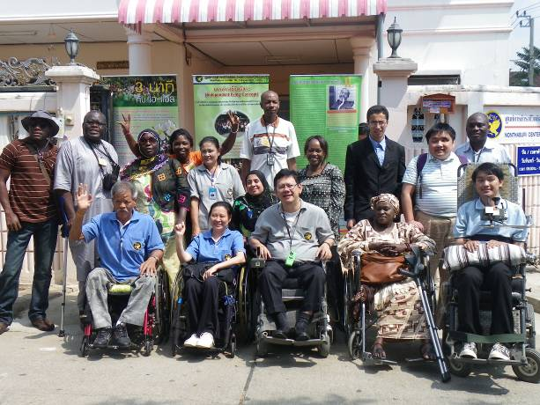
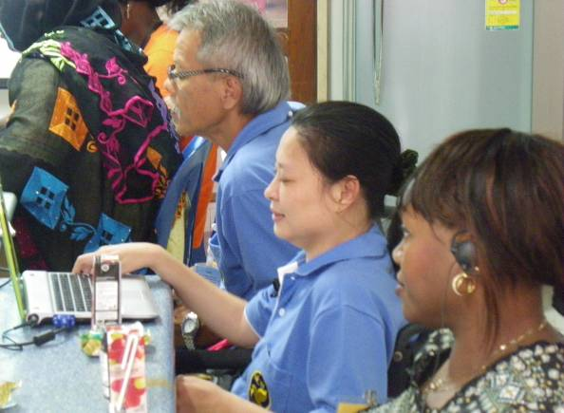

Home Visit to 2 Persons with Disabilities’ house
In the afternoon the participants had a field study to the houses of 2 persons with disabilities who have been empowered through the IL implementation by Nonthaburi Center for Independent living.
The first to be visited was Ms. Wanwilai Sudsri a 42 year old woman with disability. The type of disability she had was muscle weakness which can cause congenital defects in female members of a family. Ms. Sudsri has been living with this disability from the age of 7. She is an example of a person with disability from the Center for Independent Living of Persons with Disabilities who has been empowered by the independent living concept. She works at home with her family to made gold sheets for sticks in the Buddha image in Nonthaburi Province.
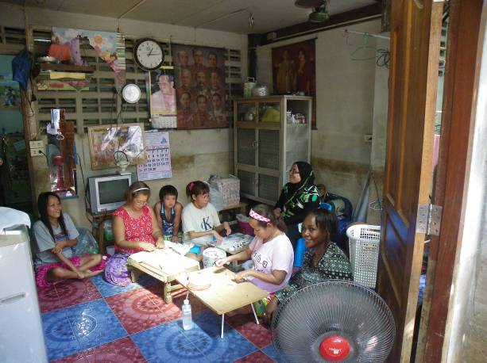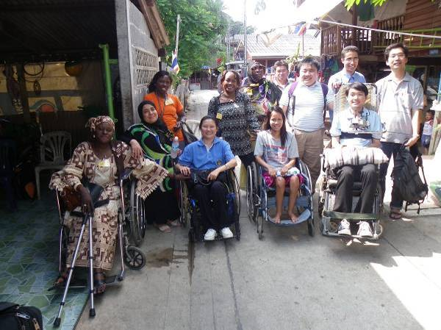
Mr. Narin Chantim is a 50 years old man with paraplegia which resulted from an accident involving a bullet 15 years ago,
Now he is a working draft of the Center for Independent Living of Persons with Disabilities in some districts in Nonthaburi province. He is the current Chairman of the Drafting committee of disabled people. Mr Chantim also helps in establishing a community for making local products such as herbal soaps, dish washing liquid for sale.

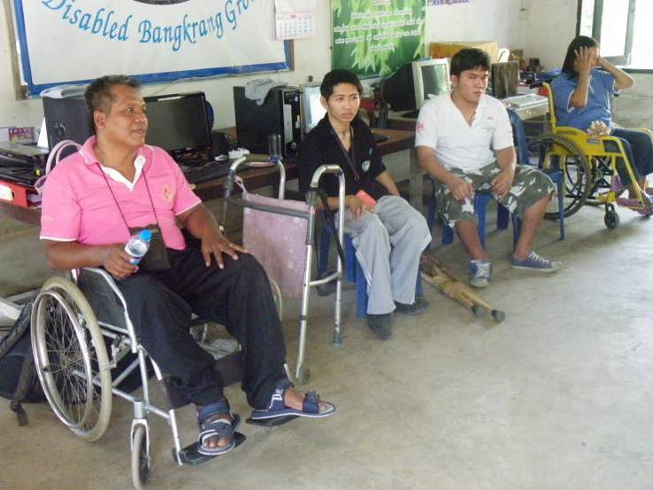
From the home visit, the participants see that IL is effective in empowering persons with disabilities in communities and can be applied in African countries as well.
08 February 2012
Presentation by Ms. Aiko Akiyama, Social Affairs Officer (UNESCAP) and Mr. Sung-Jun Ha, Consultant UNESCAP. Start with background (UNESCAP).
The Convention on the Rights of Persons with Disabilities produces a more participatory and inclusive society in which all can contribute to process of poverty reduction and the achievement of the development Goals.
The MDGs are targets which seek to address many dimensions of poverty. However, human rights have not yet played a significant role in supporting and influencing government’s MDG policies. Furthermore the MDGs, their targets and indicators, make no mention of person with disabilities. This is despite the fact that persons with disabilities are significantly over represented amongst the world's "poorest of the poor" the WHO estimate that, of the 650 million persons with disabilities around the world, 80% live in developing world.
The convention on the rights of persons with disabilities places emphasis on participation and inclusion in mainstream society. If governments fulfill their obligations in the Convention, the human right of person with disabilities will be protected and fulfilled, which will return and contribute to reducing poverty. The mechanisms that exist to help ensure governments fulfill their legally obligations include the treaty body and the report procedure. However, there mechanisms are only effective thought the involvement of civil society.
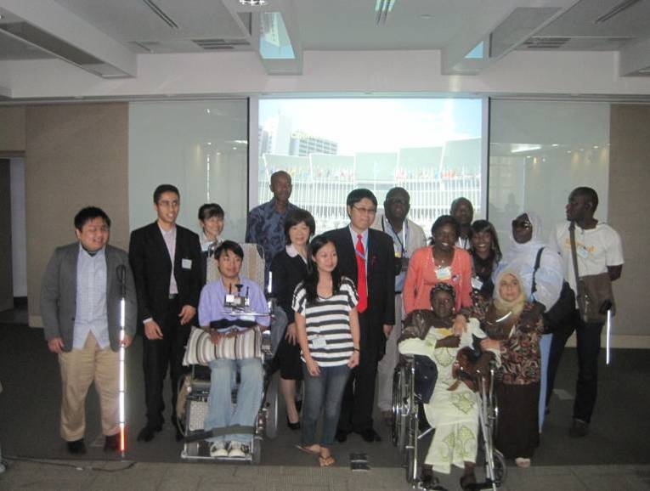

09 February 2012
Asia Pacific decade of persons with Disabilities and sub regional approach By Ms. Saowalak Thongkuay.
There are many barriers in society: physical, attitudinal, cultural and social systems. The agenda for action is clear and promotes the right of person with disabilities in line with the motto " A Voice of Our Own" The agenda for action includes national coordination, regional cooperation, disabilities specific legislation to prevent discrimination and equal opportunities: information: public awareness: accessibility and communication: education, training and employment; and understand of prevention and causes of disabilities: : promotion of assistive devices: and involvement of self help organizations.
1993-2002 hosted the first Asia decade for Disabled Persons.
2003-2012 hosted the second decade for person with disabilities.
The aim of the second decade was to promote an inclusive, barrier free rights based society for person with disability. Signing and ratification of the UN-CRPD was an aim aspect of life.

Independent Living from individual empowerment to community development by Mr.Teerayudth Sukonthavit, President of IL Nonthaburi
Thailand developed issues of independent living (IL) based on the success and failures of Japan and the US which first introduced independent living into their society in 1960s and 1970s. As there case studies Thailand was able to develop its independent living foundation, with cultural factors taken on to consideration which has made independent living in Thailand unique.
In 2002, the first IL centre was established in Thailand and this has formed a solid foundation for the expansion of the IL network in Thailand.
Set up of IL in Thailand was develop the network and collaboration between JICA< the Royal Thai government, Human care and Thai DPOS and NGO networks.
Approximately 1,000 persons with disabilities currently gain advantage from IL in Thailand and 70% of person with disabilities experience positive change in their lives as a direct result of IL give the benefits of qualities of life development. Given this success, the future goals of IL in Thailand is to develop the network of Il Centres are expand such that a greater numbers of persons with disabilities in Thailand are able to benefit from IL.
In addition to IL having the direct advantage to person with disability in their everyday lives, the awareness of IL among the community has led to positive change in attitudes among persons without disabilities in society. Promoting the IL concept to the wider community is the aim of IL centres with direct positive benefit to the disabilities community.
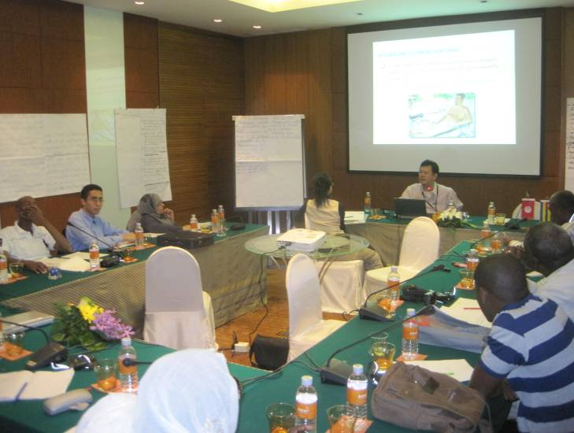

Group discussion: Let’s do it for implementation of Independent Living in Africa.
There are no IL centres in the African countries yet at the moment so it is necessary that knowledge gained from Thailand and Japan on IL (best practices) should be introduced to the national federation of persons with disabilities and stakeholders such as government, local NGOs, communities, persons with disabilities and their families in African countries. Then, starting up a working group to promote IL should follow. Also, there needs to be a plan to register more persons with disabilities in the country. After that, we should encourage persons with disabilities to form a group for their advocacy on accessibility, education, employment, etc.

10 February 2012
Adoption of Bangkok Recommendations by Participants from Senegal Ms. Wade Coumba, (Division Chef / Social and medical Action Division, Ministry of Social Action and National solidarity)

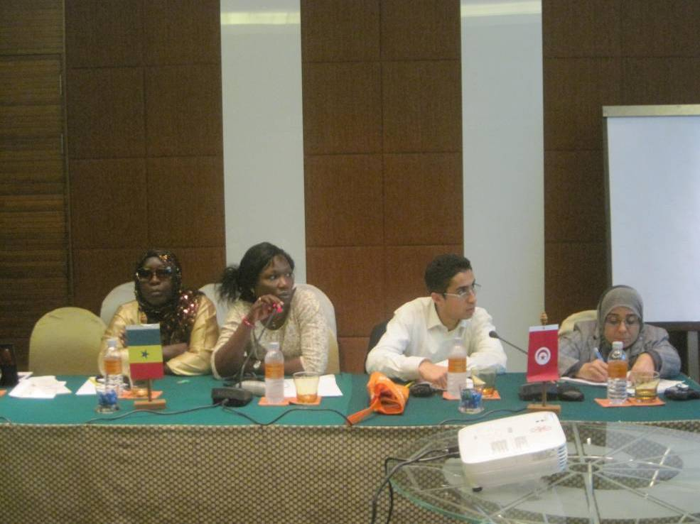

Certificate Ceremony for participants from Africa by Mr. Akihisa Tanaka, Senior JICA Representative and Ms. Saowalak Thongkuay, Regional Development Officer (DPI/AP)
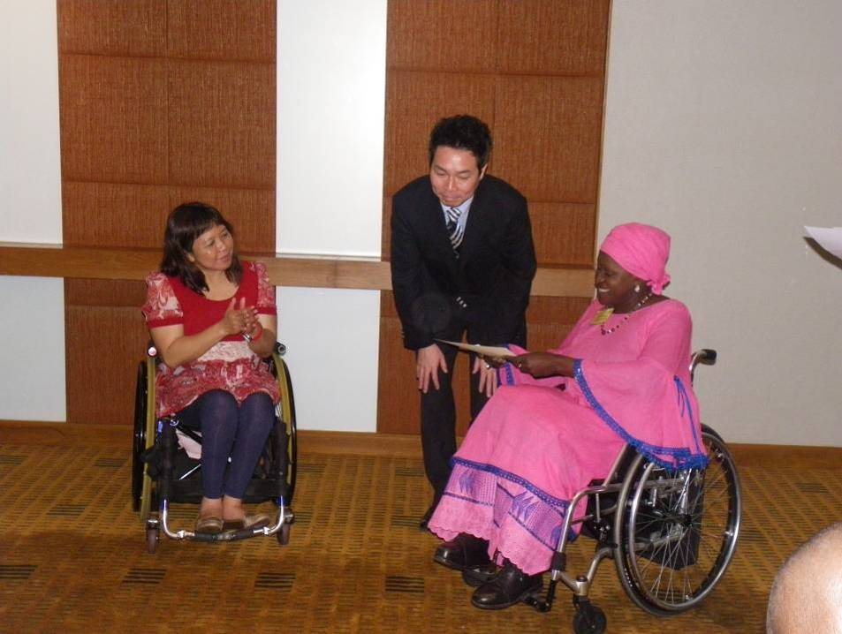
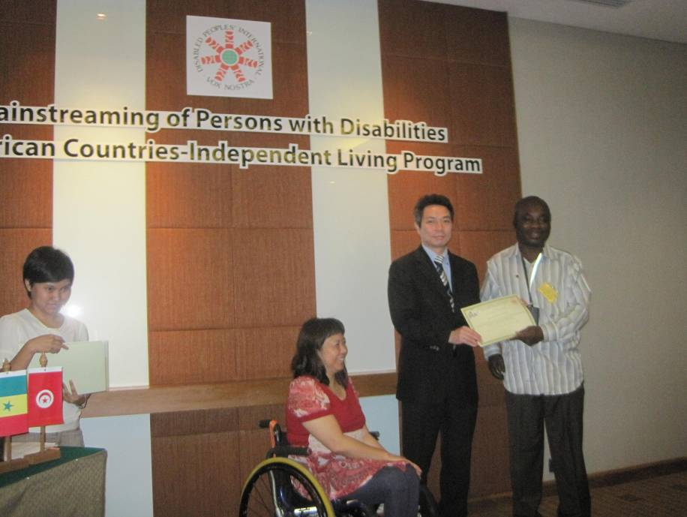

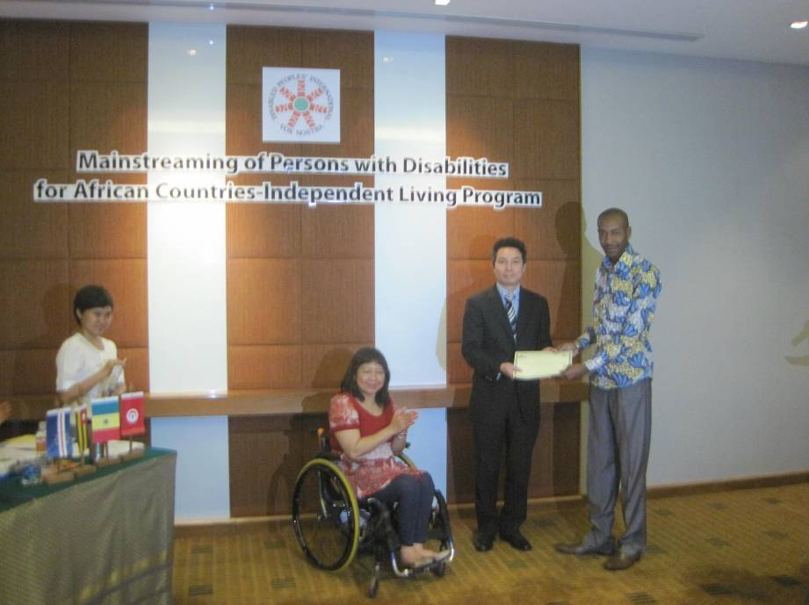
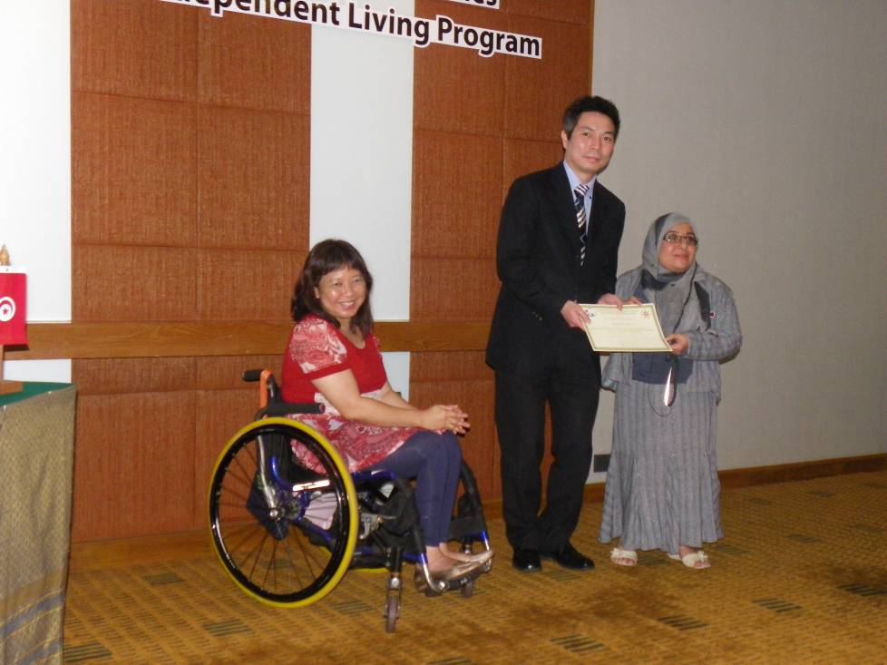
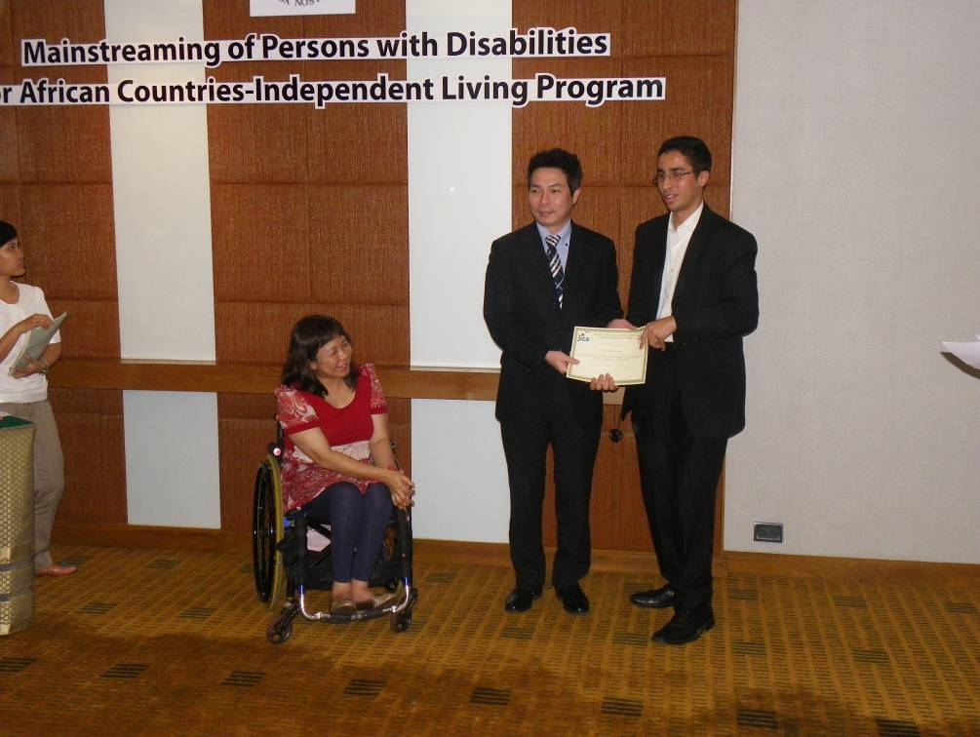
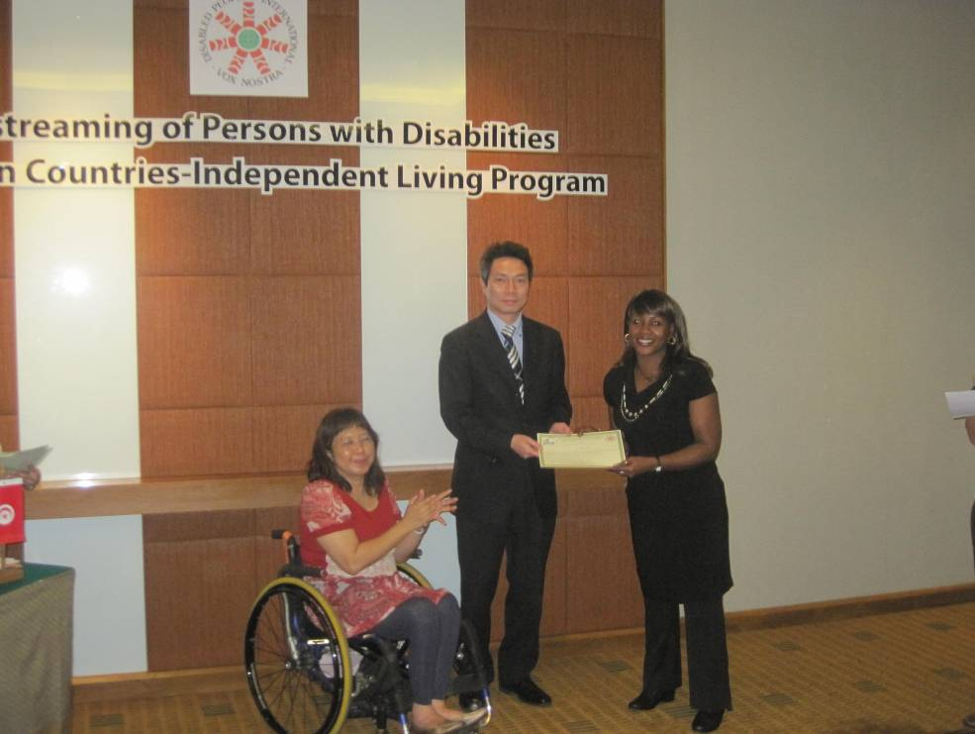
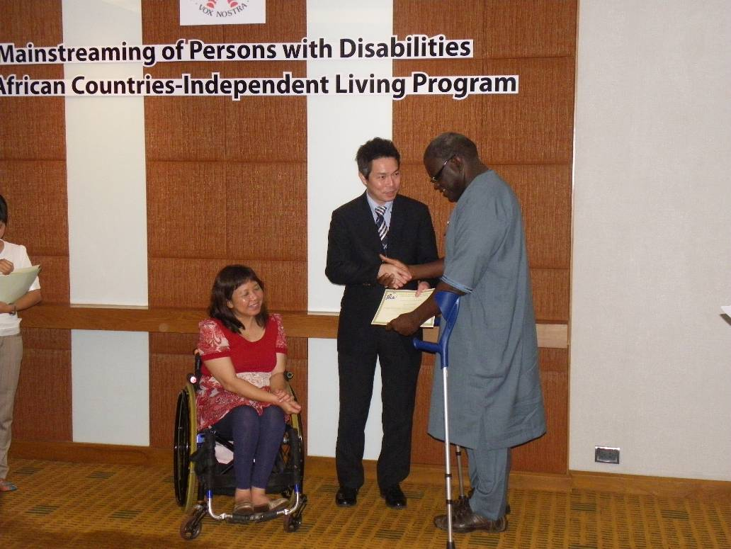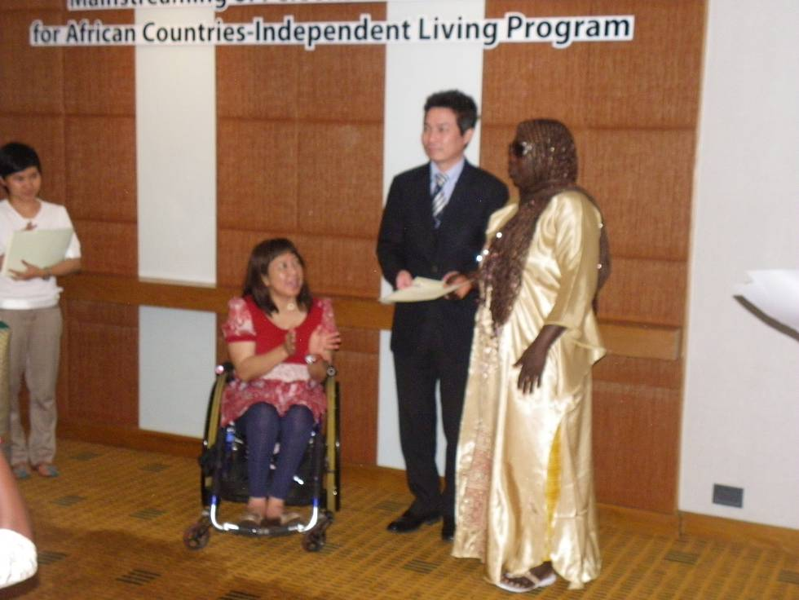

Closing ceremony By Mr. Akihisa Tanaka, Senior JICA Representative and Ms. Saowalak Thongkuay, Regional Development Officer (DPI/AP)
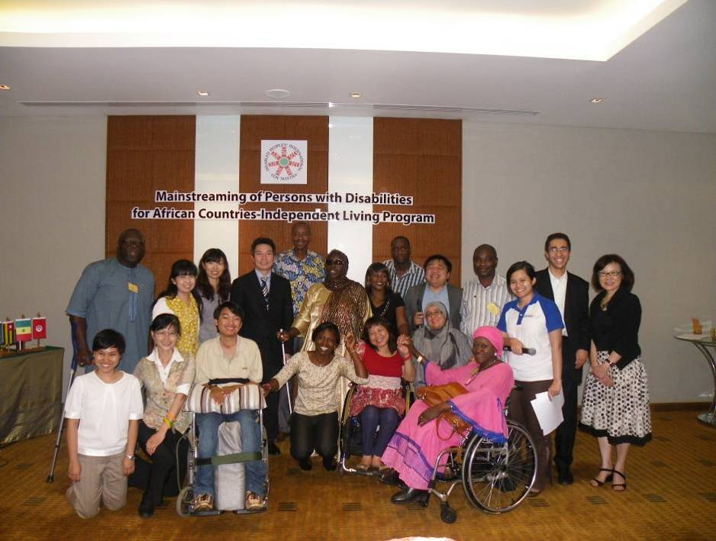

DECLARATION DE BANGKOK

Intégration des Personnes Handicapées dans les Pays francophones d’Afrique –
Programme de Vie Autonome
Hôtel Amari Watergate, Bangkok, Thaïlande

Nous, participants au Programme de Formation sur l’Intégration des Personnes Handicapées – Programme de Vie Autonome, représentant les organisations de personnes handicapées (OPH), les Gouvernements du Cap-Vert, du Sénégal, du Togo et de la Tunisie et le Secrétariat de la Décennie Africaine des personnes handicapées (SDAPH); dans le cadre de cette formation organisée au Japon et en Thaïlande du 15 janvier au 11 février 2012, par l’Agence Japonaise de Coopération Internationale (JICA), en partenariat avec l’Organisation Mondiale des Personnes Handicapées du Japon (OMPH-Japon), l’Organisation Human Care et le Bureau Régional de l’Organisation Mondiale des Personnes Handicapées pour l’Asie Pacifique (OMPH-AP),

Saluons et apprécions le rôle que joue la JICA pour l’amélioration de la qualité de vie des personnes handicapées au Japon et dans les pays en développement,

CONSIDERANT que la pauvreté est disproportionnellement élevée parmi les groupes souffrant d’exclusion sociale, culturelle et économique, notamment les personnes handicapées, qui sont de ce fait constamment négligées dans les initiatives et programmes nationaux et internationaux de développement en Afrique,

CONSIDERANT l’importance de la prise en compte des questions liées au handicap dans le cadre des stratégies adaptées en vue d’un développement durable,

RECONNAISSANT que les textes nationaux, régionaux, continentaux et internationaux sur les droits de l’homme, notamment la Déclaration Universelle des droits de l’homme et les traités internationaux relatifs aux droits de l’homme, proclament et affirment que chaque individu peut prétendre à l'ensemble des droits et libertés qui y sont énoncés, sans distinction d’aucune sorte,

RECONNAISSANT les principes et objectifs de la Convention des Nations Unies sur les Droits des Personnes Handicapées adoptée en 2006 et entrée en vigueur en 2008,

ADMETTANT que, malgré les progrès réalisés, il reste encore de nombreux défis à relever par rapport à l’intégration des personnes handicapées dans les politiques, législations et programmes de développement nationaux, concernant la prise en compte de leurs droits,

Déclarons ce qui suit :

1. Intégration du Handicap dans les Politiques de Développement
Les gouvernements devront prendre en compte les préoccupations des personnes handicapées dans les politiques et programmes de développement, notamment l’accessibilité, la réduction de la pauvreté et le renforcement des capacités des acteurs du secteur,

2. Vulgarisation du Concept Vie Autonome (VA)
Les Organisations de Personnes Handicapées et les services étatiques devront tout mettre en œuvre pour promouvoir le concept de la Vie Autonome dans nos différents pays.

3. Participation à la prise de décision
Les personnes handicapées devront être consultées et représentées dans les processus de prise de décision afin d’assurer la pleine participation et l’égalisation des chances de cette catégorie sociale vulnérable.

4. Décennie Africaine des Personnes Handicapées
Les Organisations de Personnes Handicapées et les autres de la Société Civile en partenariat avec l’Union Africaine (UA) devront s’approprier la seconde Décennie Africaine des Personnes Handicapées (2010-2019). Elles devront participer pleinement à la planification, la mise en œuvre et l’évaluation des activités de la Décennie. Nous lançons un appel à la Commission Economique pour l’Afrique (CEA) et à tous les partenaires techniques et financiers pour appuyer les activités de cette décennie afin qu’elle apporte des changements réels dans la vie des personnes handicapées.

5. La Convention des Nations Unies relative aux Droits des Personnes Handicapées

Nous lançons un appel à nos gouvernements afin qu’ils ratifient la Convention et harmonisent la législation nationale à celle-ci. Les gouvernements, en partenariat avec les organisations de personnes handicapées, devront œuvrer ensemble à la mise en œuvre effective des dispositions de ladite Convention et de son Protocole facultatif.

6. Recommandations à l’endroit de la JICA

Conscient du rôle de la JICA dans le cadre de la Coopération Internationale avec les pays du Sud, nous recommandons à cette institution de prioriser la thématique du handicap dans son partenariat avec les gouvernements africains pour rendre effective la Vie Autonome.

Nous lui demandons, dans le cadre de ses programmes de formation et de dialogue, Aide Publique au Développement (APD), d’encourager la candidature de stagiaires handicapés.

Nous, participants au Programme de Formation sur l’Intégration des Personnes Handicapées pour les pays francophones d’Afrique– Programme de Vie Autonome, apprécions la généreuse contribution des gouvernements Japonais et Thaïlandais ainsi que le soutien technique de l’Organisation Mondiale des Personnes Handicapées du Japon (OMPH-Japon), Human Care et le Bureau Régional de l’Organisation Mondiale des Personnes Handicapées pour l’Asie Pacifique (OMPH-AP), d’avoir facilité cette formation et le travail de coordination.

Fait à Bangkok, le vendredi 10 février 2012.

11 February 2012
Accessibility check, BTS and MRT
As discussed with the participants from Africa, they said that Thailand is not an easy place to visit for people with reduced mobility or other disabilities. And in rural areas public transport is limited and often inaccessible to wheelchair users.
Moving around the city can be extremely difficult for people with disabilities. The streets and pavements are uneven and few buildings provide ramps and hand rails to aid disabled access. Guide dogs are rare and there are no audio signals for the blind on traffic crossings.
Public transport is not usually equipped to facilitate disabled access. Public buses are inaccessible to wheelchair users. Disabled people are usually forced to travel through the cities by taxi. However, few taxi drivers are experienced or trained in helping a wheelchair-user in and out of their cars.
Sky Train (BTS) stations in Bangkok are on two levels, with ticketing on the lower level and the trains on the upper, making access difficult for wheelchair users. 11 stations provide disabled access although plans are in hand for elevators to be built at other stations.
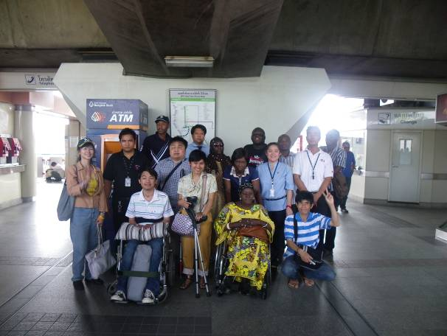
Example at present, the wheelchair-accessible sky train stations are: Chong Nonsi, KrungThon Buri, Wongwan Yai, Asoke, On Nut, Mo Chit and Siam.
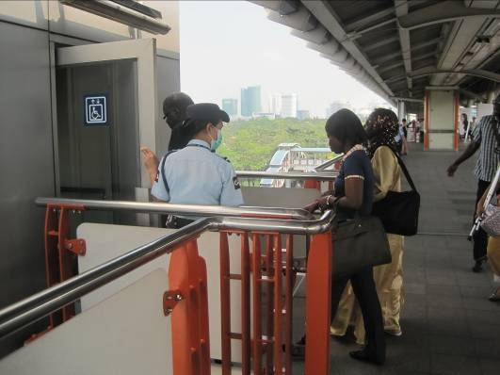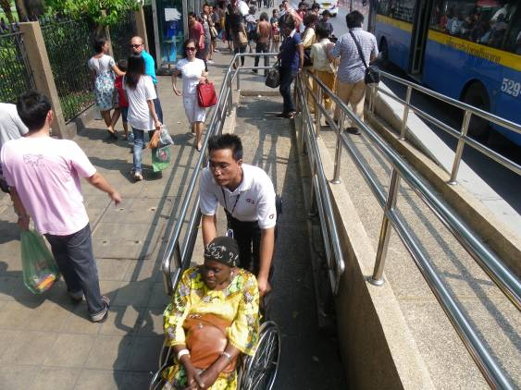

The national rail network has no special facilities for disabled passengers but assistance will be given to those who ask.

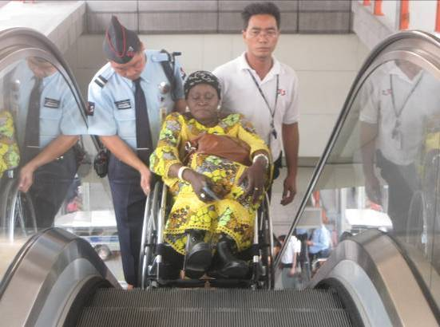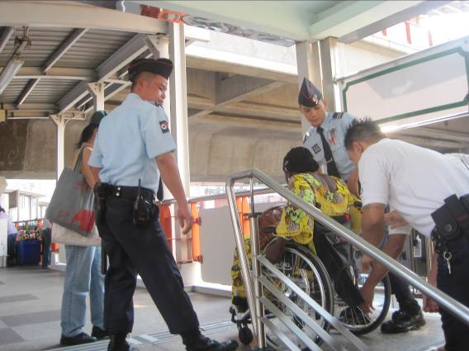
The Bangkok underground (Metro) has better disabled access and all of the stations have elevators. Assistance will be given to disabled passengers if requested. On the trains there are locks for wheelchairs.
