

Report

Removing Barriers, Promoting Integration:

Towards Implementing the CRPD,

And Post-2015 Disability-

Inclusive Development Goals

06 - 08 June 2012

Grand Auditorium - CASPD, Beijing, China

Purpose:

- Share insights and experiences among participants.
- Discuss further implementation of the UNCRPD and explore new approaches and practises for mainstream disabilities into social development in order to achieve inclusive developmental processes for disabilities person.

Organizer: China Disabled Persons’ Federation

Contact Persons: Disabled Peoples’ International, Asia Pacific (DPI/AP)
Kanokporn Nakchatree (Ms.)
Project Coordinator on ASEAN, (DPI/AP)
Telephone: 66 (0)2 271-2123
Fax: 66 (0)2 271-2123
Email: Kanokporn@dpiap.org

Address Disabled Peoples’ International – Asia Pacific
92 Phaholyothin 5 Road, Samsennai,
Phayathai Bangkok 10400 Thailand
Tel: 66 (0)2 271-2123
Fax: 66 (0)2 271-2124

Duration: 06 - 08 June 2012

Summary

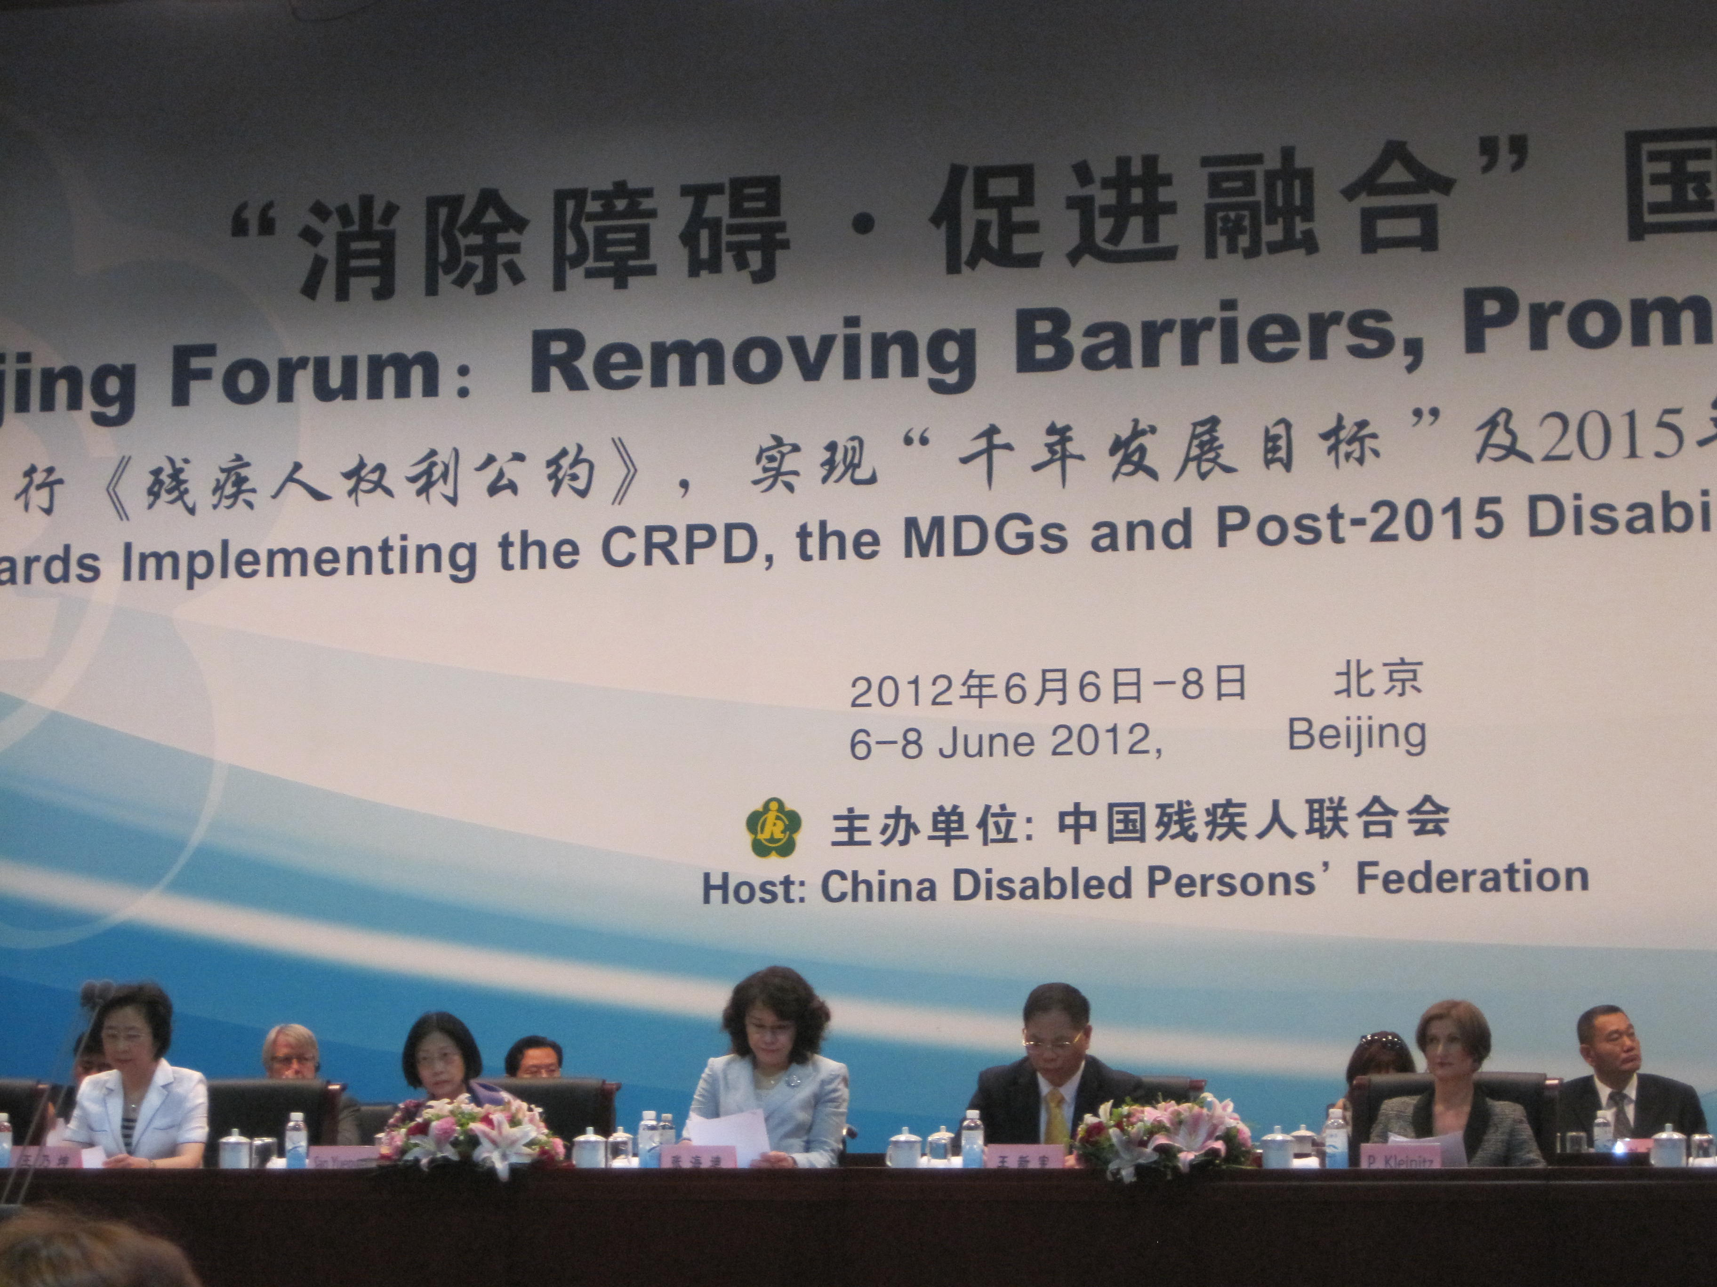

With the deadline for the achievement of the United Nations “Millennium Development Goals” in 2015 is drawing near, the subsistence and the development of persons with disabilities have become greater concern for many countries around the world. Beijing’s Forum on “Removing Barriers, Promoting Integration” and “Convention on the Rights of Persons with Disabilities (CRPD)” has become general consensuses and actions for the international community. It is expected that this forum will help generate consciousness for every persons within our societies to pay more attention to disabilities persons around the world

Beijing Declaration, as an outcome document of the forum, will strive to move forward constructive proposals, for the international community, to further realize the right of persons with disabilities and the disability issues into post 2015 development strategy.

06 June 2012

Opening Ceremony 10:00-11:00 AM.

Venue: Grand Auditorium

Chairman: Mr. Wang Xinxian, Vice Chairman and president of China Disabled Persons’ Federation (CDPF)

With 85 million disabled people, China has a largest number of persons with disabilities in the world. The Constitution of the People's Republic of China stipulates that "The State respects and safeguards human rights" The Chinese government has always held disabled people as an equal member of the big social family and considered the causes for disabled people as an integral part of the grand socialist cause with Chinese characteristics. It is the rightful responsibility for the government and the due obligation of the society to protect the rights of disabled people and create conditions in order for them to equally participation in social life.

This Forum is a grand international event on disability, and plays a significant role in order to create social’s concern for disabled people and promoting the balanced between social and economic development in countries around the world, in sprite of the global financial crisis and economic recession. The outcome for this forum is Beijing Declaration that embodies our consensus and sheds light on the future.
Speakers: Mr. Christopher Bahuet, Country Director, UNDP China, delivering message from Ban Ki-Moon, secretary General of the United Nations.

There are more than one billion people, around the world, that endured some forms of disability. This number continues to grow, substantially, as a result of population ageing and an increase of the chronic health conditions. Persons with disabilities generally have poorer health, lower education, less economic participation and higher rates of poverty. They face major impediments to their full participation in society.

Our challenge now is to translate commitments into policy and concrete action. The rights and needs of persons with disabilities must be include in all our endeavours, including disaster reduction strategies, the outcome of the forth coming UN conference on sustainable development and global efforts to articulate post 2015 UN development strategy.

Speakers: Ms. Nanda Krairiksh, Director of Social Development Division, United Nations.

The United Nations works together with stakeholders, Member States and civil society, to advance social development and the empowerment of persons with disabilities who often got left out from the society. Our efforts are to build an inclusive Society and to ensure that rights and equal opportunity are enjoyed by everyone within the society including persons with disabilities.

The achievement of a truly inclusive society requires a people-centric approach. This means that, rather than the passive provision of service and opportunity to groups or segments of society in need, the focus must be on empowerment. Persons with disabilities must be included and empowered that allow them to have opportunities to express their inspirations and visions in order to make their voices prevail in any discussions and take actions that will effect their lives.

Speakers: Ms. Diane Richler, Chair of International Disability Alliance

Our mission is to propose the right for people with disabilities. This forum will be effective by become a biggest network for people with disabilities around the world. We will try to empower CRPD for effective result. UN will be creating the new fame work for people with disabilities by cooperate with all stakeholders. We believe that our hard work will become the light for persons with disabilities around the world.
Speakers: Ms. Zhang Haidi, Chairpersonof CDPF

In 1970, we had tried to created network among us. In 1980, we drafted outline for person with disabilities. In 1990, we raised equal issue for persons with disabilities. And in 2000, the Right for Persons distribution convention was introduced to stakeholders

Ten years ago, we worked together to drafted the idea for The Convention on the Right for Persons with Disabilities (CRPD). We raise CRPD together for the millennium development goals. And before high level meeting related with us, the societies bring persons with disabilities to development goal. Persons with disabilities have their own life so we should empowerment CRPD to build sustainable and fair.

Speakers: Mr. Deng Pufang, Vice Chairman of Chinese People’s Political Consultative Conference, Vice Chairman of the State Council, Working Committee on Disability, Honorary Chairman CDPF

China is a homeland for a largest number of disabled populations in the world. The Constitution of the People's Republic of China stipulates that "The State respects and safeguards human rights" The Chinese government has always held every disabled person as an equal members of the society and also considered the cause for disabled people as an integral part of the grand socialist cause with Chinese characteristics.

In addition, the most important purpose for the Chinese government is the construction of the social security system and the disabled service system. At the same time, the government has also tried to consistently improve the disabled social security policy and the basic standard of living for disabled persons, in which they have achieved significant results.
Opening Ceremony 11:26-13:00

Venue: Grand Auditorium

Speakers: Mr. Javed Abidi, Chairperson, Disabled People’s International

People with disabilities, who have considered being about 15% of the world’s population, do not have the same living standards as the other “normal” persons. Therefore, in order to raise the living standards for people with disabilities, we should pay more attention on the topic of “Nothing about us without us” and reach out to disabilities persons at all levels within our society.

Peoples with disabilities will be the main focal point for our 2015 framework for development. We cannot make the same mistake again since it will impact the lives of persons with disabilities around the world.

Speakers: Ms. Ruth Warick, President, International Federation of Hard of Hearing People

"Hard of Hearing" is used to define all groups of people with some levels of hearing difficulties, including those with mind to profound hearing losses to those late deaf. About 278 million people have moderate to pro found hearing loss. The number of people world wide with all levels of hearing impairment is rising mainly due to a growing global population and longer life expectancies.

Speakers: Mr. Klaus Lachwitz, President Inclusion International

Inclusion International is an international federation of about 200 members in 11 countries around the world. Its role is to support every member in their struggles to support the full inclusion of persons with intellectual and families, create changes, and build inclusive communities.

The CRPD was directly informed by the voice of persons with intellectual disabilities and their families. While changes come by very slowly but we can be sure that it will happen eventually. Collaboration on CRPD implementation can help ensure progressive and innovative changes and identify innovative ways for moving forward to make the CRPD real and meaningful.

Speakers: Mr. Jan A. Monsbakken, President Elect, Rehabilitation International

Rehabilitation International (RI) is a long standing worldwide network of people, service providers, academics, professionals, and government agencies working to improve the quality of the life for persons with disabilities and people in need of rehabilitation.

RI and UN convention on the rights of persons with disabilities. In 1999, on the basis of a unanimous call from RI governing assembly, RI revealed an effort to establish UN’s convention on the right of persons with disabilities.
In 2000 and 2001 RI officers presented its charter for the third Millennium, calling for UN’s convention on the rights of people with disabilities, to nearly 100 nations and international leaders worldwide.
From 2001 to 2006, RI took an active and important role in the five year negotiations and drafting of the UN CRPD.

Speakers: Ms. Maryanne Diamond, World Blind Union

The WBC is an international non-profit organization, representation for about 285 million people, who are blind or have low vision, worldwide. The WBC has mission to achieve the goal, through our members and the organizations of blind and partially sighted person, to providing services to blind and partially sighted person in more than 190 countries and through 6 Regional Unions. The long term vision of the WBC is to create a community where people who are blind or partially sighted are empowered to participate on an equal basis in any aspect of life that they choose

Following the adoption on the CRPD by the UN in December 2006 every organization have been working hard to support our members to have their government sign, ratify, monitor and implement the convention.

Speakers: Dr. Joachim Greyer, Director General, German Social Accident Insurance

Approximately one billion people worldwide have suffered some form of disability. We will ensure that every single one of these people will be able to participate in the life within their community as equal members. Therefore, we will focus on their ability to obtain educations and to work within the society, which has become one of the major challenges for us in the 21 century.

Building rehabilitation facilities, in order to increase effectiveness and efficiency for the disabled persons, does not only contribute to fulfilling the rights of persons with disabilities but also promotes job retention, consequently economic prosperity, and social stability under the conditions of shrinking labour supplies. Therefore, rehabilitation is an important aspect, not only from the point of view of legal obligations and individual rights but also from the perspective of social peace, for social sustainability and economic growth.

Speakers: Wang Xinxian, Vice Chirman and President of CDPF

Since Chinese reform and opening up, Due to the high speed development of market economy, industrialization, urbanization, has brought many new problems to the cause of the Disable Person. Social requirement of the quality of the labor force and an improvement of the overall quality of persons with disabilities lower contradictions become increased ceaselessly. Some areas appeared to rescue lives instead of the negative employment practices, but also because the security system deviation caused many of the conditions of employment for the employment of Disable Person will reduce the phenomenon.

So, in the two system construction, must be made clear further from the fundamental interests of Disable Person. To increase the employment of Disable Person wishes, employability and living skills for the basic orientation to help the majority of people with disabilities to become a constructive force in social and family
Centred on the overall theme of "Removing Barriers, Promoting Integration",
Forum discussion will be pursued through group work. Each group will cover one of the topics listed below in relation to persons with disabilities.

Sub Forum 1:
Better Social Security System for Protection of basic Livelihood.

Sub Forum 2:
Better Access to the Physical Environment for Equitable Social Participation.

Sub Forum 3:
Better Community-Based Rehabilitation for Disability-Inclusive Development.

Sub Forum 4:
Education Empowerment for Poverty Reduction.
Time 14:30-18:00

We are attending Sub Forum 3: Better Community-Based Rehabilitation for Disability-Inclusive Development.

Topic of presentation

Development of Independent Living Movement in Asia.

By Mrs. Yukiko Nakanish from Asia Disability Institute.

UN Economic and Social Commission for Asia and the Pacific proposed 10 goals for a new Asia-Pacific decade of disabled persons from 2013 to 2022, focusing on the promotion of the rights of persons with disabilities. The forth goal, "Strengthen social protection", is to establish programmes that support independent living in the communities for persons with intellectual disabilities, which includes persons with psychosocial disabilities, persons with multiple disabilities, and persons with extensive disabilities."

IL centres, through service, begin to obtain governmental support and funding. Nowadays, IL centres are regards as not only social movement organization, but also as service organization that provide service indispensable for IL. The organization is the integrated from the combination of the social movement organization and the social service provider, which employ persons with and without disabilities as management staffs and personal assistants.

PWDs are the best experts, since they know the need of PWDs. In fact, services of IL centres are provided for 24 hours a day, and there is no limitation on targeted persons or contents of the personal assistant services. IL centres provide services that will be able to benefit from it.

The Convention on the Rights of Persons with Disabilities has emphasised on the idea that this convention will recognize the equal right of all persons with disabilities to live in the communities', with same living standard as the others. This policy shall, take effective and appropriate route in order to facilitate full enjoyment by persons with disabilities of this right and their full inclusion and participation in the community. The new Asia pacific decade of disabled persons is going to be a big responsive to the needs of disabled persons at all level; at the same time, it is going to be an important issue to help develop IL as rights of PWDs, especially of marginalized PWDs.
State Institutions and Social Insurance Systems:
A holistic welfare system caring for people with disabilities.

By Mrs. Dominique Dressler from AUVA

In 1980, through the ICDH and in 2011 through the ICF, the World Health Organization (WHO) provided a framework that enables countries from around the globe to establish a legal issue to protect the status of persons with disabilities in society.

The "claim for equal dignity for all human being', which originates from the enlightenment philosophy of the 18th century in Europe, calls on all countries’ law making institutions to set up a legal framework that as far as possible does justice to this claim.

The Austrian Welfare State. The role of the state is to precisely define and continuously review and update all existing laws to redistribute part of the tax earned from the subsidiary regions to support persons with disabilities who need special care. In addition, it has also focus on the process of laying down the principle on how to determine the extension of a disability.

Nevertheless, this small country with a still very high income per capital succeeds to ensure that persons with disabilities are able to live indignity, security and have a reasonable income. Of course, there is room for improvements, because the society that mentions the word” disability” has also to bear the consequences.
Policy Recommendations on Improving the Utilization of Comprehensive Service Facilities for Persons with Disabilities.

By Yang Lixiong China Disability Institute, Renmin University, China.

China has become stronger, from the past decades, in both political aspects and economical aspects and the Chinese government has paid more attention to the Public Welfare of the disabled. As the result, the service facilities of disable have made great progress in recent years. But their are two "deviations” in the process of Comprehensive service Facilities construction for the Disabled. On one hand, some areas pursued the luxury appearance and perfect function in the construction while ignoring the utility and effectiveness; on another hand, some Federation Organizations built the Comprehensive Service Centre from the perspective of perfecting the work condition, which further confused management with implementation in the system, reducing the quality of the services.

To improve the utilization of Comprehensive Service Facilities for the Disables, it is necessary to correct the deviation in two aspects. First, there should be an organization structure transformation for the service existing Comprehensive Service Centre in term of the “Small but Professional" mode, pushing service into the communities with service station there. At the same time, the organization should also improve the utilization of services by doing a reasonable of labour in different stations based on their level, which is municipal, district or communities. Second, establish a service system which is a separation between management and implementation and provide service guided by the need of the disabled, aiming at an enhancement in the quality.

Social Welfare System for Disabled Person in Korea.

By Byung Cheol Kim, School of Labour and Human Resource, Renmin University of China

Social welfare system in Korea has not been developed along with the original intention, but has been a mean of political legitimacy after military coup of the ruling military. Therefore, social welfare system in Korea should be introduced mainly for the demands of the times. This is not only to ensure proper livelihood in risk of all nations and still could not fully to protect people in needs in providing appropriate allocation. In 1999, the historical development of social welfare for the disabled are divided into four stages, including the early expansion period, the gradual development period and the great leap forward period. In 2009, disabled people in Korea reached 2.42 million people accounting for about 20% of the entire population in welfare institutions.

In 1999. "Social Welfare Law for the Disabled” was fully revised, realizing for the disabled. Consequently, there has been a trend towards increasing social welfare budget for the disabled in residential care.

Government Obligation to Employment Promotion and Protection of Our Government-related Security Policy Reforms.

Based on the perspective of government responsibility.

The unemployment problem in China that occurred in transition and post-crisis period has become the most serious challenges. In response, the government of China has strategically chosen to undergone a major transformation. From the initial implementation of re-employment project, a gradual transition to adopt a "re employment" and "social protection against unemployment", two pronged approach to deal with serve and complex employment situation.

Therefore, upgrading the capacity and improvement the public employment service, employment security system will be the economic and social development of China's important task. By summing up the international experience and analysis of the employment pressure facing our country, we believe that reaffirm the government responsibility to crease a "flexibility" and "security" in parallel to achieve the employment pattern is inevitable choice in China's employment to promote this end, the reform of government-related employment security the policy is really necessary.

Comparative study of Chinese and Foreign Social Security System for Person with Disabilities.

By Man Xiangyu, Zhu Xiji, Zheng Zhicong, School of Statistics, Central University of Finance and Economics, Beijing

This research has first sorts out and summarizes the models contents and characteristics of the social security system in the world for persons with disabilities. Next, it initiated the analysis process of the current social security system for the disabled in China and through a comparative study of Chinese and foreign social security system for people with disabilities; we reveal the issues and gaps in our Chinese social security system for disabled people. Finally on the basis of the comparative study of the development of the cause of the disabled in China, we come up with our proposals to improve Chinese social security system for people with disabilities, in particular, to improve employment, remove obstacles and promote the integration by enhancing the level of education of persons with disabilities.
Assessment of Living Cost for Urban Disabled People and Compensation Proposal

The poverty issue of disabled people in China is still a big challenge. There is still a wide gap between the current life status of the disabled and the average level of society. The basic needs are still difficult to be met. In this paper, it will focus on disabled people for study and combine qualitative analysis as well as quantitative analysis. An empirical analysis is from the perspective of needs of disabled people applying the ELES model. It finds the gap between cost of living for urban people with disabilities and the average level of urban residents. And it gives compensation based on the special need of life for disabled people, in order to protect their basic needs to survive within the community, as well, as to improve their living standard.

Construction of Social Security System and Service System for Disabled People to Promote Employment and Independence.

Gao Xiaoping, Jiangsu Province Disable Person’s Federation Jiangsu Nanjing

Since Chinese reform and opening up, Due to the high speed development of market economy, industrialization, urbanization, has brought many new problems to the cause of the Disable Person. Social requirement of the quality of the labour forces and improve the overall quality of persons with disabilities lower contradictions become increased ceaselessly. Some areas appeared to rescue lives instead of the negative employment practices, but also because the security system deviation caused many of the conditions of employment for the employment of Disable Person will reduce the phenomenon. So, in the two system construction, must be made clear further from the fundamental interests of Disable Person. To increase the employment of Disable Person wishes, employability and living skills for the basic orientation to help the majority of people with disabilities to become a constructive force in social and family. At the same time. To strengthen the in dept study on the connotation method of disabled social security system and service system, clear all age disabled security and service focus, Strengthen the policy measure of targeted and effective, to the two system construction on healthy and sustainable scientific development path.

Personalized Service for Disabled People in Sichuan Province

By Nao Dafu, Sichuan Province Disable Persons' Federation.

Sichuan Province also has the largest population of disable people in China. In order to further strengthen the innovate of the public administration, practise the disabled public administration to basic level, do the disable public services well, Sichuan Disabled Person's Federation system carried out the "Personalized" service tailor for the disabled people. PSDT has worked tirelessly to accomplished policy and the demand of the seamless link, and established the recommended ties between the organization and the disabled. More importantly, the organization aimed to solve the problems that are the most concerned for the disabled, and then introduced the main result from four aspects that include the security situation, solid, supervision and accurate service.

Constantly Improve Social Security Policies to Raise the Basic Living Standard of Persons with Disabilities.

By Hao Gensuo, Shanxi Province Disable Persons' Federation.

Shanxi adheres to solve the most concerned issued for Chinese population who has suffered with any form of disability through the construction of the social security system and the construction of the disable service system. In addition, the federation has also aimed to improve the disable social security policy and tried to achieve significant results from an improvement of the basic standard of living for disable persons.
07 June 2012

Time 10:30-11: 45 AM

Discuss on the Draft of Beijing Declaration in each sub forum.

Time 13:30-17: 00

Visit to China Rehabilitation Research China Braille

08 June 2012

Closing Ceremony: 09:00-10: 00

Venue: Grand Auditorium

Chair: Ms.Wang Naikun, Vice Chairman & Executive Vice President of CDPF

Beijing Declaration by Mr. Lu Shimming, Vice Chairman of CDPF

(Please see full version at appendix)

Speakers: Mr. Javed Abidi, Chairperson, Disabled People’s International.

Today is one more historic since we help each other for draft Beijing Declaration from all delegates around the world.
1. To implement CRPD for peoples with disabilities in grass root level is the most importance for development.
2. I n 2015 is agenda for people with disabilities, one importance take is exclusive agencies should listen people with disabilities. With more meaning full about "Nothing about us with out us"

Speakers: Ms. Maryanne Diamond, World Blind Union.

Thank you for organizer to create great Beijing Forum for all of us.
CRPD will be helping us by exercise and protect.
I suggest you are preparing Braille for blind person for all document during forum. And suggest using principal universal design for idea.
Speakers: Ms. Pauline Kleinitz, Technical Officer, Disability, WHO western Pacific Regional Officer.

I would like to say thank you for organization of Beijing forum for this wonderful forum. UNESCAP has worked very hard to promote CRPD. We would like to make right with concept "make the right real" more effective. We need to cooperate with all stakeholders to promote CRPD and discuss to improve human resource with professional skill in People with Disabilities to work together. We are working hard to conduct researches, gather as much evidences and recommendations as possible. Our goals are to mainstream persons with disabilities and support specific program for persons with disabilities.

Speakers: Ms. Aiko Akiyama, Representative of UNESCAP

Beijing Declaration will be representative of us to high level meeting on September 2013. Beijing Decoration will be a guide line for Inchon Forum strategy. Thank a lot for value change and warm hospitality .We are all hop to achieve goal together.

Speakers: Ms. Wang Naikun, Executive Vice President of CDPF.

This Forum is a grand international event on disability, and plays a significant role in attractive to more attraction to issues concerning disabled people and promoting the balanced social and economic development in countries around the world in sprite of the global financial crisis and economic recession. The outcome for this forum is Beijing Declaration that embodies our consensus and sheds light on the future.

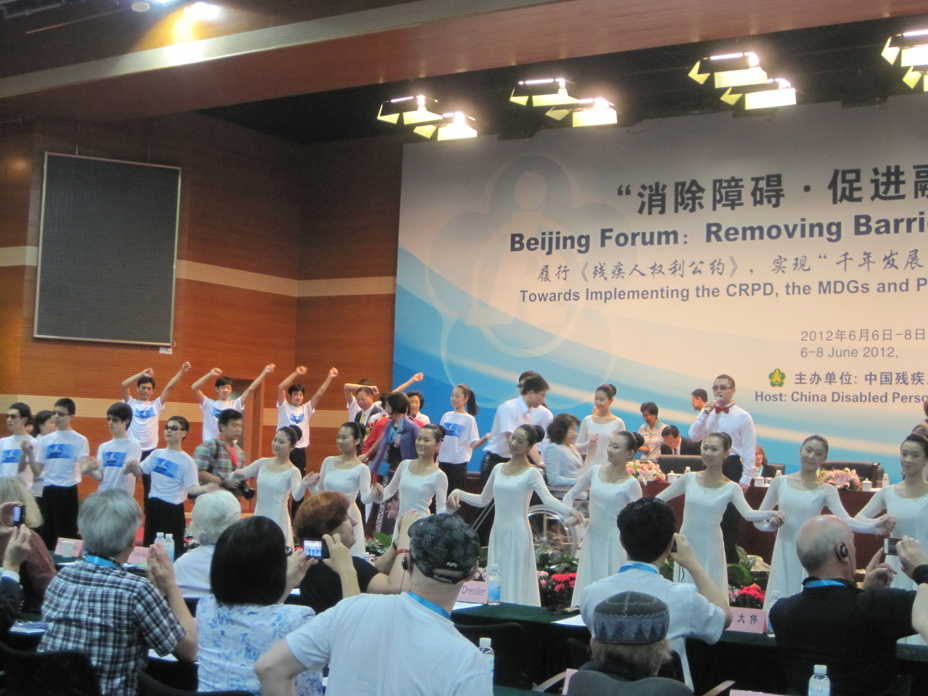

End.

