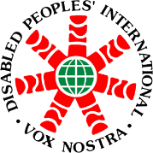

Report

Capacity Building Program with Field Exposure in

“Community Driven Development” (CDD)

For International Participants

16 - 28 July 2012

Bala Vikasa People Development Training Centre

Warangal, Andhra Pradesh, India

Program Goal:
Community Driven Development program will help increase the level of understanding of the participants on community development concepts and familiarizes them with various approaches and tools that can be applied in the process of empowering the community.

Program Objectives:
Imparting knowledge: for a better understanding of sustainable development.
To familiarize oneself on various approaches of community driven development.
Developing abilities and tools: to familiarize oneself on various approaches of community organization tools.
Enhancing values and change attitudes: to enhance one’s understanding of and respect for local communities and their inherent capacities to work for their own development.

Organizer: Bala Vikasa People Development Training Centre

Contact Persons: Disabled Peoples’ International, Asia Pacific (DPI/AP)
Apanee Mitthong (Ms.)
National Project manager, (DPI/AP)
Telephone: 66 (0)2 271-2123
Fax: 66 (0)2 271-2123
Email: apanee@dpiap.org

Contact Persons: Disabled Peoples’ International, Asia Pacific (DPI/AP)
Kanokporn Nakchatree (Ms.)
Project Coordinator on ASEAN, (DPI/AP)
Telephone: 66 (0)2 271-2123
Fax: 66 (0)2 271-2123
Email: kanokporn_adf@dpiap.org

Address: Disabled Peoples’ International – Asia Pacific
92 Phaholyothin 5 Road, Samsennai,
Phayathai Bangkok 10400 Thailand
Tel: 66 (0)2 271-2123
Fax: 66 (0)2 271-2124

Duration: 16 - 28 June 2012

Summarize

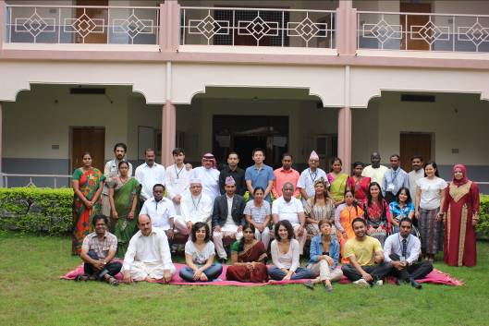
Two weeks International Capacity Building and Field Exposure Program in ‘Community Driven Development’
Bala Vikasa PDTC (People development Training Center) started the ‘two-week’ long International Capacity Building and Field Exposure program in ‘Community Driven Development’ on 16th July 2012. Twenty nine participants from 12 countries, namely Afghanistan, Bangladesh, China, Maldives, Nepal, Sri Lanka, Italy, Jordan, Sudan, South Africa, Thailand and India are participating in the training.
Mrs. Bala Theresa Gingras, Founder of Bala Vikasa and Mr. S. Shoury Reddy, the Executive Director, and all the staff members from various departments participated in the inaugural program. All the members introduced themselves in the welcome and introductory session. Mr. Bala Theresa Gingras gave a message and encouraged the participants to learn ‘Development Skills and Knowledge’ from the activities of Bala Vikasa that have been time tested for over 35 years. Mr. S. Shoury Reddy gave the orientation of the two weeks program to the participants and spoke about the various topics like Sustainable Development, ABCD approach, Strategic Planning and Result Based approach, Appreciative Enquiry, Development Communications, NLP and Conflict Resolution’.
Most participants are from the NGO sector and have a lot of knowledge and work experience in the field of development. Apart from development practitioners, three students from Catholic University, Italy and one student from Hong-Kong University of Science and Technology are participating in the training program.

Day 1: 16 July 2012

Topic: Cross cultural orientation

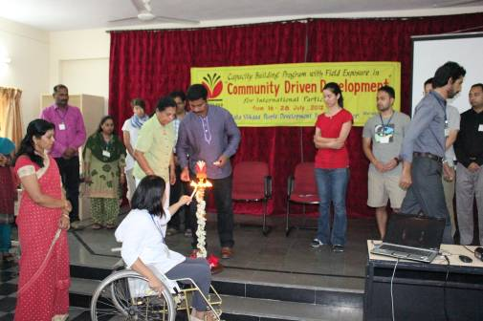
Objectives of the cross cultural orientation are numerous and include creating awareness and understanding of cultural differences to better understand the different customs and values which often conflict with one’s own. Also, sharpening analytical skills to interpret cultural differences more accurately and developing intercultural sensitivity to the differences in behaviour, patterns of thinking and communication styles. Additionally, objectives include avoiding offending others and respecting cultural differences as well as being more flexible, building tolerance, bridging cultures, and improving communication and inter personal relationships.
Culture is a set of rules or standards shared by members of a particular society which when acted upon by the members, produces behaviour that falls within the range that members consider proper and acceptable.
It is the “Collective programming of the mind and mental software of the mind which is learned and not inherited. A set of values, beliefs, attitudes, and habits unwittingly transferred from parents to their children, from teachers to students and from friends to friends

Facets of Culture

Day 2: 17 July 2012

Topic: Sustainable Development

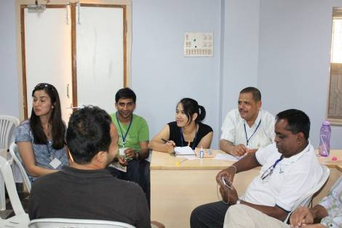
There is no single definition of sustainable development that is universally accepted at this point. However there is clear definition of the ultimate goal of sustainable development. “In order to for development to be sustained, it must meet the needs of the present without compromising the ability of the future generation to meet their needs”. Sustainable development also means that good development work is planned and implemented in such a manner as to enable benefits to continue long after development workers depart and local agents take over the management and operation of the project’s end results. In the developed and rich industrialized countries the emphasis is more on the economic and environment aspects. In the developing countries the emphasis is on meeting the basic needs and achieving economic growth. The dimensions of environment, economic, political, social, and cultural are recognized as important components to achieve sustainable development.

Key characteristics of Sustainable Development
1. It takes a long-term perspective (deep rooted cultural values evolve slowly)
2. It respects diversity/pluralism (diversity is important in many areas of development)
3. It uses an integrated approach (human and natural resources are linked)
4. It requires equity and justice (within countries- social classes, gender, among countries- rich and poor- between generations)
5. It relies on participatory approaches (people must be involved in decisions that affect them)
The Five Pillars of Sustainability are:
- Environment
- Economic
- Political
- Social
- Cultural
These five pillars should not be seen as standing independently, but as being closely linked. True sustainable development can only be achieved if development efforts respect all five dimensions and when conditions are simultaneously incorporated at all levels, into all development efforts. Sustainable development is more a process than a condition. It implies continuous change rather than a static state. This requires change in attitudes and behaviors at individual as well as at the societal levels both in the donor countries and the recipient countries.
It is important for development workers to understand that for any model of development to be successful, it must be indigenous and culture specific and should take into account the historical, social realities, the local genius, as well as the assets of the people concerned. It is important to understand the shared belief and value systems of a culture when addressing development

Day 3, 4: 18-19 July 2012

Topic: Asset Based Community Development (ABCD)

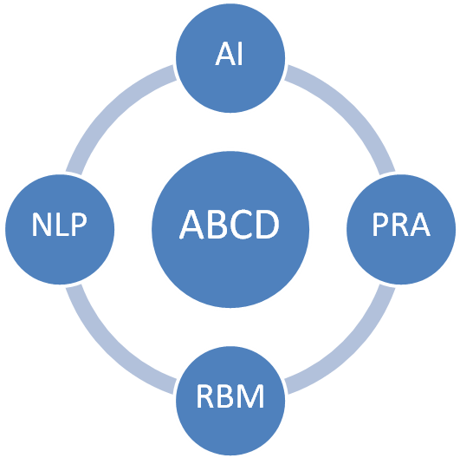

The ABCD approach to community development is “asset based” and “relationship driven”. It recognizes and reinforces the prevailing assets within the community. It is founded on the principle that recognition of strengths, skills and abilities of individuals and communities is more likely to generate positive action for change. The ABCD process, aims to assist, support, encourage, and enable communities to become involved in the development process i.e. an inclusive and interdependent process so that it becomes a daily experience for everyone in the community, and not the goal of the experience of a select few.

“Assets Based Community Development” (ABCD) approach is supported by 4 sets of tools based on “positive thinking” which are used at the grassroots, to bring about change of attitude and empowerment. At the community level:
Level: 1) An organizational Development Methodology called “Appreciative Inquiry” (AI)
Level: 2) Participatory Rural Appraisal (PRA) tools are used to enhance real participation of all the members of the community.
Level: 3) At the individual Level, Neuro Linguistic Programming (NLP) is used to bring out the best in the most passive members of the community and to enhance the best in the agents of change.
Level: 4) At the Management level, Results Based management (RBM) is followed, which focuses on the positive results to be expected and achieved in the development process.
As a strategy, ABCD pays attention to the relation of the community to the local institutions and the external economic environment on which its continued prosperity depends.
As a methodology, ABCD is guided by the notion that communities that recognize their assets and opportunities are more likely to be motivated to talk initiative to mobilize and strengthen their asset base. Guided by this, the community agent of change has to decide which combination of tools and methods are most appropriate for helping communities organize themselves to identify and mobilize their assets.
In brief, ABCD demonstrates that focusing on the assets of a community is a key ‘build block’ to sustainable community development. It challenges the traditional approach to development where the exclusive focus is on needs and problems of individuals

Day 5: 20 July 2012

Field Exposure – I Gangadevipalli

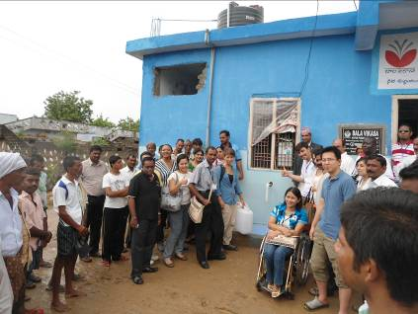

Having won several national awards of recognition, the village of Gangadevipalli, located 14 kilometers from Warangal, is renowned as a “100 percent” model village in the sense that it is considered “perfect” in all aspects of development. Water and electricity is available to all households. In this community, there are more than 18 committees, for example water, women, health, and education committees, that ensure proper facilities in the village. Alcoholism used to be a major problem in the community, but through a sensitization campaign and technical assistance, drinking alcohol in the village is prohibited and this rule is 100 percent respected. The village has its own medical services and each family the principle of two children per family. Each family has to take care of, in addition to caring for the environment of the village as a whole. All boys and girl of the village attend school. In addition, literacy course are mandatory for adults who are illiterate. Even more impressive is that the village finances itself entirely (tax on water, electricity, etc.) and the people themselves manage all aspects of life (justice committee), investigation into village infractions, management of finances and nature resource, etc.). In terms of communications, the village is on the cutting edge: a community radio, Internet access and they even have their own website describing their success.

For us, the visit to the village was very positive, yet simultaneously, difficult. The concept of democracy runs strongly through our individual and community thinking that the idea of imposing one single way of doing things is inconceivable. The idea of not being able to have more than two children or to be penalized for not taking care of your household tree by paying a fine, made us rethink some deeply rooted values. In India, the socio economic conditions are difficult and necessitate more drastic and perhaps less democratic measures. It shocked us to visit other villages that wanted to follow the example of Gangadevipali and to be as happy as the people there. We suppose that our view of the consequences imposed on the villages is just as difficult to imagine.
The fact that the method being followed in Gangadevipalli is working so well, and donors and international organization feel encouraged to replicate the model elsewhere in India and around the world, are in itself an attestation of Bala Vikasa's sucess in Gangadevipalli.

Field Exposure-II Widow program

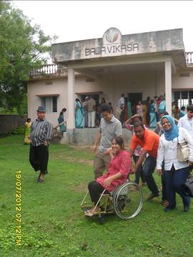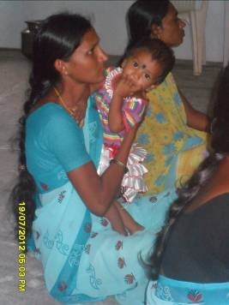

The conditions in which the widows of India live are very difficult. Mindsets such as “The husband’s death is due to the wife’s mediocre performance, the husband ‘s death is caused by the wife’s lack of potential devotion, making her incapable of using her ability to manipulate natural events and destiny for the good of the people around her etc. In general, widows are rejected by the community and treated as burdens.”
Bala Vikasa confirms that although the situation of widows in India is improving, changing the mentality of the people takes generations of hard work and dedication.
In order to better understand the reality of these women, the visit consisted of participating in a meeting that had 2 objectives:
- To update statistics of widows across participating villages;
- To listen to widowed women talk about their living situation, their present, as well as their future hopes for themselves and their children.
We were excited to meet these women and to talk about their development. It was for us the ideal moment to put into practice some of the skills and knowledge we had gained on gender and relations between men and women. But what awaited us was something completely unexpected.

Day 6: 21 July 2012

Topic: Methodology Appreciative Inquiry

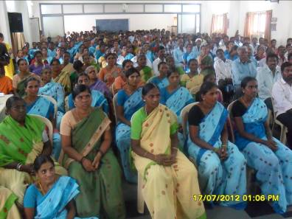
AI is the study of what gives life to human systems when they are at their best. It is an organization development methodology based on the assumption that inquiry into, and dialogue about strengths, successes, values, hopes, and dream, is in itself transformation. It is founded on the following set of belief regarding human nature and human organizing:
- Individually and collectively, people have unique abilities, skills and the aptitude to bring about changes in life.
- Organizations are human social systems, sources of unlimited relational capacity, created and lived through communication and language.
- Images we hold of the future are socially created, and once articulated; serve to guide individual and collective actions to achieve the same.
- Through human communication (inquiry and dialogue), people can shift their attention and action away from problem analysis to worthy ideals and productive possibilities for the future.
Appreciative Inquiry is a vital approach to leadership and organizational change. In short, Appreciative Inquiry suggests that human organization and change, at its best, is a relation process of inquiry, grounded in affirmation and appreciation.

Holiday Day 7: 22 July 2012

Day 8-9: 23-24 July 2012

Topic: Neuro Linguistic Programming (NLP)

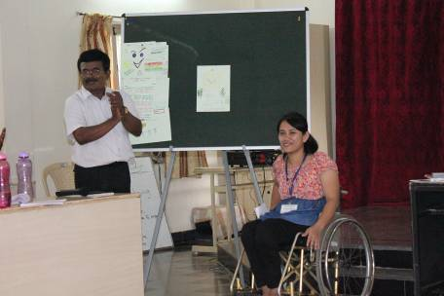
NLP motivates and empowers people to realize what they want in life. NLP technique when used at the grassroots helps motivate the poor and looks into future possibilities. On a closer look it is evident that the fundamental beliefs based on which AI is built, and the presuppositions of NLP, have similarities, each strengthening the other. NLP believes in the unlimited potential of human beings and their capacity to: enlarge the mental map and visualize the future so as to lead one to the intended destination: explore alternatives with the realization that there can never be only one solution to a problem; appreciate one’s own strengths and build on them rather than worry about weakness.
The presuppositions of NLP and the principle of ABCD approach seem to blend with each other in many ways. ABCD approach rests on the principle that the recognition of strengths, talents, and assets of individuals and communities is more likely to inspire positive action for change than an exclusive focus on needs and problems. NLP believes in the limitless power of every individual. All brains are equally potent. If one can do something, anyone can do it. NLP believes that one must trust one’s sub conscious. All there presuppositions of NLP are based on the skills, talents and assets of individuals. When they combine they become powerful. The very recognition of there, permeates self confidence generates self respect and improves self image, essential components for setting and achieving goals in life.

Day 10: 25 July 2012

Topic: Conflict Resolution
Based on these approaches, a starting point for dealing with conflict is to identify the overriding conflict style employed by yourself, your team or your organization.
Over time, people's conflict management styles tend to mesh, and a "right" way to solve conflict emerges. It's good to recognize when this style can be used effectively, however make sure that people understand that different styles may suit different situations.
Look at the circumstances, and think about the style that may be appropriate.
Then use the process below to resolve the conflict:

Step One: Set the Scene
If appropriate to the situation, agree the rules of the IBR Approach (or at least consider using the approach yourself.) Make sure that people understand that the conflict may be a mutual problem, which may be best resolved through discussion and negotiation rather than through raw aggression.
If you are involved in the conflict, emphasize the fact that you are presenting your perception of the problem. Use active listening skills to ensure you hear and understand other's positions and perceptions.
- Restate.
- Paraphrase.
- Summarize.
And make sure that when you talk, you're using an adult, assertive approach rather than a submissive or aggressive style.

Step Two: Gather Information
Here you are trying to get to the underlying interests, needs, and concerns. Ask for the other person's viewpoint and confirm that you respect his or her opinion and need his or her cooperation to solve the problem.
Try to understand his or her motivations and goals, and see how your actions may be affecting these.
Also, try to understand the conflict in objective terms: Is it affecting work? performance? Damaging the delivery to the client? Disrupting team work? Hampering decision-making? Or so on. Be sure to focus on work issues and leave personalities out of the discussion.
- Listen with empathy and see the conflict from the other person's point of view.
- Identify issues clearly and concisely.
- Use "I" statements.
- Remain flexible.
- Clarify feelings.

Step Three: Agree the Problem
This sounds like an obvious step, but often different underlying needs, interests and goals can cause people to perceive problems very differently. You'll need to agree the problems that you are trying to solve before you'll find a mutually acceptable solution.
Sometimes different people will see different but interlocking problems – if you can't reach a common perception of the problem, then at the very least, you need to understand what the other person sees as the problem.

Step Four: Brainstorm Possible Solutions
If everyone is going to feel satisfied with the resolution, it will help if everyone has had fair input in generating solutions. Brainstorm possible solutions, and be open to all ideas, including ones you never considered before.

Step Five: Negotiate a Solution
By this stage, the conflict may be resolved: Both sides may better understand the position of the other, and a mutually satisfactory solution may be clear to all.
However you may also have uncovered real differences between your positions. This is where a technique like win-win negotiation can be useful to find a solution that, at least to some extent, satisfies everyone.
There are three guiding principles here: Be Calm, Be Patient, and Have Respect.

Day 11: 26 July 2012

Topic: Strategic Planning

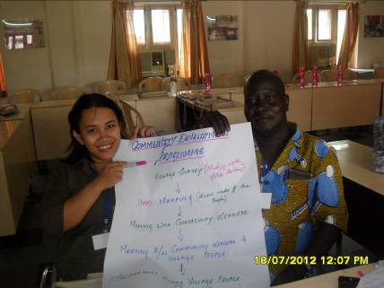

Strategic planning process helps:
Affirm the organization: It allows you to share thoughts on why your organization exists, and also helps you look closely at the things that it aspires to and values. It also helps build a shared commitment to your organization and affirm why individual members choose to be part of it.
Discover the `Best of’. It helps people value what the organization does well and in considering when it performed at its best, and discovering when it was most alive and effective.
Clarify future thinking. It provides a pause for your organization to stop and examine itself and determine if it is still headed towards its desired future. It provides an occasion to generate creative thinking, consider alternative, raise new questions and revisit your organizations vision.
Transform vision into action: Strategic planning provides an opportunity to draw a road map one which lays out the steps your organization must take to reach its vision. An action plan helps your organization to construct its future and helps transform a dream into a reality.

Day 12-13: 27-28 July 2012

Topic: Result Based Management
PRA is a set of tools which uses local graphic representations created by the community. Participation of local communities, helps bring to the fore legitimate local knowledge and valuable information. The validity of their knowledge generates new confidence. In turn, their local intellectual and analytical capabilities and the local culture are respected. The extensive and creative use of local materials and representational conversation shows a respect for the community. The emphasis is on the process. Its enhanced sensitivity focuses its attention more on marginal and vulnerable group’s women, children, aged and the destitute.
Social Mapping is one of the main tools for the ABCD approach. It deals with an elaborate inventory of the assets of a community, often time with the help of participatory techniques promoted by participatory rural appraisal. While mapping, other PRA techniques are also used such as informal interviews, Venn diagrams, etc. There are primary right brain activities. The left brain being associated with analytical through, logic, language, math and science and the right brain’s functions being holistic through, intuition, creative, art, music etc., people enjoy such activities and in the process develop their creativity and ability to imagine.

End.

