Creating New Futures for All: Children, Youth, Disability
and Situations of Forced Migration
28-30 November 2012

Theme: Respect: Protect: Promote: Best interests: Best Practices

The Creating New Futures for All is an international symposium explores the intersection of three seminal instruments which set out a clear agenda for promoting and pursuing the inherent dignity and worth of all members of society. Children’s right to provision, protection, and participation are critical aspects of the UN Convention on the Rights of the Child (UN CRC), which aims to promote and protect the dignity, identity, safety and welfare of children. The UN Convention on the Rights of Persons with Disabilities (UN CRPD) and the Convention and Protocol relating to the Status of Refugees (Refugee Convention and Protocol) provide frameworks for the protection, recognition and respect of two other groups widely recognized as being on the margins: persons with disability and refugees.

The symposium comprises two workshops as the following:
- Wednesday 28th November 2012, Persons with Disabilities and Forced Migration workshop for Disabled People’s Organization,
- Thursday 29th –Friday 30th November 2012, the conference on Children, Youth, Disability and Situations of Forced Migration.
The symposium co-chairs by Prof. Mary Crock, Professor of Public Law Associate Dean Postgraduate Research, University of Sydney and Prof. Ron McCallum, Emeritus Professor of Labour Law, Chair, and UN Committee on the Rights of Persons with Disabilities

Symposium Information:

Children in situation of displacement face a heightened risk of discrimination, disadvantage, exclusion and even physical and psychological abuse. This risk is magnified greatly by disability and exacerbated further by other factors such as age and gender, as well as by socioeconomic and citizenship status. Even where resources are available to support displaced groups and/or those with disabilities, children and young people are more likely to be isolated and excluded and thus deprived of important services and facilities aimed at ensuring provision of their basic rights. Rarely are such children consulted on issues that affect them, and have few opportunities to contribute to community processes or the improvement of programs and services aimed at supporting them.

The development of and support for human rights law in these areas has been a positive step towards improving the situation. However, there remains a very evident need to continue national and international dialogue around the most appropriate respectful and effective ways to support and empower those children and young people most at risk of not realizing their full human potential.

Creating New Futures for all brings together leading academics and organizations specializing in children’s rights, refugee protection and disability. The Symposium goal is to promote the sharing of knowledge, experience and good practice around inclusion of children and young person with disabilities and those displaced by war, conflict or disaster. With an audience that includes both service professional and policy makers, the initiative is designed to progress international dialogue around children’ rights, including in relation to initiatives such as UNICEF’s Global Partnership on Children with Disabilities and I am a Child Too campaign. The event also builds on the Shafallah Declaration on Crisis, Conflict and Disability undertaken at Qatar.

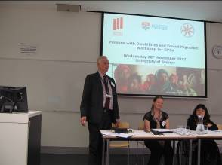 | 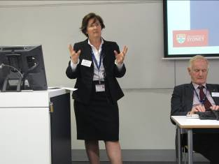
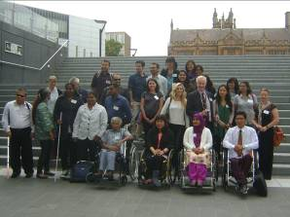 | 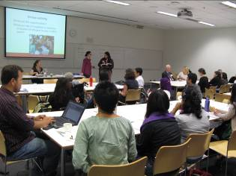
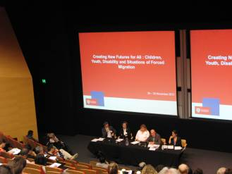 | 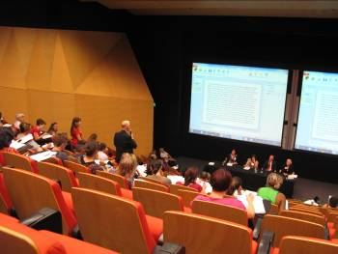
Annex 1: Workshop Agenda _Persons with Disabilities and Forced Migration Workshop for Disabled Peoples’ Organizations
Annex 2: The Statement of the Workshop

