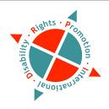

Report

“DRPI Asia Pacific Regional Disability Rights Monitoring Training”

3rd -10th July 2011
Bangkok, Thailand

By

Chona M. Sabo

Organized by: Disability Rights Promotion International (DRPI)
In collaboration with Disabled Peoples’ International – Asia Pacific (DPI/AP)

Contact Address: Disability Rights Promotion International (DRPI)
York University
Address: 4700 Keele Street Toronto, Ontario, Canada M3J 1P3
Tel: (416) 736-2100 ext. 22112
Fax: (416) 736-5227
Email: mrioux@yorku.ca
Website: http://www.yorku.ca/SHPM/
http://www.yorku.ca/gradcdis
http://www. yorku.ca/drip

Disabled Peoples' International Asia-Pacific Region (DPI/AP)
Address: 92 Phaholyothin 5 Road, Samsennai, Phayathai Bangkok
10400 THAILAND
Tel: 66 (0)2 271-2123
Fax: 66 (0)2 271-2124
Mobile: 66-8-1558-1903
Email: saowalak@dpiap.org
Website: http://www.dpiap.org/

Contact Person: DRPI
Ms. Marcia H. Rioux PhD
Co-Director, DRPI
Tel: (416) 736-2100 ext. 22112
Fax: (416) 736-5227
Email: mrioux@yorku.ca

DRPI-AP
Ms. Chona M. Sabo
Regional Officer, DRPI-AP
Tel: 66 (0)2 271-2123
Fax: 66 (0)2 271-2124
Email: chona_drpi@dpiap.org

DPI/AP
Ms. Saowalak Thongkuay
Regional Development Officer, DPI/AP
Tel: 66 (0)2 271-2123
Fax: 66 (0)2 271-2124
Mobile: 66-8-1558-1903
Email: saowalak@dpiap.org

Aims:
Disability rights monitoring involves collecting information about the whether or not persons with disabilities are able to enjoy their human rights. Credible and accurate information about the human rights situation of people with disabilities can persuade governments that abuses are occurring and that action is needed to fulfill human rights obligations. Recording information about the experiences of individual persons with disabilities can uncover a pattern of discrimination affecting large numbers of people. Data outlining the extent of disability discrimination can:
- promote greater awareness of the need for social change,
- provide facts and figures useful for lobbying and other advocacy, and
- supply governments with credible documentation to support the creation of more inclusive social policies and laws.
The DRPI project has developed a holistic approach to monitoring disability rights, focusing on finding the facts in three key areas:
1. Individual experiences of persons with disabilities (through face to face interviews);
2. Systemic measures taken to protect and promote disability rights (laws, policies, programs)
3. Societal attitudes toward disability (by looking at depictions and coverage of disability in the media).

Methodology:

The training involves lectures, general and small group discussions, debates, role play and brainstorming. The workshop is designed to be a dynamic and interactive learning experience and that everyone will be expected to attend and actively participate in all sessions.

Outcomes:

In this training workshop, participants learned about DRPI’s tools and methods for monitoring in the first two focus areas (individual experiences of persons with disabilities and systems). The training also addressed how the information collected can be analysed and reported as well as how to organize and coordinate a disability rights monitoring project.

Report on DRPI Asia Pacific Regional Disability Rights Monitoring Training
Participants from five countries namely Bangladesh, Cambodia, Lao, Nepal and Thailand participated in these eight (8) days DRPI Asia Pacific Regional Disability Rights Monitoring Training in Bangkok, Thailand.
We had a sight seeing affair on July 03, 2011 for out of the country participants as it was an election day in Thailand. Everyone enjoyed the beauty of Bangkok as we witness its historical event at Rattanakosin Exhibition Hall, uncover every inch of its remarkable spots at Grand Palace, bargain happy moments at MBK Center and dine to unwind at Prince Palace hotel in the evening.

Sight Seeing Schedule
July 03, 2011, Sunday

Time | Details | Remarks
09:30 | Leave Prince Palace Hotel
10:00-11:30 | Rattanakosin Exhibition Hall
11:30 - 13:00 | Lunch | Sky High Restaurant
13:00 - 15:00 | Grand Palace
15:00-18:00 | MBK Center
18:00 | Go back to Prince Palace Hotel
19:00 | Dinner | Prince Palace Hotel

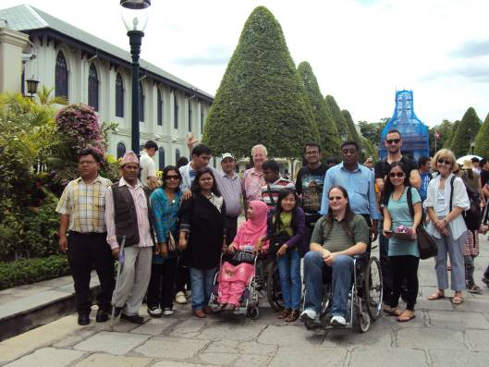

One
fine afternoon
with the participants at
Grand Palace…

Grand pose with Mr. Lauro & Mr. Ranil
at Grand Palace…
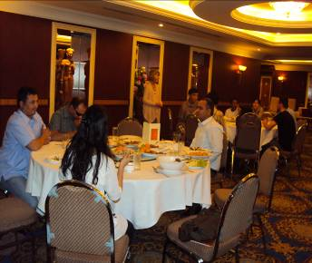
Dining at Prince Palace Hotel

Opening Ceremony

Opening Ceremony
DRPI Asia Pacific Regional Disability Rights Monitoring Training
04 July, 2011
09:00 – 10:30 at Prince Palace Hotel
Bangkok, Thailand

Time | Details | Remarks
09:00 – 9:40 | Welcome Remarks | Ms. Saowalak Thongkuay  Regional Development Officer  Disabled Peoples’ International-Asia pacific (DPI/AP)  Bangkok, Thailand  &  Ms. Marcia Rioux  Project Director & Principal Investigator  Disability Rights Promotion International (DRPI)  Professor, York University  Toronto, Canada
09:40-10:10 | Speech | Mr. Patrick Anderson  Chief, Social Integration Section, Social Development Division, United Nations Economic and Social Commission for Asia and the Pacific (UNESCAP) Bangkok, Thailand
10:10:-10:30 | Speech | Ms. Kingkaew Inwang  Secretary-General of National Office for Empowerment of Persons with Disabilities  The Ministry of Social Development and Human Security Bangkok, Thailand

Opening & Welcome Remarks
By:
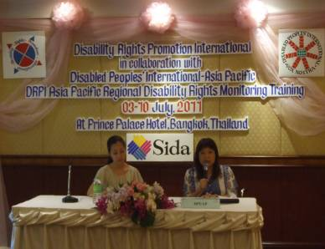

Ms. Saowalak Thongkuay (DPI/AP)
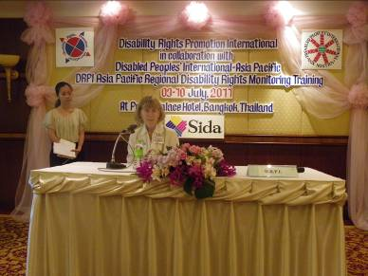

Ms. Marcia Rioux (DRPI)

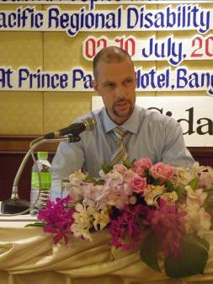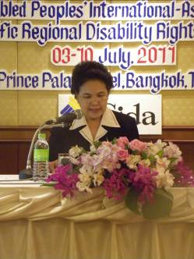
Mr. Patrick Anderson
Chief, Social Integration Section, Social Development Division, United Nations Economic and Social Commission for Asia and the Pacific (UNESCAP)
Ms. Kingkaew Inwang
Secretary-General of National Office for Empowerment of Persons with Disabilities
The Ministry of Social Development and Human Security

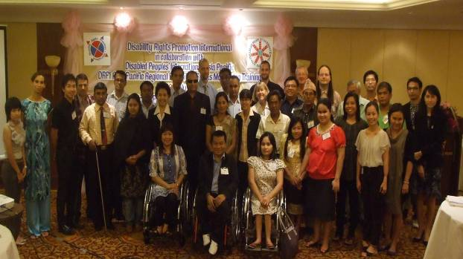

Group photo with participants, guests and facilitators…

Human Rights, Disability & Monitoring

The Global Picture of Disability
There are more than 665 million persons with disabilities in the world. In some countries they make up more than 15% of the population. Persons with disabilities are the world’s largest minority group.
80% of persons with disabilities live in developing countries.
(UN Development Programme)
20% of the world's poorest people have some kind of disability and tend to be regarded in their own communities as the most disadvantaged. Persons with disabilities are often the “poorest of the poor”. (World Bank)
80% of persons with disabilities live in rural areas.
(UN Department of Economic and Social Affairs, Factsheet)
- Women and girls with disabilities are recognized as having multiple disadvantages. They experience exclusion because of both their gender and their disability. They are particularly vulnerable to abuse. (UN Department of Economic and Social Affairs, Factsheet).
- 30% of youth who live rough (that is, live on the streets) have some kind of disability (UNICEF).
- Death rates for children with disabilities may be as high as 80% in some countries.
(United Kingdom Department for International Development)
● In countries with life expectancies over 70 years, people spend
an average of 8 years living with disabilities.
(UN Department of Economic and Social Affairs, Factsheet)
● Only 45 countries have anti-discrimination or other disability-specific laws.
(UN Department of Economic and Social Affairs, Factsheet)
● By July, 2011, 103 countries had ratified the United Nations
Convention on the Rights of Persons with Disabilities and
90 countries had ratified its Optional Protocol.
(UN Enable website, Department of Economic & Social Affairs)

Disability as an Personal Problem | Disability as a Result of the Way Societies and Communities are Set up
Does you disability stop you from going out as often or as far as you would like? | What is it about the area where you live that makes it difficult for you to get around in your neighborhood?
Does your disability cause problems at work? | Do you have problems at work because of the physical environment or the attitudes of others?
Do you live with relatives or someone else who can help or look after you because of your disability? | Are the services in your community so poor or so limited that you need to rely on relatives or someone else to provide you with the right level of personal assistance?
Have you had to adapt where you live because of your poor disability? | Did that poor design of your home mean that you had to have it adapted to suit your needs?

From Charity to Rights
Recipients of Charity | Rights-Holders
The person giving charity has the power to decide what to give.  For example, the charity-giver wants to donate a coat to a person in need. | The person with a disability has the power to challenge unjust or inappropriate resource allocation.  The rights-holder can say: “I don’t want a coat. I want shoes.”
The person receiving charity has no power to decide what he or she prefers.  For example, the charity-recipient receives shoes that are not the right size. | The person with a disability has the power to make choices.  The rights-holder has the opportunity to choose a pair of shoes that fit perfectly.
The person receiving charity has no legal entitlement to the resources and is dependent on the whim of the charity-giver.  For example, the charity-giver decides not to provide clothes this year. | The person with a disability has a legal entitlement to resources equal to those enjoyed by their fellow human-beings.  The rights-holder does not have to worry about the generosity of the person giving charity. Adequate clothing is considered essential to survival, a right everyone is entitled to.

To achieve full recognition of people with disabilities as rights-holders, people must understand:

• the needs of people with disabilities are
not “special”
• the issues are politicized
• separate but equal is not equal
• people with disabilities have to be
recognized as decision-makers

The general human rights principles that apply equally to men, women, boys and girls are the following:
1. Dignity refers to the inherent worth of every person. Human rights are intended to promote human dignity
2. Autonomy is the right of an individual to make his or her own choices independently.
3. Participation, Inclusion & Accessibility - Inclusion involves organizing systems of society; both public and private, to enable all people to participate fully and effectively. To achieve full participation, an accessible, barrier free physical and social environment is necessary.
4. Non-Discrimination & Equality - The principle of non-discrimination means that all rights are guaranteed to everyone, without distinction, exclusion or restriction based on disability or race, sex, language, religion, political or other opinion, national or social origin, property, birth, age, or any other status.
Equality, in the context of disability requires creating societal conditions that allow for difference in order to guarantee the equal participation and inclusion of people with disabilities in all aspects of society.
5. Respect for Difference - Respect for difference involves acceptance of persons with disabilities as part of human diversity and humanity
What is Monitoring?

(a) Tracking (monitoring) Individual Experiences
(b) Tracking (monitoring) Systems (laws, policies, programs and services)
(c) Tracking (monitoring) Attitudes

Holistic Monitoring

Individual Experiences Monitoring

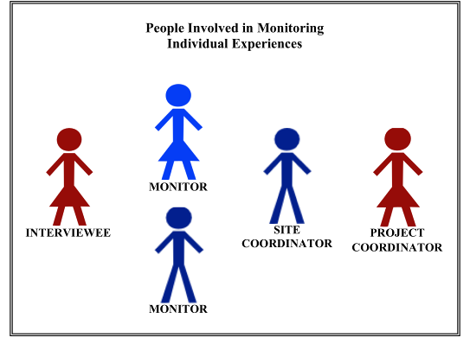
Systemic Monitoring (Laws, Policies & Programs)
1. Systemic Monitoring in Practice
Involves looking at whether the legal and policy frameworks of a country meet a country’s
human rights commitments and whether they meet international principles of human rights.
2. Reporting on Findings
Start by providing an overview of the general legal provisions governing persons with
disabilities in the country.
3. Qualities and Skills of Systemic Monitors
a. Objectivity
b. Commitment
c. Social and political awareness
d. Broad Knowledge / Information
e. Thoroughness
f. Accuracy and Precision

Holistic Reporting:
Putting the Pieces together to Create a Holistic Report

A. Introduction to Holistic Reporting
A holistic monitoring report presents a comprehensive picture of the human rights of persons with disabilities living in a particular country.

Things to consider in Holistic Reporting:
1. What types of questions can be answered by a report using this approach?
2. What does the holistic monitoring report provide? – Filling the gaps

B. Writing a Holistic Monitoring Report
Things to consider:
1. Getting ready to write the Report
2. Holistic Reporting – Step-by-Step:

Step 1 - Identify the ‘hot rights issues’ – that is, the issues from the individual experiences interviews that were the most important.
Step 2 – See how the ‘hot rights issues’ relate to the rights guarantees set out in human rights treaties

Provision of health & life insurance without discrimination
[CRPD; Art.25 (e)]

Provision of appropriate health services
[CRPD; Art.25 (b)]

Equal access to health care and programmes provided to general population
[CRPD; Art.25 (a)]

Right to health & implications for personal safety & security

Step 3 – Identify the questions about systemic issues and societal attitudes hidden or embedded in
the individual stories
Step 4 – Find the patterns of the denial of rights: Organize the monitoring information available around the ‘hot rights issues’.
Step 5 – Find the gaps in the protection and practice of disability rights: Put together and analyze the monitoring information from the different focus areas.

DIAGRAM: Multi-step holistic monitoring approach

STEP 2
See how the ‘hot rights issues’ relate to the rights guarantees set out in human rights treaties
STEP 1
Identify the ‘hot rights issues’
STEP 3
Identify the questions about systemic issues and societal attitudes hidden or embedded in the individual stories
See how the ‘hot rights issues’ relate to the rights guarantees set out in human rights treaties

STEP 4
Find the patterns of the denial of rights

STEP 5
Find the gaps in the protection and
practice of disability rights
Using Monitoring Information to Improve the Lives of Persons with Disabilities

Tracking or monitoring rights does not end with collecting information, analyzing it and writing reports. Many different groups can use human rights monitoring information to achieve the goal of improving the lives of persons with disabilities:
- organizations of persons with disabilities (DPOs)
- other organizations interested in promoting the rights of persons with disabilities
- governments
- national human rights institutions
- private organizations and businesses
- media

Taking Action at the Country & Community Level

- Lobbying for Changes in Laws, Policies and Programs.
(b) Bringing a Legal Claim
(c) Raising Awareness through Public Education and Action

Taking Action Internationally

- Taking Action under the Convention on the Rights of Persons with Disabilities (CRPD)
There are two (2) main ways that the Committee on the Rights of Persons with Disabilities monitors whether countries are meeting their obligations under the CRPD:

▪ State (Country) Reporting Process (CRPD, Articles 35 & 36)
▪ Individual and Group Communications (Complaints) Process
(Optional Protocol to the CRPD)

DPOs can participate in both of these processes in the following ways:
Periodic State (Country) Reporting

- State (Country) Reports:

The Committee on the Rights of Persons with Disabilities has published Guidelines for State Reports on the CRPD. Countries that have ratified the CRPD are required to provide comprehensive reports to the Committee on the Rights of Persons with Disabilities explaining the steps they have taken to make sure that persons with disabilities in their country are enjoying the human rights guaranteed by the Convention. These reports are called “State Reports”.
A country’s first State Report must be submitted within 2 years of that country’s ratification. After the first State Report, the country must submit subsequent State Reports at least every 4 years.

(b) Writing a Parallel Report

DPOs can play an important role in the state reporting process by submitting “Parallel Reports” (also known as “Shadow” or “Alternate” Reports) about how well the country has met its obligations. The Committee will use the additional information included in Parallel Reports to question and challenge claims made by the country. Parallel Reports provide another way for the Committee to get a full picture of whether the country is fulfilling its obligations under the CRPD and other Conventions.

To date, no formal guidelines for Parallel Reports have been published by the Committee on the Rights of Persons with Disabilities.

What happens with State Reports and Parallel Reports?

Once the Committee receives a State Report, it sets the date during one of its twice-yearly meetings in Geneva when it will consider the State Report with representatives of the country.

Before this meeting, the Committee reviews the State Report and any Parallel Reports received and sends the country a “List of Issues”, asking the country to clarify, complete and/or update the information that it provided in the State Report. The country must respond to the List of Issues in writing.

Finally, the Committee adopts and publishes its own report called “Concluding Observations”. This report identifies areas where the country should make changes to laws, policies or practice in order to meet its human rights obligations

DPOs and their allies can use the information to pressure governments to make changes.

- Supporting an Individual or Group Complaint:

If a country has ratified the Optional Protocol to the CRPD, individuals and/or groups in that country can bring complaints to the Committee on the Rights of Persons with Disabilities claiming that their rights under the Convention have been violated. These complaints are referred to as “communications”.

2. Taking Action under other Core UN Human Rights Treaties:
- In addition to the CRPD, there are 8 other core United Nations human rights treaties that all apply to persons with disabilities. Each treaty is monitored by a committee of experts similar to the Committee on the Rights of Persons with Disabilities
- DPOs are encouraged to submit their own Parallel Reports under these treaties or work with other NGOs and networks in their countries to ensure that a disability perspective is included in collective Parallel Reports.
- DPOs may also want to support the submission of individual or group complaints under these treaties.

Final Points about International Action:

Lobbying and advocacy is the key to social change and social justice. The United Nations has put these processes in place to ensure that countries are progressing in implementing rights, addressing rights violations and moving towards social justice for persons with disabilities and all others in societies throughout the world. DPOs can use these international processes to effect change at the country and community levels – using the pressure of international opinion to influence change at home. To do this, it is important for DPOs:
- To make sure that any statements or decisions by international monitoring bodies (e.g. expert committees, Human Rights Council, Special Rapporteurs and Independent Experts) are brought to the attention of country media, politicians (e.g. opposition parties) and other interested pressure groups.
- To work towards the universal ratification of the CRPD and its Optional Protocol so that these international processes can be used by disability rights activists in every country.

The exercise of rights of persons with disabilities happens at the local, national, regional and international levels of action. Ensuring that all persons with disabilities around the world are able to exercise their rights is an effort that crosses national boundaries. The solidarity of the movement for disability rights is vital to achieving that goal.

Attached:
Annex A: Training Agenda
Annex B: List of Participants
Annex C: Opening speech of Mr. Patrick Anderson of UNESCAP
Annex D: Opening speech of Ms. Kingkaew Inwang of NEP

Participants and Facilitators in Actions

