Employability and Disability Equality Training (DET) for Accor Group Human Resources Staff (Thailand and Laos)

Mission: Krabi, Thailand
Organized: AAPC (Thailand) Limited
Contact: Mr. Christopher Lejeune
Location: Mercure Krabi Deevana Hotel.
Moo 3 , Ao Nang Soi 8, Nopparatthara Beach Road,
Ao Nang Beach, Maung, Krabi 81000 Thailand.

Address: AAPC (Thailand) Limited Human Resources Department, AAPC (Thailand) Limited
36/F, The Offices at Central World
999/9 Rama 1 Road, Patuwan,
Bangkok 10330 Thailand
Phone : + 66 (0) 2659 4551
Mobile : +66 (0) 859 803 363
Christophe.LEJEUNE@accor.com
Duration: 26-27 September 2011

Mission members: 6 persons

No. | Name | Position | Remark
1. | Ms. Saowalak Thongkuay | Regional Development Officer | Mission Leader
2. | Mr. Wansao Chaiyakul | DET trainer | DET team leader
3. | Ms. Sureeporn Yupa | DET team member | DET team
4. | Ms. Mariam Ali | DET team member | DET team
5. | Mr. Supawat Samurpark | DET team member | DET team
6. | Mr. Somchay Pumjaroen | Personal Assistance | Mission Member

Aims:
- To introduce DPI-AP as Accor's partner on a disability employment project to 60 HR colleagues from Accor hotels in Thailand and Laos ;
- To present some disability facts, current situation and training module that will be deployed for their hotels.

The mission’s methods:
- To facilitate DET
- To increase Accor Group HR staff’s understanding of employability for persons with disabilities in the hospitality industry.
- To facilitate simulation exercise on disability

Outcomes:
- Accor HR staff will gain a clear vision on disability and employment of persons with disability in the hospitality industry.
- To share strategies on the formulation and implementation of an appropriate disability policy for the company.
- Disability inclusive policy is well recognized.

26th September 2011

10:30 AM: The DPIAP Team arrived at Krabi Airport in the morning and transferred to the meeting venue Mercure Krabi Deevana Hotel, by the hotel van. This is a new property which will be officially opened in October 2011. We briefly met some of the Accor staff who would be participating in the training session.
A short accessibility check was also conducted on arrival. The hotel features one accessible room with hand rails and a sliding door at the entry point. There was also a shower curtain in place of a screen door for easy access into the shower area and it was all on the same level, with no steps to manoueuvre. There were also two public unisex accessible toilets for guests use on the property. Built in ramps were present throughout the property and access to the meeting room was gained by using the corridor where the administrative offices were and up a service lift.
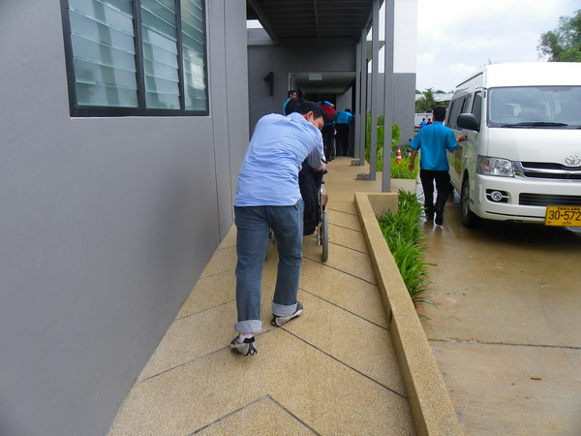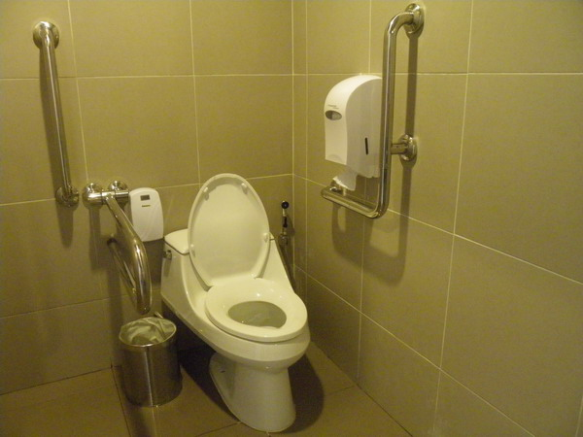

13:00 PM: Field visit to Krabi Ao Nang Beach and Fossil Shell Beach at Ban Laem Pho Krabi for several hours.
18:00 PM: Invitation to dinner with all the Accor participants and Mr Christophe at an external venue. The Accor Human Resources staff had been advised by Mr Christophe that DPIAP would be visiting to make a presentation but they had deliberately not been briefed on the content of the workshop.

27th September 2011

08:30 AM: DPIAP requested to be allowed to observe how Accor conducts their Communication Skills and CSR activity training which would go until 10:00am.
This morning session was started with an ice breaker activity that involved communicating with the rest of the team without speaking a word. Next was a quiz to test the Accor staff’s knowledge on CSR activities carried out by the company, followed by a presentation on CSR and the answers to the quiz.
The Accor Group intends to begin its project of offering employment, internships and other learning opportunities to persons with disabilities in 2012 and is committed to ensuring that this process becomes an ongoing one.
After this, Ms Saowalak was invited to provide a short overview of DPI, its origin and the work done by the organisation.

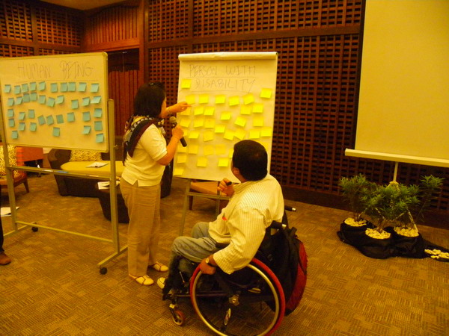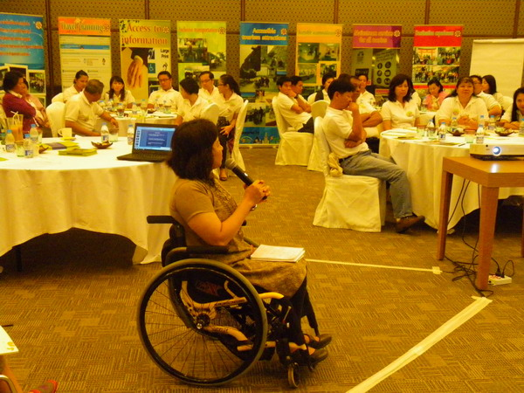

10:00 AM: DPIAP session on DET and Employability began. The session was conducted in Thai with the employability section conducted in English. Accor participants were presented with ear plugs or eye glasses that partly obscure the vision and asked to put them on for some understanding of what a hearing or visual disability may feel like. They then watched a 10 minute movie on disability, and were asked to explain their personal experience of it as well as what they understood the message to be.
Following this was an introduction to DPIAP, disability and disability statistics and then a lecture on employability of persons with disabilities, how to create opportunities, workplace accommodations, recruitment and other matters relating to Human Resources management.
The DET session began after this which was highly interactive and involved all the Accor staff discussing attitudes, stereotypes, barriers and the core subject of disability among other issues. Due to time restrictions, a simulation exercise for the participants of the workshop could not be conducted. However from the activity involving ear plug as and partially obscuring eye glasses, the participants were able to gain some personal experience and understanding of visual and hearing disabilities.
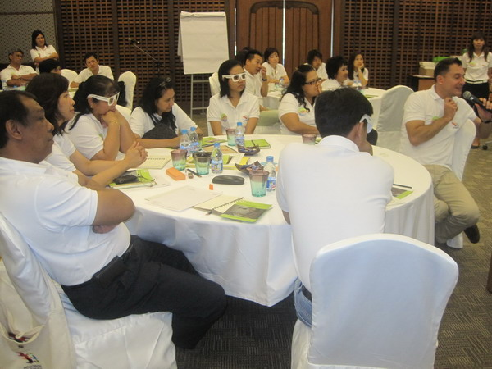
14:30 PM: Following lunch, Accor staff were advised DPIAP were available to respond to any feedback, questions or concerns they may have had regarding the presentation. DPIAP were observers during the afternoon session when it resumed in the meeting room where the Accor staff proceeded to organize participatory activities and games for the upcoming year.
Additionally Mr Christophe explained that he would advise DPIAP when Accor would hold its next ‘Keys to Communication’ session for observation purposes.

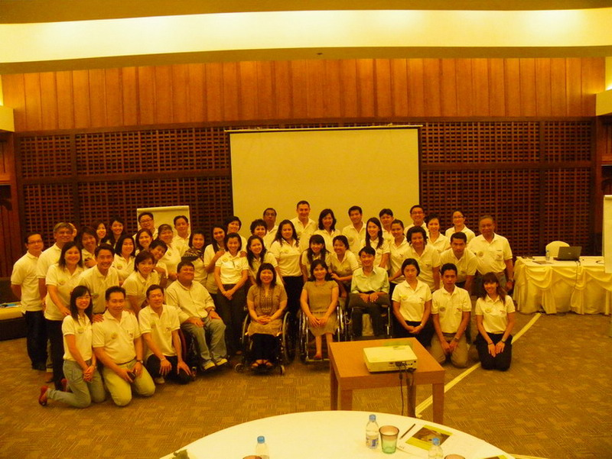

16:30 PM: Departure from Mercure Krabi Deevana Hotel to the airport for flight back to Bangkok.

Tentative Mission Program (as of 22 Sep 2011)
Day 1 – 26 September, 2011: Accor meeting
Time | Activity | Speaker/Facilitator
0800 | Mission team arrive to Krabi | By TG 241
1000-1200 | Attend the meeting
1200-1300 | Lunch
PM | Attend the meeting
Day 2 – 27 September, 2011: CSR day
Time | Activity | Speaker/Facilitator
100-1230 | Understand Disability Equality  -Introduction of your NGO / Team  - What is disability?  - Disability facts in Thailand  - Latest Thai law / legal implementation  - DET Training  - Channels to recruit future disable employees / interns  - Others | DPIAP team
1230-1330 | Lunch
1330-1600 | open space where some of our HR Managers could meet you and discuss face to face specific needs or topics | DPIAP team
1850 | Depart for Bangkok | By TG 250

