

Report

International Conference on Social Welfare Issues in the ASEAN Region

By

Ms. Worapan Buranasilpin

Mission: Jakarta, Indonesia
Organized: Public Relation Bureau, General Secretariat, Ministry of Social Affairs,
Republic of Indonesia
Contact: Prof. Dr. Bambang Shergi Laksomno, MSc
Head of Steering Committee
Address: C/O Public Relation Bureau,
Phone/Fax: 6621 3100470
E-mail: bshergi.laksmono@gmail.com

Contact persons: DPI/AP
Ms.Saowalak Thongkuay
Mobile: 668-1-558-1903

Email: saowalak@dpiap.org
Ms. Worapan Buranasilpin
Mobile: 668-6-581-3415

Email: worapan@dpiap.org
Address 92 Phaholyothin 5 Road, Samsennai,
Phayathai Bangkok 10400 THAILAND
Tel: 66 (0)2 271-2123
Fax: 66 (0)2 271-2124

Duration: 26 October- 1 November 2011

Mission members: 2 persons

No. | Name | Position | Remark
1. | Ms. Saowalak Thongkuay | Regional Development Officer | Mission Leader
2. | Ms. Worapan Buranasilpin | Secretary | Member

Aims:
- To exchange information on ADF;
- To attend the International Conference on Social Welfare Issues in the ASEAN Region;
- To strengthen partnership with AGENDA.

The mission’s methods:
- To attend the International Conference on Social Welfare Issues in the ASEAN Region;
- To visit and give inputs to AGENDA program;
- To give a presentation on ASEAN and Disability;
- To share information of ADF;

Outcomes:
- The understanding of Social welfare challenges were recognized especially on disability and aging person.
- Partnership with multi stakeholders related to disability is expanded and strong.
- AGENDA grant approved.

Program
Day 1 – Wed, 26 October, 2011: Registration
Time | Activity |  | Speaker/Facilitator
08:00 | Mission team depart to Jakarta |  | By TG 433
11:35 | Mission team arrive to Jakarta
Afternoon | Check in at Hotel |  | The Sultan Hotel Jakarta  Jl. Gatot Subroto  Jakarta, 10002  Tel: (62-21) 570 3600  Fax: (62-21) 573 3089  Email : hotel@sultanjakarta.com  Website: http://www.sultanjakarta.com/
Afternoon | Registration |  | Hotel Lobby
15:30 | Visit AGENDA |  | PPCI, AGENDA  Jl. Cikini 5 No. 15-A Jakarta Indonesia 10330 Jakarta  Tel: +62 21 3190 6562  Fax: +62 21 3190 6563  Email: info@agendaasia.org  Website: http://www.agendaasia,org
Day 2 – Thu, 27 October, 2011: Conference program
Time | Activity |  | Speaker/Facilitator
09.00 – 11.00 | Opening Ceremony |  | Jakarta Convention Center (JCC)
11.00 –12.00 | Hospitable, taking pictures and back to the hotel
12.00 – 13.30 | Lunch |  | Lagoon Cafe, Sultan Hotel
13.30 – 13.45 | Keynote Address, Prof. Bambang Shergi Laksmono, MSc  “Institutional Cooperation for ASEAN Community in Social Welfare and Social/Human Development: The Way Forward”
13.45 – 14.00 | Plenary Session I, Prof. Jim Ife  “Free Trade and Community Empowerment in Human Rights Perspective: Challenge for ASEAN Countries”  Moderator: Widodo Suhartoyo
14.00 – 14.15 | Coffee Break
14.15 – 16.15 | Parallel Discussion
14.15 – 16.15 | Sub-Theme : Social Work Education & Profession
14.15 – 16.15 | - Prof. Ngiam Tee Liang (Singapore)  - Fentiny Nugroho, Ph.D (Indonesia)  - Bala Raju Nikku, Ph.D (Nepal)  Moderator : Nafsiah Ariefuzzaman, MSW |  | ASEAN Room 9
14.15 – 16.15 | 1. Dr. Decha Sungkawan (Thailand)  2. Isbandi Rukminto Adi, Ph.D (Indonesia)  3. Mr. Oudone Maniboun (Lao-PDR)  Moderator : Johana Debora Imelda, Ph.D |  | ASEAN Room 8
14.15 – 16.15 | - Prof. Tatsuru Akimoto (Japan)  - Yolanda G. Ealdama (the Philippine)  - Mr. Emil Zahrin Ali, (Brunei Darussalam)  Moderator : Binahayati, Ph.D |  | ASEAN Room 6
14.15 – 16.15 | - Prof. Zulkarnain A. Hatta (Malaysia)  - Dr. Mary Lou Alcid (the Philippine)  - Mr. Saneth Vathna (Cambodia)  Moderator : Irfani Dharma |  | ASEAN Room 5
14.15 – 16.15 | Sub-Theme : Social Work Education & Profession
14.15 – 16.15 | - Prof. Ngiam Tee Liang (Singapore)  - Fentiny Nugroho, Ph.D (Indonesia)  - Bala Raju Nikku, Ph.D (Nepal)  Moderator : Nafsiah Ariefuzzaman, MSW |  | ASEAN Room 9
14.15 – 16.15 | 1. Dr. Decha Sungkawan (Thailand)  2. Isbandi Rukminto Adi, Ph.D (Indonesia)  3. Mr. Oudone Maniboun (Lao-PDR)  Moderator : Johana Debora Imelda, Ph.D |  | ASEAN Room 8
14.15 – 16.15 | - Prof. Tatsuru Akimoto (Japan)  - Yolanda G. Ealdama (the Philippine)  - Mr. Emil Zahrin Ali, (Brunei Darussalam)  Moderator : Binahayati, Ph.D |  | ASEAN Room 6
14.15 – 16.15 | - Prof. Zulkarnain A. Hatta (Malaysia)  - Dr. Mary Lou Alcid (the Philippine)  - Mr. Saneth Vathna (Cambodia)  Moderator : Irfani Dharma |  | ASEAN Room 5
14.15 – 16.15 | Sub-Theme : Aging
14.15 – 16.15 | - Dr. Ho Thi Kim Than (vietnam)  - Dr. Nugroho Abikusno, MD., MSc  (nytr., DR.PH)  - Fransiskus Kupang (the Philippine) |  | ASEAN Room 9
14.15 – 16.15 | - Susana Concorda Harding (Singapore)  - Natapat Sarobol (Thailand)  - Dr. Pay Sambo (Cambodia)  Moderator : Juda Damanik, MSW |  | ASEAN Room 8
14.15 – 16.15 | Sub-Theme : Disaster Management
14.15 – 16.15 | - Dr. Ismail Baba (Malaysia)  - Prof. Manohar Pawar (Bangladesh)  Moderator : Parni Hadi |  | ASEAN Room 1
14.15 – 16.15 | - Prof. Mayumi Sasaoka (Japan)  - Dr. Aleli Bawagan (the Philippine)  Moderator : Johana Debora Imelda, Ph.D |  | ASEAN Room 2
19.00 – 21.00 | Welcome Dinner & Art Performance
Day 3 – Fri, 28 October, 2011: Conference program
08.30-09.45 | Plenary Session II  Panel Discussion  Prof. Martha Haffey, MSW., DSW., LCSW (USA)  Dr. Ling How Kee (Malaysia)  “Profesionalism:Challenge for Social Work Education and Practice in ASEAN Context”
09.45 – 11.00 | Plenary Session III  Julian Chow, Ph.D  “Strengthening Social Welfare Policy and Social Work Profession for Poverty Alleviation: A Challenge for ASEAN Countries”
11.00 – 13.30 | Lunch
13.30 – 15.30 | Informal Meeting, Ministry of Social Affairs & ASEAN Countries Delegations
13.30 – 15.30 | Parallel Discussion
13.30 – 15.30 | Sub-theme : Disability  - Prof. Irwanto (Indonesia)  - Ms. Saowalak Thongkuay (Thailand)  - Kylie Valentine (Australia)  Moderator : Eva Kasim, MDS |  | ASEAN Room 9
13.30 – 15.30 | Sub-theme : Migrants Workers  - Mr. Van Kham Tran (Vietnam)  - Mrs. Nani Dada Rosada (Indonesia)  - Ms. Cherrie O. Oringo (the Philippine)  Moderator : Ms. Maulani |  | ASEAN Room 8
15.30 – 15.45 | Coffee Break
15.45 – 17.45 | Parallel Discussion
15.45 – 17.45 | Sub-theme : Child Welfare
15.45 – 17.45 | - Taufan Damanik (Indonesian representative for Children’s Rights at the ACWC ASEAN)  - Diane Swales (Regional Adviser UNICEF East Asia and Pacific Regional Office)  Moderator : Suratman |  | ASEAN Room 9
15.45 – 17.45 | - Fatimah Zuraida (Malaysia)  - Prof. Maria Lyra T. del Castillo (the Philippine)  - Makmur Sunusi, Ph.D/Dr. Kanya Eka Santi, MSW (Indonesia)  Moderator : Susi Tanjung |  | ASEAN Room 8
15.45 – 17.45 | - Ms. Nantaporn Ieumwananonthachai (Thailand)  - Dr. Nguyen Dinh Ton (Vietnam)  - Prof. Bong Joo Lee (Korea)  Moderator : Nurliana Cipta Apsari, MSW |  | ASEAN Room 6
15.45 – 17.45 | Sub-theme : Corporate Social Responsibility
15.45 – 17.45 | - Dana L. Wolf (USA)  - Prof. Stephen Yeung-Soong Park (Korea)  - Ms. Mordiah Jackia (Brunei Darussalam)  - Ms. Ngo Huong (Vietnam)  - Ms. Azlinda Azman (Malaysia)  Moderator: Drs. Rachmat Sutarnas Marpaung, MSc  Johana Debora Imelda, Ph.D |  | ASEAN Room 4-5
19.30- 21.00 | Closing Remarks & Conference Conclussion
Day 4 – Sat, 29 October, 2011:
11:00 | Meeting with AGENDA
Day 5 – Sun, 30 October, 2011: Expo
Morning | Visit to International Social Solidarity Expo 2011 at Jakarta Convention Center (JCC)
Day 6 – Mon, 31 October, 2011: Bali program
04.00 – 06.00 | Departed from Sultan Hotel to Sukarno-Hatta Airport
06.00 – 09.00 | Heading to Denpasar, Bali
09.00 – 12.00 | Bayaan Village, The John Fawcett Foundation
12.00 – 14.00 | Lunch |  | Klapa Restaurant, Pecatu, Denpasar, Bali
19.00 – 21.00 | Farewell Dinner and Art Performance
Day 7 – Tue, 1 Nov, 2011: Depart to Bali
16:10 |  | Depart for Bangkok | By TG 432

The conference aims to further develop fine foundations toward enhancing the process of the establishment ASEAN of Social-Culture Community with particular form to the welfare condition human development in the region as well as to strengthen the productive cooperation between countries in the ASEAN region and increased human and social development. This included 7 sub-themes, Social Work Education and Profession, Aging, Disaster Management and Post-disaster Social Reconstruction, Promoting the Welfare of Migrant Workers, Disabilities, Child welfare and Corporate Social Responsibility

The delegates were social work practitioners, social work educators, social policy scholars, students, government officials and decision makers from Academics, Social Organizations, NGOs, and Business from 10 ASEAN countries and Head of the Provincial Social Service in Indonesia. Some speakers were from non-ASEAN countries, such as from Japan, South Korea, Australia, India and the United States.
DPI/AP by Ms. Saowalak Thongkuay was a representative on a sub-theme disabilities to present on “Disability and Aging: Challenge of social welfare in Thailand” which can be summarized that a current paradigm of development partnership did not get sufficient engagement to vulnerable people especially persons with disabilities who live in the rural area in ASEAN. Social welfare and protection should be a central element of the development agenda. Paradigm shift of the development is to engage persons with disabilities and vulnerable people in social welfare development processes in term of right based approach rather than charity based approach.

Source: http://icsw.depsos.org/en/

Please refer to the attachment for document related to the conference.

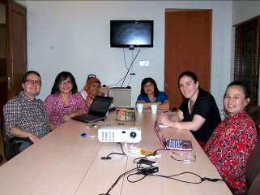
Meeting with AGENDA

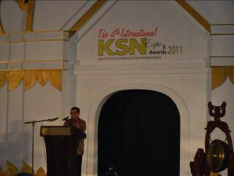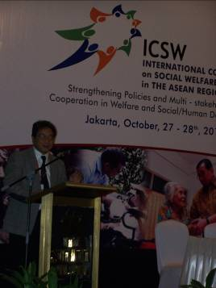
Opening Ceremony and Keynote Address

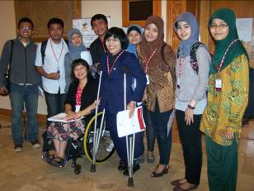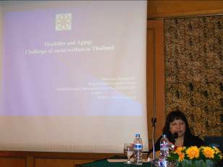
Parallel Discussion Sub-theme: Disability
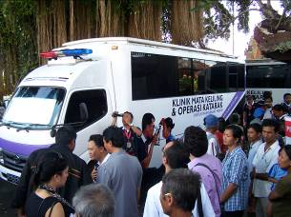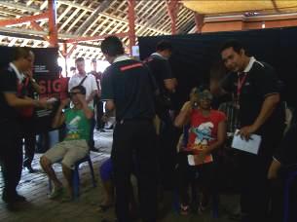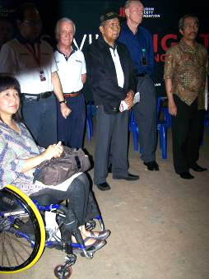
Visit Bayaan Village, The John Fawcett Foundation, Denpasar, Bali

