VIETNAM REPORT

EMPLOYMENT OPPORTUNITIES FOR PERSONS WITH DISABILITIES

VISITS TO DP HANOI AND PROTEC PLANT

Visit to DPI HANOI on 1st June 2011

Persons in attendance: Mr Vu Manh Hung, Chairman of DP Hanoi, Mr Lan (English-Vietnamese interpreter working as PA for HILC)
DPIAP team consisting of Kwanruthai Savangsri, Sureeporn Yupa, Walaiphorn Phanomkun, Worapan Buranasilpin, Mariam Ali

A meeting was arranged between the DPIAP team and DP Hanoi at their offices on the 1st of June. The purpose of the visit to get an overview and better understanding of how DP Hanoi implements its employment program for persons with disability.

DP Hanoi has established the Include Agency with the purpose of training and assisting persons with disabilities in the pursuit of employment in Hanoi.
Hanoi consists of 8 districts with each district having training centers which provide vocational training for all people, which people with disabilities also attend. In addition to this DP Hanoi organizes training workshops for persons with disabilities. These workshops are sponsored by companies and local government initiatives. The types of workshops organized include tailoring and producing handicrafts. There are also courses offered on soft skills such as behavioral training and communication skills in the workplace which is a one week course. Another course on offer is a three month basic computer skills class. The Include Agency aims to act as a link between employers, employees and persons with disabilities.

DP Hanoi works closely with the Vietnam Chamber of Commerce and Industry (VCCI) and the Blue Ribbon Employer Council (BREC) in the hiring and retention of persons with disabilities. VCCI is a national organisation which assembles and represents employers and the business community of all economic sectors in Vietnam. BREC was established in 2007 with the purposes of promoting the employment of Vietnamese persons with disabilities along with supporting employers recruiting persons with disabilities. Currently BREC has 45 employers as members. BREC’s website has information about employment opportunities available for people with disabilities in different companies as well as a job search section.

In the event that the Include Agency collaborates with a company seeking to employ persons with disabilities, DP Hanoi disseminates this information through its network. In the future, Include Agency plans to start micro finance for persons with disabilities. Currently there is a project for persons with disabilities of 2 levels.

i)Persons with Disabilities that want to start a business

ii)Persons with Disabilities who already have a business to hire other persons with disabilities to work within the businesses.
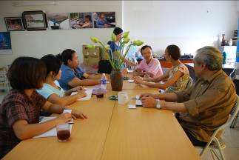

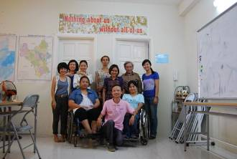

Some of the challenges facing persons with disabilities in the workplace include accessible transportation means to and from work, and also accommodations within the workplace. In general, persons with disabilities have to make do with the conditions of the job as employers are reluctant to make accommodations. Additionally, companies have different policies about compensation when hiring people with disabilities- some companies will have an equal pay policy while others with pay people with disabilities less than the other workers.

It is important to note that in Vietnam, there is a government regulation related to the number of hours people with disabilities work for. For every 8 hour shift, persons with disabilities are expected to work for only 7 hours but to receive wages for an 8 hour shift. It is unclear how well this regulation is applied or enforced.

According to DP Hanoi, persons with physical disabilities have a higher success rate in obtaining employment than people with other disabilities e.g sensory ones like hearing or sight impairments.

Resources:

www.brec.vn

