This meeting was initiated by Disabled Peoples’ International Asia Pacific (DPI/AP) and participants from the Mekong region were invited to share and discuss the project “Capacity Building of Disabled peoples’ organizations in Mekong region to increase organizational effectiveness and achieve sustainability”.
Program for Task Force Meeting
Disabled Peoples’ International Asia Pacific Office
30th and 31st May 2012
92 Phaholyothin 5 Road, Samsennai, Phayathai Bangkok 10400 THAILAND.
DAY 1, 30.5.2012
TIME | ACTIVITY | REMARKS
09:00 - 09:15 | WELCOME  Opening remarks | by DPI/AP, Ms. Tina
09:15 - 09:45 | SHORT INTRODUCTION OF THE PARTICIPANTS | Mr. Nouaneta, Mr. Zin Min Htet, Mr. Saorath, Ms. Hong Ha and PA, Ms. Phornphan, Mr. Udomchock, Ms. Sureeporn
09:45 - 10:30 | INTRODUCTION OF MEKONG PROJECT: “Capacity Building to Disabled Peoples’ Organization (DPO’s) in Mekong Region to increase organizational effectiveness and achieve sustainability.”  - overview about the project  - focus on list of organization  - need assessment survey | Ms. Tina
10:30 - 10:45 | COFFEE BREAK
10:45 - 12:15 | SITUATION OF PEOPLE WITH DISABILITIES AND THEIR ORGANIZATIONS IN THE MEKONG COUNTRIES, Practical examples and experience sharing | - by Mr. Ngin Saorath, Executive Director CDPO, Cambodian Disabled People´s Organization (CDPO)  - Mr. Nouaneta Latsavongxay, Project Manager of the Disability Right Promotion Unit, The Lao Disabled People’s Association (LDPA)  - Mr. Zin Min Htet, Chair Person, Disabled People’s Development Organization (DPDO), Myanmar  - Ms. Nguyen Hong Ha, Program Director, Hanoi Independent Living Center  - Mr.Udomchock Churat, Thailand Council for Independent Living
12:15 - 13:15 | LUNCH BREAK
13:15 - 13:45 | Continuation of practical examples and experience sharing | - by Ms. Phornphan Srikhatthanaprom, Program Coordinator on Human Migration, Labor Migration Department, Mekong Institute
13:45 -15:00 | DISCUSSION PART I  - set up a task force team  - discuss ways to find grassroots level groups for the target group of the project  - discuss list of DPO’s participants in each countries  - develop key activities and criteria for target group | Facilitator Ms. Tina
15:00 - 15:30 | COFFEE BREAK
15:30 - 16:30 | DISCUSSION PART II  - draft guideline of Needs Assessment Survey | By Ms. Tina and participants
16:30 - 17:00 | CLOSING REMARKS AND PROSPECT OF THE NEXT DAY | By Ms. Tina
DAY 2, 31.5.2012
TIME | ACTIVITY | REMARKS
09:00 - 09:30 | RECAP OF THE PREVIOUS DAY | by Ms. Tina and participants
09:30 - 10:45 | CONTINUATION OF DEVELOPING NEEDS ASSESSMENT SURVEY  - create and discuss the contents of the Needs Assessment Survey  -discuss form of questionnaire | by Ms. Tina and participants
10:45 - 11:00 | COFFEE BREAK
11:00 - 12:15 | CONTINUATION DEVELOPING NEEDS ASSESSMENT SURVEY  - complete the draft | by Ms. Tina and participants
12:15 - 13:15 | LUNCH BREAK
13:15 - 15:00 | SET UP PROGRAM  - create provisional program of the workshop  - discuss implementation | by Ms. Tina and participants
15:00 -15:15 | COFFEE BREAK
15:15 -16:30 | SUMMARY OF THE MEETING  - prospect the next steps and cooperation between the task force team members  - recap of our meeting  - future cooperation  - summarizing results and outcomes of the meeting | by Ms. Tina and participants
PA – Personal Assistant
REPORT
On 29th of May 2012 the participants arrived from Lao PDR, Vietnam, Myanmar, Cambodia and Thailand. The venue of the meeting was at DPI/AP office in Bangkok.
On the first meeting day on 30th of May, we started with an introduction for each participant. After this Ms. Tina presented the contents of the project. The project is designed in three phases:
- Phase 1: Task Force Team meeting
- Phase 2: Needs Assessment Survey Development
- Phase 3: Program Implementation (Organizational Development)
This first coincidence belongs to the first Phase and contents that set up a task force team to provide guidance and develop a key activity. Our task force team members include experts on each area.
The outcome of this first action was to develop a list of DPO’s participants in each country and to draft the guideline for the Needs Assessment Survey. Besides, after this two day meeting we would have a provisional program of the workshop.
After the first session Ms. Tina invited the participants to present about their organization and their experiences in working with the DPO’s in their countries.
After the presentation we set up our task force team members who are as follows:
- Lao PDR Mr. Nouaneta
- Myanmar Mr. Zin Min Htet
- Cambodia Mr. Saorath
- Vietnam Ms. Hong Ha
- Thailand Mr. Teerayudth
- Mekong Institute, Ms. Phornphan
- DPI/AP Ms. Saowalak, Ms. Tina, Ms. Worapan
The Task Force team discussed the difficulties and problems which we are going to expect when we are going to work with DPO’s in the grass root level.
After we confirmed the names of the task force members we discussed the key activities. It includes the following: Together we will draft the survey guidelines, the experts will find translator for survey from English into native language, the members are in collaboration with DPI/AP, the TFT will coordinate and select DPO’s at the grass root level independently, they also will coordinate the distribution of Need Assessment Survey to the selected DPO’s in each country, they will assist to define the training curriculum for the participants in the workshop (Phase 3), they will help to identify the trainer or being the trainer for the training/workshop, they will support the evaluation process, they will take care of logistics arrangement and support. DPI/AP has the overall program management and will coordinate and collaborate with TFT. DPI/AP is also responsible for logistics arrangement, in-country design and coordination with TFT, we will disseminate the Need Assessment Survey to TFT and some more activity of the co-operating partners in the project is already in the overview of the project. These are just some points we discussed in our meeting.
Furthermore we developed some Criteria of the target group (DPO’s). We decided that we will invite 4 Participants from Lao PDR, Cambodia, Myanmar, Vietnam, Thailand (LCMVT), cross disability, we will focus on DPO’s in the grass root level, it should be gender balanced, the person minimum of 2 years experience in disability organization and disability movement, the representatives should be leader or decision maker of the DPO, it is prioritized on young leader with good educational background and the ability to share the knowledge after the training with their colleagues and other organizations are welcome.
In the afternoon we started to draft the need assessment survey. We had to consider how to formulate the questions that it is understandable for everyone and what type of question we will use. This regard takes a lot of time and we went on with this on the second day. We considered again shared our ideas and we were able to finish the draft on time. After the lunch break we started to create a provisional program for the workshop which will be held at the beginning of October. We did a brainstorming on what could be a good training schedule for one week training to the participants of DPO’s in the grass root level.
At least we summarized our meeting with all necessary outcomes and concluded the next steps for our future cooperation and collaboration.
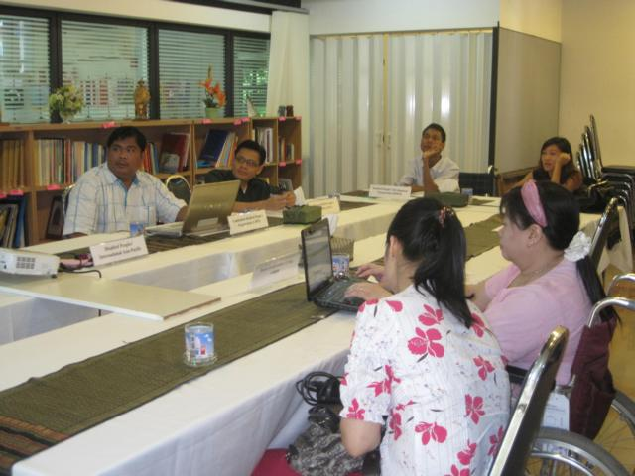
In the meeting room with the members of our Task Force Team.
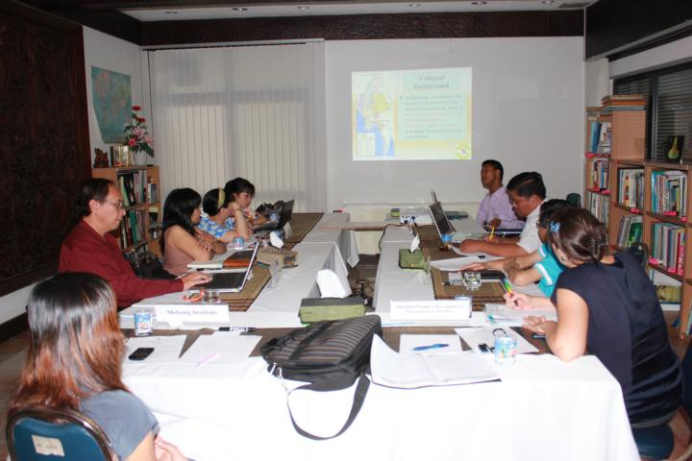
The participants listen to the presentation of Mr. Zin Min Htet from Myanmar.
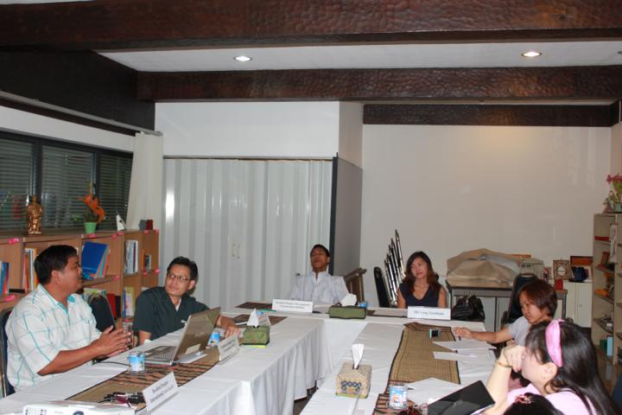
During the meeting we had some discussions and shared our experiences.

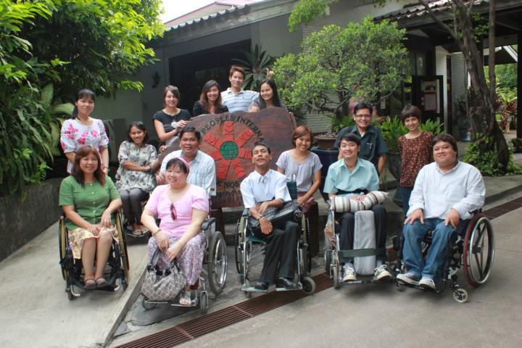
Group photo with DPI/AP staff and Task Force Team members in front of DPI/AP office.

* Report prepared by Tina Schaarschmidt

