

Report

Mission to Vietnam
27 May – 3 June 2011

By

Ms. Kwanruthai Savangsri
Ms. Sureeporn Yupa
Ms. Mariam Ali
Ms. Walaiphorn Phanomkun
Ms. Worapan Buranasilpin

Acronyms

DOLISA Department of Labour, Invalids and Social Affairs

DPOs Disabled People’s Organizations

HILC Hanoi Independent Living Center

IL Independent Living

MOLISA Ministry of Labour – Invalids and Social Affairs

PC Peer Counseling

PWDs Person with Disabilities

VND Vietnamese Dong

WWDs Women with Disabilities

Mission: Vietnam
Organized by: Hanoi Independent Living Center (HILC)
Contact Address: Hanoi Independent Living Center
Address: Số 42 Kim Mã Thượng, Ba Đình, HN Điện
Tel: 84.43.7674.808
Fax: 84.43.7674.809
Email: ttsongdoclaphn@gmail.com
Website: http://ttsongdoclaphn.vn

HILC
Contact persons: Ms. Nguyen Hong Ha
Mobile: 0934642939, 0904789596
Email: hhaand2@yahoo.com, ttsongdoclaphn@gmail.com
Ms. Nguyen Bich Thuy
Mobile: 01695211278
Email: ttsongdoclaphn@gmail.com

DPI/AP
Ms. Worapan Buranasilpin
Mobile: +66 0865813415
Email: worapan@dpiap.org

Duration: 27 May – 3 June 2011

Mission members:
No. | Name | Position | Remark
1. | Ms. Kwanruthai Savangsri | National Project Coordinator | Mission Leader
2. | Ms. Sureeporn Yupa | Project Coordinator on Reproductive Rights of WWDs | Mission Member
3. | Ms. Mariam Ali | ASEAN Business Coordinator | Mission Member
4. | Ms. Worapan Buranasilpin | Personal Assistant | Mission Member
5. | Ms. Walaiphorn Phanomkun | Personal Assistant | Mission Member

Aims:
- Sharing information of 1) DPI/AP’s role in Independent Living( IL )/ Independent Living Center (ILC) development in South East Asia 2) Development of IL/ILC in Thailand 3) Support from the Thai Government in disability development
- Follow up ILC in Vietnam.
- Monitoring of HILC
- Annual Report of peoples’ understanding and development of the IL concept in Vietnam.

The mission’s methods:
- Attend the inauguration of an IL centre in Hai Phong
- Interview PWDs who are involved in the IL movement
- Visit DPOs and PWDs in Hanoi

Outcomes;
- Understanding of the development of IL in Vietnam
- Report of the activities and developments of HILC
- Promoting the personal assistant (PA) service system in Vietnam

Schedule
Date | Time | Details | Remark
May 27 (Fri) | 13:00 | Arrive at Hanoi by QR 614 | Ms. Kwanruthai Savangsri  Ms. Sureeporn Yupa  Ms. Mariam Ali  Ms. Worapan Buranasilpin  Ms. Walaiphorn Phanomkun
May 27 (Fri) |  | Arrive at HILC | Hanoi Independent Living Center  Address: Số 42 Kim Mã Thượng, Ba Đình, HN Điện  Tel: 84.43.7674.808  Fax: 84.43.7674.809
May 28 (Sat) | 09:00 | Travel to Hai Phong city and stay at the Hotel Level. | Hotel Level  71 Lach Tray Str – Hong Bang District – Hai Phong  Tel: (84-31) 3 626 888  Fax: (84-31) 3 641 261
May 29 (Sun) | 08:00-08:30 | Hai Phong IL Workshop Registration | Hotel Level  71 Lach Tray Str – Hong Bang District – Hai Phong  Tel: (84-31) 3 626 888  Fax: (84-31) 3 641 261
 | 08:30–08:45 | Introduction | MC
 | 08:45–09:00 | Opening speech by organizers | Ms. Nguyen Quynh Hoa
 | 09:00–09:15 | Speech by the Mobilization Board on establishing Hai Phong ILC | Mr. Do Van Binh,  Vice- Director of Hai Phong Department of Labor, Invalids and Social Affairs
 | 09:15–09:55 | IL/ILC concepts  Q/A | Nguyen Hong Ha  Director of HILC Project
 | 09:55–10:15 | (1) DPI/AP role in IL/ILC development in South East Asia  (2) Development of IL/ILC in Thailand  (3) Support from the Thai Government in disability development | DPI/AP group
 | 10:15–10:35 | Tea break
 | 10:35–10:55 | Hanoi ILC Development  Q&A | Nguyen Bich Thuy  HILC Executive Director
 | 10:55-11:15 | HILC video
 | 11:15–11:45 | Speech by authorities from Hai Phong
 | 11:45–12:00 | Group photo
 | 12:00-13:30 | Lunch at the hotel
 | 13:30-14:30 | The changes in my life  (one of HILC user shares about the changes in his life after participating in IL movement and using HILC services  Q&A | Nguyễn Khánh Lâm
 | 14:30-15:00 | Q&A about the workshop contents | Nguyen Hong Ha  Nguyen Bich Thuy  DPI/AP  Hai Phong organizers
 | 15:00- 15:45 | Closing | MC
May 30 (Mon) | 09:00 | Peer Counseling Training
 | 11:00 | Interviewing some participants | DPI/AP
 | 16:00 | Return to Hanoi
May 31 (Tue) | 08:30-11:00 | Home visit to PWDs  - Ms. Ngo Tuyet Lan  - Ms. Dinh Thi Mui  - Mr. Lam Son Thong | Accompanied and interpreted by HILC secretary
May 31 (Tue) | 15:00 | Meeting with Ms. Hong Ha | Hanoi Independent Living Center  Address: Số 42 Kim Mã Thượng, Ba Đình, HN Điện  Tel: 84.43.7674.808  Fax: 84.43.7674.809
Jun 1  (Wed) | 09.00 | Interviewing PAs of HILC | Pay day for Pas
Jun 1  (Wed) | 14.00 | Meeting with DP Hanoi | DP Hanoi  P1506, nha A, 102 Thai Thinh,  Dong Da, Ha Noi
Jun 2  (Thu) | 08:30 - 11:00 | Home visit to PWDs  - Ms. Nguyen Thi Anh Ngọc  - Ms. Pham Thi Thanh Van and - Mr. Pham Quang Nam | Accompanied and interpreted by Mr. Hai, a Member of HILC
Jun 2  (Thu) | 14:00 - 16:30 | Visit Hanoi museum | Accompanied by Mr. Hai, a Member of HILC
Jun 3 (Fri) | 08:30 - 11:00 | Home visit to PWDs  - Ms. Nguyen Thuy Chi  - Mr. Bach Dinh Vinh |  | Accompanied and interpreted by HILC secretary
Jun 3 (Fri) | 15:00 | Visit Protect Factory
Jun 3 (Fri) | 23:20 | Depart to Bangkok by QR 615 |  | Ms. Kwanruthai Savangsri  Ms. Sureeporn Yupa  Ms. Mariam Ali  Ms. Worapan Buranasilpin  Ms. Walaiphorn Phanomkun

Report of the Mission
29 May 2011
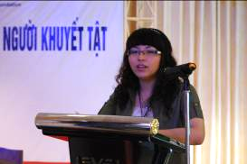
Ms. Nguyen Quynh Hoa
Hai Phong Independent Living workshop start and opening ceremony
Ms. Nguyen Quynh Hoa the leader of Hai Phong city welcomed everyone and introduced the workshop. In 2010 they introduced IL in Hai Phong because people to empower people with disabilities to live independently in the society in Hai Phong.

Speech by the Mobilization Board of establishing Hai Phong DPO by
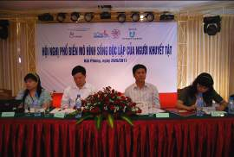
Mr. Do Van Binh, Vice- Director of Hai Phong Department of Labor, Invalids and Social Affairs Mobilization board of establishing Hai Phong DPO.
Welcome everyone to Hai Phong city. In Hai Phong, traffic accidents and natural causes primarily are the causes of disabilities in people. There needs to be more energy directed to integrate PWDs in the community for a better standard of life. From 2011-2016, support will be received from the government plus organizations within the society to boost this effort. They are now introducing to the 1st annual meeting to learn the concept of independent living in the society from Hanoi Independent Living Centre. The disability community in Hai Phong created an organization to support PWDs become socially active in the community 67 people were mobilized to join the organization. In April this year had the first organization meeting which enabled us to learn IL from HILC. This model increases the self confidence of PWDs in life and we believe this will be a fundamental step in the lives of PWDs in Vietnam with the help of the government.

2. IL/ILC concepts
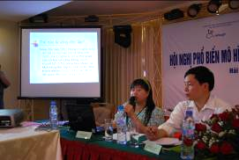
by Ms. Nguyen Hong Ha, Director of HILC Project (Annex No.1)
IL concept it refers to living independently with the help of the community to be able to live free and for PWDs to have control over many aspects of their lives be in study, where to live, who to live with etc. The end goal is equality with all people in the society. This concept is no charity based but is in fact rights based with the intention of providing permanent support to PWDs.

Barriers to PWDs
1. Barriers from PWDs themselves.
2. Barriers from the society such as a lack of accessibility in the society in public transportation, education and employment etc.

HILC try to practice the IL concept by providing skills for living well and show PWDs their potential to encourage them to achieve in the society.

Targets of IL
1. Help PWDs achieve their potential.
2. Have better means of transport and accommodation.
3. Better financial and educational aspects.

Currently for the HILC, there is only partial support from the government in Vietnam. HILC also receives support from an international donor. ILC is a not-for-profit centre where PWDs come to develop and gain knowledge. Training courses are provided for PWDs as well as for the personal assistants. In the composition of an Independent Living Centre, 51 % of board should be persons with disabilities and the manager of the centre as well should be a PWD.

Mr. Ed Roberts (1939- 1955) was the first initiator of IL and started Independent Living in America for people with disabilities. In 1987 Human Care started the ILC in Japan and this has grown and developed to many centers all over the country. There are a lot of ILC in many countries all over the world-from America to Taiwan to the Philippines. IL concept enables and empowers persons with disabilities to live active lives in the society.
What do you think of the IL concept?

1. Firstly, the IL concept embodies working together and supporting each other.
2. What is needed for PWDs in Hai Phong?
- Disability law
- Policies
3. Policy on Social protection concern to
- Pension for PWDs and elderly people
- Policy in the community
- Pension for medical service

3. Presentation by DPI/AP (Anndex No.2-3)
(1) DPI/AP role in IL/ILC development in South East Asia;
(2) Development of IL/ILC in Thailand
(3) Support from Thai Government in disability development
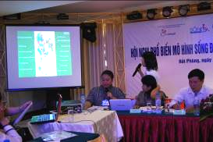
By Ms. Kwanruthai Savangsri National Project Coordinator and
Ms. Sureeporn Yupa Project Coordinator on Reproductive Rights of WWDs
Ms. Mariam Ali ASEAN Business Coordinator

4. Hanoi ILC development (Anndex No.4)
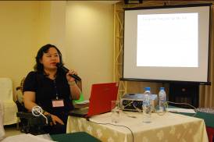
By Ms. Nguyen Bich Thuy HILC, Executive Director
HILC was started in 2009. There are currently 60 people receiving services aged between 18-60 years of age. There are 7 officers working in HILC and 83 PAs.
Personal Assistant Service
The personal assistant service is a service that allows PWDs stay independent within the society. We can provide PA for persons with severe disabilities to be able to access the community. HILC is also an information centre PWDs. In Hanoi we provide the PA service to PWDs living in 7 districts in Hanoi.
HILC provides training of PAs to help /assist PWDs learn life skills as well as skills for education and employment. PAs undergo a training course and receive a certificate after the course. Most PAs are students and generally work half a day at a time. The shifts are determined by the distance the PA has to travel to the PWD and how often the shifts will be. It is important for the PWDs and PA to work together as a team and learn how to treat each other to ensure a safe, comfortable environment for both.
Target
- Input
- Provide supporting service
- Peer Counseling
-Peer Counseling concept encourages more confidence and independence.
4. Provide information and mobile support for community
5. Change attitudes of the society
6. Cooperate with the government in policy matters. Work alongside the government to encourage them to fund ILC all over Vietnam.
7. Recognition of the PA system and also promoting it as a worthwhile job.
ILP – Independent Living Program
Here PWDs learn daily living and social skills training and they are taken outside to events and daily activities such as the market where they can meet members of the community and also other PWDs. PWDs are happy to become one of the community not just survivor.
What does the PA do
IL gives the training and is a free service. PA should understand and respect people with disabilities, and perform tasks asked of them that the PWDs wants done. The PA does the task the PWDs would like to do e.g cooking, setting the table, washing clothing etc.
PA can cook or clean the house and take them to school and general daily things that the PWD would like.
PA are not volunteers and are paid for the services they do for the PWDs. At HILC, the Nippon Foundation supports the independent living centre financially and PAs are paid from the contributions of this donor.

Hanoi People Committee in Hanoi city recommendations.
- Different Living.
- Acknowledge people with disabilities

5. HILC video
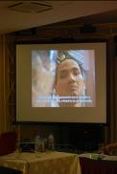
In Hai Phong, 74% of people with disability are living in rural areas. The government has provided 2050 wheelchair to people with disabilities and 1,000,000 VND for people with disabilities. This event today is very helpful to PWDs to show how they can improve their lives. I would like to invite you to see VDO of 3 cases from Hanoi Independent Living

(The example of VDO share the story of 3 case of PWDs member of HILC. All of them develop them self by using IL concept to improve their life)

6. The changes in my life by Mr. Nguyen Khánh Lâm, HILC user
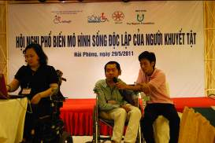
Mr. Nguyen Khánh Lâm
I was living with my parents 3 years ago. After I joined the HILC, I found out the many opportunities that people with severe disabilities can experience. For the first time I went to Big C and also went to market. I also learnt how to cook with my PA.
I have more confidence now. Before, I didn’t have any confidence. Now I’ve changed my life and even went to attend my friend’s wedding. I’ve been to play games and sing karaoke with friends. In Ho Chi Minh city, I went to visit an orphanage and visited children with HIV. Also for the first time I went to visit my grandfather.
Last year in Hanoi I attended the AESAN Peoples’ Forum. People with severe disabilities now have the opportunity to learn more with this system.

Q & A
Q: How many hours do you have a PA each day?
A: Most of the time I live with my family. My PA stays with me 8 hours each day.

7. Questionnaire (Annex No.5)
Interviewing PWDs in Hai Phong regarding the Independent Living concept and Independent Living Centre.
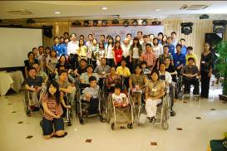

Take group photo after finish program
30 May 2011
Peer Counseling (PC) Session
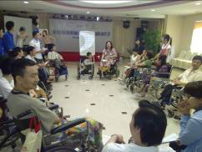
The session began with a message to the participants to understand more clearly why role play is important. Role play allows PWDs to exchange their experiences with each other by asking participants to raise their issues and receive responses. People with Disabilities can make their own decisions after learning from the experiences of other people. They have also gain more confidence. PWDs who lack problem solving skills learn in these sessions how to solve problems. They also gain more friends from PC.
Grouping during role playing allows:
- PWDs to have more friends.
- PWDs to express their feelings and have more confidence, and also to learn practical problem solving.
- Performing role play frequently is good for skills practicing.

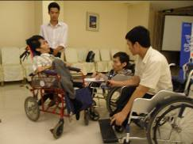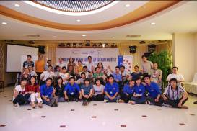
Peer Concealing Program Group photo with volunteer

31 May 2011
Home visit 3 case
Ms. Dinh Thi Mui
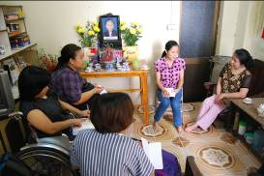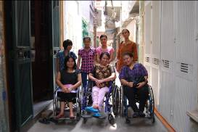
She is a 56 year old with polio. She is unemployed. She learnt about HILC from TV and applied to join the centre. She started to use the PA service in August 2010, and has one PA from Monday to Saturday, 07.30 -16.30. On Sunday she stays home alone. After she started using the PA service, she is able to go out in society and goes out more often to meet friends who are with and without disabilities, as well as go to the market to buy some food. Before having a PA she only stayed at home. Her PA is a student who is 22 years old who found out about the PA role from the internet.
Miss Mui goes to HILC to join activities and training courses. She also joins in the PC program and ILP. She would like people in society to know more about PWDs. In her opinion, IL is a concept that allows her to make decisions by herself and make friends. After attended PC training and ILP she understands more about IL and always tell her friends about it. In the future she would like to open a shop to sell dry foods.

Ms. Ngo Tuyet Lan
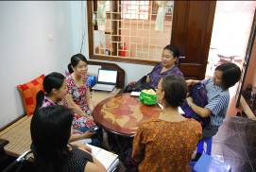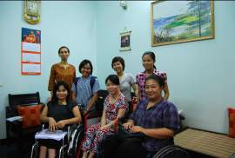
She is 53 year old woman with polio. She teaches mathematics to secondary school students in her house. She learnt about HILC from the internet. She is a friend of Ms. Mui and they met at HILC. She started to use the PA service in April 2010. She has one PA who works in the mornings from 08.00 to 12.00, and in the afternoons from 15.00 to 19.00 from Monday to Saturday. After she started using the PA service she can go out more often to meet more friends. She thinks PA is very important for her. Without the PA system, she can’t go out or do activities outside.
IL to her signifies that she is in control and can solve problems and make decisions herself. She attends training at HILC 3 times a month. After joining IL activities she feels more confidence. She would like to have more students to teach.
Her PA is 33 years old and she heard about HILC from friend a year ago. After working with PWDs she thinks society needs to do more to help PWDs and PAs are very important for PWDs since PAs help PWDs live independently.
Mr. Lam Son Thong
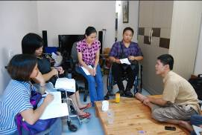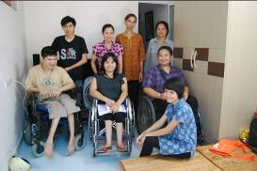
He is a 26 year old man with Cerebral Palsy. He is studying at home and would like to be a mechanic to repair electronics. After joining HILC he got the PA service. His PA who is a college student teaches him basic education such as how to write as well as mathematics. He has 2 PAs, one starts from 08.00-12.00 in the morning and the other one starts from 13.00 - 16.00 in the afternoon. His PA also teaches him some computer skills. His PA learnt about HILC from a friend who is a PA at HILC.
Mr Thong heard about HILC from other PWDs in December 2009. After joining HILC he has more confidence and lives independently. He can make decisions by himself. With his PA he can go out more often, he goes to the park twice a week. He used to join ILP and stayed in the experience room with his PA 3 times.

15.00 Meeting with Ms. Nguyen Hong Ha Director of HILC
Expanding IL concept
To expand the IL concept to other provinces of Vietnam, HILC went to 3 provinces - Can Tho, Hai Phong and Da Nang, to see the background of IL concept from them and chose 3 PWDs and 3 PAs to come to Hanoi to learn IL skill, how to work with government, local government and DPOs to set up ILC. After they went back to their provinces they organized a meeting to inform local government of IL and to learn how to get support from government.
Can Tho is the first province to organize a workshop. They have good relations with the local government. They invited DOLISA, DPOs and asked the government to provide the land to set up ILC and office of PWDs. The government promised to support them in this.
In Hai Phong the government does not have any background with regards to PWDs. In this case they need to conduct the training first then set up the center so the government can see their progress and get more information and knowledge about PWDs as well as the IL concept.
Ms. Nguyen Quynh Hoa is a leader of PWDs in Hai Phong. She is a teacher at a government college. At the moment the PWDs group in Hai Phong are trying to train people to work with them. They plan to find 10 persons and hope to have 3 of them as leaders.
From Ms. Hong Ha evaluation she thinks the seminar in Hai Phong was good. However ILC is still new for the participants. Now they are starting the process to form DPOs.
In Da Nang they do not have many groups who use the IL concept. They conducted a meeting with volunteers 1 day before the seminar. It was a one day training for volunteer on how to push wheelchairs and how to assist PWDs.
HILC
Personal Assistants
At first, the target for PAs were people who could work permanently however this idea failed as most people think PWDs are persons who only lie on bed all the time. Also they did not know the IL concept. Sometimes they trained house maids to be PAs but it did not work well because they would not change some of their habits and they did not understand the IL concept either. For students, they are eager to learn and live independently also which is why they understand IL concept easily. Some students used to work as volunteers so they are willing to be PAs. Media is one of the channels to raise awareness and raise the profile of PAs job. They used the word “being friends with PWDs” in the announcement which interested the students and they applied for the positions.
90 percent of PAs at HILC are students. Some of them are graduate students who are waiting to start their master degree. They can work 8 hours a day.
The PA role is open to people who are 18 -35 years old with at least a high school education. It is better to have students as PAs since they can learn quickly and do not break the rules. HILC have PAs rotating shifts so PWDs can learn how to work with different people. Some users did not want to accept new PAs but they have to abide by HILC rules. In the first year HILC meet with the parents of PWDs to make them understand IL and the PAs role clearly. They learn about the rights of PWDs and that they should not depend on their family all the time. PAs change the lives of PWDs so they will not be a burden to their families. Also it is important for them to note that PAs work only with PWDs not with their families.
Some of the rules of PAs include not sharing secrets of PWDs to others, and PAs can’t make decisions for PWDs.
Personal Assistant System
HILC tries to match the time of PAs and users such that they live near each other. They use the map to link this. Some PAs can’t work 8 hours a day and in this case the user may have 2 PAs a day.
At the moment HILC has 83 PAs. There are 60 users and the number is increasing.
There are 2 levels for PAs
First level- 6 months contract 100 hours practicing 13,000.00 VND/hour paid
Second level – after 6 months 15,000.00 VND/hour paid

HILC is supported by the Nippon Foundation for the salaries of PAs. At the moment they are in the process to register the center with the government. If the government approves this, they may receive support from government for payment to PAs. DP Hanoi will assist to find funding support for HILC.

Basic training > registration > PA Coordinator agree > practicing > 6 months contract
Payment is counted per hour. PAs receive about 3,000,000.00 VND per month.

Other matters concerned ILC
- The government can’t support the PAs payment because graduates who work at the government receive 1,000,000.00 VND per month. In this regards government can support for bonus for PAs.
- HILC invited some representatives from the Vietnamese government to go to Japan to visit the Japanese government and observe ILC there.
- Vietnam has a disability pension which amounts to 180,000.00 VND per month for person with severe disabilities. Persons with very severe disabilities receive 360,000.00 VND
- DP Hanoi assists some PWDs who are illiterate in education. Some of them learn how to use computers and PAs take them to study
- HILC conducts one ILP day each month for PWDs to share their problems.
- HILC pay transportation costs for PWDs to come to attend IL training.
- PWDs can receive wheelchairs from DPOs
- Every 6 months DP Hanoi work with NGOs and MOLISA to distribute wheelchairs to PWDs
- HILC was started with just 2 users and 2 PAs

1 June 2011
Interview PAs of HILC
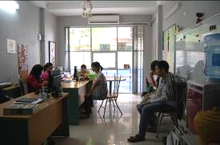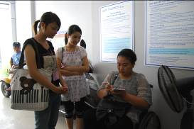
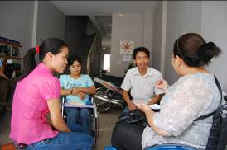
DPIAP took the opportunity of interviewing some PAs when they came in to collect their monthly salary on the designated pay day.
Mr. Dien Bien
He is a student of Social Science and Humanities. He has been working for 3 months. He would like to be a social worker and he learnt about HILC from his friend. Now he works with 2 PWDs for 5 hours a day in the afternoon.
Mr. Le Van Long
He is a student and is in his second month as a PA working at HILC and receives 13,000 VND/hour. He like this job so event he is student but can support other people and also can get money.
02 June 2011
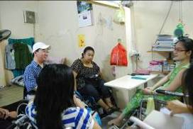
Home visit to PWDs 3 case
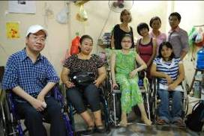
Accompanied by Mr. Hai, a Member of HILC and his PA. Mr Hai has Muscular Dystrophy and works at home as a sports editor for TV Channel.

Ms. Nguyen Thi Anh Ngọc
Ms. Ngoc is 19 years old. She was born with a curved spinal cord. After having a spinal cord operation when she was 14, she became PWD (spinal cord injury).
She is studying Psychology in the third year in a university near her house. In the university there are 15 students with various disabilities studying there.
Her PA assists her to go to university. Since the university is not accessible, her friends and PA assist her to go upstairs by carrying her when she has to attend her classes in other floors. She and her friends with disabilities requested the university to make a more accessible environment possible within the university. The university will change some places but not all because the university will be relocated in a couple of years. Currently, only one building has a lift.
After she graduates, she would like to work in hospital.
She learnt about HILC from her friends and some officers at her university. She has been using a PA since December 2010. She uses only one PA (Morning 06.00-11.00 am. Afternoon 13.00-18.00 pm.). Before that her friends and family assisted her to go school.
Before hearing about the IL concept she used to live her life independently which is similar to IL concept, however this concept has changed they way she thinks. In her opinion IL means PWDs can do everything they want. This concept is suitable for PWDs. She goes to HILC every 2 months and used to attend PC and ILP training.
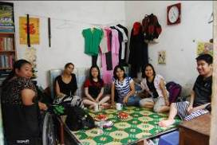
Ms. Pham Thi Thanh Van and Mr.Pham Quang Nam
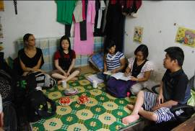

Ms. Van and Mr. Nam are brother and sister and have muscular dystrophy.
Ms. Van, the older sister is 22 years old. She has already graduated from university and would like to continue to study for her master degree and work part time at a publishing house.
She heard about HILC from the club of students with disabilities in university. There are more than 40 students (non PWDs and PWDs) more than 20 persons are volunteers. She uses 1 PA, 8 hours a day from 07.00 am – 11 am. and 1 pm – 5 pm. Her PA assists her with personal hygiene such as taking a shower, as well as going shopping, and from home to university.
IL means she can make her own decisions and live more independently. Before having a PA she had to depend on her friends for assistance.
Mr. Nam her younger brother, is 20 years old. He is studying Meteorology in the second year.
He learnt about IL in March 2011. He thinks IL is not only for PWDs it is for everyone. They can make their own decisions. He attended Training with HILC twice in 2010. This year he received the PA service. He uses PA from 07.00-11.00 am. Having a PA he can go out more often. He thinks PA can assist him and his PA is also his friend.
Both of them go to HILC every 3-4 months. They will attend PC training for the first time on 4th June 2011. They have already attended the Independent Living Program Training.

03 June 2011
Ms. Nguyen Thuy Chi

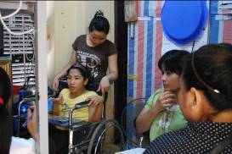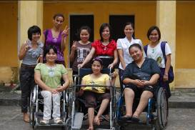
Ms. Chi is a 20 year old woman with Cerebral Palsy.
She is studying in the 1st year in the college of Journalist and Social Management. After graduation she would like to work in social work with PWDs.
She is staying in a dormitory of the college on the 1st floor. The dormitory is free for students with disability. There are only 2 students with disabilities at the college.
She heard about HILC from the internet and joined in August 2010. She received PA service in January 2011. Before having the PA service from HILC she had her own PA age over 40 years old. She paid 1.5 million VND for previous PA. At the moment she has 2 PAs, one working from 07.00 am. – 16.00 pm., the other one working from 17.00 pm. – 11.00 am. (overnight PA). Her PA helps her with daily activities which she cannot do by herself. On the weekend she goes out with her PA to the park.
IL means she can make her own decision.

Mr. Bach Dinh Vinh

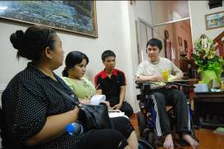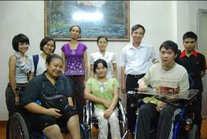
Mr Vinh is 37 years old. He got an accident in 1993. Now he is working at home as a magazine editor on computers. He found out about HILC and PA from the internet, and then his father contacted HILC. He is familiar with HILC for almost 2 years now. After becoming HILC member, he got the PA service immediately. He has 2 PAs for morning and night. He usually contacts HILC by email since he is quite busy working so he does not have much time to go to HILC.
For him IL means he can decide by himself. His PA enables him to fulfill his dreams.
Analysis of Hanoi Independent Living Center
(1) Degree of understanding of participants with disabilities on IL concept.
Three leaders with disabilities from Hai Phong city received IL training in Hanoi last year and brought the concept to Hai Phong city. From the questionnaire and interviews of participants with disabilities from Hai Phong, more then 50% understand the basic IL concept and they want to learn and want to live independently. But for the government, this is still a very new concept which they do not have much interest in. Hai Phong’s government does not have any background information about PWDs. In this case they need to conduct the training first then set up the center so government can see their progress and know more information about PWDs as well as IL concept.
(2) How is their impression on IL concept, who practices IL in community, and activities of Hanoi ILC.
They are impressed by the Independent Living concept. At HILC, PWDs enjoy the trainings and activities. HLIC also provides transportation costs to travel to the centre and they appreciate this and are keen to learn more about IL, equality, rights etc.
In Hanoi there are 7 districts serviced by HILC. There are currently 60 members with disabilities most of them they are severe disabilities and HILC provide ILP, PC and PA for them. The centre has 83 PA and provides an information service for individuals. HILC can provide training for member to understand IL concept.
From the interviews conducted, we found some members have only attended ILP or PC once or twice, and after that they got a PA. Some of them are not very clear on the IL concept but they need to have PA. For those that need a PA, there is a very short time to learn how to be with PA in the experience room, and how PA can support people with disabilities in term of IL concept.
We observed that in some cases PWDs are entirely reliant on the PA service in their homes. Accessibility and empowerment are important aspects of the IL concept and we feel there are certain changes that can be done to ensure some more accessibility within the homes of some PWDs, meaning there is not such a heavy reliance on PA for every action or task required. In this way, PWDs with some mobility, can retain their independence and perform tasks without depending on a PA for every task.
(3) Their willingness to accept the Independent Living Concept.
There are willing to learn more about Independent Living. For those who have severe disabilities 99% are happy and like to live independently they are happy to develop themselves through the IL concept.
(4) Their needs
Most of them after they learn Independent Living they want to find
- Employment (find job to get money and have a better life)
- Education
- Rights to family

