Report of Mission to India
09th June 2011

10:30 AM: Meeting with DPI India, the purpose of the meeting is to confirm the mission schedule and its logistic arrangement. Annex 1 is the mission schedule.

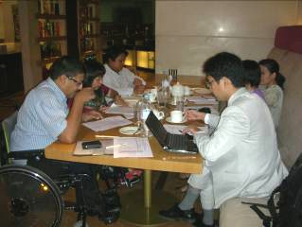

13:30 PM: Courtesy visit to Royal Thai Embassy, the purpose of the visit are to 1) introduce co organizer of the regional workshop in August, 2) share information on disability and development in Asia Pacific Region especially upcoming event in Inchon 2011 and Mainstream disability Perspective in ASEAN mechanism. Furthermore, we invited Thai Ambassador to join the regional workshop in August 2011. The response is very positive that the representative from the Embassy will attend the workshop in case the ambassador would not be available. In this regard, the ambassador, HE, Pisan Manawapat kindly suggested that action taken by persons with disabilities and their organization, Disabled Peoples’ Organization (DPOs), is very crucial to success independent living and lead to full participation and equal opportunity.
NB: HE Pisan Manawapat is at the middle, behind RDO
.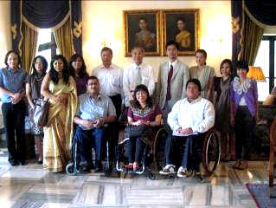

15:30 PM: Meeting with K. G. Balakrishnan, Chairperson of National Human Rights Commission. The purpose of the visit are to 1) share information on CRPD and its implementation 2) to explain the regional workshop in August and its expected outcomes which concerned to National Human Rights Institutions 3) to invite Justice Balakrishnan to participate the workshop. He also mentioned that the situation of mention illness is in at risk because its definition is not clear. Therefore, intellectual disability and psychosocial survivor are still excluded in term of Legal capacity.

NB: 1. India is a state party to CRPD

2. Justice K.G. Balakrishnan is a former Chief Justice of India. ( 2 right from the picture)
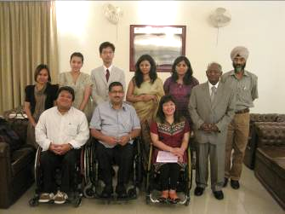
17:00 PM: Meeting with Mr. KM. Acharya, Secretary of Ministry of Social Justice and Empowerment, the purpose of the meeting is to seek collaboration from the Ministry of Social Justice and Empowerment for the regional workshop in August. The response is positive since India had organized DPIAP Regional Assembly in 1997. For decade, there is no regional event concerning to disability and development. The workshop in August will bring 100 overseas participants together with min 50 Indian participants. Mr. KM. Acharya request DPIAP to submit an official letter as soon as possible. He also appreciates a coordination of OHCHR and expects that ESCAP will confirm the coordination soon. Annex 2 is tentative program and general information for the workshop in August.
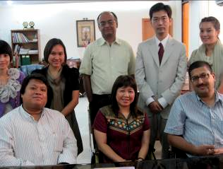

17:30 PM: Meeting with Mr. Pankaj Joshi, IAS Joint Secretary of Ministry of Social Justice and Empowerment, the purpose to the meeting is to discuss in detail of the regional workshop in August and share information on the disability movement in Asia Pacific, the Decade and Inchoen event 2012.

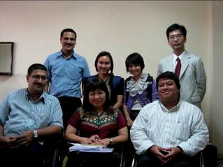
10th June 2011
!0:30 AM: Accessibility Audit for City Tour, additional program on 22nd August 2011. The mission team visited 2 world heritage site of India. 1) Humayun’s Tomb, 2) Qutub Minar.

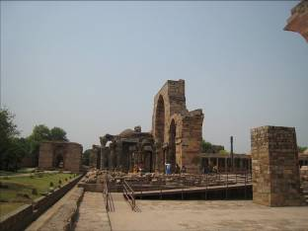 |  | 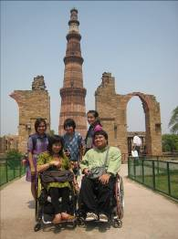
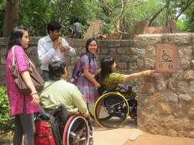 | 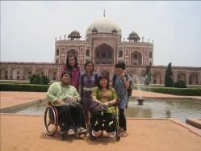

16:30 PM: Meeting with Mr. Sunny Chadha, Assistant Director of Sales, Shangri-La’s Eros Hotel. The purposes of the meeting are to confirm necessary arrangements for the event and to sign contact to the hotel.

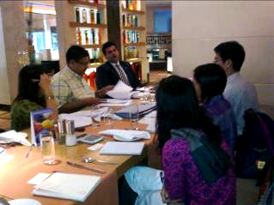
11th June 2011
15:30 PM: Press Conference at Indian Women’s press corps, the purpose of the conference are to inform the media company the workshop in August and to raise awareness to Indian Society on disability friendly environment. Annex 3 is for more details of the news.
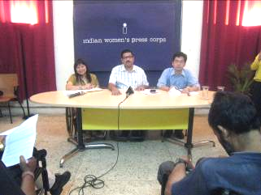
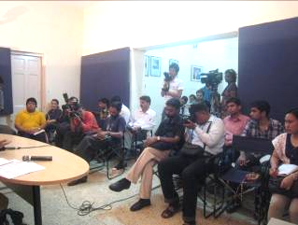
15:30 PM: Visit Action for Ability Development and Inclusion (AADI), the purposes of the visit are to check buses with lift that will use for transportation during the event. AADI kindly provides 2 buses to pick up and send of participants. We also observe SAMBHAV center where provides showcases in various ways in which the principles of universal design can be applied in different areas of life like communication ( enhancing listening, understanding and alternative modes of communication); learning (play, concept teaching and self learning); movement ( transfers, supported walking, alternative methods of mobility, and outdoor traveling); and just doing things ( for well being, safety, eating, drinking self care, home chores, work and managing money). For more details of AADI, please visit http://aadi-india.org/
