TRANSED 2012' Steering Committee meeting to preparation for TRANSED 2012, New Delhi, India

Mission: New Delhi, India
Organized: Svayam - Working towards inclusive environment
Contact Address: Mr. Subhash Chandra Vashishti
Project Coordinator-TRANSED 2012
Secretariat TRANSED 2012, India
Address: Jindal Centre, 12, Bhikaji Cama Place, New Delhi-110066
Tel: +91 - 11 – 26188360-74 Direct: +91 11 41462323
Fax: +91 - 11 – 26105671, 26170691
Email: subhash.vashishth@transed2012.in, secretariat@transed2012.in,
Transed2012.india@gmail.com, subhash.vashishth@jindalsaw.com, subhash.vashishth@svayam.com
Website: http://www.savyam.com, http://www.transed2012.in

Duration: 19 - 22 September 2011

Mission members: 2 persons

No. | Name | Position | Remark
1. | Mr. Wansao Chaiyakul | Project Coordinator | Mission Leader
2. | Mr. Arsin Chaiyakul | Personal Assistance | Mission Member

Aims:
- To visit and reports the 13th International Conference on ’Mobility and Transport for Elderly and Disabled Persons’ TRANSED 2012 held on September 17 - 21, 2012 Delhi, India to Royal Thai Embassy;
- To have the steering committee meeting on the TRANSED 2012
- To feedback and discussion on the preparation on TRANSED 2012

The mission’s methods:
- Visit to Royal Thai Embassy.
- To organize the steering committee meeting
- To have the technical checking on the preparation of TRANSED 2012

Outcomes:
- The Outcome of the steering committee meeting will contribute to the TRANSED 2012

19 September 2011

Courtesy visit to Royal Thai Embassy, the purpose of the visit are to inform and introduce the 13th International Conference on ’Mobility and Transport for Elderly and Disabled Persons’ TRANSED 2012 held on September 17 - 21, 2012
20 September 2011

10.00 AM: Field visit to The LaLiT New Delhi accessibilities checking of the hotel facilities as plenary room and room for TRANSED 2012’s participants. LaLiT hotel is the prospective venue that locates in downtown near MRT Shivaji station and market.

14.00 PM: Visit Svayam office at Jindal SAW Limited Building (Jindal is supporting organization to TRANSED). To have the meeting with Ms. Sminu Jindal, chairperson of Svayam and TRANSED task force team. Steering Committee had feedback and suggestion on the accessibility checking at LaLiT hotel.
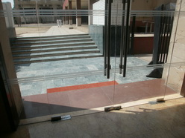
Plenary hall located in the first floor of the hotel and there is one unisex accessible toile room at that floor. TRANSED 2012’s steering committee and the secretariat team agree together to advise the hotel providing the temporary accessible toilet for persons with disabilities at the first floor, the temporary should width and had more space for wheelchair to turn around the wheelchair.

TRANSED 2012’s secretariat plan to arrange the area beside the plenary room to set up the welcome dinner however the area is outdoor area and there are some step, the hotel and TRANSED 2012’s secretariat will provide the ramp.

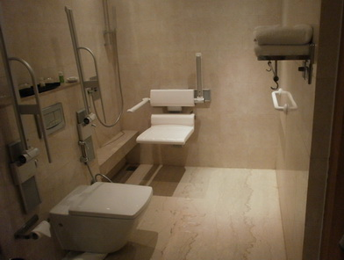
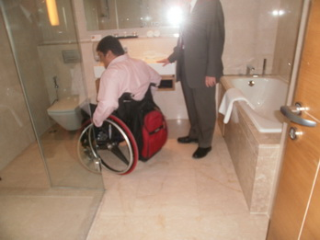
For the hotel’s accessible room, there are four accessible rooms available for wheelchair persons but the non accessible rooms are convenient because the toilet door is narrow. The steering committee advised the hotel and the secretariat provide the optional facilities such as wheelchair shower, bucket and bowl even though the toilet rooms and shower room width enough for wheelchair to enter, to provide the optional facilities be in convenient for PWDs to feel comfortable.

The secretariat team reviewed the preparation of the TRANSED 2012, logistic, program, road show promotion and abstract selecting. There are 308 abstracts submit to the TRANSED 2012 so that the processing of reviewing and selecting eventual the selecting of the abstract need to have the process and partner to working together. The steering committee suggested the process of selecting should have to list of countries, authors and topics? That should be very useful to help orient the process of selecting. The list of selected abstracts including the details will announce at www.transed2012

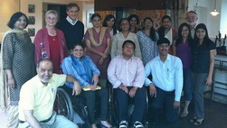

Ms. Sminu Jindal had a notice on how to promote the TRANSED 2012 through the social media and mass media so that the secretariat will promote the TRANSED through the media.

21 September 2011

10.00 AM: The steering committee and the TRANSED 2012 secretariat team discuss on the process of present the abstract. The steering committee worry on that because of there are a lot of abstract to present on the TRANSED and how to manage the time line and method of presenting the abstract, parallel section and panel section are the choice of design to present the abstract on TRANSED 2012
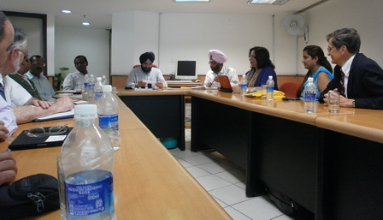

16.00 AM: Meeting with Mr. Shri Arvinder Singh, Minister of Transport, Govt. of Delhi, the purpose of the meeting is to seek collaboration from the Transport Department of Delhi to support the TRANSED 2012 held in Delhi. Mr. Shri Arvinder Singh and Delhi government had the strong determine to support and collaboration to support the TRANSED 2012.
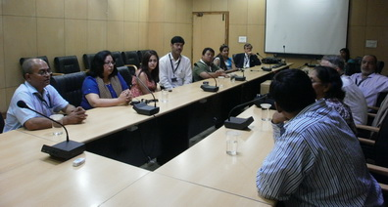

17.00 AM: Meeting with Delhi Multi Model Transit System’s high level officer to seek the collaboration from DIMTS to support the TRANSED 2012.

Tentative Mission Program (as of 16 Aug 2011)
Day 1 – 19 September, 2011: Visit to Royal Thai Embassy
Time | Activity | Speaker/Facilitator
10.20 | Mission team arrive to India | By 9W63 , Jet Air Ways
19.00 - 20.00 | Visit to Royal Thai Embassy
Day 2 – 20 September, 2011: Steering Committee Meeting
Time | Activity | Speaker/Facilitator
10:00 -13:00 | Social tour (Qutub Minar- Accessible World Heritage Site), Visit to the proposed conference venue
13.00-14.00 | Lunch at Hotel Lalit
14.00-17.00 | Review Meeting & Presentations by Steering Committee members, Scientific Committee & Secretariat (Members will present their brief reports on their efforts towards the TRANSED 2012, Svayam will present its report on the progress thus far)
Day 3 – 21 September 2011: Technical Tour and Feedback
Time | Activity | Speaker/Facilitator
10:00 -13:00 | Technical Tour to BRT followed by visit to DIMTS office (Delhi Multi Model Transit System)
13.00-14.00 | Lunch
14.00-17.00 | Feedback session
19.00 | Joint Dinner of Local Organizing committee, International Steering Committee & International Scientific committee.
Day 4 – 22 August, 2011: Mission team depart from India
Time | Activity | Speaker/Facilitator
12:15 | Mission team depart from India | By 9W64 Jet Airways

