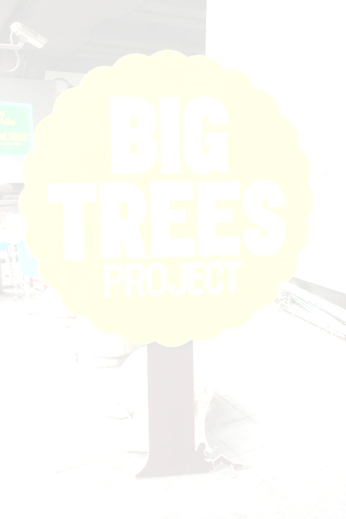
Report:
The BIG TREE and SABEI WALK project: Speak Out (Quietly) for Bangkok

On 27th of May 2012 some people came together to raise awareness for a quite and peaceful Bangkok. This initiative is running under the Quiet Bangkok Group, Big Trees Group, and Bangkok Sabai Walk Project. Of course it will raise awareness for the trees. Trees are our friends and we need them to breath. Without trees we are not able to survive. That’s why it is so important to have trees in a city and to protect the forests on this earth. A city with trees looks much better and it is better for all of us and our health.

Bangkok is such a city which needs more trees. If you walk on the street you can not find trees. There are only a few but really seldom to see. In Bangkok you have some parks but not enough to clean the air from his terrible pollution. Sometimes there is a blanket of smog around Bangkok and it feels like that there is no fresh air which you can breathe. It is like going to suffocate. The traffic in this city is unbelievable. Is this good or not? It isn’t for us and that’s why we came together and wear our T-shirts to promote a green, quite and peaceful Bangkok.

We met at the last station of the BTS at Mo Chit. All of us put on the T-Shirt and then we went upstairs and stand in a line and wait for the BTS. Then we got inside and stand in a line. At some stations we got off again and wait for the next BTS. We tried to spread our message to a lot of people that they think about our environment and to find support for our idea.

We went down with the BTS until Udom Suk where we change the BTS into the other direction again. We stand again in a line in the BTS and showed our concern. We kept shutting our ears and were holding our finger on our mouth. We got off at Siam station where we pool together in the middle of the station and we showed up again our message through our gestures.

After this we went down to Siam square and go on to promote an accessible footpath. We also collected opinions from people who came along and ask them how they would like to make Bangkok better. We let them sign at the poster and collect their messages.

The Sabei Walk project is one special idea to make the surroundings at Siam square better. At the moment it is hard for people who are using a wheelchair to go on the street. There are a lot of gaps and large curbstones. That makes the movement very difficult. Also for people who are deaf and blind have difficulties because there is no special relief for them. Bangkok is a city where you can find a lot of barriers especially if you are a person with disability. But not only for people with disabilities it is hard to get around also for elderly who have difficulties to walk and families who have to push their baby buggy. Of course not only this area needs improvement but we have to start somewhere.

I really hope that more and more people became aware about an accessible
environment for everyone in a green nature without noise and pollution.
