Visit to Protec Helmet Factory, Hanoi on 3rd June 2011
Protec Factory is the first nonprofit helmet factory in the world which was started in 2001 in Hanoi by the Asian Injury Prevention Foundation, a registered US not-for-profit organisation. The main purpose of the foundation is to reduce the devastating rate of road crash injuries and fatalities in the developing world. Protec helmet factory produces lightweight helmets adapted for the tropical climates of Asia for motorbikes and bikes.
The helmet factory is located close to Hanoi’s airport, has more than 200 workers and out of those, claims 30% of staff are persons with disabilities. The Human Resources Manager, Ms Nguyen Anh Cam, advised they have over 20 persons with disabilities working in the factory in different parts of the assembly line. The factory is all on one floor and the assembly line was designed to be lower in order that persons with disabilities may be able to work comfortably. Protec Company keeps over 10 donated wheelchairs in the factory to enable persons with physical disabilities to move and work comfortably in the environment.
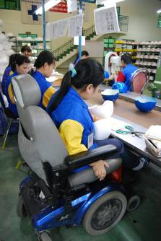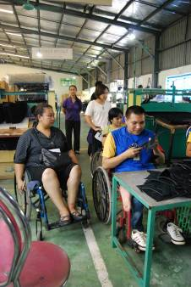

From the beginning in 2001, Protec began hiring persons with disabilities to work in the factory. Some of the staff with disabilities have now been with the company for a decade. There are different disabilities represented within the company. We observed, several different degrees of physical disabilities and hearing impaired. Persons with disabilities mainly work within the assembly line. Recruitment of persons with disabilities has been through word of mouth and also via job fairs organized by BREC (Blue Ribbon Employment Council). Most staff with disabilities working working at Protec live close to the factory and do not usually experience one of the biggest challenges for persons with disabilities, which is accessible transportation. The staff with disabilities working there arrive and leave from work in various types of motorized three wheeled scooters or motorbikes, or even by electric wheelchair. As they live close by, their mode of transportation allows them to travel independently without worrying about accessible public transportation.
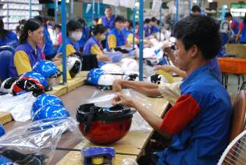

Persons with disabilities working at Protec company receive the same salary as their non disabled colleagues, although they work for 7 hour shifts, and not 8 hour shifts. Ms Nguyen Anh Cam explained that sometimes, some staff with disabilities will work an 8 hour shift as well. She advised that this government regulation is a disincentive for many companies in Vietnam not to hire persons with disabilities. Initially when the company was started in 2001, many non disabled staff did not want to work alongside with persons with disabilities for a number of reasons, including preconceived prejudices. However a few months after the start of the hiring of people with disabilities, management noted that attitudes had shifted and all staff integrated well together within the company. There is a probation period for all staff which is between one and three months long at the start of their employment with the company.
In terms of accessibility, the workplace is all accessible and on one floor, including the cafeteria, accessible toilets and pathways. As mentioned earlier, the assembly line was altered to be more accessible for people with disabilities to be accommodated
Challenges of hiring Persons with disabilities included:
- The working times for persons with disabilities is an hour shorter than the non- disabled staff. This means that the assembly line slows down significantly when persons with disabilities leave earlier.
- Attitude to work. Some persons with disabilities never having previously been employed have difficulty adapting to the work demands and regulations and need extra time to adjust to this.
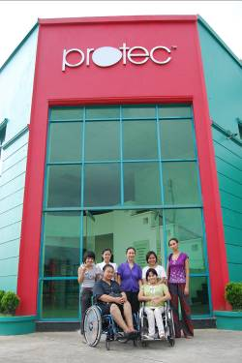
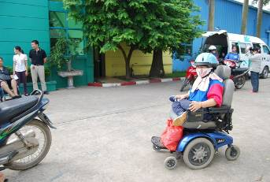

Resources
http://www.asiainjury.org/main/protec.html

