Report DPI/AP
Volunteer program “worldwarts” 2011/2012

One year was my contract between ‘bezev’ (disability and development cooperation) and Disabled Peoples‘ International Asia Pacific (DPI/AP) to work as a volunteer under the worldwarts program from August 2011 until August 2012 at the DPI/AP office in Bangkok, Thailand.
DPI is a world cross-disability, self-help, human rights organization of persons with disabilities (PwD). It was established in 1981 and adopted the motto “Nothing about us without us”. It is promoting full-participation and equalization of opportunity of PwD by delivering “A voice of our own”. There are seven regions around the world namely Africa, Asia-Pacific, Middle East, Europe, North America, the Caribbean and Latin America. DPI Asia Pacific has 25 members in Asia and the Pacific e.g. India, Australia, Solomon Island, New Zealand, Philippines, Indonesia and Cambodia. Mostly they organize activities that hasten the empowerment of persons with disabilities. DPI/AP promotes human rights of PwD and is strengthening self-help organizations of PwD. Furthermore their work is regarded to Advocacy, Accessibility, Women with disabilities, Youth Leadership and Independent Living. That means further they promote a barrier free society and an economic and social inclusion of PwD. Besides, DPI holds a special consultative status for the United Nations and collaborates with UNESCAP, UNESCO, ILO and so on.
At the beginning I had some time to read about the work of DPI because most of my colleagues had been on a mission and so it was only me and three other people in the office. I read a lot but the only thing I learnt from reading was the theoretical background but not how DPI is implementing its mission and how they are working to achieve their aims to reach full participation and equality for persons with disabilities in the society. The first thing I learnt was about the terminology. It’s better to talk about a person with disability than to mention their disability first. It has a lot to do with human rights and it goes along with the disability issue. DPI promotes human rights because the disability rights issues are human rights. That is one of the most important things.
When I arrived I had some work with me from my German organization “bezev” (disability and development cooperation) and I started to answer the questions of this country profile about Thailand. I tried to find out about figures and laws all regarding to disability. I had to answer questions what specific laws are existing to include persons with disability in the education, health system, HIV, pension and employment. It was very difficult to find some documents and some of my colleagues assisted me to find some Links where I could find some information. I tried my best but it was not possible to finish all of the questions. In my second month I took over the information support from another volunteer at DPI/AP. She explained me what I have to do and there was also a folder which explained how information support works. But the same as I felt when I read about the work of DPI it is theoretical and I could not imagine how it works in reality. When I first started my computer and I received almost 100 Emails. I was a bit overwhelmed by this big amount and I started to read the Emails. It was quite hard for me to find out which Emails are important and which are not. It took some time to find out who is sending which information and who belongs to which group. The Email address of information support gets a lot of other Newsletters and is included in different groups which are all about ASEAN, human rights and disability. It is a lot of work to find out the connections and to understand. I think it took me another 2 months. I was also busy to create the weekly Newsletter and at the beginning I was unsure about the contents and I didn’t know what is important for our network. But after a while you will find out which events are coming up and what’s happening and worth to mention in your News.
I was also involved in some training which DPI organized and I got some assignments as well. There I learnt about Disability Equality training and Independent Living (IL) Program. I couldn’t understand when I first took part in it but when you see it again than you will understand and it will change something in you too. My attitude changed because it makes you more aware of the environment and the society which is barrier for persons with disabilities (PwD) and it’s not the person with the disability which is “not able” to participate in the society. That’s why we are talking about human rights because every human should have access and should be able to participate in the society and should have the same rights than others. But PwD have to overcome the barrier and they have to fight for their human rights too.
When I was familiar with the information support I wanted to do something else. I didn’t feel like that I am doing something useful for the organization. That’s why I came up with the idea to do some Interviews with PwD after I talked with ‘bezev’. The idea was coming from them because they collect some live-stories from PwD around world and will upload these stories on their website or publish it in their brochure. It is interesting to interview PwD about their experiences during their lives and to compare it with the context of the culture. I decided to make some Interviews with my colleagues and I recognized the language barrier was a big problem. That’s why I only used the English versions which I could do by myself. I had to transcribe the interviews and with some help the videos were subtitled. It was a good experience for me because I get more information and impressions what it means to be a PwD in Thailand. The biggest difficulties here are the accessibility of the environment and the inclusion of PwD in ordinary schools and not in special schools. Another problem is still the religion of the people. As Buddhist there is always a reason why you become PwD and so it’s still the case that some people think that you did something bad when you are PwD in your life before. To overcome such challenges is quite hard and it causes a lot of problems.
The most important project for me was the ABILIS project. Therefore I had to read a lot about capacity building and need assessment surveys. It was my job to take care of the project and to contact the members and set up a task force team which was involved to implement this project. The name of it was “Capacity building for DPOs in the Mekong region to increase organizational effectiveness and achieve sustainability”. Now I could learn how to run a project and what belongs to it. You have to get in contact with the persons you want in your team, you have to write the official invitations, arrange the accommodation for them as well as the pick up from and send off to the airport, prepare documents and the meeting room and of course you have to make a schedule and an agenda for the meeting. You can not do everything by your own so you have to involve your colleagues and ask them to support you in different tasks. Therefore you will have some meetings and renew the things after the consideration and it’s a lot of work to arrange everything. First it is important to get an idea what your project is going to achieve and which steps are necessary to make it real. You have to understand every detail and you are the person who has the plan and you will lead the others to support the project in some parts of the project. I created the questionnaire and I discussed it with my team members during our task force team meeting. It was quite exciting and interesting and sometimes not so effective as their imagination were a bit different from my. But anyway we were able to finish this meeting with good results and the next step was the spreading of the questionnaires. It takes a lot of time and it was almost the end of my year as a volunteer and I will not be here anymore when the workshop for the DPOs will take place. But I did my best to push this project forwards and I hope it will be successful.
As I mentioned above there are a lot of activities and I’d like to list some of them which I attended. It was a wonderful opportunity and very impressive for me. During my internship I got the opportunity to attend a lot of conferences, seminars and workshops.
I attended following activities:

- Inauguration of “ASEAN Disability Forum” cum workshop on the participation of Thai Disability community to develop a better life of PwD in Southeast Asia through ASEAN Socio-Cultural Community, Centara Grand at Central World, BKK, 18 – 19.09.2011
- Mainstreaming of PwD for African Countries – Independent Living Program, BKK, 10 – 17.09.2011
- Disability Awareness Campaign on Accessible Tourism for Elderly & Disabled, Sunway Pyramid, Selangor, Malaysia, Convoy, 27.11.2011
- Conference and Exhibition on Accessible Tourism 2011 (Pro-ICAT), Malaysia, 26.11.2011
I joined a conference about Accessible Tourism which was good to get information about the challenges and developments on accessibility. It mentioned a lot of steps forward and how to get in contact with the business factor to promote accessible tourism.
- Network development and capacity building for women with disabilities: The myths of women with disabilities, New York City Hotel, BKK, 2 – 4.12.2011
- Regional Stakeholder Consultation for the High-level Intergovernmental meeting on the final review of the Implementation of the Asian and Pacific Decade of Disabled Persons, 2003-2011, UNESCAP, Conference Center, BKK, 14 – 16.12.2011
This meeting was very interesting and it was the first time I could attend such an important meeting. Before this meeting I already had the opportunity to visit the UNESCAP building during the African training. It was all about the UNCRPD and the review as well as the look forward to the next decade. They discuss about goals, indicators and so on. I could learn about the UNCRPD and the Asia Pacific Decade of PwD.
- Mainstreaming of PwD for African Francophone countries – Independent Living Program, BKK, 4 – 11.2.2012
- International Seminar “Civil-Military Cooperation on Disaster Management”, Challenger Hall, IMPACT, BKK, 8.3.2012
- Regional Preparatory Meeting for the High-level Intergovernmental Meeting on the Final Review of the Implementation of the Asia and Pacific Decade of Disabled Persons, 2003-2012, UNESCAP, Conference Center, BKK, 14 – 16.3.2012
- ESCAP and Leonard Cheshire Disability, Disability – Inclusive MDG’s and Aid Effectiveness Conference, UN, BKK, 14 – 16.3.2012
This conference gave me the opportunity to learn more about the Millennium Development Goals and I learnt that there is no goal especially for PwD. So if we talk about education for children we should think about every child and this includes also children with disabilities and when they are going to build schools they should keep in mind that it is accessible as well.
- Economic and Social Commission for Asia and the Pacific, 68th session, BKK, 17- 23.5.2012 - 3rd High Level Consultation, G 20 Mexico Summit: Perspectives from Asia-Pacific, Adoption of the document for Incheon (Korea), UN Conference Center, BKK, 23.5.2012
- Tumma – Tummung Project: Speak out for quiet and accessible BKK and Siam Square Sidewalk, BTS, BKK, 27.5.2012
Therefore I got a T-shirt with our objectives for the demonstration and then we went with the Skytrain (BTS) to raise awareness on this issue. After this we collected signatures at Siam square and let people write what they want to make Bangkok more quiet, green and accessible.
- Task Force Team meeting for the project: “Capacity building for DPO’s in the Mekong region to increase organizational effectiveness and achieve sustainability”, DPI/AP office, BKK, 30 – 31.5.2012
- Exhibition “Dialogue in the dark”, BKK, 2.6.2012
I went to this exhibition with my colleague and we could experience what it means to be blind. You will be guided by a person who is visually impaired through different field of environment e.g. street, market, nature, restaurant or living room.
- ASEAN workshop on the Rights of Persons with Disabilities and the UN Convention on the Rights of Persons with Disabilities (CRPD); organized by National Office of Empowerment of PwD (NEP), Ministry of Social Development and Human Security (MSDHS), Siam City Hotel, BKK, 25 – 29.6.2012
This meeting was very interesting because the participants came from the governments and that means they have influence and so they have to become aware of disability issues as well.
- 2012 IPSR Annual Conference of “Marginalized Population and Social Justice”, Royal River Hotel, BKK, 2.7.2012
- APEC Digital Opportunity Center, Opening Ceremony at the Foundation for support and development of PwD, Thailand Pakkred, Nonthaburi, 19.7.2012

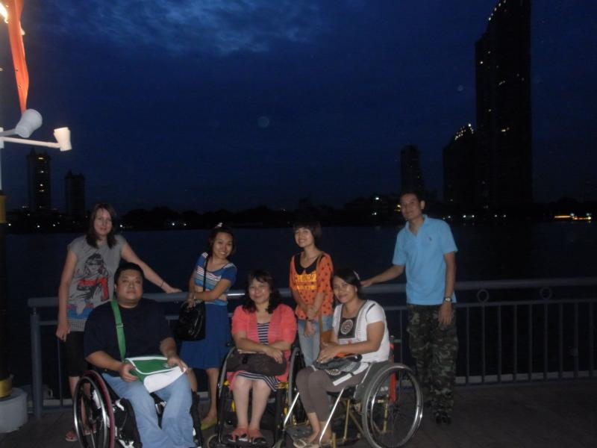
My colleagues from DPI/AP who joined me on my last day.

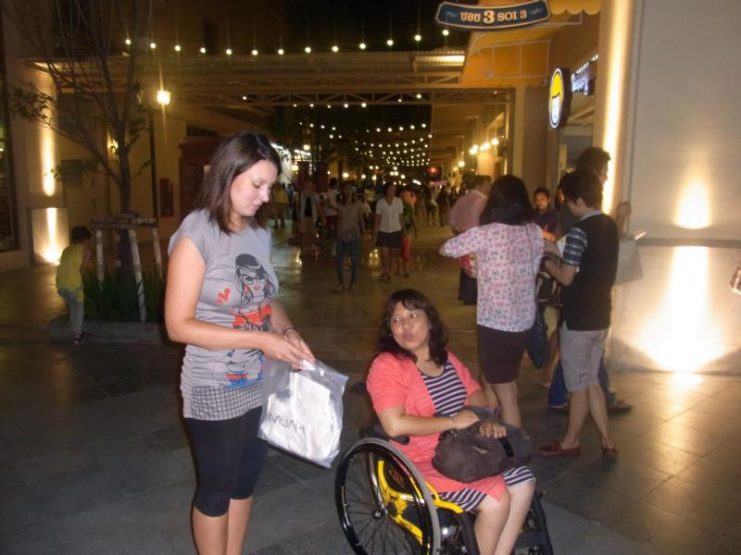
On my last day we went to Asiabotique close to the Chao Phraya river.

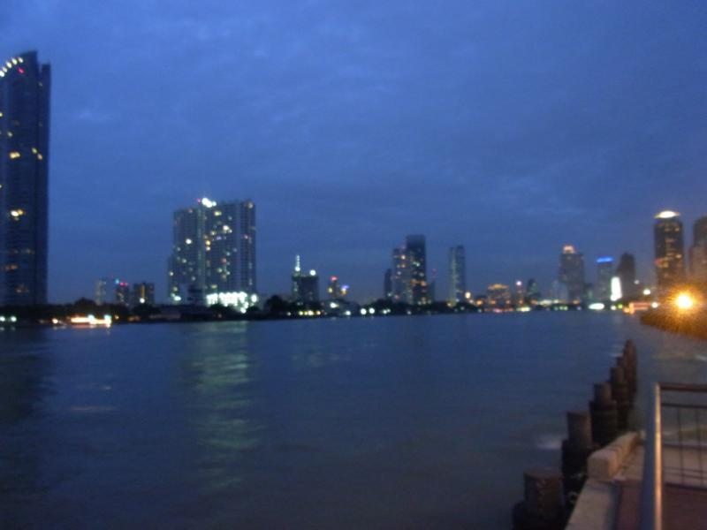

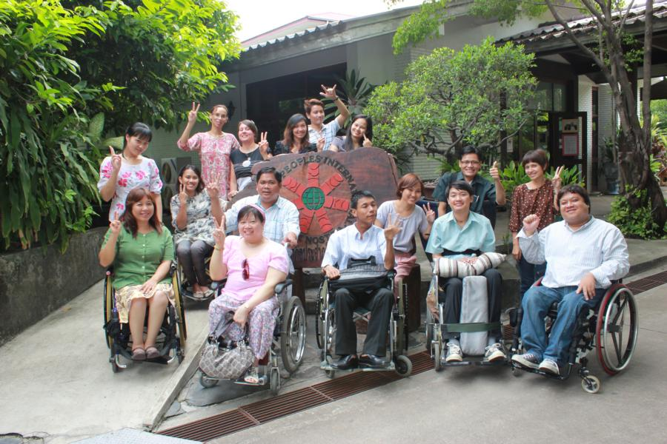
The Task Force Team members which came to DPI/AP office for the Mekong project and my colleagues’ from DPI/AP.

