Consultation visit to Nonthaburi Center for Independent Living by Special Rapporteur on Disability, Suaib Chalklen: Summary

Date: Monday 12th December 2011
Participants:
Name | Position/Organisation
Mr. Suaib Chalklen | Special Rapporteur on Disability
Mr. Teerayudth Sukonthavit | Director – Nonthaburi Center for Independent Living, Thailand
Ms. Saowalak Thongkuay | Regional Development Officer, Disabled Peoples' International Asia-Pacific Region(DPI/AP)
Ms. Worapan Buranasilpin | Secretary to Regional Development Officer – DPI/AP

Summary:
The consultation began with a short presentation by director of the Nonthaburi Center for Independent Living (NCIL), Teerayudth Sukonthavit. Mr Sukonthavit gave a brief history of the Independent Living (IL) movement and an update on the IL situation in Thailand. This is detailed in full in the report ‘IL situation and IL movement in Thailand’, by the Thailand Council for Independent Living in 2010. In brief:
- IL was introduced to Thailand in 2002. There was a pilot stage from 2002 – 2004
- In 2005, The Center for Independent Living (CIL) was established to expand and guide the IL project in Thailand.
- In February 2006, CIL the Thailand Council for Independent Living (TIL) was established to coordinate information exchange between IL centers in Thailand, support CIL and manage the growing network in Thailand.
- There are currently 13 CIL in 6 provinces in Thailand
- The office is supported by local government, with the need to raise further funds

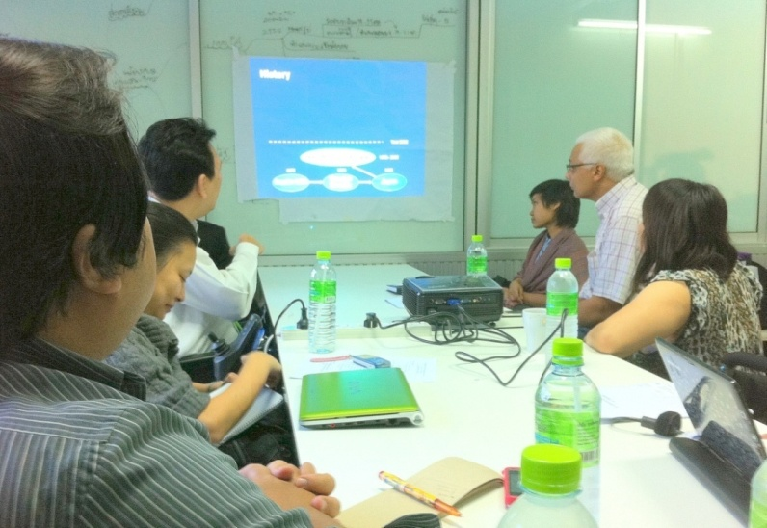
Following the presentation, participants engaged in discussion about mechanisms and ways to move forward as a movement. Important points from this discussion include:
- Utilising the Convention on the Rights of Persons with Disabilities in pushing the Thailand disability movement forward
Thailand signed the Convention on the Rights of Persons with Disabilities on the 29th July 2008
Therefore, the Thai government has a responsibility to adhere to its agenda. To ensure accountability, legal action can be pursued to ensure the rights of people living with disability are ensured. The example given was family members from an inclusive school in South Africa demanding the equal funding entitles by other schools. Through legal action, this was a successful action.
To demand accountability, people living with disability must have knowledge about the convention. This involves networking, research and capacity building within the disability movement. Mr Chalklen shared contact details to facilitate networking and suggested several options for capacity building, including:
- Building capacity in the centre through visiting other countries and learning from their actions. To do this, applying for scholarships, travel money etc was encouraged where needed;
- Applying for an intern/volunteer (potentially from Australia, though an AusAID supported program: http://www.ayad.com.au/ ); and
- Garnering support from other organizations/governments/networks to share knowledge and information about the convention in local language.

- Strengthening and building a coordinated approach in the Thailand disability movement
To push the movement forward, it is important to ensure actions are coordinated, inclusive and well-known. The challenge was put to the CIL to think about the main issues currently facing Thailand in order to develop a ‘Call to Action’ that could garner significant numbers of supporters.
Strengthening the network also includes ensuring the network organization and mechanisms of action are clear to all participants.
The need to improve communication within the centre was also discussed, as working successfully and efficiently at am International level (and sometimes National) requires English language skills.
- Funding
In order to grow and capacity build any organization, funding is essential. Funding options were discussed in this consultation, with Mr Chalklen stressing the importance of finding alternative and diverse funding sources.

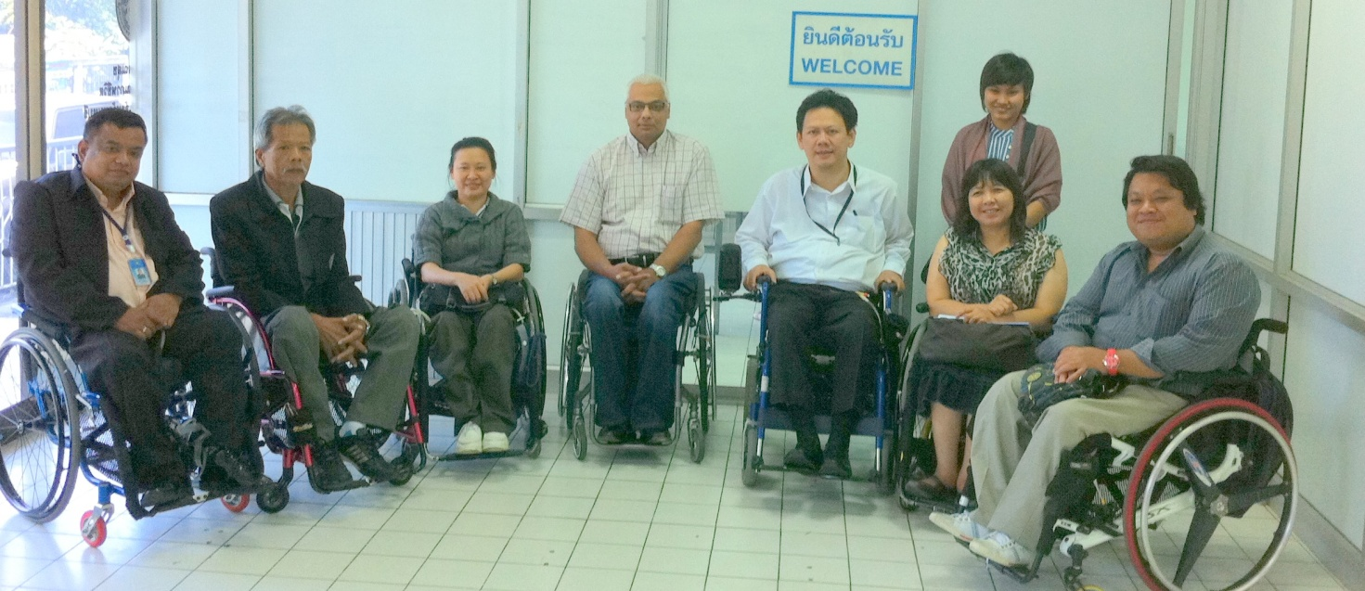
The consultation highlighted many important challenges currently facing the disability movement in Thailand, with a focus on the IL network.
The consultation also identified many methods in which to push the movement forward.

