

Ms. Saowalak Thongkuay
Regional Development Office (RDO)
Disabled Peoples’ International Asia Pacific (DPIAP)
Speech to Seminar on ASEAN Mechanism and the Convention on the Rights of Persons with Disabilities, September 9-10, 2009, APCD training building, Bangkok, Thailand

Almost 60 per cent of the world’s 650 million persons with disabilities live in Asia and the Pacific according to the United Nations (UN) estimates. This translates into some four hundred million persons with disabilities in the region who need support in realizing their human rights. But these figures are all estimates at present. Differences in definitions of disability, methods of data collection as well as capacity of data collecting professionals prevent a more definitive accounting of the number of persons with disabilities in the Asia-Pacific, and in the rest of the world. There are also problems in some countries of low priority and exclusion from official statistics of the data on persons with disabilities.

Data from the country profiles collected by the Asia-Pacific Development Center on Disability (APCD) provide an approximated number of persons with disabilities (PWDs) in some of the countries in the South East Sub region or ASEAN as below:
Table 1
Country | Estimate No. of PWDs
Brunei Darussalam | 30,000
Cambodia | 554,000
Indonesia | 6 million
Lao PDR | 52,200
Malaysia | 139,000
Myanmar | 2% of population
Singapore | 759,000
The Philippines | 942,098
Thailand | 1,100,762
Viet Nam | 4,039,241

Available data reveal wide disparities in the proportion of persons with disabilities in the Asia Pacific region, ranging from 0.7 per cent (Cook Islands) to 20 per cent (Australia).

The UN, through the Economic and Social Commission for Asia-Pacific (ESCAP), reports that in many cases in developing countries disability is caused by inadequate maternal and childhood nutrition, infection and disease, the lack of clean water, accidents, armed conflict, terrorism and antipersonnel landmines. 17 per cent of Afghans became disabled because of the armed conflict. In Cambodia, 18 per cent of the persons with disabilities are amputees likely caused by antipersonnel landmines. In countries that are experiencing fast-paced globalization with the consequent tougher competition and higher level of stress, the number of persons with psychosocial disabilities is on the rise. Conflicts and natural disasters have also contributed to the increase.

Poverty and marginalization characterize the situation of majority of the persons with disabilities in the region. ESCAP considers them to be “among the poorest of the poor and the most marginalized in the society.” Living mostly in the rural areas, they have difficulty accessing whatever facilities for them are available because they are usually located in the cities. They generally have limited access to education, employment, housing, transportation, health services and recreation, leading to their economic and social exclusion. The International Labour Organization (ILO) states that the unemployment rate among persons with disabilities is usually double that of the general population and often as high as 80 per cent. They frequently face various barriers such as negative attitudes of employers, lack of accessible facilities, and lack of vocational and technical trainings.

Women and girls with disabilities in developing countries face triple discrimination due to their status as females, persons with disabilities and their over representation among the poor. They are two to three times more likely to be victims of physical and sexual abuse at home or in institutions for persons with disabilities. Few victims ever talk or file a grievance due to lack of confidence and knowledge of where or whom to turn for help.
Please contact:
Children with disabilities are largely excluded from educational opportunities. It is estimated that for the majority of countries in the region less than 10 per cent of children with disabilities are enrolled in school. The ESCAP Survey in 2004 indicates for example that the school enrolment rate of children with disabilities is 2 per cent in the Philippines and 4 per cent in Bangladesh and Pakistan.

Although the founding document of the Association of Southeast Asian Nations called for “partnership in order to strengthen the foundation for a prosperous and peaceful community of Southeast Asian Nations”, This decision to move forward from common to proper noun has set into motion parallel efforts to formulate and carry out plans of actions towards constructing the security, economic, and socio-cultural pillars of the ASEAN Community.

To have effective social pillar, the purposes, activities and achievements of ASEAN have to communicate to the peoples of Southeast Asia. They have to be convinced that the governments of Southeast Asia are truly committed to engaging each other for the common good. They have to be aware and convinced that ASEAN as an organization could provide strategic capable direction of drawing together diverse but constructive ways and opinions of contributing to the establishment of a regional community. The official track should set the direction to promote an enabling environment, and inspire our people. ASEAN should continue to play the critical role of being called “an enabling and enriching catalyst” for regional understanding and cooperation.

In this regard, ASEAN should continue to engage and empower the regional networks of civil society, think tanks, professional organizations, academic institutions, the scientific community, the humanitarians and first responders, the private sector, and other advocacy groups that are committed to the ideals and purposes of an ASEAN Community. The most prominent is council among others. Being on the ground, the non-governmental sectors and civil society organization could help bring the ideals, spirit and message of ASEAN to their respective constituencies. But most importantly, they should be encouraged to continue to strive and pursue their own and independent ways and means of contributing to establishing the ASEAN Community.

According to, Joint Communique of the Sixth ASEAN Ministerial Meeting for Social Welfare and Development Ha Noi, 6 December 2007, it stated that inclusive, barrier-free and rights-based society for our Disabled are needed due to the rapid social and economic changes arising from globalization that contribute to the complexity of challenges in all sectors and affect human security, and further marginalize those living with disabilities. With the ultimate goal of “mainstreaming persons with disability in development”, the committees commended the inclusion of concerns and experiences of persons with disabilities as an integral dimension of policies and regulations in all spheres of ASEAN society to ensure that all those living with disabilities are given equal opportunity and access to the employment market.

In Disability and Development issues, the establishment of ASEAN Persons with Disabilities Forum will play a leading role in the promotion, protection, networking and collaboration among Civil Society Organizations, Disabled People Organizations, and Governmental Organization besides working in parallel with ASEAN in construction ASEAN community. Furthermore, the forum will continue to undertake functional cooperation in the fields of people-to-people interactions, cultural tourism, academic exchanges, promotion and protection of the rights of vulnerable group, women, children, and information exchanges through broadcast, print and electronic media along side with ASEAN.

Besides, the Convention on the Rights of Persons with Disabilities or CRPD that Thailand and the Philippines already ratify has the eight guiding principles that underlie the Convention and each one of its specific articles: 1) Respect for inherent dignity, individual autonomy including the freedom to make one's own choices, and independence of persons. 2) Non-discrimination. 3) Full and effective participation and inclusion in society. 4) Respect for difference and acceptance of persons with disabilities as part of human diversity and humanity. 5) Equality of opportunity. 6) Accessibility. 7) Equality between men and women. 8) Respect for the evolving capacities of children with disabilities and respect for the right of children with disabilities to preserve their identities.

Lastly, Millennium Development Goals Frameworks (MDGs), The MDGs eight goals and 17 specific targets from halving the proportion of people living below poverty line to halving the proportion of people without sustainable access to resources and MDGs promote social inclusive in development. These are some of the mandates of the ASEAN bodies responsible for social welfare in term of rights based approach, rural development and poverty eradication.

The Forum can assist ASEAN to formulate the roadmap towards achieving the MDGs by incorporation with the CRPD.

Recommendation from the Seminar

- To establish ASEAN Disability Forum
- To adopt ASEAN decade of Persons with disabilities by ASEAN
- To encourage all ASEAN countries members to ratify CRPD
- To set up sub commission to response for the disability issues to promote and protect the rights of persons with disabilities
- To initiate the specific mandate to promote and protect the rights of person with disabilities.

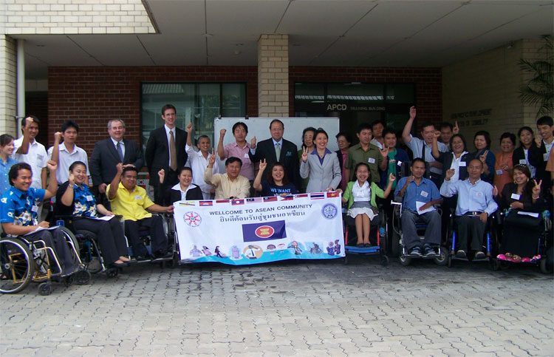

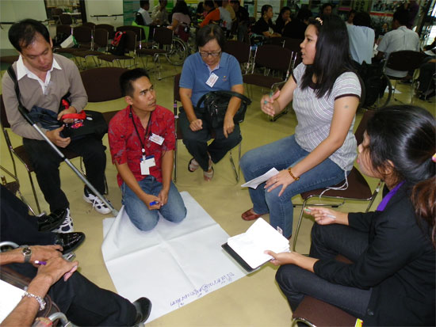

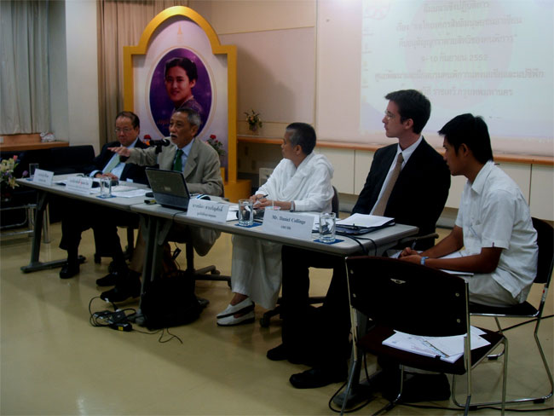

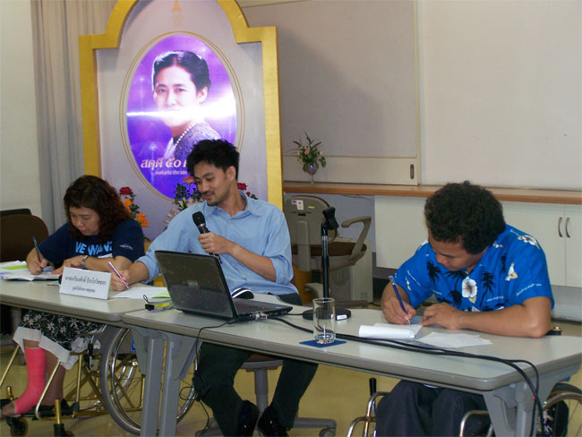

ESCAP Fact Sheet, page 11, available in http://www.unescap.org/esid/psis/FactSheets.pdf
See Fifth quinquennial review and appraisal of the World Programme of Action concerning Disabled Persons, Report of the UN Secretary General to the General Assembly, A/63/183, 28 July 2008.
www.apcdproject.org
http://www.dinf.ne.jp/doc/english/intl/02rnn/dsfad_e.html
Poverty Reduction and development in Cambodia: Enabling Disabled People to pay a role by Philippe Thomas, Disability Policy Officer , Disability Knowledge and Research, April 2005.
Source: Malaysia Medical Population.
http://www.sma.org.sg/smj/4208/4208a4.pdf
ESCAP, op.cit.
See Cambodia country profile, http://apcdproject.org/countryprofile/cambodia/cambodia.html
http://www.aseansec.org/16570.htm
http://www.aseansec.org/21221.htm
http://www.un.org/disabilities/default.asp?navid=14&pid=156
http://www.undp.org/mdg/

