Mission: Durban, South Africa
Event: The 8th DPI World Assembly
Contact: The Conference Company
Tel: +27 31 303 9852
Fax: +27 31 303 9529
Contact persons: DPI/AP
Ms.Saowalak Thongkuay
Mobile: 668-1-558-1903

Email: saowalak@dpiap.org
Mr. Wansao Chaiyakul
Mobile: 668-1-978-4383

Email: worapan@dpiap.org
Address 92 Phaholyothin 5 Road, Samsennai,
Phayathai Bangkok 10400 THAILAND
Tel: 66 (0)2 271-2123
Fax: 66 (0)2 271-2124

Duration: 8 October- 15 October 2011

Mission members: 2 persons

No. | Name | Position | Remark
1. | Ms. Saowalak Thongkuay | Regional Development Officer | Mission Leader
2. | Mr. Wansao Chaiyakul | Coordinator, web master | Member

Aims:
- To strengthen DPI capacity;
- To exchange information;
- To seek partnership for DPIAP regional program.

The mission’s methods:
- To attend the 8th DPI World Assembly;
- To exchange idea with expected partners;

Outcomes:
- DPI New Executive Officers.
- Durban Declaration
- The visit of Special Rapporteur on disability

Program: attachment A
Outcomes: attachment B, C, D

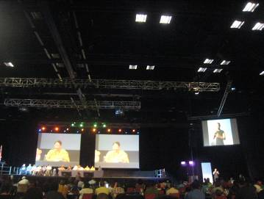
Closing Ceremony
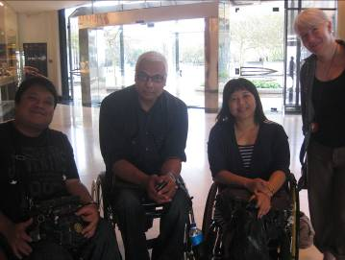
Meeting with Mr. Shuaib, UN Special Repporture on Disability
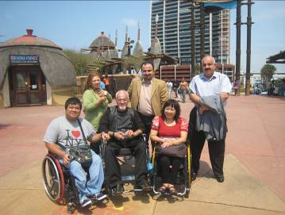
New friends, DPOs from Kurdistan

