Report
Thematic workshop on Disability Rights
ACSC/APF 7
3-5 May, 2011

The outcomes

  - Recommendations on the implementation of disability policies in practices, especially with a focus on multiple discriminations through multi-sectoral approach.
  - Recommendations on mainstreaming disability perspectives in ASEAN blueprints, particularly Socio-Cultural Blueprints.

The recommendation focuses to 4 areas as1) Multiple Discrimination, 2) Ratification and implementation of CRPD, 3) Political rights, and 4) Health.

It will be complied with ASEAN Peoples’ Forum that will be adopted by participants on the last day. Then, recommendation will be submitted and present to ASEAN Submit on May 7. The recommendation will be share afterward.

In this regard, the Asean People’s Forum (APF) had chosen Sureeporn Yupa, of Disabled Peoples' International Asia Pacific (DPI/AP), to represent Thailand during the May 7.

APF is ASEAN Civil Society Organizations Meeting in parallel to ASEAN submit. A host country will take turn by ASEAN Chairman. Next year, Cambodia will be a Chairperson; therefore, thematic workshop on Disability will be organized by Cambodian Disabled People Organization (CDPO) or DPI Cambodian in collaboration of DPIAP and CSOs.

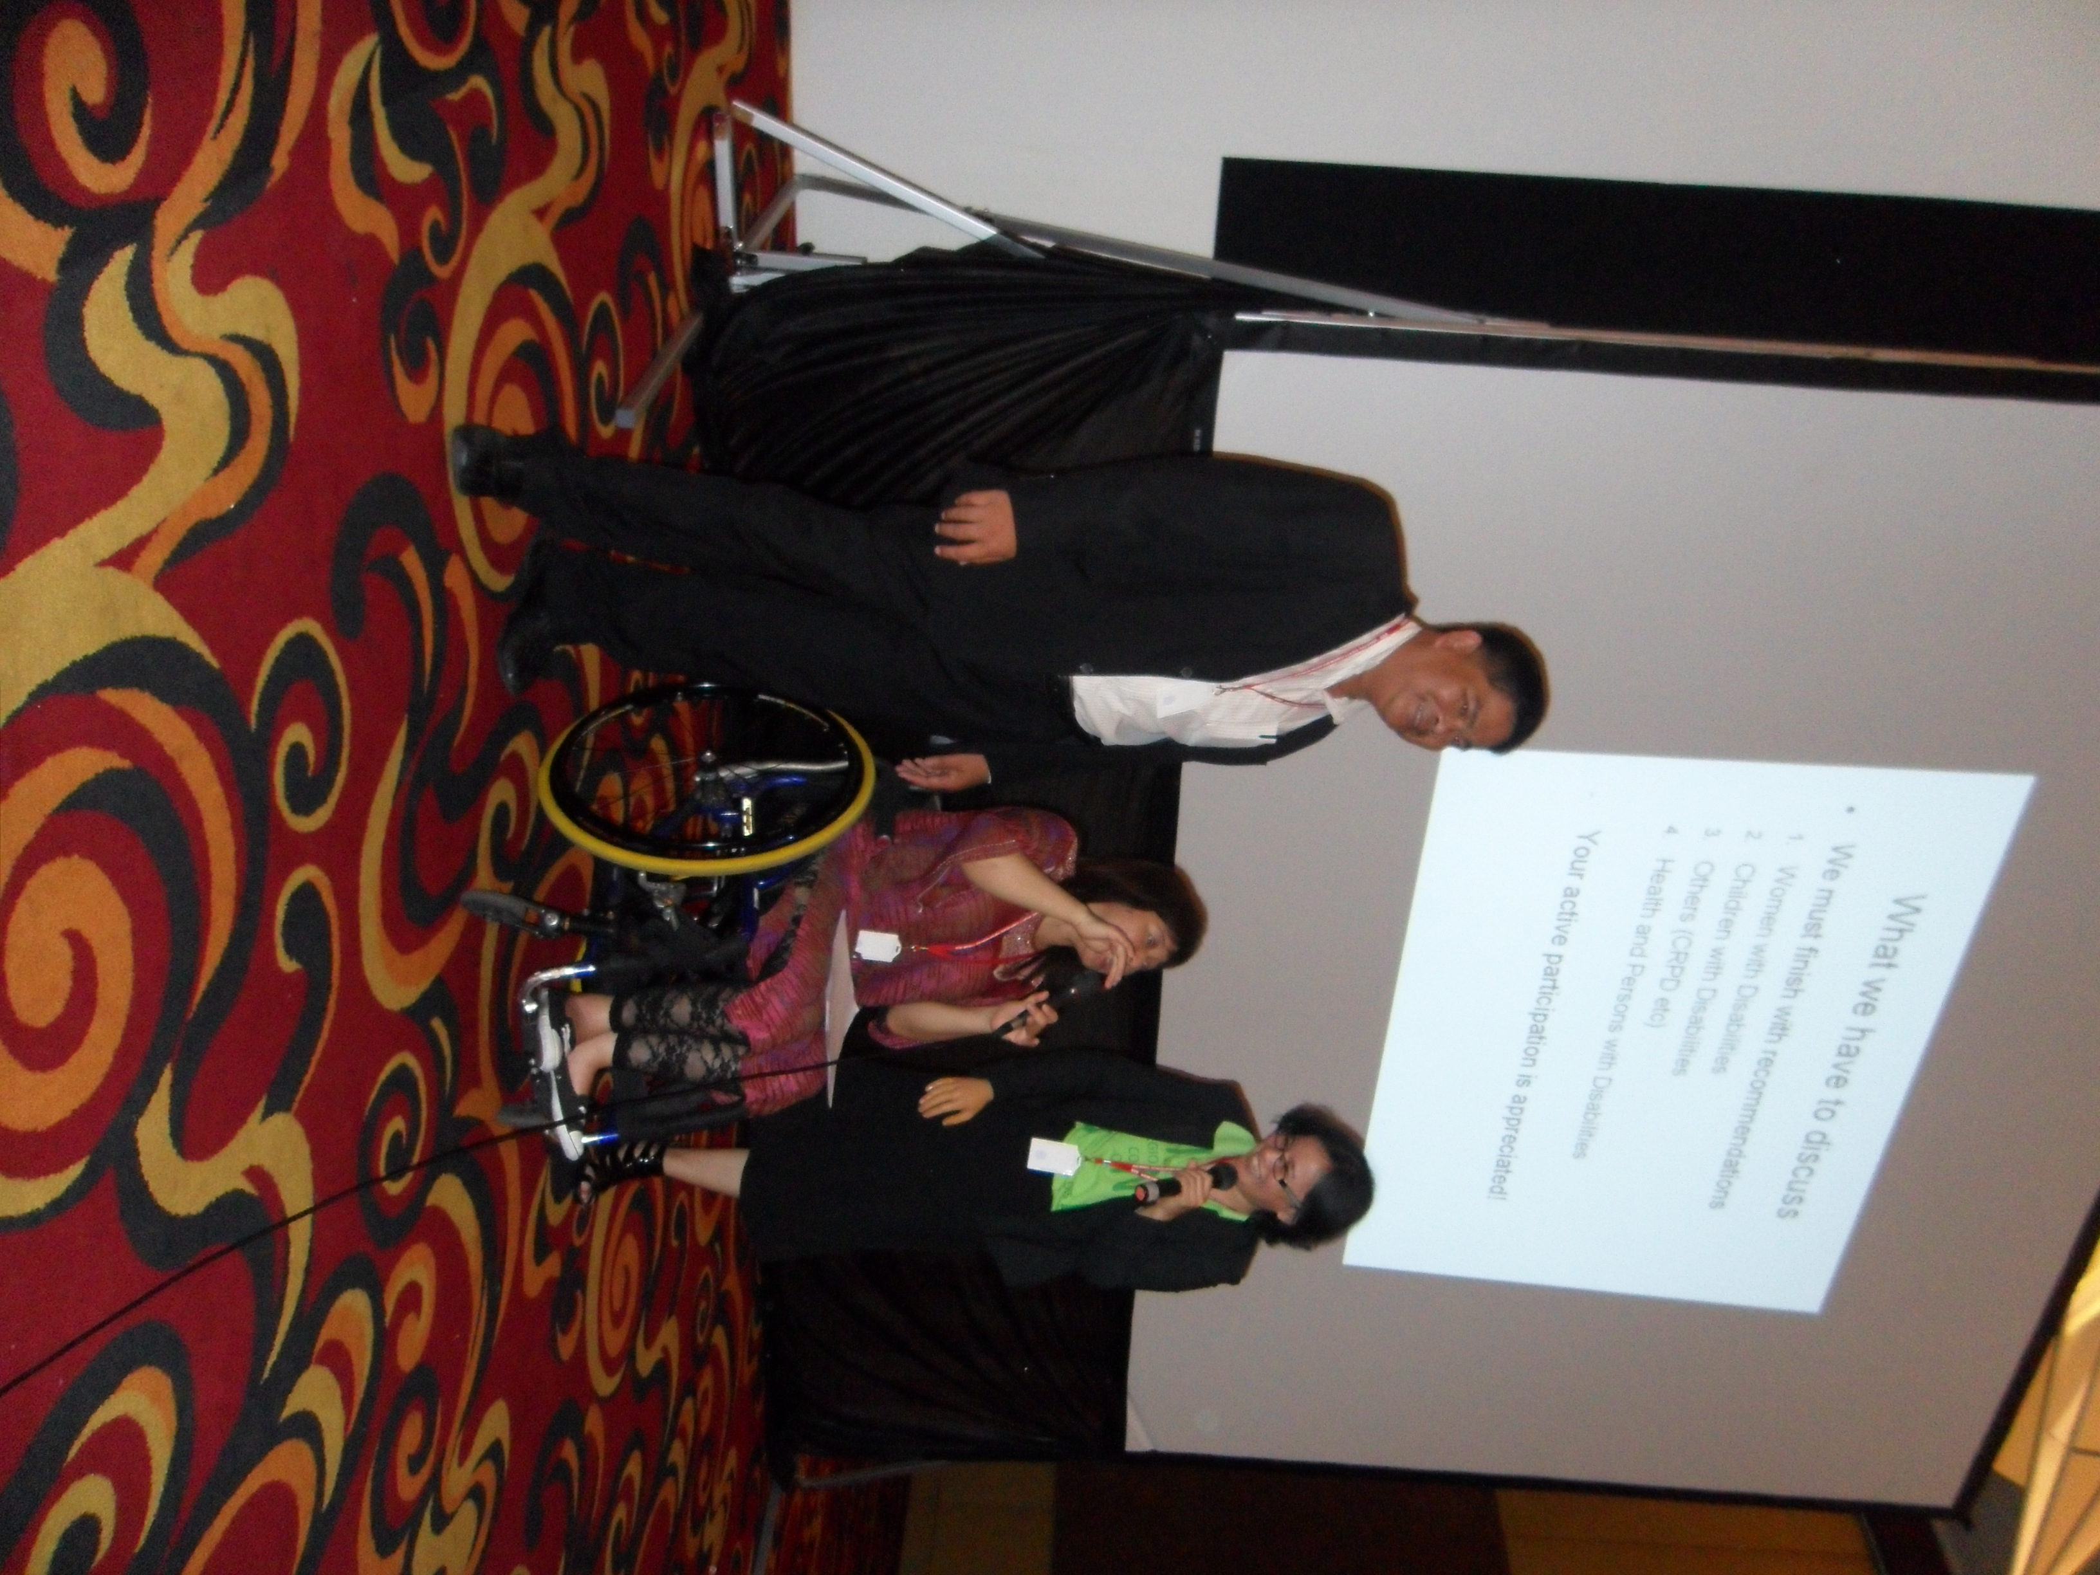 | 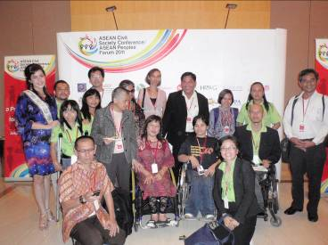
Closing and handover ceremony from DPI Indonesia, from right side , Ms Maulani Rotinsulu, Ms. Saowalak Thongkuay, Mr. Ngin Saorath | Group pictures among DPIAP, DPI Indonesia, DPI Cambodia and some CSOs.

