30 March 2012
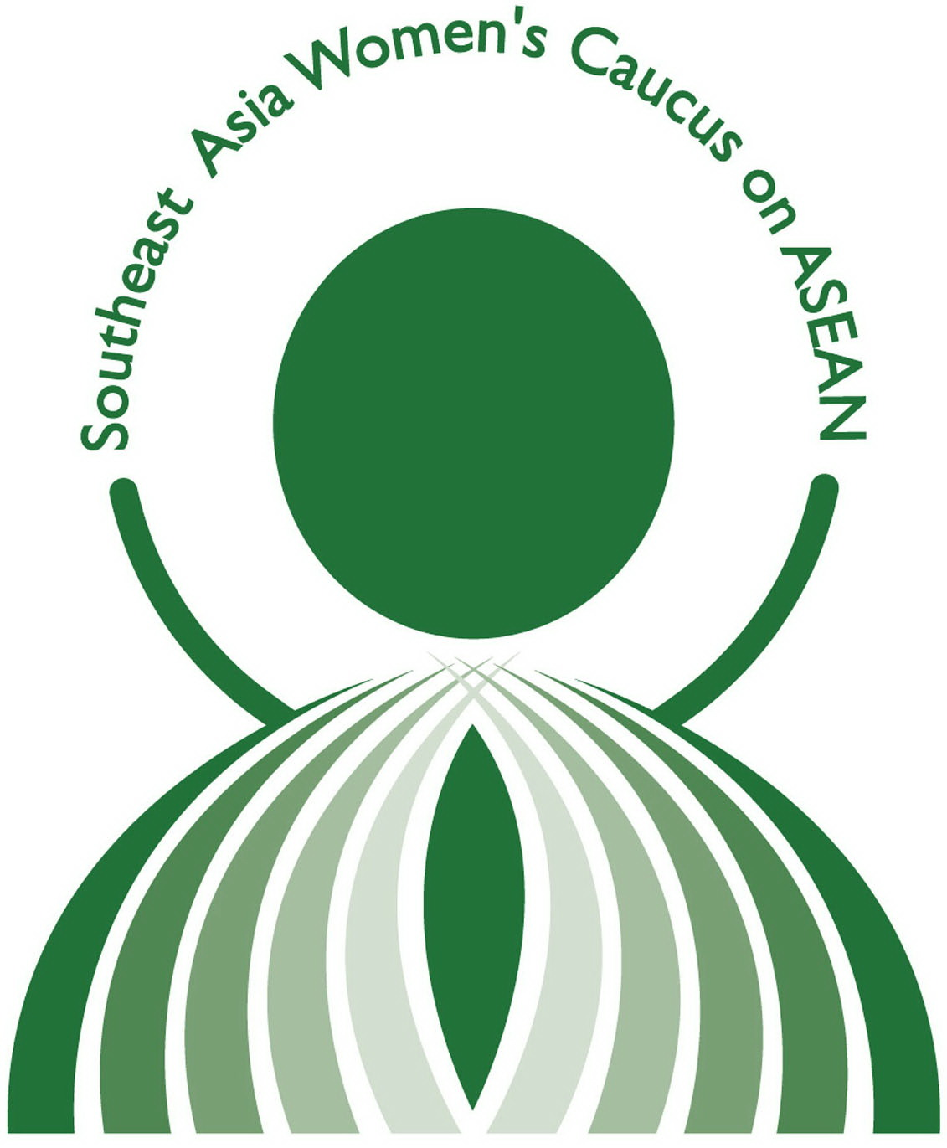
For immediate release

STATEMENT

Contact Persons:
Thida Khus - +855 12838464, thida_khus@silaka.org
Nina Somera - +66 811621073, nina@apwld.org

Women’s Caucus on APF/ ACSC 2012:

Not in Our Name: Engage with ASEAN women

Independent women’s organisations and activists call on ASEAN governments and the current ASEAN chair, Cambodia, to embrace civil society as a vital democratic partner instrumental to the enjoyment of human rights. Women from 10 ASEAN member states as well as Timor Leste, are participating in the 8th ASEAN People’s Forum/ ASEAN Civil Society Conference (APF/ACSC 2012) in Cambodia as the Southeast Asia Women’s Caucus on ASEAN.
The Women’s Caucus is concerned by the exclusionary practices of parts of ASEAN that limit independent women’s organisations from amplifying the voices of women. We are also concerned about the secretive process of drafting the ASEAN Human Rights Declaration (AHRD) that, to date, has not openly involved civil society.

We are also alarmed about the decision of the Cambodian government to require States to select civil society representatives to engage in the traditional interface that occurs at the conclusion of the APF/ACSC. While we welcome the decision to focus the interface as “gender and development”, we question the value of an interface that censors the voices of women to engage in honest and critical dialogue. Civil society represents the ASEAN community and the interface is the closest the ASEAN community can get with ASEAN, the body. Any attempt to hand pick representatives devalues the dialogue and renders it an alibi to repressive practices.

We call on ASEAN states to demonstrate their commitment to women’s rights where it counts: by guaranteeing and delivering rights enjoyment for all women. ASEAN members should guarantee that there will be no erosion of rights in the AHRD and no inclusion of ‘morality, moral values or traditional values’ clauses that serve to undermine rights.

We call on the Cambodian government and ASEAN to
- Let people collectively and peacefully organise and interface with ASEAN leaders in a democratic and independent process;
- Release the draft AHRD, conduct open, safe and inclusive public consultations that involve women’s rights advocates and reconsider the timeframe for approval to ensure full and meaningful participation;
- Sincerely respect, protect, promote and fulfill women’s human rights, including women’s rights to meaningfully represent themselves and participate in a political process.

The Women’s Caucus is a network of more than 60 organizations across 11 countries in Southeast Asia, engaging ASEAN to advance women’s human rights.
- 30 -

