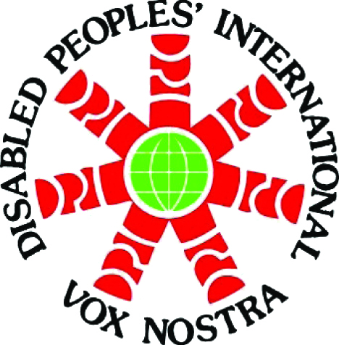
Disabled Peoples’ International
Organisation Mondiale des Personnnes Handicapées
Organización Mundial de Personas con Discapacidad

A Voice of Our Own • Notre Propre Voix • Nuestra Propia Voz

Announcement of the New DPI Executive Officers

DPI Chairperson
Javed Abidi (Asia/Pacific)

DPI Deputy Chairperson for Human Rights
Michael Fraser (North America/Caribbean)

DPI Deputy Chairperson for Development and Under-Represented Groups
Rachel Kachaje (Africa)

DPI Secretary, Sécretaire, Secretario
Samuel Kabue (Africa)

DPI Treasurer
Wilfredo Guzman Jara (Latin America)

DPI Information Officer
Kalle Könkkölä (Europe)

