Report of the Inaugural Forum on the
Global Partnership on Children with Disabilities

UNICEF House
New York, New York, USA
14 -15 September 2012
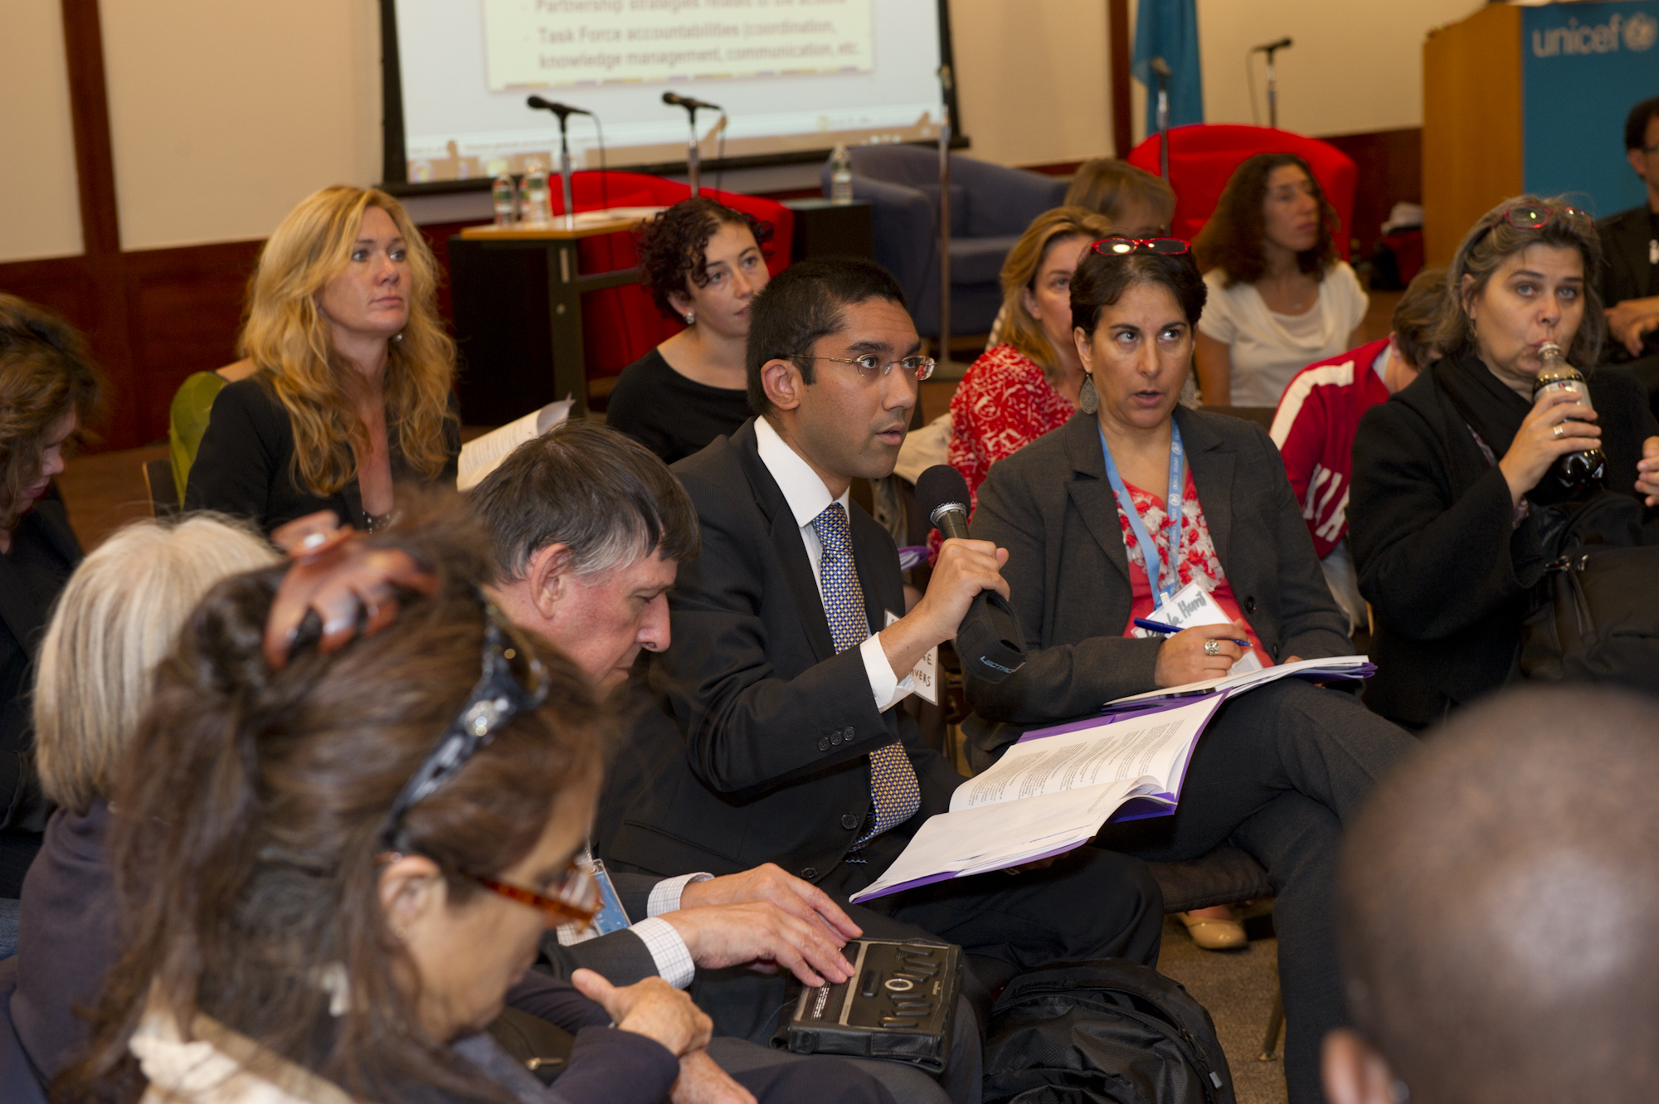
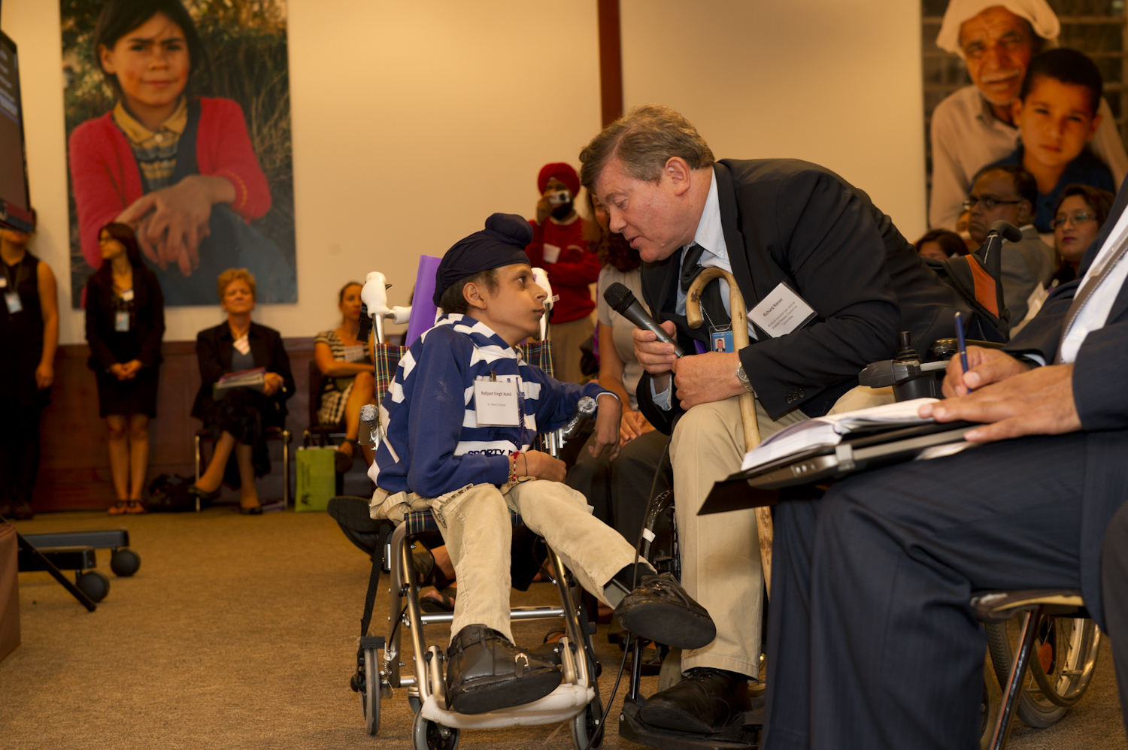

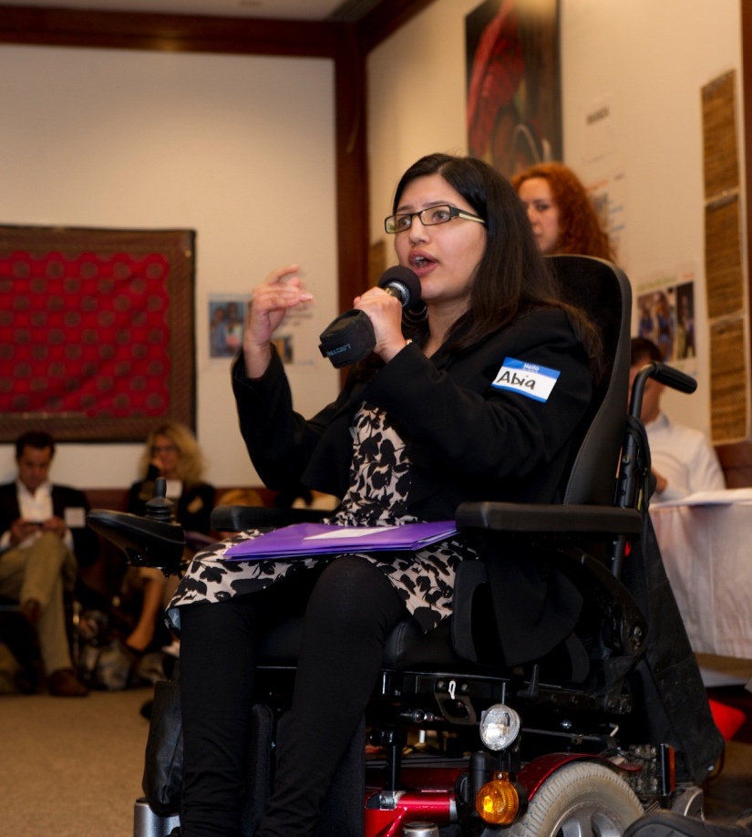

Written by:
Kate Riordan, Better Care Network
October 8, 2012

Summary
The Global Partnership on Children with Disabilities (also referred to as GPcwd and ‘the Partnership’) is a network of more than 100 organizations, including international NGOs, national/local NGOs, Disabled People’s Organizations (DPOs), governments, academia and the private sector, working to advance the rights of children with disabilities at the global, regional and country levels. In line with the Convention on the Rights of Persons with Disabilities (CRPD), the Partnership provides a platform for advocacy and collective action to ensure the rights of children with disabilities are included in and prioritized by both the disability and child rights agendas.
An initial call to partners was made in 2011 in New York, during the Fourth Conference of State Parties to the Convention on the Rights of Persons with Disabilities (CSP-CRPD), followed by a small consultation held in conjunction with the UNESCAP and Leonard Cheshire Disability Conference on Disability-Inclusive MDG’s and Aid-Effectiveness in March 2012. The partners agreed on organizing a major event around the Fifth CSP-CRPD.
The inaugural Forum on the GPcwd involving more than 180 registered participants was held 14-15 September 2012 at UNICEF House in New York, where for the first time the partners came together to discuss ways to advocate for an inclusive post-2015 agenda; establish four task forces with the aim to influence the mainstreaming of disability rights in global child-focused agendas, namely in nutrition, education, humanitarian action and assistive technology; and discuss collaboration at the country level in Haiti, Rwanda, Turkey, Azerbaijan, Malawi, Mozambique, Bangladesh and for the Central and Eastern European and Commonwealth of Independent States Region (CEE/CIS). A Call to Action was made to meet the critical need for inclusive, integrated and collaborative rights-based development with a focus on children with disabilities.
Coordination of the GPcwd is currently being led by UNICEF and each task force is coordinated by one or two of the partner organizations. An initial workplan from September 2012 - August 2013 has been created with the aim to report back to the group at a follow up meeting in New York one year later. The outcomes of the first year activities will influence the GPcwd contributions to the High Level Meeting on Disability being held 23 September 2013 in New York.
A special thanks to the core group of representatives from the International Disability Alliance (IDA), International Disability and Development Consortium (IDDC), Global Partnership on Disability and Development (GPDD) and the Inter-Agency Support Group for the CRPD (IASG) that developed the vision for the Forum and the GPcwd overall.
For a list of Forum participants see Annex A.
For a mapping of the GPcwd partners and the thematic areas in which they work see Annex B.
For a complete list of partner organizations involved in the GPcwd visit: http://www.unicef.org/disabilities/index_65776.html
For further information on the GPcwd visit: http://www.unicef.org/disabilities/index_65319.html

I. Overview of the Situation of Children with Disabilities in Development:
What the Evidence and Experience Tell Us

In comparison to their peers without disabilities, children and adolescents with disabilities (referred to broadly as ‘children with disabilities’ for this report) are more likely to experience poorer health, decreased access to education, compromised economic opportunities, and greater poverty and inequity. While data for children with disabilities are commonly lacking, it is estimated that one in ten children experiences a disability and an overwhelming majority of children with disabilities are denied access to basic social services, such as education. Exclusion of children with disabilities is not solely limited to domestic environs or the medical and education fields. Issues related to children with disabilities are commonly, and at times, systematically excluded from mainstream development and rights agendas.

In an effort to catalyse further attention and collaboration to reverse exclusionary or marginalizing trends, experts and representatives from governments, bilaterals, NGOs and DPOs, gathered September 14-15, 2012 in New York for the 2012 Forum on the Global Partnership on Children with Disabilities. The Global Partnership on Children with Disabilities (GPcwd) is a network of more than 100 organizations, including international NGOs, national/local NGOs, Disabled People’s Organizations (DPOs), governments, academia and the private sector, working to advance the rights of children with disabilities at the global, regional and country levels. Using a rights-based approach, the Partnership provides a platform for advocacy and collective action to ensure the rights of children with disabilities are included in and prioritized by both the disability and child rights agendas.

Meeting delegates explored the evidence and experiences on the intersection of children with disabilities and development priorities. In particular, this global gathering served as an opportunity to prepare the broad community of actors to advocate for increased integration of children with disabilities in development, disability and children’s rights agendas, with a particular eye toward the emerging post-2015 development landscape.

The Forum provided space for partners to reflect on the current base of evidence and experience to inform and facilitate debate on the realities of children with disabilities globally, including, for example:

- Children with disabilities are commonly among the most stigmatized and marginalized within schools, families, and society. Misperceptions and harmful cultural attitudes, beliefs and practices result in poorer health outcomes and opportunities for participation. Many children with disabilities experience increased exposure to violence and unnecessary institutionalization.
- Children with disabilities are not a homogenous group. Within that group, further marginalized subgroups exist such as girls or children of ethnic minorities, requiring flexible responses that accommodate and reflect the diversity within the broader disability community.
- The intersection of excluding factors must be given particular consideration, for example: childhood and disability or gender and disability. As referenced in Article 6 of the CRPD, many children with disabilities are subject to multiple forms of discrimination.
- Despite increasing commitment by States to the CRPD, policies and programmes related to children with disabilities have not yet been consistently grounded in a human-rights based approach and the rights of children with disabilities are not sufficiently addressed in the priorities of governmental, development, child rights and disability platforms.
- Children with disabilities have been historically excluded or treated as an after-thought in core global development frameworks, as opposed to being included as a central and cross-cutting consideration from the beginning. This commonly results in the “retrofitting” of policies and programmes which is often less effective.
- Programmes for children with disabilities are rarely linked to or integrated with on-going systems and programmes, rarely reaching the scale or support of the disability or child rights agendas. Effective growth in this area requires recognition of the rights of children with disabilities by key stakeholders, coupled with the availability of strong examples of integrated experiences that can be taken to scale.
- Children with disabilities, their families and their representative organizations are rarely empowered to be integrally and systematically involved in all relevant decision-making processes.

II. Call to Action: Partners for and with Children with Disabilities

In recognition of both the promising developments made to date, and the understanding of the compelling needs related to children with disabilities, the Forum and the commencement of the GPcwd serve as a Call to Action to meet the critical need for inclusive, integrated, collaborative rights-based development with a focuses on children with disabilities. It makes public a collective commitment to ensure that all efforts possible are made to halt the continued marginalization of children with disabilities, not just within day-to-day life and social norms, but also within the design and delivery of legislation, programming, and resource allocation.

“Every one of us can and must mainstream the needs of children living with disabilities into our policies, planning and actions, while advocating with others as well,” said Mr. Anthony Lake, UNICEF Executive Director. “Our partnership sends a clear message to children with disabilities and their families: You will not be forgotten, you will not be overlooked, you count. Over the next year, let’s match our efforts to the strength of children everywhere, and measure our results against their dreams. Children do not accept unnecessary limits, and neither should we.”

The Partnership commits itself to:

- Creating a platform to promote synergy across all stakeholders, including duty bearers and rights holders, to address legislative, policy and programming issues and concerns related to the integration of children with disabilities
- Grounding all efforts in an ethos of partnership, with an ultimate goal of achieving a new development framework for inclusive societies
- Promoting a balance between including issues related to children with disabilities in all development efforts and delivering disability-specific programmes within sectors
- Facilitating collaboration in countries and engaging governments in order to deepen national investments and overcome institutional barriers in terms of political will, fiscal space, coordination and data collection
- Placing disability issues at the core of equity and sustainable growth agendas, highlighting how equity viewed through the lens of disability, can be a means to test the universality of rights, access and development in a sustainable and peaceful society for all citizens
- Grounding issues on children with disabilities in a human rights approach, in accordance with the CRC, CRPD, and other relevant treaties and frameworks
- Prioritizing investments and commitments to data collection related to children with disabilities and their families to respond to historic gaps in knowledge around issues of children with disabilities and to facilitate informed decision-making in the development of inclusive policies and programmes
- Focusing the first year of activities for the GPcwd on integrating disability issues within three core global agendas namely nutrition, education and humanitarian action, in order to reduce the exclusion of children with disabilities from health, education, protection and participation platforms
- Empowering children with disabilities, their families and their representative organizations to advocate on their own behalf and foster child-to-child approaches to advocacy and human rights awareness
- Defining the roadmap to 2013 through key initiatives, including UNICEF’s dedication of the 2013 State of the World’s Children to children with disabilities and the upcoming 2013 High Level Meeting on Disability

Partners indicated their intention to utilize the Partnership as a mechanism for grounding all development frameworks within a rights-based approach that upholds the ability of all children with disabilities to understand and advocate on behalf of their rights.

Partners articulated their commitment to forging strong linkages across the thematic areas as well as creating a clear and collective goal for children with disabilities within the post-2015 agenda. In order to do so, participants’ submitted additional priorities that they would like to see the Partnership address, including:

- Giving attention to children with invisible disabilities
- Influencing developments at multiple levels, including national plans and programmatic design, planning, implementation and monitoring & evaluation
- Raising the profile of children with disabilities issues within development frameworks to further global, regional and country-level commitments
- Incorporating innovative technology solutions and implementation to increase universal access
- Identifying mechanisms and opportunities for NGOs, including DPOs, to participate in the global agendas for and with children with disabilities

Participants highlighted a desire to launch the GPcwd with a detailed architecture for coordination and organization in place, replete with next steps, roles, responsibilities and commitments from a broad range of partners. This is something for the partners to discuss at the Forum in 2013.

III. Advancing the Rights of Children with Disabilities through the Global Partnership on Children with Disabilities

- Looking at Inclusion, Equality and Equity through the Lens of Disabilities

During the opening session of the Forum, Christian Salazar, UNICEF Deputy Director of Programmes, spoke about the importance of partnerships that address change at the community, national and international levels, and emphasized the role of civil society and youth in advocating for their inclusion in society, in line with the spirit of ‘Nothing About Us Without Us”. Yannis Vardakastanis, the Chair of the International Disability Alliance (IDA), called for a clear recognition of the rights of people with disabilities in the post-2015 agenda, Sustainable Development Goals (outcome of Rio+20), and the Quadrennial Comprehensive Policy Review (QCPR) Process. Their comments were supported by Krishneer Sen, a student at Gallaudet University, who went on to underscore the importance of creatively engaging youth with disabilities through social media and other forms of interactive engagement. Abia Akram, the Coordinator for Disabled Peoples’ International’s (DPI) Global Network of Emerging Young Women Leaders with Disabilities, provided a unique perspective on the critical importance of considering gender when promoting the rights of youth and children with disabilities.

The participants acknowledged the multitude of competing priorities, agendas and communities of rights holders within the development sector. Yet, they underscored the broader impact that can be made in terms of inclusion, equitable protection and development for all, by targeting children with disabilities within development efforts.

Some observations from the discussions emphasized that there appears to be an increasing understanding of the exclusion of children with disabilities from the development and rights agendas. However, while effective programming certainly exists and progress has been demonstrated, gaps still remain in terms of continuous and sustainable national and international commitment, politically, programmatically and in terms of allocation of resources for children with disabilities. Notably, needs remain in terms of motivating political decision-making to establish programmes, processes and systems that incorporate children with disabilities in ways which can be scalable, systematic and universal. The Forum underscored the role evidence can and should play in advancing legislative, policy and programming. These considerations must be made across all levels of strategy and programme development, monitoring and evaluation, advocacy and communication, and reporting and financing.

There is also a common misconception that to advocate for the rights of children with disabilities is to do so on behalf of a very small percentage of children. Considering that at least one in ten children in the world live with a disability, this percentage is not small nor should it be disregarded. However, creating systems, policies and programmes that can integrate children with disabilities into mainstream efforts, while also giving them opportunities to engage in key decision making processes, will strengthen systems and promote inclusive development, not just for this particular constituency, but for the whole population.

- Realizing Inclusion and Equity for Children with Disabilities in the Post-2015 Development Agenda

In this session, participants examined the experience of integrating disability rights within broader development platforms and outlined potential approaches to deepening the rights-based and inclusive ethos of future development platforms, most notably the post-2015 development agenda currently being outlined to replace the existing Millennium Development Goals (MDGs).

Recognizing the absence of disability in the MDGs, two high level panels examined the impact of exclusion and how to ensure their rights are explicitly addressed in the forthcoming post-2015 framework. The panels were moderated by Abid Aslam, Editor of UNICEF’s flagship publication, State of the World’s Children Report, and included remarks from Dr. Lenin Moreno, Vice President, Ecuador; Carsten Staur, the Ambassador to the UN for Denmark; Ron McCallum, Chair of the CRPD Committee; Richard Morgan, Senior Advisor on the Post-2015 Agenda for UNICEF; Diane Mulligan, Coordinator of International Advocacy and Alliances for CBM; Kudakwashe Dube, Chief Executive Officer of the Secretariat of the African Decade of Persons with Disabilities and Member of the executive Board of Beyond 2015and Iain Levine, Deputy Executive Director of Programme for Human Rights Watch.

These speakers acknowledged the importance of a twin-track approach, as articulated in the CRPD, to influence the post-2015 agenda: 1) advocating for particular consideration for children with disabilities in the framework, most ideally with a specific indicator on children with disabilities, and 2) advocating for cross-cutting principles and approaches based on inclusion that will ensure protection and empowerment of the rights of children with disabilities, regardless of whether children with disabilities are explicitly articulated. Salient themes that must be advocated for across indicators should be inclusion, accountability, representation and participation, which should encapsulate children and adults with disabilities.

The following opportunities were identified to achieve more dedicated consideration of people with disabilities, with a focus on children, within the upcoming development framework:

- Advocate to the UN Country Teams and Resident Coordinators of the 50-100 countries holding national consultations on post-2015 agenda to propose inclusive national consultation processes, providing an opportunity for the concerns of people with disabilities and their representative organisations to be involved
- Promote the rights of children with disabilities in the forthcoming series of global thematic consultations, most notably the one focussing on inequality
- Integrate the children with disabilities agenda within the Beyond 2015 Campaign, one of the largest campaigns mobilizing civil society organizations and providing an available platform to facilitate participation and incorporation of the views of children with disabilities and their advocates
- Include children with disabilities issues within two major international mechanisms, the high level panel convened by the UN Secretary General and co-chaired by Liberia, UK, and Indonesia and the second, the working group of member states on sustainable development goals following Rio Plus 20
- Utilize cross-sectoral data collection opportunities
- Mainstream issues of children with disabilities within other implementation frameworks, such as treaties on torture and minorities. Additionally, utilize existing high level representatives for whom children are one of the primary target groups of their mandate, for example the Special Rapporteurs on Health, Education, Sale of Children, and Violence against Children

The first day concluded with a performance by Sidiki Conde and was followed by a reception at UNICEF House hosted by Anthony Lake, UNICEF Executive Director and who was joined by Timothy Shriver, CEO and Chairman of Special Olympics and Ariel Ary, Special Olympics Global Messenger.

“It is a reality that, for people like us, it is almost impossible to be accepted in a mainstream school. But it is even harder for us to be allowed to become productive members of a society. Under these circumstances, we become isolated and a burden to society. We deserve to be given the opportunity to grow in all areas. We must be valued for what WE have and NOT for what we LACK. We must have the same opportunities at all levels, health, education, sports, and jobs.” – Ariel Ary, Special Olympics Global Messenger

- Influencing the Global Child Rights and the Disability Agendas

The second day was opened by Maria Veronica Reina, Executive Director of the Global Partnership for Disability and Development (DPDD), and during the first session participants examined approaches for increasing attention and mainstreaming disability in specific thematic areas where linkages and opportunities can mutually influence each other.

In the initial year the GPcwd focus will be on the Global Nutrition Agenda (including Scaling Up Nutrition (SUN) and REACH Movements), the Global Partnership on Education (GPE) and efforts to advance inclusive emergencies and humanitarian action for children with disabilities.

The session was moderated by Judy Heumann, Special Advisor for International Disability Rights at the US Department of State and included opening presentations from Alana Officer, Coordinator of Disability and Rehabilitation for the WHO on nutrition; Robert Prouty, Head of the Global Partnership on Education (GPE) on inclusive education; and Ann Marit Sæbønes, Special Adviser, Ministry of Children, Equality & Social Inclusion, Norway on inclusive humanitarian action.

The partners separated into working groups by thematic area to discuss the current situation and identify key activities to undertake in the first year. The task forces will report on progress, challenges and make recommendations for moving forward at the Second Forum on the GPcwd envisioned to take place around August-September 2013. The results of the first year’s activities will also feed into the GPcwd contributions to the High Level Meeting on Disability (September 2013) and influence advocacy efforts for the post-2015 agenda.

Following is a brief outline of each of the targeted global thematic agendas the GPcwd aims to influence:

- The Global Nutrition Agenda
Evidence supports the existence of an intimate relationship between disabilities and nutrition, recognizing that nutritional deficiencies are both a cause and effect of disability. Some children with disabilities are at a higher risk of undernutrition due to reduced cognitive function and their reliance on others to satisfy basic needs. Disability itself can also undermine nutrition because of immunity and inability to absorb nutrients. In other instances, undernourishment leads to poor health and limited life opportunities and often times to disabling conditions, such as stunting as well as intellectual, motor and hearing problems. In other instances folic acid and maternal iodine deficiency pose marked risks to the health and well-being of children, causing or exacerbating disabilities. In some cases, iodine-induced hypothyroidism can lead to extremely adverse health consequences. Physical growth measurement is the most common measurement used when measuring nutrition. However, disability can complicate this measurement given the exacerbating impacts disability can pose on the absorption of nutrition if particular support is not provided.

Health campaigns, including those focused on nutrition, are commonly not made accessible for or give attention to children with disabilities and their families. In some instances, they are deliberately exclusive based on misconceptions that children with disabilities should not receive the same information and priority in life-saving or life-enhancing interventions as their peers without disabilities. Too often stigma and discrimination preclude these children from receiving equitable services, food, resources, and medical support, leading to further malnutrition or exacerbation of disabling conditions. Undernutrition and disability are integrally linked and experts recognize that prevention of both requires a marked reduction in undernutrition and an increase in interventions targeted to address the need of children with disabilities.

The following current initiatives within the global nutrition agenda present particular opportunities for influence and will be addressed by the nutrition task force:

- Scaling Up Nutrition (SUN) Movement aims to involve all countries which have populations experiencing undernutrition and all relevant stakeholders, including government, UN agencies, academia, civil society, donors and private companies. One hundred organizations are currently endorsing the SUN framework, which has outlined key priorities for action in terms of addressing malnutrition and the mobilization of support for investing in nutritional interventions, increasing food production, expanding social marketing for better nutrition and improving nutritional content of food.

- Renewed Efforts Against Child Hunger (REACH) links to the SUN Movement and targets joint UN and government programming, convening different government agencies and ministries to address child nutrition, with a goal to meet MDG 10 Target 3C: “Halve, between 1990 and 2015, the proportion of people who suffer from hunger”.

Nutrition Task Force Plan of Action for the First Year

- Develop a comprehensive mapping of all of the major stakeholders working in nutrition around the world, identifying who the actors are, what they are doing, and where they are working. This mapping will then be made available on the UNICEF website and potentially the WHO website and a mechanism will be identified to maintain the content.
  - Timeframe: next 12 months with priority to complete earlier
  - Lead: Handicap International

- Collect all relevant evidence and technical content in order to underscore the importance of disability and nutrition and actions needed sector wide.
  - Timeframe: 9 months
  - Lead: Leonard Cheshire International with support from UNICEF and all the technical partners in the working group

- Draft simple and clear messages, converting technical content into accessible advocacy and communication messages that articulate the importance of considering disability and nutrition together. The output will be targeted to a broad range of stakeholders to guide what they can do, what the obstacles are, and how they can enable families with children with disabilities to get appropriate services.
  - Timeframe: end of year with the focus on 10 months
  - Lead: UNICEF

- Target and engage key global mechanisms and players, such as the SUN and REACH and Promise for Renewal Campaigns. Integrate disability in the highest level of their agendas through use of developed technical and communication materials.
  - Timeframe: Yearlong
  - Lead: UNICEF and WHO, as major players in these initiatives can facilitate and conduct advocacy at the highest level for children with disabilities to be on countries’ and partners’ agendas

- The Global Partnership on Education
In assessing the state of education for children with disabilities, there is consensus that these children are not being included in regular or mainstream education programmes. Social factors, such as stigma and exclusion, coupled with inadequate resources and inaccessibility, make exclusion from education a reality for an overwhelming majority of children with disabilities globally.

The Global Partnership on Education (GPE) is dedicated to ensuring good quality education for all and supporting the development of education sector plans and education partner coordination at the country, regional and global levels. In these efforts, GPE prioritizes the poorest and most vulnerable and has been transformative in their ability to mobilize international cooperation in education. As the GPE endeavours to finalize its strategic plan, children with disabilities must be a central consideration. In particular, the GPcwd has the opportunity to advocate for the use of existing funding within the GPE to promote accessible and inclusive learning spaces, investment in teacher training for disability-inclusive education, and commitment to collecting data for evidence building and progress monitoring.

Robert Prouty from the GPE emphasized the importance of inclusive education through providing ten very strong “recommendments”:

- Thou shalt not approve any education plans without a disability focus
- Thou shalt not collect data without providing services
- Thou shalt analyse existing capacity and work to fill capacity gaps
- Thou shalt provide technical guidance to support inclusion
- Remember to establish communities of practice
- Thou shalt lobby thy neighbour
- Thou shalt lobby our Board
- Thou shalt honour the principle of 'nothing about us without us'
- Thou shalt ensure that thy work will last long in the countries and the schools with which we work, and in the hearts and minds of the children for whom it has been given us to work
- Thou shalt honour the rights of all children

It was agreed that further consideration will need to be given to monitoring developments in inclusive education to ensure that the education sector commits itself to measurements for achievement and evaluation of progress for education of children with disabilities. However, this commitment to measurement must be coupled with the recognition that normative testing and curriculum may be prohibitive to adequately capturing progress among some particular disabilities. While flexible curriculum and assessments were proposed by some as a solution, many continued to urge that the education sector must not “dumb down” education or elude monitoring and evaluation for progress related to children with disabilities. Momentum is underway to utilize this partnership as a mechanism to advocate for enhanced attention to such curriculum and assessment issues, to provide further consideration on the establishment of a twin track approach to including children with disabilities in education settings and enhance the capacity building of schools of education and teacher training to support education and assessment of diverse learners.

Additional recommendations on how to increase global focus on children with disabilities included ensuring inclusion as an organizing principle in all education plans, with each also including a disability focus, recognizing the minimal success achieved in “retrofitting” policies and programming to be inclusive.

Education Task Force Plan of Action for the First Year

- Produce an advocacy document to influence the strategies of the Global Partnership on Education and Reading achievement, as well as the Global Learning Metrics (Brookings Institute). Develop clear and concrete suggestions on the three specific strands highlighted in the Background Note on Inclusive Education: (1) using existing funding to build accessibility and inclusion instead of barriers; 2) investing in teacher training for disability-inclusive education; and 3) collecting data for evidence building and progress monitoring.
  - Timeframe: November 2012
  - Lead: UNICEF (HQ and CEE/CIS offices) and UNESCO

- Develop guidance addressing the full implementation of Article 24 of the CRPD and use it to influence the High Level Meeting on Disability and Development.
  - Timeframe: August 2013
  - Lead: UNESCO and UNICEF with inputs from partners

- Establish a coordinating procedure to link all interested parties in a global community of interest and map a network of all interested stakeholders to develop concrete proposals and follow through on developing documents related to item 2.
  - Timeframe: August 2013
  - Lead: UNESCO and UNICEF with inputs from partners

- Establish a list-serve to share good practices (yahoo group).
  - Timeframe: October 2012
  - Lead: Richard Rieser

- Inclusive Humanitarian Action

“It is time that an understanding of disability issues and the needs of persons with disabilities, girls and boys, must be an integral part of both humanitarian actions in emergencies and long-term development planning. In order to become real, disability issues, including those for children, must be also on the international agendas, as post 2015 and Rio+20.” - Ann-Marit Sæbønes, Special Adviser, Ministry of Children, Equality and Inclusion, Norway

As one of the most vulnerable groups among children, children with disabilities face particular and exacerbated risks during emergencies and conflict. Human rights treaties and guiding frameworks, such as the CRPD, demand the protection and security of people with disabilities in situations of risk. The Convention on Cluster Munitions (CCM) requires each State party to provide age and gender sensitive assistance, including medical care, rehabilitation and psychological support. Yet, it is known that responses aimed to reduce risk and protect and support children in times of humanitarian action often exclude children with disabilities. Food, shelter, healthcare, education and support services, such as child, adolescent and youth-friendly programmes, are often inaccessible and exclude children with disabilities. The physical environment is also frequently challenging. In emergencies, children frequently loose access to assistive devices, pre-existing services and access to other support mechanisms. In addition, emergencies and violence can lead to psychosocial disabilities as well as physical disabilities. Children with disabilities are affected by further delays in accessing rehabilitative and other services.

Acknowledging the particular risks posed to children with disabilities in humanitarian settings, key opportunities have been identified for the GPcwd to advance inclusive humanitarian action. Most notably, it was agreed that the global agenda on humanitarian action can be strengthened to:

- Avoid systematic exclusion. Capitalize on distinct opportunities in both preparedness and response, to enhance consideration of children with disabilities and reduce exclusionary policies by involving DPOs in all aspects of disaster risk reduction (DRR) and management. Involve people with disabilities in all negotiations on crisis, conflicts and natural disaster aspects of DRR and disaster management, with governments and partners.
- Respond to emergencies as an opportunity to build society back better, without barriers, through use of universal design in situations where adequate preparedness and accessibility plans had previously not been implemented.
- Utilize the guidance that currently exists, showing examples of rights-based engagement of DPOs in planning and design, inclusive registration and assessment, responses to children disabled by conflicts, etc. Identify mechanisms to use and disseminate guidance that is currently available.
- Ensure accessibility across all domains, facilitating equity in services from water and sanitation to education to child friendly spaces, both during and post crisis programmes.
- Educate government and implementing agencies on the responsibility of stakeholders to ensure the rights of people with disabilities, including children, in situations of risk, as enshrined in the CRPD.

Inclusive Humanitarian Action Task Force Plan of Action for the First Year

- Create a web-based platform on disability inclusive emergencies.
  - Timeframe: End of 2012
  - Lead: IDDC

- Disseminate information and share good practices through the platform, facilitating more global access to good practices, check lists, documents, policies and programmes, which are currently available but have sporadic dissemination.
  - Timeframe: End of 2012
  - Lead: IDDC

- Support successful adoption of the General Assembly Resolution on disability in humanitarian action.
  - Timeframe: January 2013
  - Lead: Permanent Representative to Mission of Brazil & UNICEF

- Ensure inclusion of disability inclusive disaster risk reduction in the Hyogo Framework for Action on Disaster Risk Reduction (DRR).
  - Timeframe: End of October 2012
  - Lead: IDDC

- Assistive Technology
Following the request of numerous partners during the Forum, it was also decided that a fourth task force should be established on Assistive Technology (AT), which will look at a range of cross-cutting issues for children with disabilities. The Assistive Technology task force will consider current gaps and accelerate the global effort of innovation in order to develop and scale up programmes/projects/initiatives. One of its goals is to map major aspects of concerns and needs in the area of access and innovation as well as ensuring universal access to technologies. The main purpose of the task force is: (1) ensure availability and affordability of assistive technology at global scale especially in under-developed areas (2) create sustainable and action-oriented collaboration/partnerships among the use of ICT to accelerate the inclusion of people with disabilities (3) influence the global agenda on AT so that CRPD complaint policy and plans on AT are adopted at global, regional and national levels and (4) focus on inclusive technology, therefore programmes/designs and contents should be open in content and easily accessible.
The task force will comprise representatives from governments, civil society, inter-regional and international organizations, experts on ICT and disabilities, donors as well as practitioners. The task forces’ aim is to influence the availability, affordability and development of inclusive and accessible technologies for children with disabilities and harness their potential to equalize opportunities for educational participation and success, social and community engagements, skill and interpersonal development. Furthermore, the capacity of children to be engaged, productive, and full citizens in the future is the centre focus.
Assistive Technology Task Force Plan of Action for the First Year

- Develop a position paper on Assistive Technology which sets out global standards;
  - Timeframe: September 2013
  - Lead: WHO and other partners (TBD)

- Identify a range of open source assistive technologies, which can enhance inclusion and access to education for children with disabilities. This set of tools could be tested in 3 GPE (Global Partnership for Education) countries;
  - Timeframe: TBD
  - Lead: TBD

- Work with partners to select 2-3 innovation programmes/projects/activities on assistive technologies.
  - Timeframe: TBD
  - Lead: TBD

- Scaling up National Plans with an Inclusive Approach for Children with Disabilities

With the aim of increasing co-operation and effectiveness at the country level, representatives from eight country and regional delegations provided an overview of what is happening in their respective contexts vis-à-vis children with disabilities and inclusive development. They were able to interact with the partners using a marketplace methodology through small groups and one-on-one discussions, enabling them to start outlining specific ways to collaborate. This exercise was intended to ensure that the work of the GPcwd will be highly interactive and operational in countries and across regions. Each country utilized the networking exercise to forge key contacts among the participants, ranging from DPO representatives, governmental organizations, UN agencies, NGOs and academic institutions, to support the advancement of their work at country level. More details on what was discussed with each country and the CEE/CIS Regional Office are contained in Annex C of this report.

- Roadmap to 2013: Next Steps to Move the Global Partnership Agenda Forward

During the final session, moderated by Rosemary Mackay from AusAID, a panel including Maria Veronica Reina, representing Global Partnership on Disability and Development (GPDD); Connie Laurin-Bowie, representing International Disability Alliance (IDA); Diane Mulligan, representing International Disability and Development Consortium (IDDC); and Rosangela Berman-Bieler, representing Inter-agency Support Group for the CRPD (IASG) together outlined the ways the GPcwd will influence the disability and child rights agendas to achieve better results for children with disabilities.

The Global Partnership on Children with Disabilities is intended to be a multi-sectorial global collaborative process driven by its members. UNICEF will coordinate for the first year, during which time the Partnership will operate under a very light structure and no specific funding allocation, to keep the focus on knowledge brokering, enhancing the community of practice and keeping key stakeholders and target groups informed and energized.

The Partnership initially aims to:

- Increase impact on developing an ‘inclusive’ post-2015 development agenda
- Advocate for children with disabilities in leading up to the 2013 High Level Meeting on Disability
- Invest in influencing the global thematic areas (nutrition, inclusive education and humanitarian action) to specifically focus on children with disabilities
- Facilitate collaboration on inclusive development at the country level

Particular targets and potential collaborators beyond those within the GPcwd were also identified. For example, the participants identified champions within the children’s rights community such as the child rights specific Special Rapporteurs to the UN Secretary General, as strategic opportunities for seeing that broader child rights mandates take specific consideration of the rights of children with disabilities. Considerations will also extend to resourcing and budgeting to create the fiscal space to respond to accessibility needs and quality, inclusive, rights-based development and humanitarian processes.

In reflecting on the future operation of the GPcwd, the participants underscored the importance of ensuring that all materials and communications related to the GPcwd be accessible to all. Also noted was the importance to involve and empower children with disabilities. This includes making their participation more meaningful through the availability of child-friendly summaries of issues, different fora to have their voices heard and other supportive components and mechanisms. All information must be accessible and reflective of the strengths and needs of those engaging in the GPcwd.

Key recommendations and partnership accountabilities for each task force are also summarised in Annex D.

Concluding remarks were provided by Shuaib Chauklen, UN Special Rapporteur on Disability, who highlighted the importance of the timing of this partnership and potential contribution it can make to advance the rights of children with disabilities.

V. Annexes

Note: The annexes to the report are provided in a separate excel document, as they were too large to include in this document.

A. List of Participants
B. Mapping of Organizations in the Global Partnership on Children with Disabilities by Area of Work
C. Summary of the Templates from the Focus Countries and Regions
D. Summary of Task Force Action Plans 2012-2013

