International Disability Day – “ONE WORLD FOR ALL”
By Caroline Mayger, VSO Disability Advisor, DRD, HCMC, Vietnam

The Disability Resource and Development (DRD) in HoChiMinh of Vietnam is organization that advocates for a better life of people with disabilities www.drdvietnam.com

Opening on December 3rd 2005 as a celebration of the Disability International Day, DRD have worked for more than 4 years and made achievements in advising and supporting people with disabilities. DRD has been developed as a model to change society’s deep-rooted belief that people with disabilities are incapable and helpless by demonstrating that given opportunities, even the most disadvantaged people with disabilities can be community builders (please see DRD Reports on the website for more information) http://drdvietnam.com/page/vi/DRD%20reports ).

Once again DRD organise an event to celebrate ‘The International Day for People with Disabilities’ with sponsorship from The FORD Foundation, Handicap International, Loreto and the LIN Centre, Sapuwa Drinks and Thai Tuan Company.

This follows on from the hugely successful event of the ‘The Sky is the Limit’ that took place in April 2009 and showcased the spectacular musical talents of people with disabilities in HCMC.

The program is based on the theme “Empowerment of Persons with Disabilities and Their Communities around the World” which comes from the Millennium Goal of ‘Full and equal enjoyment of human rights and participation in society by persons with disabilities.’

Yen Vo, the Director of DRD said “celebrating this event is a great way for people with and without disabilities to come together and enjoy themselves. We want the world to know and share with us the range of creative talent that people with disabilities have.”

The slogan this year “One World for All” is aimed at promoting the world as one place where we can all live alongside each other, regardless of disability, culture, ethnicity, gender and creed.

It is important that we recognise our differences and that part of equality and participation is respecting that and responding to the uniqueness and value we all bring to the communities we live in. We are all responsible for challenging discrimination and working towards a vision of world equality.

The organisers hope that by running this event, different groups of people will join together and recognise the skills and qualities of all people enabling communities to cross the barrier of discrimination and working towards one world where all can live together, enjoying all human rights and full participation.

The event is open to all and the organizing committee would like to extend a warm welcome to all of HCMC residents. It will be a fun filled program aimed at bringing people closer together through fun activity, friendship and better understanding of each other.
The main program includes an exhibition of art produced by people with disabilities from across the south of Vietnam, an art auction of the winning piece, a musical showpiece by disabled artists and a program of games for both able bodied and disabled contestants. There will be prizes for all of the competition winners and panel of well known judges to oversee the program and prize awards.
This years’ event will take place on Saturday November 28, 2009, 8am at Labor Culture Palace (Cung Văn hóa Lao động), 55B Nguyen Thi Minh Khai Street, District 1, Ho Chi Minh City and is expected to attract around 400 people.

1/ Last Dec. 3rd, 2008 “Unique 15.3%”
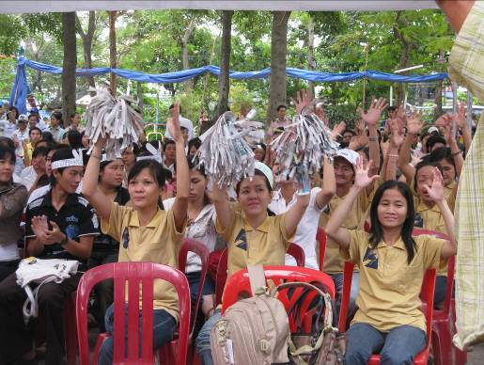
2/ National Day on Disability April 18th, 2009 “The Sky is the Limit”
