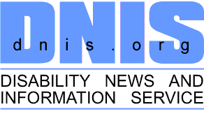
Interview

India should ratify 'Optional Protocol': Shuaib Chalklen
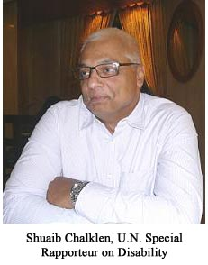
He is a prominent leader who has made extensive contributions to the advancement of disabled persons within both regional and global frameworks. He has assumed numerous positions in the fields of disability, governance and administration at the national and global levels. Shuaib Chalklen, U.N. Special Rapporteur on Disability of the Commission for Social Development, says “international cooperation and exchange of information is a critical factor”. In an exclusive interview with Anika Sharma of D.N.I.S., Chalklen says that he looks at disability as a cause and is still trying to make a revolution. He talks about various disability movements in Africa, issues faced by disabled persons vis-เ-vis access and shares his views on the new Disability Law in India. Excerpts:
D.N.I.S.: When did you first become aware of the disability issues? What influence this has had on your way of thinking and on your life?
Shuaib Chalklen: I became disabled in 1976. As far as I know, the disability movement in South Africa started in the 1980s. However, I became personally aware of that only in 1990 when I met a group of disabled persons in Cape Town. It had started in Johannesburg and was quite a strong movement in most of the Northern part of the country. But it was very weak in Cape Town and its surrounding areas. I formally joined the National Movement in 1991-92 and took up a job as a National Training Officer in the disability movement. It was an eye-opener to look at disability also as a cause. I hadn’t thought of it in this context before. There was only one cause in South Africa at that time and it was fighting the previous regime and the Apartheid system, so that was the main cause for everybody. Therefore, disability was something new for me, but it was also a good thing, personally.
D.N.I.S.: How strong is the disability movement in Africa? Can you give us an insight into its history?
Shuaib Chalklen: In the whole of Africa, in each country, there are at least a few organizations of disabled people. But it depends on how you define a strong movement. In my view, a strong movement is a movement that can challenge the state to achieve something. The objective of the exercise is to change the conditions of disabled people. So, a strong movement must be gauged around that. Does it have an impact? Therefore, if I look at Africa as a whole, there are only a few countries that have changed the conditions of disabled people. And part of the reason is that, in many African countries, the movements are very weak. There is a strong state that doesn’t allow civil society to flourish or grow.
D.N.I.S.: Can you tell us something about the latest developments in terms of new concepts vis-เ-vis access in Africa?
Shuaib Chalklen: There are some countries in Africa where access is non-existent. Algeria, Libya and Tunisia are some examples. But, there are some developments related to access in North Africa, Morocco and Egypt. There are wheelchair accessible rooms in hotels, but if you go further than that, then there is no access. In Sub-Saharan Africa, access doesn’t exist. In South Africa, you may find some access. If you go to a beach in South Africa, along a promenade, then you’ll find that public toilets are accessible, there are pedestrian crossings for blind people, and so on.
D.N.I.S.: So, what is the government doing about this?
Shuaib Chalklen: Twenty-two countries in Africa have ratified the Convention, out of 54. I have worked in every single African country in three years and all these governments have told me that they have got wonderful policies on disability. When I meet the Prime Ministers and Ministers and ask them about the Convention, they tell me: “No, we don’t need to ratify it. We have a wonderful policy on disability.” Strangely, they do not implement even one of its provisions. Now, there could be two reasons for that. Either they have got weak movements, so nobody apprises them or they have got a compromised leadership. The leadership of the disability movement is so close to the government that the leader doesn’t challenge them because the government gave him an office, the government gave him a car, so he is not going to complain. There are disabled people, but they have no say.
D.N.I.S.: There is a huge debate in the Indian disability sector regarding a new and comprehensive law based on U.N.C.R.P.D. What are your views on the subject?
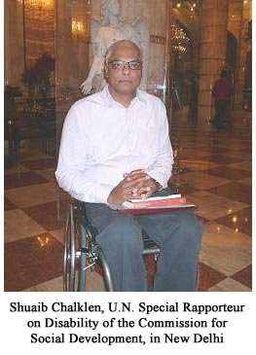
Shuaib Chalklen: Well, I am not fully aware of the debate. But, in my view, if we look at all the U.N. documents from the World Program of Action, the Standard Rules up to the Convention now, none of them made a division on the basis of different categories of disability. The Convention on the Rights of Persons with Disabilities (C.R.P.D.) is one document that makes reference to all the rights of all the disabled people. So, we would suggest that, in India or in any other country, there should be one law for all disabled people. And, as I said earlier, the objective of the exercise is to change the conditions of disabled people. But, what we often find is that there are so many committees and so many different organizations that it becomes difficult. So, my own view is that, there should be only one legal instrument because despite the implementation challenges, different ministries and agencies work differently. If you have one law, then it becomes easier for disabled people, legally, to challenge it if it is not implemented.
However, to come back to the C.R.P.D., it is only one Convention that has an “Optional Protocol”. And, I believe, India did not ratify the “Optional Protocol”. I would strongly suggest that they do so. This is something that organizations like N.C.P.E.D.P. should work on and encourage the government to ratify the “Optional Protocol”. Because, I can see no reason why a democracy like India should not ratify the “Optional Protocol”. What’s the motivation for that? I know that some of the countries have ratified the Convention with reservations because they have got problems with Article 12 (Legal Capacity) but I believe that it is the question of how they interpreted it. In my opinion, I would strongly discourage any country from ratifying with reservations.
D.N.I.S.: As a U.N. Special Rapporteur, what are the major challenges that lay ahead in 2011?
Shuaib Chalklen: One of the challenges is international cooperation. We don’t exchange enough information on technical capacity. We don’t do that at all. Secondly, implementation is a challenge. If countries ratify the Convention, they must implement. The other challenge that I work on quite frequently, and also mention in different countries is, the position of women with mental disabilities. I don’t know about India, but that’s a huge challenge in Africa.
D.N.I.S.: You are in a very responsible position as of now, in the United Nations. So, what do you think you can do in terms of meeting these challenges?
Shuaib Chalklen: Well, the only thing that I can do is, when I get into a meeting I talk about these issues. I can only raise awareness. I am not an organization, I am just an individual. So, awareness raising is really the main concern.
D.N.I.S.: What other methods would you use?
Shuaib Chalklen: I am targeting a few countries, like the Nordic countries. We are going to have a Nordic Country Meeting on mainstreaming disability in development. However, on the question of goals on women with mental illnesses, I am working with a world network of users and survivors of psychiatry. Another thing I am trying to do is to get on to the Organisation for Economic Co-operation and Development (O.E.C.D.) meeting in South Korea. It is very difficult since it is a closed club of some of the richest countries of the world.
D.N.I.S.: How many countries are expected at the O.E.C.D. meeting?
Shuaib Chalklen: Well, I don’t know what the exact membership of the O.E.C.D. is. May be, 12 to 15 countries. However, I have got a very ambitious agenda. If you look at all the things I told you about what a single person is trying to do in this world, then in simple words, I am still trying to make a revolution!
Source: http://dnis.org/interview.php?issue_id=2&volume_id=8&interview_id=159

