
Ms. Saowalak Thongkuay
Regional Development Office (RDO)
Disabled Peoples’ international Asia Pacific (DPIAP)

Mainstreaming disability perspectives in the e regional Development trends in Asia Pacific Region

- To ensure the new century achieves economic and social development progress, social protection should be a central element of the development agenda. Investment in children, women, persons with disability, and people of all age and reducing vulnerability of people at risk will assist countries to develop their human potential, reduce poverty, achieve sustainable growth by enhancing production and create opportunities for individual self-reliance.
- World Bank Research suggested that the most crucial aspect of human security usually is in the area of human dignity; the lack of political voices, legal rights, access to justice and the ability to contest discrimination so the poor people always deprive of their rights. Furthermore, a study of donor policies and practices carried out for the Japan International Cooperation Agency (JICA) found the current paradigm of development partnership had not get sufficiency engaged vulnerable people especially persons with disabilities who live in the rural area in developing countries in Asia Pacific Region.
- Mainstreaming disability perspective into the regional and sub regional development agenda by realizing disability and development process. Since 1992, disability community witnessed and experiences remarkable progress in Asia Pacific region. Many Disabled Peoples’ Organizations (DPOs) was formulated and empowered. Many countries established and strengthened disability laws, access to build environment. However, realizing the actual situation of persons with disabilities in Asia Pacific Region. Persons with disabilities are still faced many barriers and marginalized in society because of deprivation of the fundamental civil rights and lack of access to fundamental social services, especially in rural area.
- From the DPOs view points, we urge you to attention to the following areas;
  - Paradigm shift of the development, to engaged persons with disabilities and vulnerable people in social development processes. Social development should be rights base approach rather than charity based approach.
  - The social development should keep on its original approach as people centered and harmonize and apply the Convention on the Rights of Persons with Disabilities (CRPD) into all development components and its program.
  - Empowerment to all stakeholders especially in technical support, transfer knowledge and know how are crucial to achieve mainstreaming disability perspectives in social development agenda.
  - A universal social safety net mechanism should be set up to response to globalization.
  - The community based approaches to development for instance independent living philosophy (IL), Self Help Organization (SHOs) that emphasize rights of persons with disabilities and vulnerable group should be an important aspect of increasing human security and advancing social development.
  - To address those challenges and realize human rights of persons with disabilities, on behalf of DPOs in Asia and Pacific region, we would like to propose for your consideration a toward people centered decade: a new Asia Pacific Decade toward the full implementation of the Convention on the Rights of Persons with Disabilities (CRPD) and its strategies should be developed to empower and mainstream disability perspectives in regional and sub regional social, economic and political development agenda.

Source: Social Protection in Asia Pacific Asian Development Bank 2001, Published by Asian Development Bank, 2001
Study of donor policies and practices carried out for the Japan International Cooperation Agency (JICA)
Mainstreaming Disability: Turning Ideas into Action”, Disability Knowledge and Research Programme (2003 – 2005)

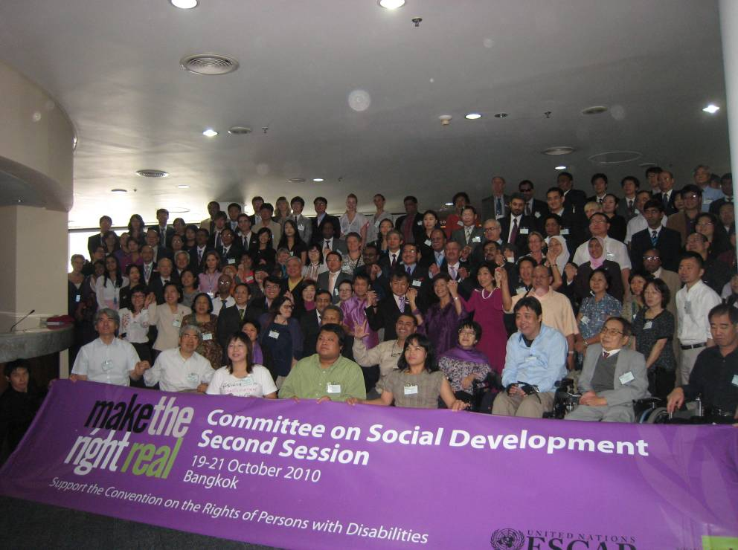
Group pictures
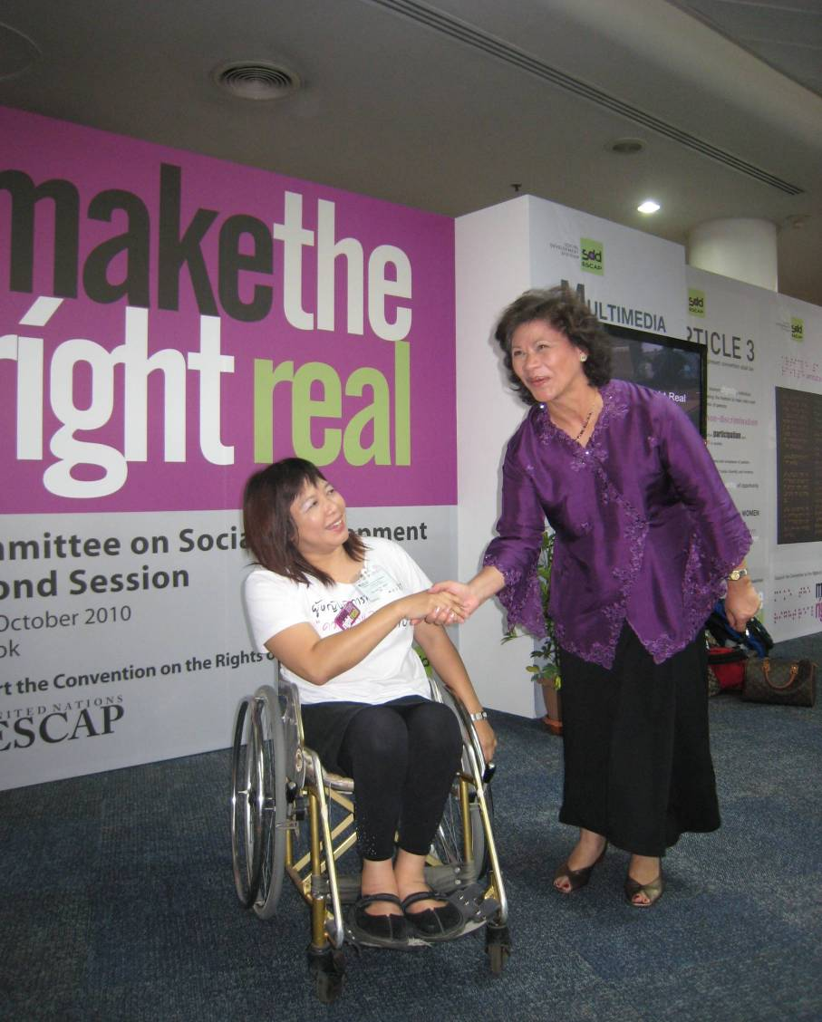
Ms. Saowalak Thongkuay, Regional Development Office (RDO) DPIAP and Ms. Noeleen Heyzer, Under-Secretary-General of the United Nations and Executive Secretary of ESCAP promote the campaign “Make the Right real” Challenge of the New Asia Pacific Decade beyond 2013

